

Modul Profile Manager

MicroStep HDO s.r.o

júl 2025

Pracovné postupy

Content

Obsah 5

1. Aplikácia Profile Manager 11

1.1. Ako sa prihlásiť do aplikácie 11

1.2. Horná lišta aplikácie 12

1.3. Zmena farby hornej lišty aplikácie 16

1.4. Ako pridať na plochu okná prieskumník, tabuľka a graf 16

1.4.1. Pravidlá pre názvy okien 17

1.5. Ako sa odhlásiť z aplikácie 18

1.6. Ako zmeniť jazykovú verziu 19

1.7. Ako zmeniť predvolené nastavenia 19

1.8. Ako zobraziť profil prihláseného užívateľa 20

1.9. Globálny dátumový rozsah 21

1.9.1. Ako aplikovať dátumový filter vo vybranom okne 22

1.9.2. Ako aplikovať dátumový filter vo všetkých oknách naraz 23

1.10. Ako obnoviť viditeľné dáta 23

1.11. Všeobecné nastavenia 23

1.11.1. Globálne všeobecné nastavenia 23

1.11.2. Všeobecné nastavenia pre tabuľku 28

1.11.3. Všeobecné nastavenia pre graf 31

1.11.4. Všeobecné nastavenia pre prieskumník 33

1.12. Nastavenia pre sviatky 35

1.12.1. Ako vytvoriť profil pre sviatky 35

1.12.2. Ako vybrať profil pre sviatky 39

1.12.3. Ako odstrániť profil pre sviatky 40

1.13. Ako zobraziť informácie o statuse 40

1.14. Ako zobraziť upozornenia 41

1.15. Ako zväčšiť okno stromovej štruktúry 42

1.16. Synchronizácia panelov 44

1.16.1. Zarovnať časové rozsahy 44

1.16.2. Ako synchronizovať tabuľky 45

1.16.3. Ako synchronizovať grafy 47

1.17. Ako importovať, exportovať a ukladať zostavy 47

1.17.1. Ako importovať zostavu 48

1.17.2. Ako exportovať zostavu 50

1.17.3. Ako aktualizovať zostavu 50

1.17.4. Ako uložiť novú zostavu 52

1.17.5. Ako zarovnať zostavu do stĺpcov 54

1.17.6. Ako zarovnať zostavu do riadkov 56

1.17.7. Ako zarovnať všetko do jedného panelu 58

1.17.8. Ako rozdeliť zostavu do samostatných panelov 58

1.17.9. Ako nastaviť globálny časový rozsah pri zobrazení zostavy 59

1.17.10. Ako zatvoriť zostavu 61

1.18. Ako horizontálne zarovnať okná 62

1.19. Ako vertikálne zarovnať okná 63

1.20. Ako zobraziť a stiahnuť exporty 63

1.21. Ako zobraziť importy 65

1.22. Klávesové skratky 67

1.23. Ako vyhľadať profil v aplikácii 71

1.24. Informovanie užívateľa o odhlásení 71

1.25. Ako zobraziť čas, ktorý ostáva užívateľovi do odhlásenia 72

2. Práca s adresármi a profilmi 74

2.1. Ako pridať nový adresár 74

2.2. Ako premenovať adresár 76

2.3. Ako editovať adresár 77

2.4. Ako zmazať adresár 78

2.5. Ako kopírovať adresár 78

2.6. Ako vystrihnúť/presunúť adresár 79

2.7. Ako nahrať súbor 79

2.8. Ako zmazať dáta profilov 81

2.9. Ako filtrovať adresáre a profily 84

2.10. Ako zrušiť filter adresárov a profilov 85

2.11. Ako zobraziť komentáre 85

2.12. Ako zobraziť tooltip 86

2.13. Ako zobraziť charakter 88

2.14. Ako obnoviť zoznam 89

2.15. Ako nastaviť práva používateľov a skupín 89

2.16. Ako vytvoriť export 94

2.17. Ako vytvoriť import 98

2.18. Ako pridať nový profil 101

2.18.1. Ako zadať definíciu pre počítaný typ profilu 105

2.19. Ako pridať novú zostavu 112

2.20. Ako premenovať profil 113

2.21. Ako editovať profil 113

2.22. Ako zmazať profil 114

2.23. Ako zobraziť závislosti profilu 114

2.24. Ako vytvoriť nový profil 116

2.25. Ako nastaviť Politiku profilu 116

2.26. Ako zobraziť informácie o profile 117

2.27. Ako skopírovať profil 118

2.28. Ako vystrihnúť/presunúť profil 121

2.29. Ako zobraziť náhľad časovej rady v strome 122

2.30. Ako zväčšiť okno pre vytvorenie a úpravu počítaného profilu 123

2.31. Ako premiestniť okná 123

2.32. Ako premenovať dokument 124

3. Spoločné ovládacie prvky pre prieskumník, tabuľku a graf 125

3.1. Ako obnoviť dáta v oknách 125

3.2. Ako zmeniť dátumový rozsah 125

3.3. Ako zväčšiť okno cez celú plochu aplikácie 126

3.4. Ako zatvoriť okno 127

3.5. Nastavenie názvu a farby panelu 127

3.6. Ako exportovať zobrazené dáta z okna Prieskumník 129

3.7. Ako skryť horný panel s tlačidlami v okne prieskumník, tabuľka a graf 129

3.8. Ako pridať profil do grafu a tabuľky 130

4. Práca s oknom Prieskumník 132

4.1. Ako zobraziť profily z vybraného adresára v okne Prieskumník 132

4.2. Ako vytvoriť nový adresár 132

4.3. Ako synchronizovať prieskumník so stromom 132

4.4. Ako filtrovať profil 133

4.5. Ako zoradiť dáta v stĺpcoch 134

4.6. Ako vypočítať hodnoty v stĺpcoch Min, Max, Sum, Avg a Count v okne Prieskumník 134

4.7. Náhľad časovej rady 135

4.8. Ako presunúť profil z okna Prieskumník do okna Graf alebo Tabuľka 138

4.9. Ako upraviť pridať alebo odobrať stĺpce v okne Prieskumník 139

4.10. Ako upraviť polia Názov a Komentár 141

4.11. Funkcie pre prácu s adresármi v okne Prieskumník 141

4.12. Funkcie pre prácu s filtrami v okne Prieskumník 142

4.13. Tlačidlo Branch view 143

4.14. Ako zobraziť vymazané položky v okne Prieskumník 145

4.15. Ako skopírovať zobrazené dáta 146

4.16. Použiť ako východzie nastavenie Prieskumníka 148

4.17. Ako filtrovať v stĺpcoch pomocou * wildcard 149

5. Práca s grafom 152

5.1. Ako zobraziť profil v grafe 152

5.2. Ako zobraziť informačné okno s hodnotami pre konkrétne miesto v grafe 153

5.3. Ako zmeniť v grafe dátum od-do 155

5.4. Ako uložiť graf vo formáte JPG 155

5.5. Ako skopírovať celý graf do nového okna 155

5.6. Ako nastaviť parametre grafu 156

5.6.1. Ako nastaviť počet desatinných miest pre každú z Y-ových osí 158

5.6.2. Ako vypnúť vodorovné čiary 159

5.7. Funkcie pre prácu nad označenými profilmi 160

5.7.1. Ako vybrať profily 161

5.7.2. Ako zobraziť vlastnosti profilu 161

5.7.3. Ako zmeniť nastavenia označeným 162

5.7.4. Ako označiť všetky profily 164

5.7.5. Ako odznačiť všetky profily 165

5.7.6. Ako invertovať označené profily 166

5.7.7. Ako zobraziť len označené profily 167

5.7.8. Ako označené profily nezobrazovať 167

5.7.9. Ako odstrániť označené, všetky alebo chybné profily 168

5.7.10. Ako nastaviť koeficient označeným profilom 169

5.7.11. Ako nastaviť offset 171

5.7.12. Ako zobraziť štatistické čiary 172

5.7.13. Ako nahradiť text označeným 174

5.8. Funkcie pre prácu s jedným profilom 175

5.8.1. Ako upraviť nastavenia 176

5.8.2. Ako odstrániť profil 178

5.8.3. Ako presunúť profil na začiatok 179

5.8.4. Ako posunúť profil hore 180

5.8.5. Ako posunúť profil dole 181

5.8.6. Ako presunúť profil na koniec 181

5.8.7. Ako zobraziť komentár 182

5.8.8. Ako nájsť prvú hodnotu 183

5.8.9. Ako nájsť poslednú hodnotu 183

5.8.10. Ako zobraziť subprofily 184

5.8.11. Ako otvoriť umiestnenie profilu 185

5.8.12. Ako otvoriť info okno 187

5.8.13. Ako nastaviť koeficient 189

5.8.14. Ako zadať offset 190

5.8.15. Ako vymeniť profil 193

5.8.16. Ako editovať profil 194

5.8.17. Ako nastaviť farbu pre profil 196

5.8.18. Ako nastaviť veľkosť bodu 197

5.8.19. Ako zobraziť profil v tabuľke 201

5.9. Rýchla zmena typu grafu 203

5.10. Ako priblížiť vybranú časť grafu 205

5.11. Ako posúvať graf 206

5.12. Ako zrušiť zoom 207

5.13. Ako zobraziť/skryť legendu 207

5.14. Ako zobraziť/skryť tooltip 208

5.15. Ako nastaviť y-ovú os, aby bolo vidieť hodnoty 209

5.16. Ako vymeniť profil 211

6. Práca s tabuľkou 215

6.1. Ako zobraziť profil v tabuľke 215

6.2. Ako nastaviť stĺpcové zobrazenie 216

6.3. Ako prepnúť na jednoprofilové zobrazenie 217

6.4. Ako zmeniť časový formát zobrazenia 219

6.5. Ako nastaviť počet stĺpcov 219

6.6. Ako vybrať spôsob prevzorkovávania 221

6.7. Ako zobraziť prvú hodnotu 222

6.8. Ako zobraziť poslednú hodnotu 222

6.9. Ako zobraziť aktuálny deň 222

6.10. Ako zobraziť konkrétny dátum 223

6.11. Ako posúvať dátum o deň, týždeň, mesiac 224

6.12. Ako pridať stĺpec Suma, Priemer, Min, Max 225

6.13. Ako zapnúť/vypnúť tooltip 226

6.14. Ako zapnúť/vypnúť zvýraznenie riadku 227

6.15. Ako upraviť hodnotu profilu v tabuľke 228

6.16. Ako zmeniť definíciu profilu 229

6.17. Ako odstrániť profil z tabuľky 230

6.18. Ako zapnúť automatické nastavenie šírky stĺpcov 230

6.19. Ako otvoriť umiestnenie profilu 231

6.20. Ako pridať profil 232

6.21. Ako exportovať zobrazené dáta do CSV 235

6.22. Ako zmeniť definíciu 236

6.23. Ako zmeniť metadáta profilu 236

6.24. Ako odstrániť profil zo zobrazenia 238

6.25. Ako zobraziť profil v grafe 239

6.26. Ako nájsť pozíciu v grafe 240

6.27. Ako otvoriť profil v strome 241

6.28. Označiť blok pomocou ľavého tlačidla myši 241

6.29. Ako nastaviť, aby sa kurzor posúval v tabuľke pomocou kolieska myši 242

6.30. Ako zmeniť poradie profilov v tabuľke 244

7. Aritmetika počítaných profilov 247

7.1. Pravidlá prevzorkovávania 247

7.1.1. Pravidlá prevzorkovávania vstupného profilu na výstupný so zohľadnením charakteru 247

7.2. Počítaný profil 248

7.2.1. Spôsob zápisu výrazu 250

7.2.2. Vyčíslenie výrazu 250

7.2.3. Aritmetické operácie: 250

7.2.4. Funkcie 251

8. Príplatkové/doplnkové funkcie 262

8.1. Monitorovanie profilov 262

8.1.1. Ako vytvoriť nový monitorovací job 262

8.1.2. Ako editovať job v JMW 268

8.1.3. Ako zmazať job 269

8.1.4. Ako exportovať monitorovacie joby a výsledky jobov 269

8.1.5. Ako zobraziť všetky monitorovacie joby 270

8.1.6. Ako obnoviť zoznam jobov v okne „Monitoring“ 270

8.1.7. Ako zobraziť prehľad výsledkov monitorovacieho jobu 270

8.2. Analýza profilov 270

8.2.1. Ako vytvoriť analýzu profilov 271

8.2.2. Ako zobraziť existujúcu analýzu profilov 274

8.2.3. Ako zmeniť platnosť vytvorenej analýzy profilov 275

8.2.4. Ako exportovať zobrazené dáta v analýze profilov 275

8.3. Report Manager 276

8.3.1. Ako vytvoriť nový report 276

8.3.2. Práva pre Report Manager 283

8.4. Ako obnoviť vymazané položky z koša 284

# Profile Manager application

The “Profile Manager” application is a tool used to present profiles (time series) in graphical or tabular form, as well as for their basic management. A profile is a time-unlimited series of values with various meanings. This documentation applies to version 4.3.301.

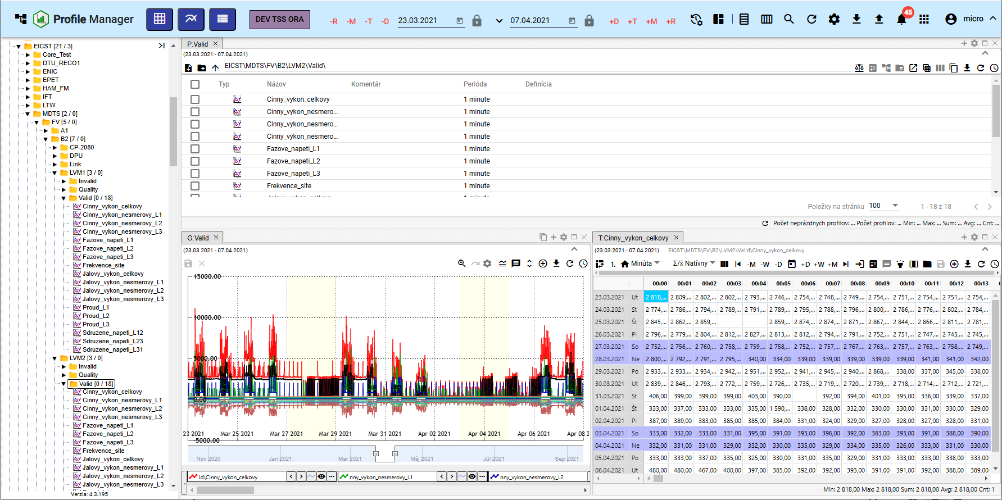

Figure 1: “Profile Manager” application

## How to log in to the application

When the “Profile Manager” application is launched, a login screen will appear. A username and password must be entered. Checking the “Remember me” checkbox will mean that login details do not need to be re-entered on subsequent logins. The application will remember them. To log in, press the “Log in” button.

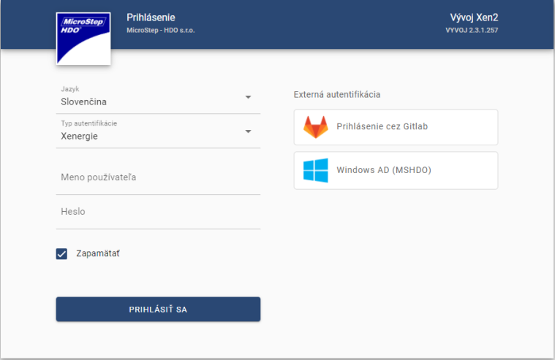

Figure 2: Logging in to the “Profile Manager” application

## Application top bar

In the application top bar you will find:

* a button that allows you to minimize and maximize the application menu

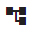

Figure 3: Button to hide and show the application menu

* Application name "Profile Manager" - after pressing the button, the "Profile Manager" application is reloaded.

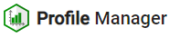

Figure 4: "Profile Manager" button

* “Add Table” button - by dragging the button onto the screen, a “Table” window is added.

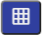

Figure 5: “Add Table” button

* “Add Chart” button - used to add a “Chart” window to the application workspace.

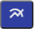

Figure 6: “Add Chart” button

* “Add Explorer” button - dragging the button onto the application screen adds the “Explorer” window.

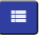

Figure 7: “Add Explorer” button

* button representing the environment name – both text and color can be set for the button.



Figure 8: Environment Name

* global date range - represents the date filter, chapter 1.9



Figure 9: Global Date Range

* Synchronize Panels button – allows aligning time ranges (1.16.1) and synchronizing tables (1.16.2)



Figure 10: Synchronize Panels button

* button for importing and downloading reports – procedures are detailed in chapter 1.17



Figure 11: "Reports" button

* button for profile search – profile search is detailed in chapter 1.23



Figure 12: "Profile Search" button

* “Refresh Visible Data” button – used to refresh data in the application, chapter 1.10



Figure 13: "Refresh Visible Data" button

* “Export” button – contains a list of exports, chapter 1.20.



Figure 14: "Export" button

* “Import” button – contains a list of imports, chapter 1.21.



Figure 15: "Import" button

* “Notifications” button – signals changes made in the application, chapter 1.14



Figure 16: "Notifications" button

* Button to display the list of applications. This is where the list of applications for the given environment is located. Clicking on an application in the list will open it in a new browser tab.



Figure 17: Button to display the list of applications

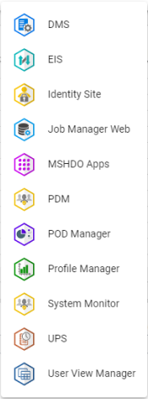

Figure 18: List of applications

* button displaying the logged-in user's name, which allows:
  + changing the language version of the application, chapter 1.6,
  + restoring default settings, chapter 1.7,
  + display keyboard shortcuts
  + display profile, 1.8
  + display application and service status information, chapter 1.13
  + sign out of application, chapter 1.5.

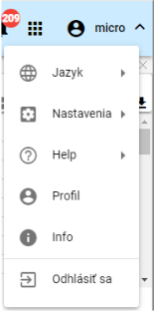

Figure 19: Button with the logged-in user’s name

* The "Hide Top Toolbar" button is used to hide the top toolbar. Subsequently, the button's appearance changes and is used to display the top toolbar. Figure 21.

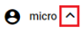

Figure 20: "Hide Top Toolbar" button

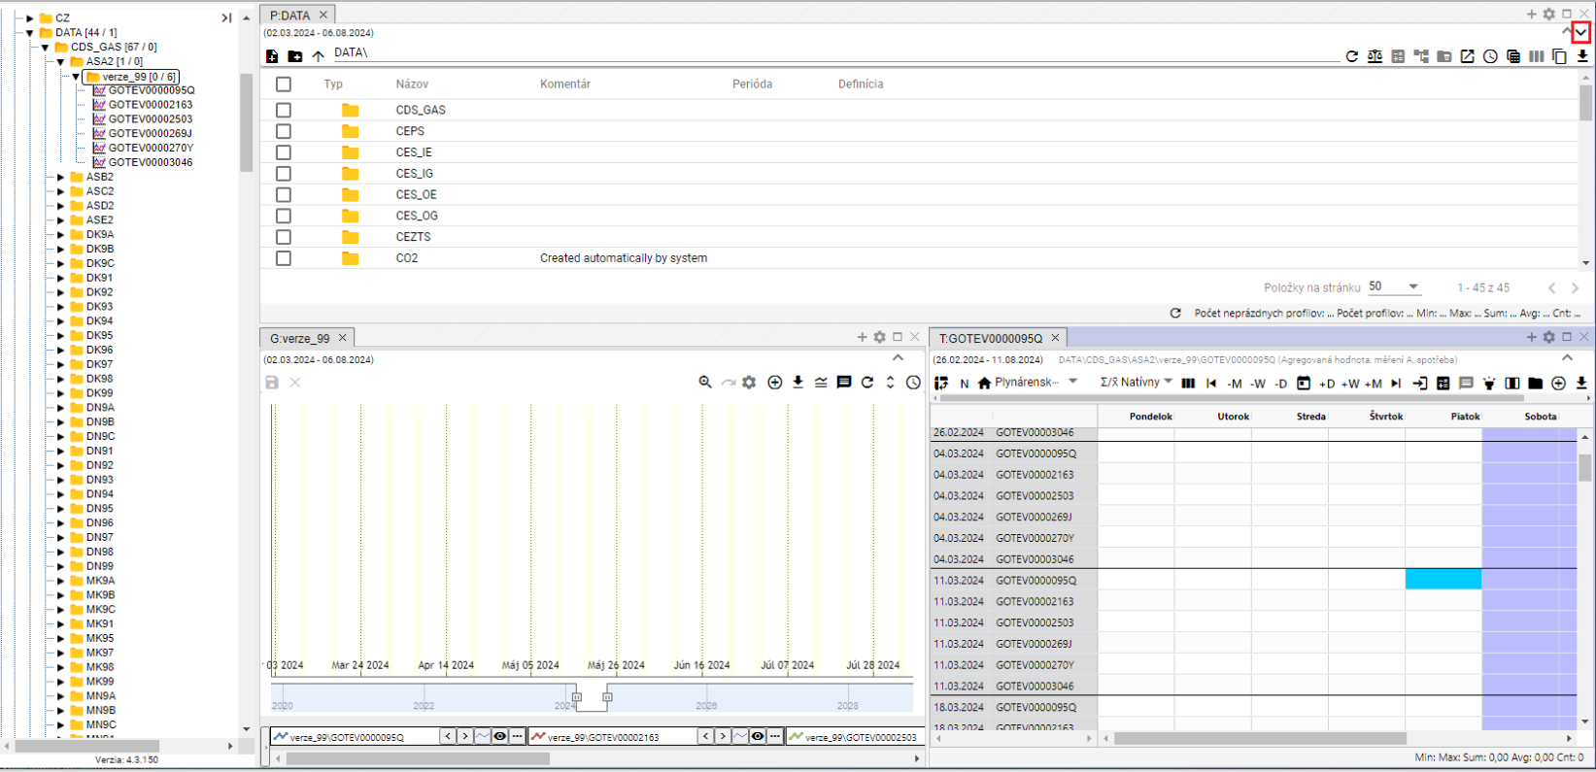

Figure 21: Button to display the top toolbar



Figure 22: Application Top Toolbar

## Changing the Application Top Toolbar Color

The customer can request a change to the top toolbar color. Changing the color of the top toolbar serves to differentiate the Development, Testing, and Production environments.



Figure 23: Application Top Toolbar

## How to add Explorer windows, tables, and charts to the dashboard.

You can add any number of Explorer windows, tables, and charts to the "Profile Manager" application dashboard. Proceed as follows:

1. Click and drag the button to the application canvas.
2. Hold the button over the canvas and move to the location where you want to add the window.
3. Choose the shape the window should have.

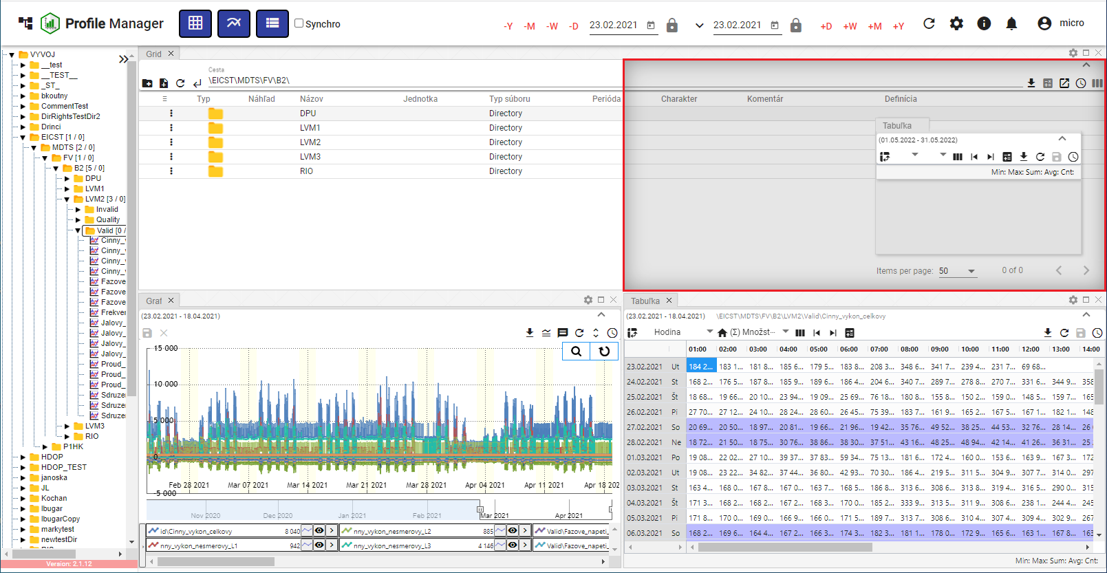

Figure 24: Selecting the shape and location of the window

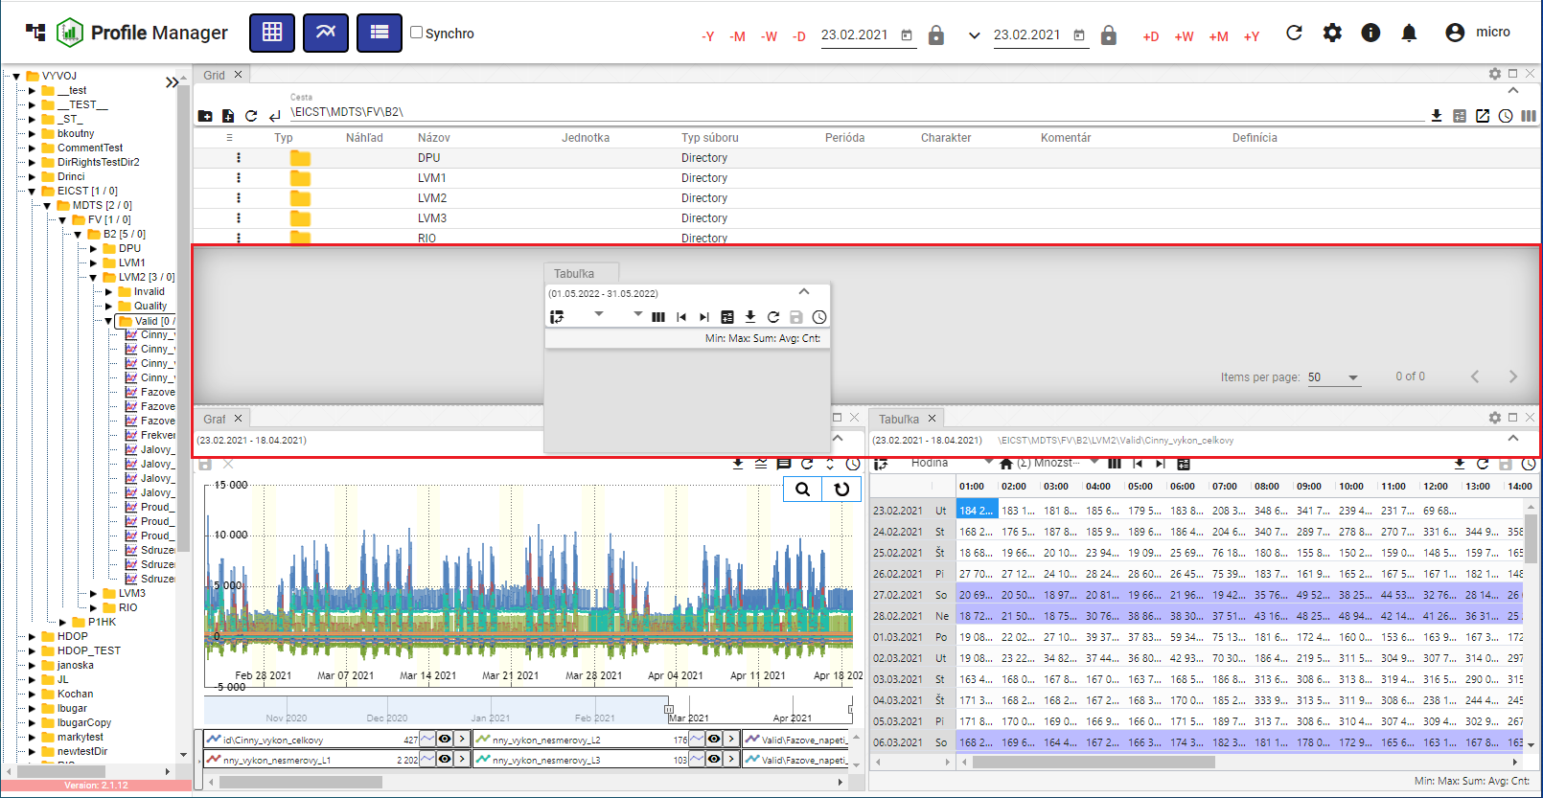

Figure 25: Shape and location of the window table

1. Releasing the button adds the window to the selected location.

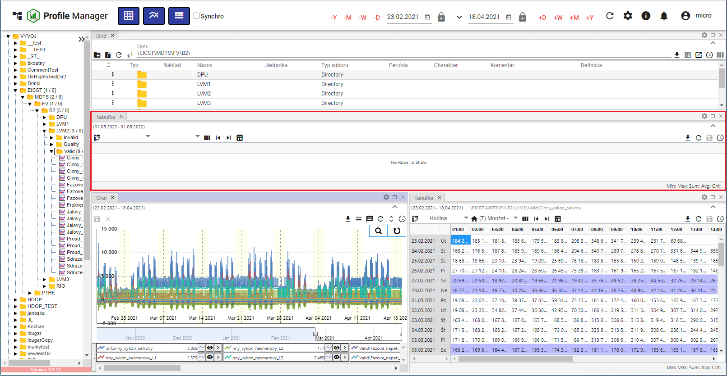

Figure 26: Added window table

### Window Naming Rules

Explorer, Chart, and Table windows are automatically named according to the following rules:

Table

The name for the table is "T: <name of the first profile in the table>".

Example: "T:ProfilHPFC".

Chart

The name for the chart is "G: <name of the first profile in the chart>".

Example: "G:ProfilHPFC"

Explorer

The name for the Explorer in Slovak and Czech is "P: <name of the directory I am in>".

Example: "P: AdresarTEST".

In the case of the root directory, the word will be "P:Root".

In English, the explorer is named "E: <name of the directory I am in>".

Example: "E:AdresarTEST"

In the case of the root directory, the word will be "E:Root".

Explorer – Branch view

Explorer – Branch view is named „B: <the name of the directory where the branch view was started >“."

Example: „B:AdresarTEST“. In the case of the root directory, the name will be „B:Root“.

The window title is adjusted accordingly with each profile or directory change. If the user enters a window title using the button, automatic adjustment is disabled from that point on and will no longer be applied.

## How to log out of the application

You log out of the application by pressing the button with the logged-in user's name. A window will appear where you press "Log Out".

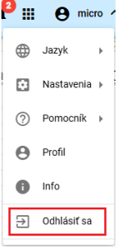

Figure 27: "Log Out" item

## How to change the language version

To change the language version, press the button with the logged-in user's name and then move the mouse cursor to the "Language" item. Select the language version in the window that appears.

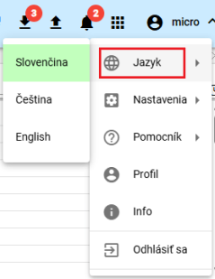

Figure 28: Change Language Version

## How to change the default settings

To restore the default settings in the "Profile Manager" application, proceed as follows:

1. Click the button labeled with the logged-in user's name.
2. Use the mouse cursor to navigate to the "Settings" item.
3. Click the "Set Default Settings" button.

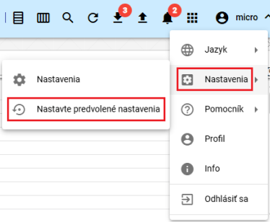

Figure 29: "Settings" item

1. A confirmation window will appear, in which press the "Yes" button.

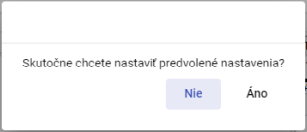

Figure 30: Confirmation for setting default settings

## How to display the logged-in user's profile

You display the logged-in user's profile:

1. Click the button labeled with the logged-in user's name.
2. Click on the "Profile" item.

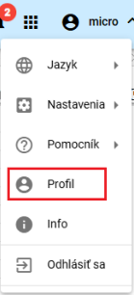

Figure 31: "Profile" item

1. The profile of the logged-in user will be displayed in a new browser tab in the "IdentitySite" application.

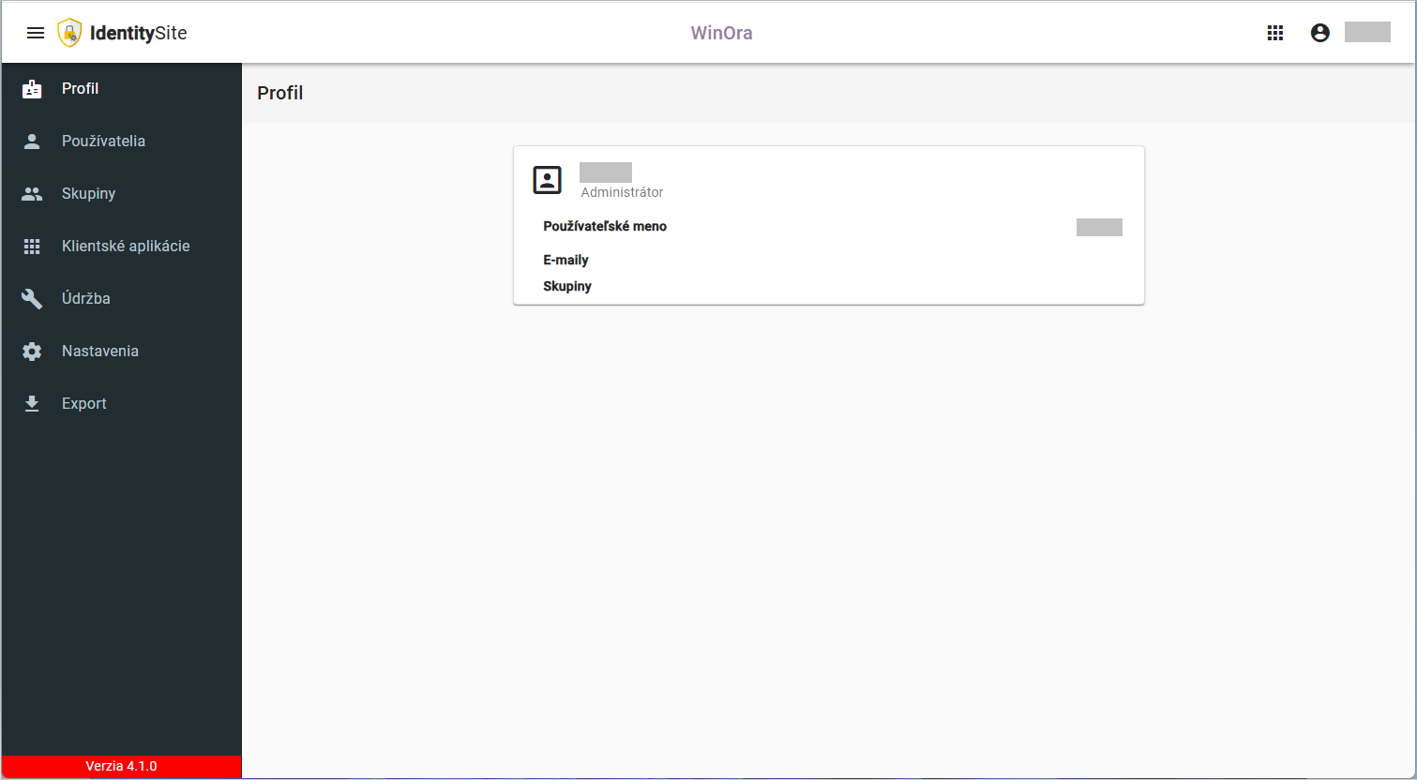

Figure 32: Profile of the logged-in user in the "IdentitySite" application

## Global Date Range

By default, the date filter is set to the current date.



Figure 33: Global Date Range

Clicking the button displays the default date range options, Figure 34.

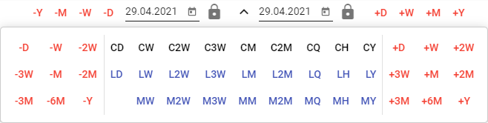

Figure 34: Default Date Range Options

You can lock dates. When changing the date range, the locked date does not change.



Figure 35: Locking the Date

### How to apply a date filter in the selected window

The date range in the application's top bar is linked to the selected window. If the date range changes in the selected window, it will also change in the application's top bar. If the date range changes in the application's top bar, it will be applied to the selected window.

Proceed:

1. Select the window in which you want to apply the filter by clicking on the top part of the window, Figure 36.

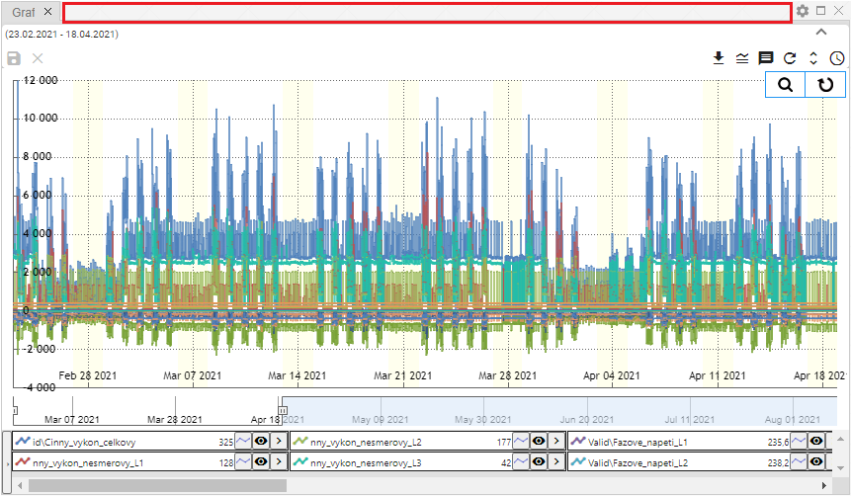

Figure 36: Area to select the window

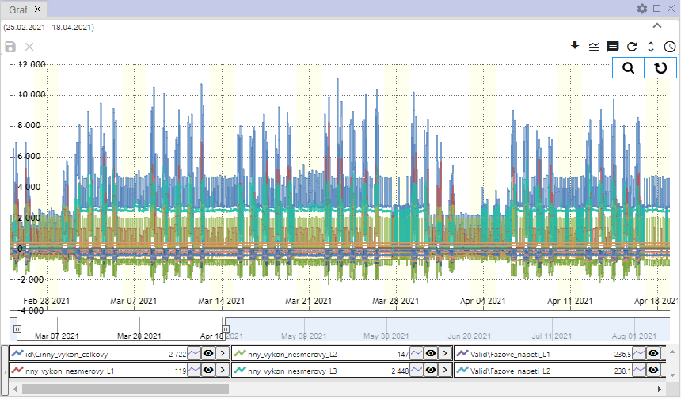

Figure 37: Selected window for the filter

1. Select the date filter from the top bar of the application.



Figure 38: Global date range

1. Data will be displayed in the selected window according to the chosen date filter.

### How to apply the date filter across all windows at once

Proceed:

1. Check the "Synchro" checkbox.



Figure 39: "Synchro" checkbox

1. Select one of the Explorer, Table, or Chart windows by clicking in the top part of the window, see Figure 36 and Figure 37.
2. Subsequently, enter the date filter in the top bar of the application.



Figure 40: Global Date Range

1. The date filter is applied to all windows in the application.

## How to restore visible data

To restore data in the "Profile Manager" application, press the "Restore Visible Data" button, which is located in the application's top bar.



Figure 41: "Restore Visible Data" button

## General Settings

The "General" tab in the "Settings" window is divided into sections:

* Global – general settings for the "Profile Manager" application,
* Table – general settings for the table,
* Chart – general settings for the chart,
* Explorer – general settings for the explorer.

Individual settings are described in the following subsections.

### Global general settings

#### How to enable automatic refresh after profile modification

To refresh the data after saving, proceed as follows:

1. Click the button with the logged-in user's name, located in the top bar of the application. Hover the mouse cursor over "Settings" and click "Settings" in the displayed window.

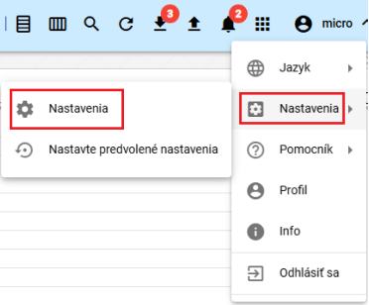

Figure 42: "Settings" item

1. A "Settings" window will appear.
2. In the "General" section, check the "Refresh displayed data after saving" box.

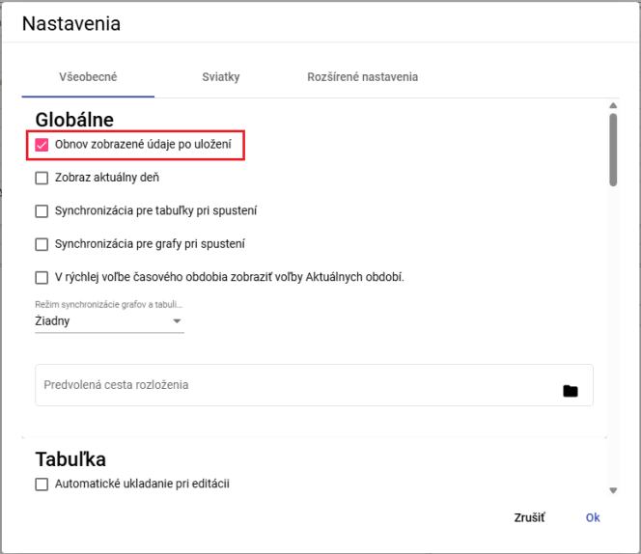

Figure 43: "Refresh displayed data after saving" item

1. Save the changes by clicking the "OK" button.

#### How to display new windows in the current day

To display new Explorer, Table, and Chart windows in the current day, proceed as follows:

1. In the "Settings" window, on the "General" tab, in the "Global" section, check the "Show current day" box, Figure 43.
2. Save the changes by clicking the "OK" button.

#### How to synchronize time for tables

To synchronize time for tables, proceed as follows:

1. In the "Settings" window, in the "General" tab, in the "Global" section, check the "Synchronize for tables on startup" box, Figure 43.
2. Save the changes by clicking the "OK" button.
3. Subsequently, restart the application.
4. If you check the "Synchronize for tables on startup" box, the "Synchronize tables" button will also be checked, 1.16.2.

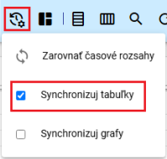

Figure 44: "Synchronize tables" field

1. The text "SYNC" will appear in the table window.

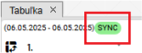

Figure 45: The text "SYNC" will appear in the table window.

#### How to synchronize time for charts

To synchronize time for tables, proceed as follows:

1. In the "Settings" window, on the "General" tab, in the "Global" section, check the box "Synchronize for charts on startup", Figure 43.
2. Save the changes by clicking the "OK" button.
3. Subsequently, restart the application.
4. If you check the "Synchronize for charts on startup" box, the "Synchronize charts" button will also be checked, 1.16.3

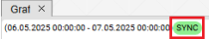

Figure 46: The graph will display the text “SYNC”

#### How to enable synchronization between the chart and the table

To enable synchronization between the chart and the table, proceed as follows:

1. In the “Settings” window, in the “General” tab, in the “Global” section, select an item in the “Chart and Table Synchronization Mode” field. You can choose:
   1. none - synchronization between the chart and the table is disabled.
   2. start - the beginning of the chart is synchronized,
   3. middle - the middle of the chart is synchronized.

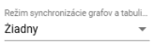

Figure 47: Chart and Table Synchronization Mode

1. You save changes by pressing the "OK" button.
2. Then restart the application.

#### How to display Current Period options in the Quick Time Period Selection.

In the Quick Time Period Selection, AR, AM, AT, AD options will be displayed instead of +R, +M, +T, +D. MR, MM, MT, MD will be displayed instead of -R, -M, -T, -D.

Proceed:

1. Check the "Display Current Period options in the Quick Time Period Selection" box.
2. Save the changes by clicking the “Ok” button in the “Settings” window.
3. Restart the application. The changes will then appear in the application.



Figure 48: Quick Time Period Selection

#### How to set the path to the default layout

The "Default layout path" field is used to set the path to the saved "Profile Manager" application layout. The set layout will be displayed each time the "Profile Manager" application is opened.

Proceed:

1. In the "Settings" window, in the "General" tab, in the "Global" section, in the "Default layout path" field, enter the path to the saved layout or click the button to display the "Select layout" window, where you can search for the saved layout.

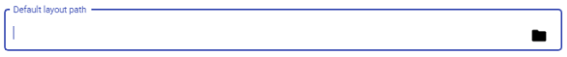

Figure 49: "Default layout path" field

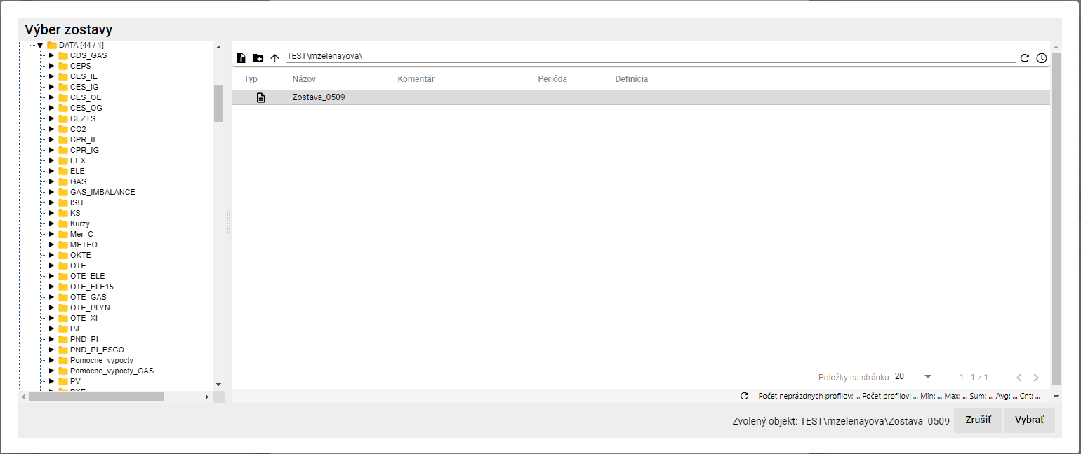

Figure 50: Select layout

1. In the "Select layout" window, click the "Select" button.
2. In the "Default layout path" field, you will find the path to the layout you have selected.



Figure 51: Selected layout

1. To save the changes, click the "OK" button in the "Settings" window.

### General settings for the table

#### How to set up automatic saving of changes in the table

Enabling automatic saving in the table will immediately save any changes made to the table. Proceed as follows:

1. In the "Settings" window, in the "General" tab, in the "Table" section, check "Automatic saving during editing".

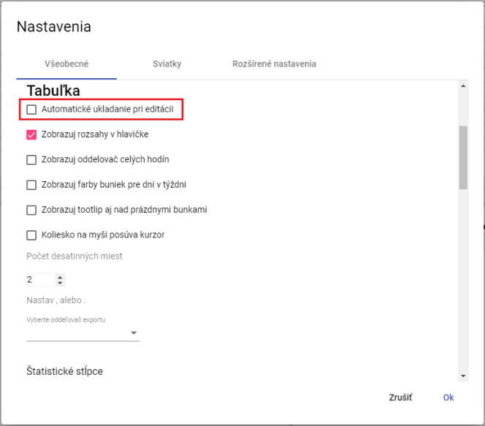

Figure 52: Table Settings

1. Save the changes by clicking the "OK" button.

#### How to display ranges in the header for the table

You set the ranges for the table header:

1. In the "Settings" window, in the "General" tab, in the "Table" section, check "Display ranges in the header", Figure 52.
2. Save the changes by clicking the "OK" button.

#### How to set the display of whole hour separators for the table

You set the display of the whole hour separator in the Table window:

1. In the "Settings" window, on the "General" tab, in the "Table" section, check "Display whole hour separator", Figure 52.
2. Save the changes by clicking the "OK" button.

#### How to set the cell color display for days of the week in the table

You set the cell color display for days of the week:

1. In the "Settings" window, on the "General" tab, in the "Table" section, check "Display cell colors for days of the week", Figure 52.
2. Save the changes by pressing the "Ok" button.

#### How to display tooltips also over empty cells in the table

To configure the display of tooltips also over empty cells in the table, proceed as follows:

1. In the "Settings" window, in the "General" tab, in the "Table" section, check "Show tooltip also over empty cells", Figure 52.
2. Save the changes by clicking the "Ok" button.

#### How to configure the mouse wheel to scroll the cursor

You configure cursor scrolling via the mouse wheel:

1. In the "Settings" window, in the "General" tab, in the "Table" section, check "Mouse wheel scrolls cursor", Figure 52.
2. Save the changes by clicking the "OK" button.

#### How to set the number of decimal places in the table

To set the number of decimal places in the Table window, proceed as follows:

1. In the "Settings" window, in the "General" tab, in the "Table" section, set the "Number of decimal places" item, Figure 52.
2. Save the changes by clicking the "OK" button.

#### How to set the export delimiter for the table

To set the export delimiter for the table, proceed as follows:

1. In the "Settings" window, in the "General" tab, in the "Table" section, in the "Select export delimiter" field, choose the delimiter.
2. Save the changes by clicking the "OK" button.

#### How to set the used statistical columns in the table

To set which statistical columns to use in the table, proceed as follows:

1. In the "Settings" window, on the "General" tab, in the "Table" section, select the statistical columns to use. You can select the Sum, Average, Min, and Max columns.

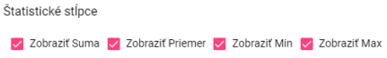

Figure 53: Statistical Columns

1. Save the changes by clicking the "OK" button.

#### How to set right alignment

To set right alignment in the table, proceed as follows:

1. In the "Settings" window, in the "General" tab, in the "Table" section, check the "Show pinning on the right" box.



Figure 54: "Show pinning on the right" item

1. Save the changes by clicking the "OK" button.

#### How to set default column widths for the table

To set the default column widths for the table, proceed as follows:

1. To set the default values for column widths, check the "Apply Default Values" box, which can be found in the "General" tab within the "Table" section of the "Settings" window.

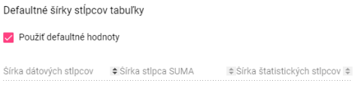

Figure 55: "Apply Default Values" item

1. To set custom values for column widths, leave the "Apply Default Values" box unchecked. This will enable the fields for setting column widths.

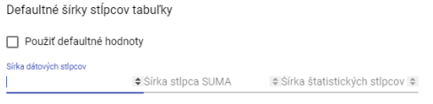

Figure 56: Entering Custom Values for Column Widths

1. Enter the column widths and save the changes by clicking the "OK" button.

### General settings for the chart

#### How to set the default line type for the chart

The default line type for the chart can be "Line" or "Stepped Line". To set the default line type, proceed as follows:

1. In the "Settings" window, in the "General" tab, in the "Chart" section, you can select the default line type.
2. By clicking in the "Default Line Type" field, you can select either "Line" or "Stepped Line".

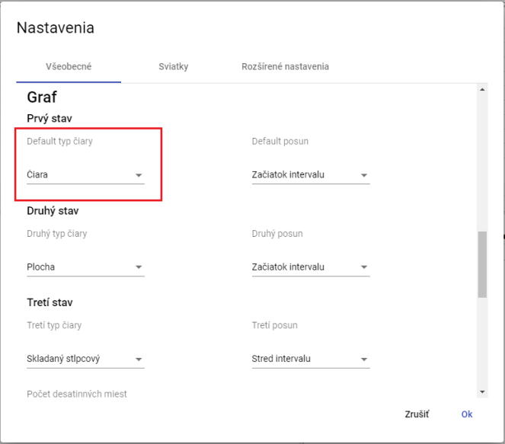

Figure 57: Selecting the default line type for the chart

1. You save the changes by pressing the "OK" button.

#### How to set the second and third line type for the chart

To set the second and third line type, proceed as follows:

1. In the "Settings" window, in the "General" tab, in the "Chart" section, click in the "Second Line Type" field, which will display a window where you select the line type.
2. To select the third line type, click in the "Third Line Type" field, which will display a window where you select the line type.
3. Save the changes by clicking the "Ok" button.

#### How to set the standard offset, second and third offset for the chart.

Proceed:

1. In the "Settings" window, in the "General" tab, in the "Chart" section, click in the "Default offset" field and select one of the options displayed.
2. In the "Second offset" field, select an item for the second offset.
3. In the "Third offset" field, select an item for the third offset.
4. Save the changes by clicking the "OK" button.

#### How to set the number of decimal places for the chart

Proceed:

1. In the "Settings" window, on the "General" tab, in the "Chart" section, enter the number of decimal places in the "Number of decimal places" field.
2. Save the changes by pressing the "OK" button.

#### How to set the display of the chart start date.

Proceed:

1. In the "Settings" window, in the "General" tab, in the "Chart" section, check the "Show chart start date" box.
2. Save the changes by clicking the "OK" button.

#### How to display the current time

Proceed:

1. In the "Settings" window, in the "General" tab, in the "Graph" section, check the "Display current time" box.
2. Save the changes by pressing the "OK" button.

#### How to zoom out by dragging to the left

The "zoom" function is used to magnify the selected area in the graph. The "zoom out" function will move the selected area further away in the graph. To zoom in on a specific area in the graph, left-click in the graph and use the mouse cursor to mark the area in the graph by dragging from left to right. To move the area further away in the graph, do the opposite – mark the area in the graph from right to left, diagonally upwards.

Proceed:

1. In the "Settings" window, in the "General" tab, in the "Graph" section, check the "Zoom out by dragging to the left" box.
2. Save the changes by clicking the "OK" button.

#### How to set it up so that zooming automatically switches to panning.

The "Automatically switch to pan after zoom" field means that if you click the "Switch to zoom" button in the graph window, after zooming in on a selected area in the graph, panning will be automatically activated. If the "Automatically switch to pan after zoom" field is not checked, activating the "zoom" function will start the zoom, and it will remain active until you cancel it.

Proceed:

1. In the "Settings" window, in the "General" tab, in the "Graph" section, check the "Automatically switch to pan after zoom" field.
2. You save the changes by pressing the "OK" button.

### General settings for the explorer

#### How to set decimal places in the Explorer window

To set the number of decimal places for statistics in the Explorer window, follow these steps:

1. In the "Settings" window, in the "General" tab, at the bottom of the "Settings" window, in the "Explorer" section, set the number of decimal places.

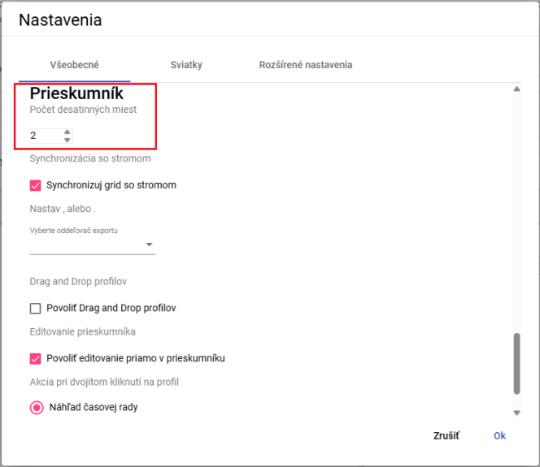

Figure 58: Entering the number of decimal places in the Explorer window

1. Save the changes by clicking the "OK" button.
2. In the Explorer window, the statistics will be displayed with the specified number of decimal places.

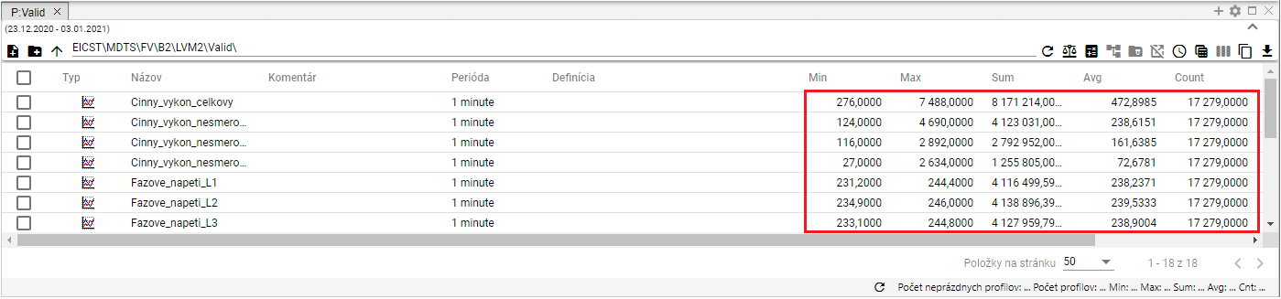

Figure 59: Selected number of decimal places in the Explorer window

#### How to synchronize the Explorer window with the tree view.

To synchronize the Explorer window with the tree view, proceed as follows:

1. In the bottom part of the "Settings" window, in the "General" tab, in the "Explorer" section, check the "Synchronize grid with tree view" box.
2. Save the changes by clicking the "OK" button.

#### How to set the export separator for Explorer

To set the export separator for Explorer, proceed as follows:

1. At the bottom of the "Settings" window, in the "General" tab, in the "Explorer" section, there is a field called "Select export separator", where you can choose a period or a comma as the separator.
2. Save the changes by clicking the "OK" button.

#### How to enable Drag and drop functionality for profiles

To enable the "Drag and drop profiles" functionality, proceed as follows:

1. In the bottom part of the "Settings" window, in the "General" tab, in the "Explorer" section, check the "Drag and drop profiles" box.
2. Save the changes by pressing the "Ok" button.

#### How to enable editing directly in the Explorer window

The "Enable editing directly in Explorer" option is active by default. It allows you to edit the "Name", "Comment", and "Definition" fields directly in the Explorer window.

To disable the feature, proceed as follows:

1. Uncheck the "Enable editing directly in Explorer" box.
2. Save the changes by pressing the "OK" button.

#### How to choose an action for double-clicking a profile

You can choose an action to be triggered when double-clicking a profile. Proceed as follows:

1. In the bottom part of the "Settings" window, in the "General" tab, in the "Explorer" section, select one of the three actions.

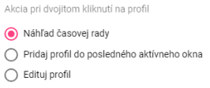

Figure 60: Selecting an action for double-clicking a profile

1. Save the changes by clicking the "OK" button.

## Holiday Settings

### How to create a holiday profile

The holiday profile allows displaying holidays in all profiles. To create a holiday, you need to have a holiday profile created, Image 61, where you enter the value 1 on days when there is a holiday and the value NaN on days when there is no holiday. Create the holiday profile with a period of DAY.

The advantage of the holiday profile is that you decide which holidays you want to display – Slovak or from another country, or from multiple countries at once. The created holiday profile can also be shared for other applications.

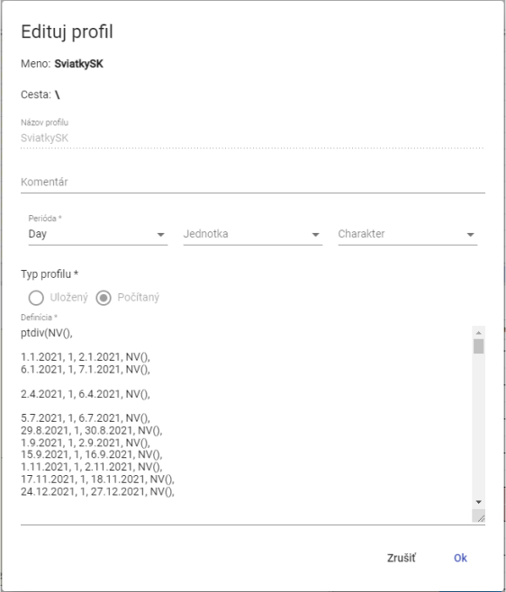

Image 61: Example of a holiday profile definition

You create a holiday profile:

1. Click the button with the logged-in user’s name, which is located in the application’s top bar. Use the mouse cursor to navigate to “Settings” and click “Settings” in the displayed window, Figure 42.
2. A window “Settings” will appear, in which click on the “Holidays” tab.

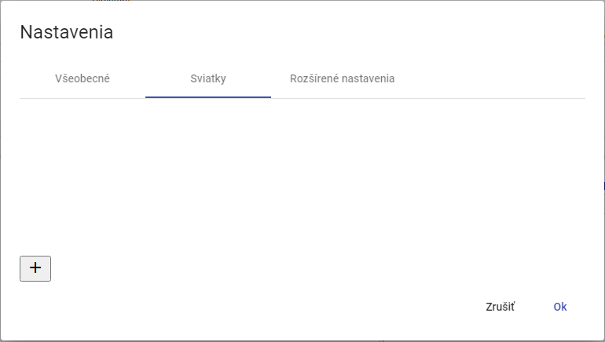

Figure 62: "Holidays" tab

1. Click the button to create a profile.

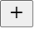

Figure 63: Button to create a profile

1. A "Holidays" window appears, used to create a profile.

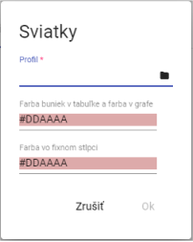

Figure 64: Creating a profile

1. In the "Profile" field, enter a profile or click the button to select a profile.
2. After clicking the button, a window appears for profile selection.

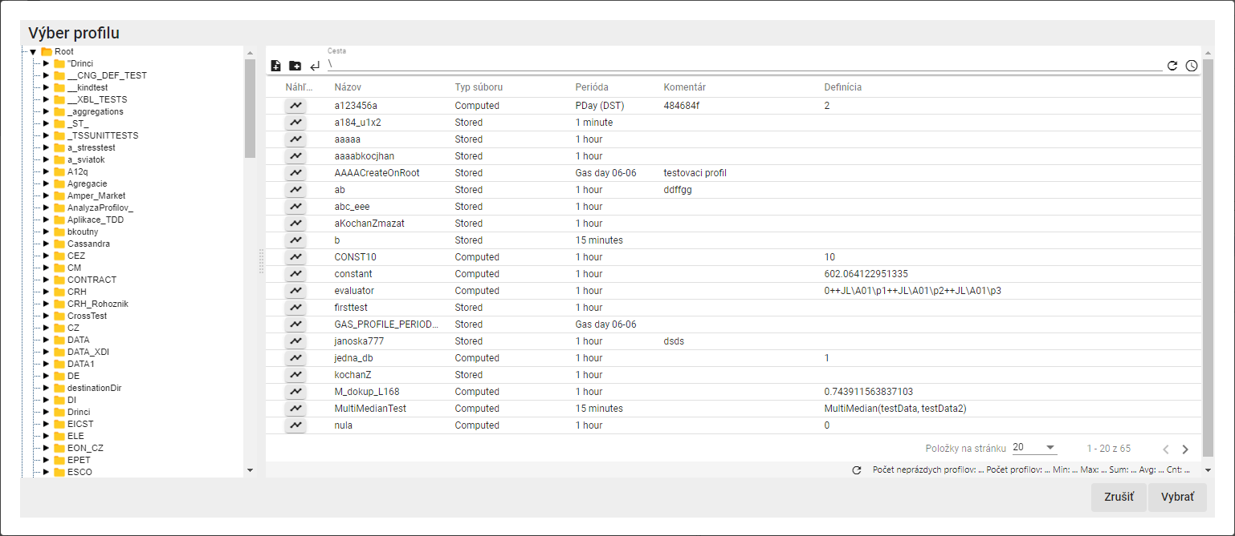

Figure 65: Profile Selection Window

1. Select a holiday profile and click the "Select" button.
2. Select a color for the "Cell color in table" and "Color in fixed column" fields.

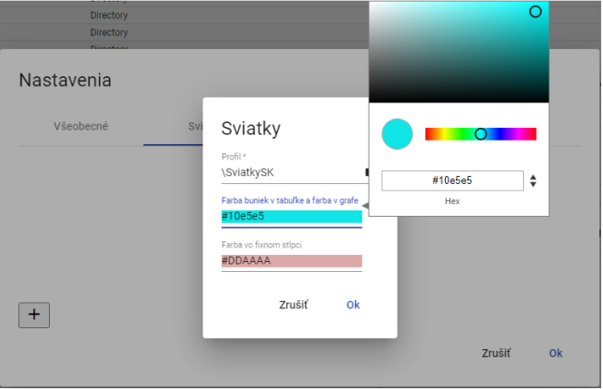

Figure 66: Color Selection

1. You create a profile by clicking the "OK" button.
2. The created holiday profile will be displayed in the "Holidays" window.

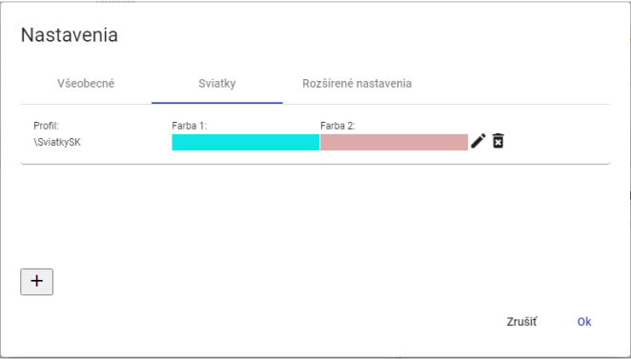

Figure 67: Created Holiday Profile

1. You save the created profile by clicking the "OK" button.

### How to select a holiday profile

You edit the holiday profile:

1. Click the button with the logged-in user's name, located in the top bar of the application. Position the mouse cursor over "Settings" and click "Settings" in the displayed window, Figure 42.
2. A window "Settings" will appear, in which click on the "Holidays" tab.
3. Click the edit button next to the profile you want to modify.



Figure 68: Edit profile button

1. A "Holidays" window will appear for profile editing.

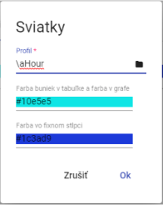

Figure 69: Editing profile for holidays

1. Edit details.
2. You save changes by pressing the "OK" button.
3. In the "Settings" window, press the "OK" button.

### How to delete a holiday profile

You edit the holiday profile:

1. Press the button with the logged-in user's name, located in the top bar of the application. Hover the mouse cursor over “Settings” and click “Settings” in the window that appears, Figure 42.
2. A “Settings” window will appear, in which click on the “Holidays” tab.
3. Press the delete button next to the profile you want to delete.



Figure 70: Delete profile button

1. A confirmation window for deleting the profile will appear, in which click the “Yes” button.

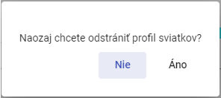

Figure 71: Profile Deletion Confirmation

1. The profile will be deleted from the list of holiday profiles.
2. Confirm profile deletion in the “Settings” window by clicking the “OK” button.

## How to view status information

To view status information, click the button with the logged-in user's name. A menu will appear, in which select the “Info” item. Subsequently, the “Status Information” window will appear, providing information on the status of the “Profile Manager Web” application and the status of the TSS Service, TSS Core, MSHDO.DMST.API, DMS and MSHDO.Xenergy.UTS.Api services.

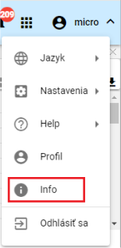

Figure 72: “Info” item

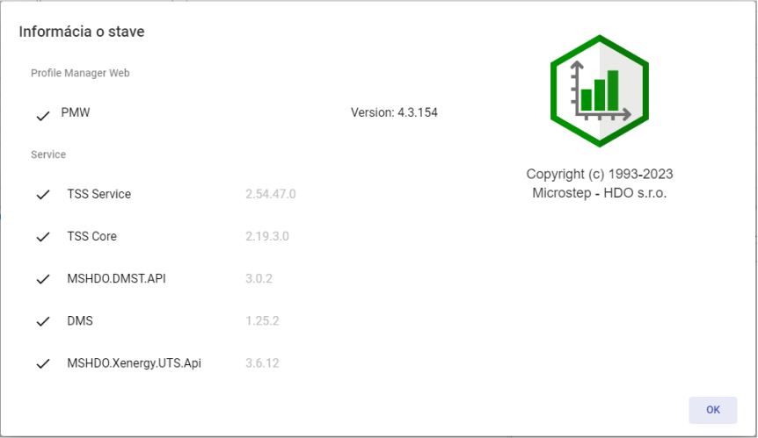

Figure 73: “Status Information” window

## How to view notifications

The “Notifications” button indicates changes made in the system. For example, directory creation and similar actions. If there are notifications in the application, the number of notifications is displayed in a red circle in the upper right corner of the “Notifications” button.



Figure 74: “Notifications” button

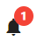

Figure 75: New notification

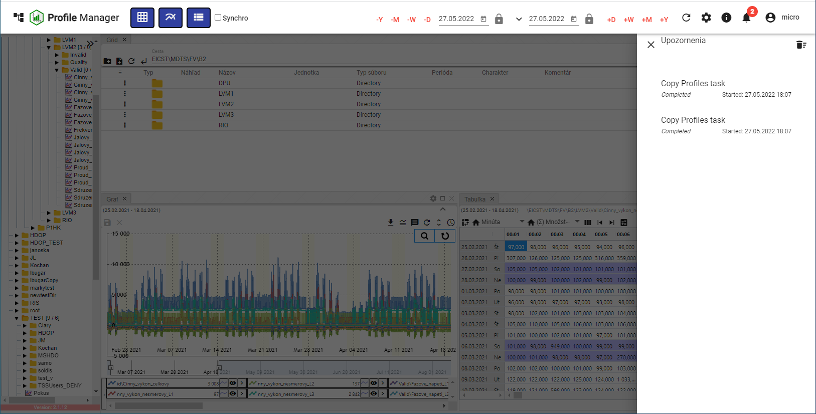

Figure 76: Notification Block

To delete notifications, press the button with a trash icon, which is located in the upper right corner of the “Notifications” block. A confirmation window will appear; press the “Yes” button.

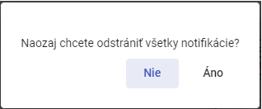

Figure 77: Confirmation Window for Deleting Notifications

## How to resize the tree structure window

To resize the tree structure window, press the button, Figure 78, located in the upper right corner of the tree structure. The tree structure window will then resize, Figure 80. To return the tree structure to its standard width, press the button in the upper right corner of the tree structure again, Figure 79.

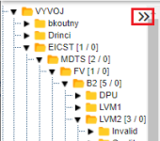

Figure 78: Button for resizing the tree structure

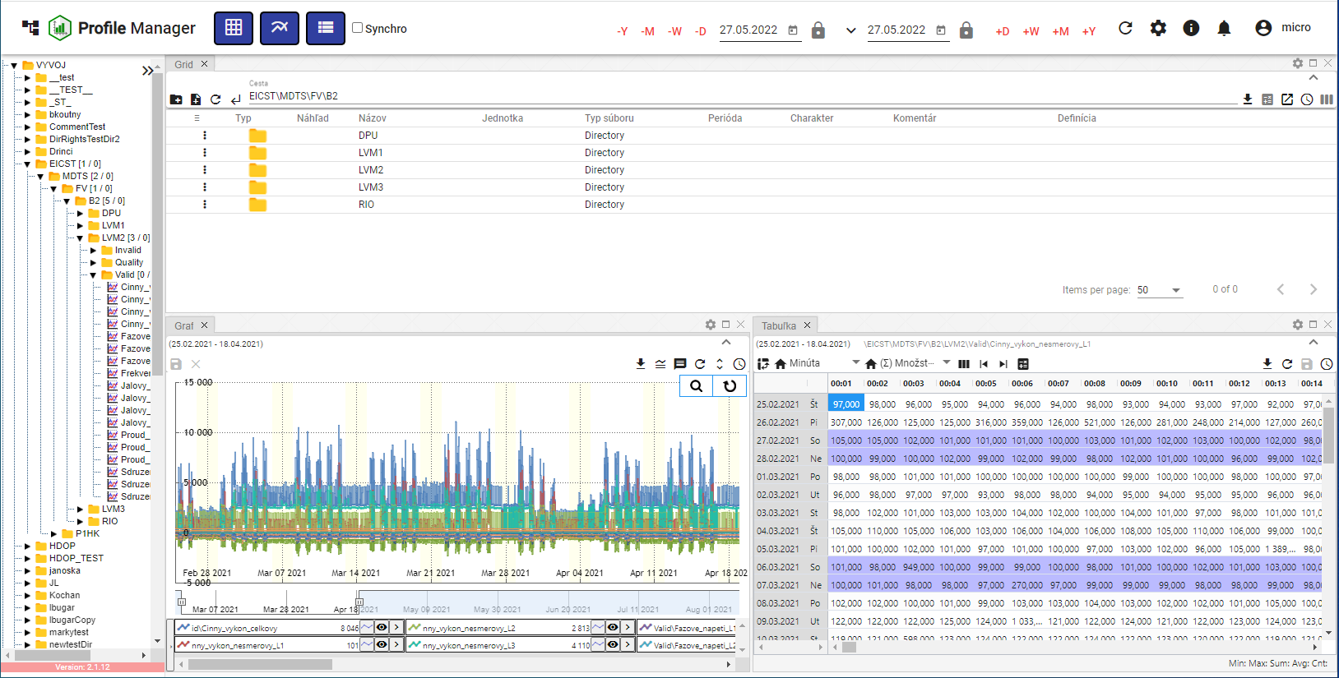

Figure 79: Standard width of the tree structure window

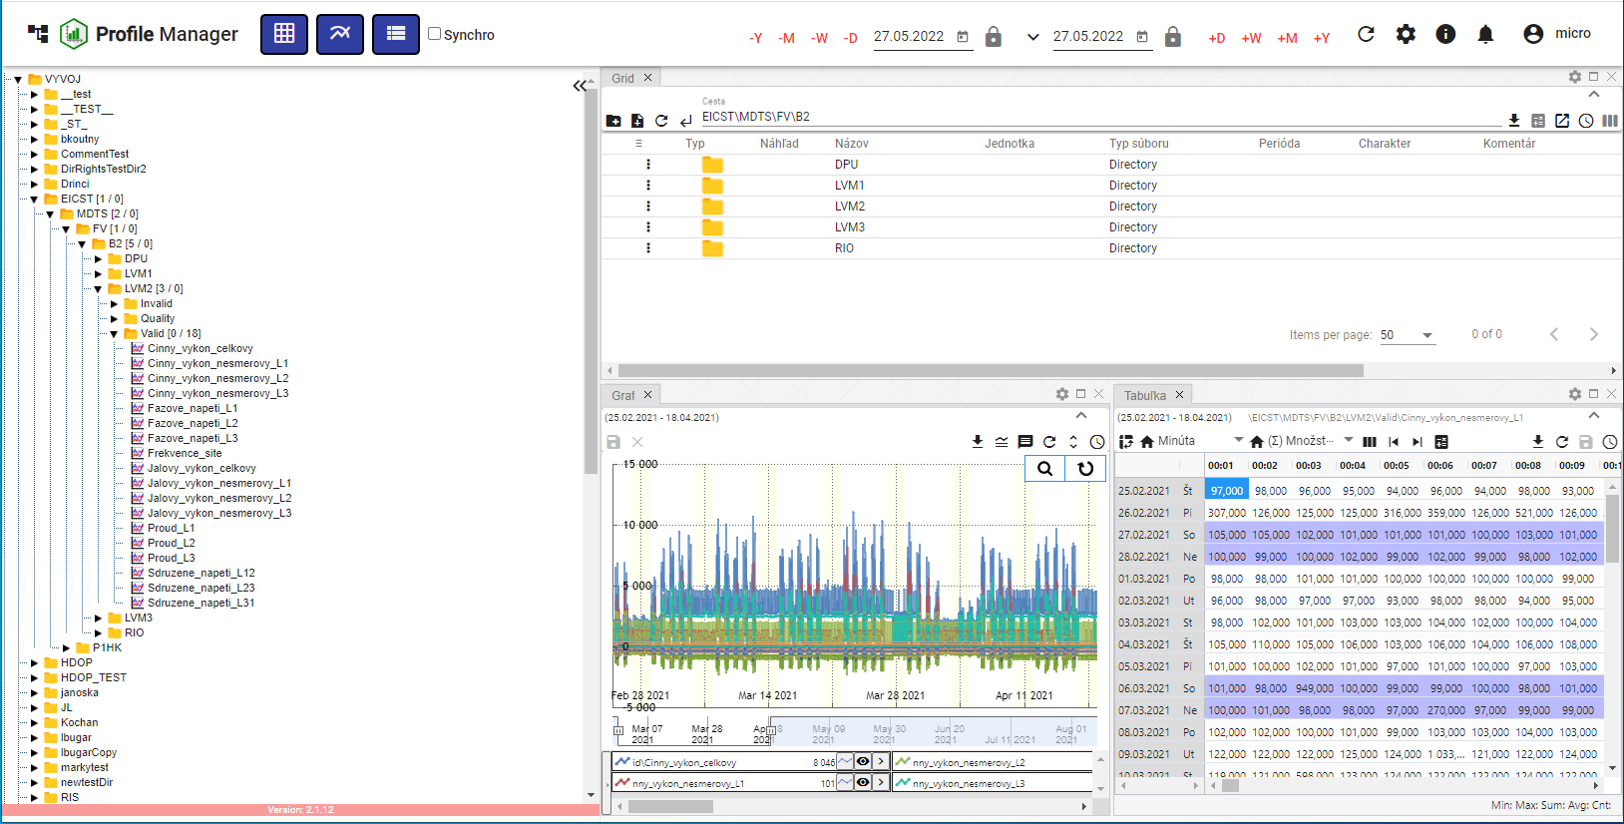

Figure 80: Resized tree structure window

## Panel Synchronization

The "Panel Synchronization" button is used to synchronize open windows in the "Profile Manager" application. It allows aligning time ranges (chapter 1.16.1) and synchronizing tables (chapter 1.16.2).

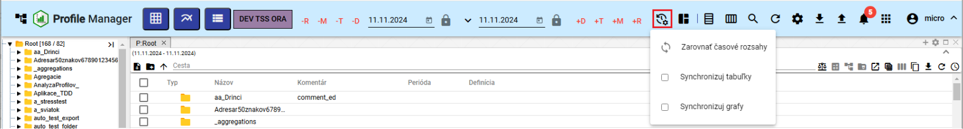

Figure 81: "Panel Synchronization" button

### Align time ranges

If different date ranges are set in the windows and you want to set a uniform date range in all open windows, proceed as follows:

1. Click on the window header of the window whose date range you want to set in the other windows.

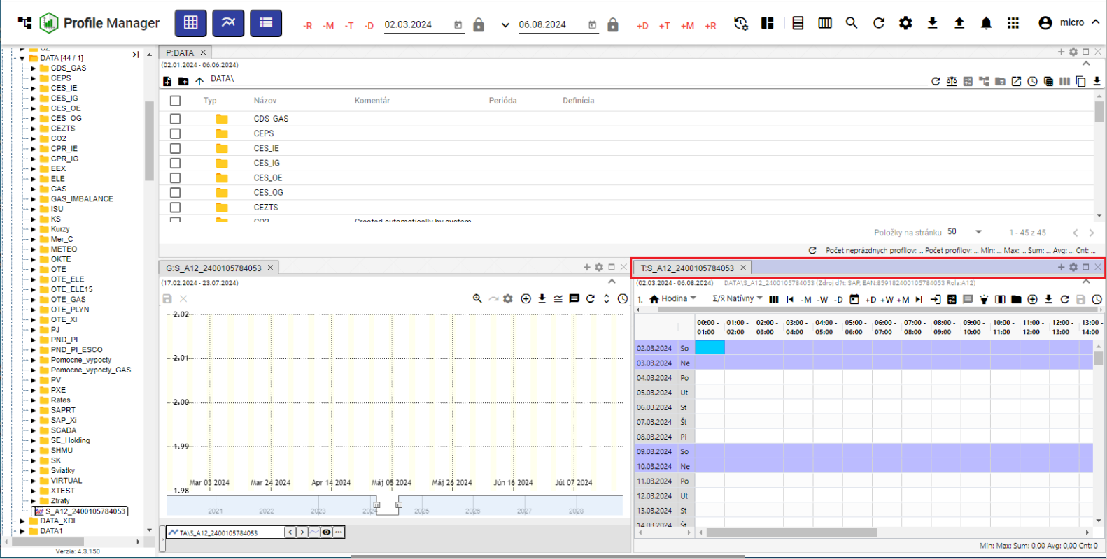

Figure 82: Active window

1. Press the "Synchronize Panels" button and click on "Align Time Ranges".

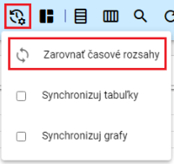

Figure 83: "Align Time Ranges" item

1. The date range set in the active window will be applied to all windows.

### How to synchronize panels

The "Synchronize Tables" item means that the range start and cursor will be synchronized to all open tables.

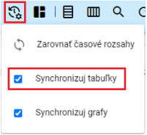

Figure 84: "Synchronize Tables" item

To have the tables synchronize on every launch, check the "Synchronize for tables on launch" box in the "Settings" window, under the "General" tab, in the "Global" section (Figure 85). If table synchronization is enabled, the text “SYNC” will appear in the table window (Figure 86).

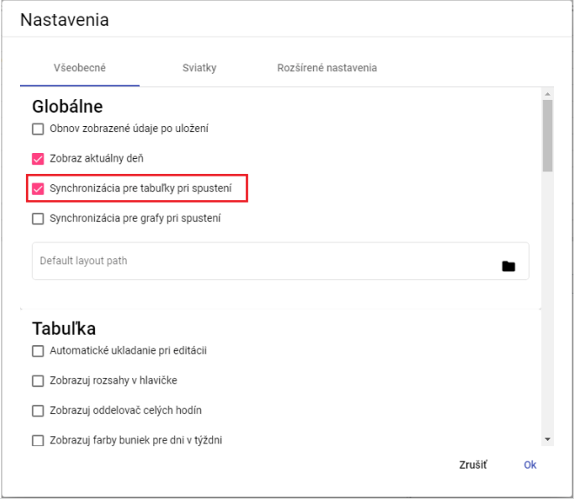

Figure 85: "Synchronize for tables on launch" box

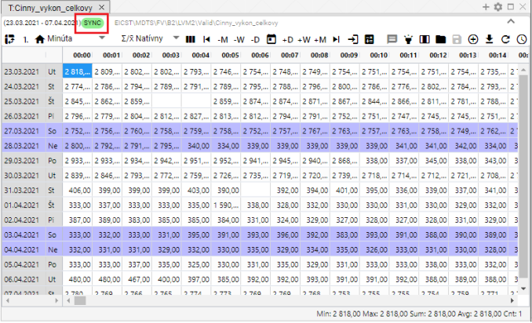

Figure 86: The text “SYNC” will appear if table synchronization is enabled.

### How to synchronize charts

To synchronize charts each time the application launches, check the "Synchronize for charts on launch" box in the "Settings" window, under the "General" tab, in the "Global" section (Figure 85). If you set chart synchronization in the "Settings" window, the "Synchronize charts" box will be checked in the "Synchronize Panels" button (Figure 87) and the text “SYNC” will appear in the chart window (Figure 88).

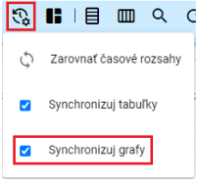

Figure 87: "Synchronize charts" item

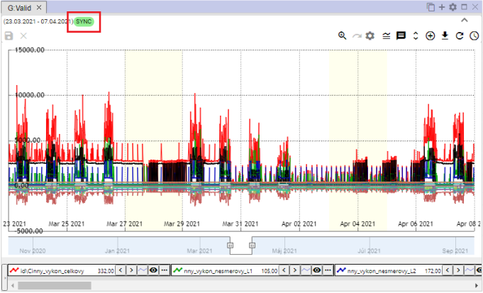

Figure 88: The text “SYNC” will appear in the chart window if chart synchronization is enabled.

## How to import, export, and save reports

The button, Figure 89, is used for importing, saving, and downloading reports. Report import is detailed in the following chapter 1.17.1, and report download is described in chapter 1.17.2.

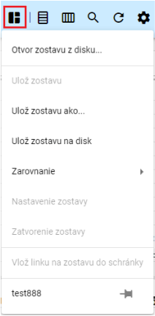

Figure 89: "Report Management" button

### How to import a report

To import a report, proceed as follows:

1. Click the "Report Management" button to display a window where you select "Open Report from Disk...".

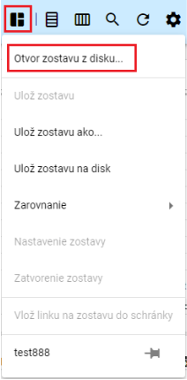

Figure 90: "Open Report from Disk..." item

1. A window will appear where you select the report you want to import.

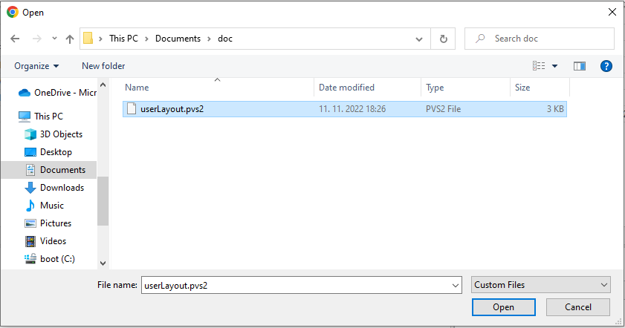

Figure 91: Selecting a report for import

1. Confirm the selected report for import by clicking the "Open" button.
2. The selected report is being imported and the appearance of the "Profile Manager" application will change according to the settings of the selected report – the number and size of windows, the data displayed in the windows, and so on.
3. Next to the "Report Management" button, the name of the imported report will be displayed.



Figure 92: Imported Report Name

### How to export a report

You export the report as follows:

1. Click the "Report Management" button.
2. Select "Save Report to Disk".

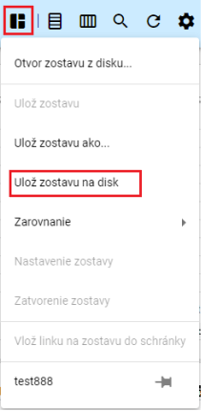

Figure 93: "Save Report to Disk" item

1. Subsequently, the report will be downloaded.

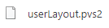

Figure 94: Downloaded Report

### How to update the report

To update the report, proceed as follows:

1. In the profile tree, open the report you want to update. To open the report, double-click the report name in the profile tree.

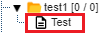

Figure 95: Report in the profile tree

1. Subsequently, the name of the open report will be displayed next to the "Report Management" button.

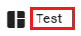

Figure 96: Name of the open report

1. Make the changes to the report that you want to save.
2. Save the changes by pressing the "Report Management" button and then selecting the "Save Report" item.

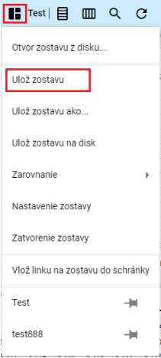

Figure 97: "Save Report" item

1. A confirmation window will appear; press the "Yes" button.

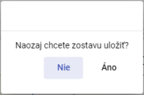

Figure 98: Confirmation window for saving the report

1. The report will be updated.

### How to save a new report

You can save the appearance of the "Profile Manager" application – the number and size of displayed windows, the data displayed in the windows – as a report.

You can save a new report in the profile tree as follows:

1. Make the settings in the application that you want to save as a report.
2. Press the "Report Management" button and select "Save Report As..." in the displayed window.

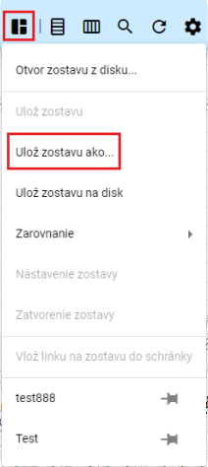

Figure 99: "Save Report As..." item

1. A "New Report" window will appear.

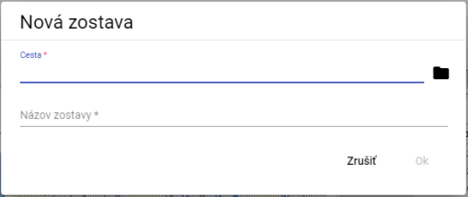

Figure 100: "New Report" window

1. In the "Path" field, enter the path where you want to save the report in the profile tree. You can also enter the path by clicking the button and selecting a directory in the profile tree where the report should be saved.

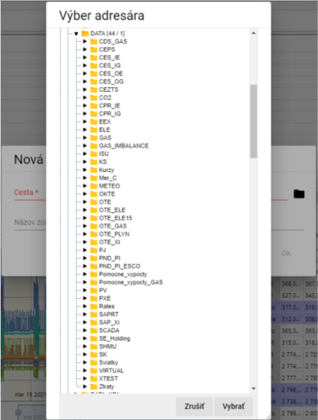

Figure 101: Selecting a directory to save the report

1. Enter the report name.

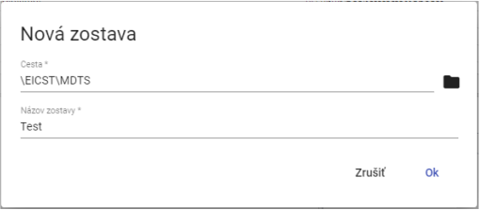

Figure 102: Entered Data

1. Save the new report by clicking the "OK" button.
2. To display the report in the profile tree, click on the directory in the profile tree and select "Refresh".

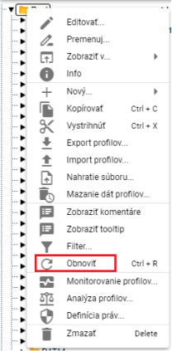

Figure 103: "Refresh" Item

### How to align the report to columns

Proceed:

1. Click the "Report Management" button, located in the top bar of the application.
2. A menu will appear. Use your mouse cursor to select the "Alignment" item and then select the "To Columns..." item.
3. A menu will appear, in which select the number of columns.

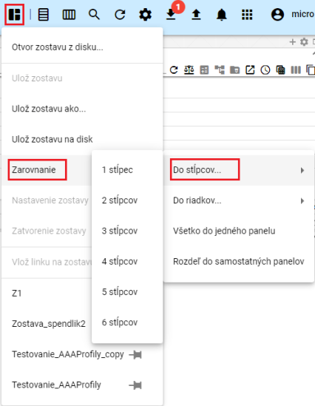

Figure 104: "To Columns..." item

1. The windows in the "Profile Manager" application will align into the selected number of columns.

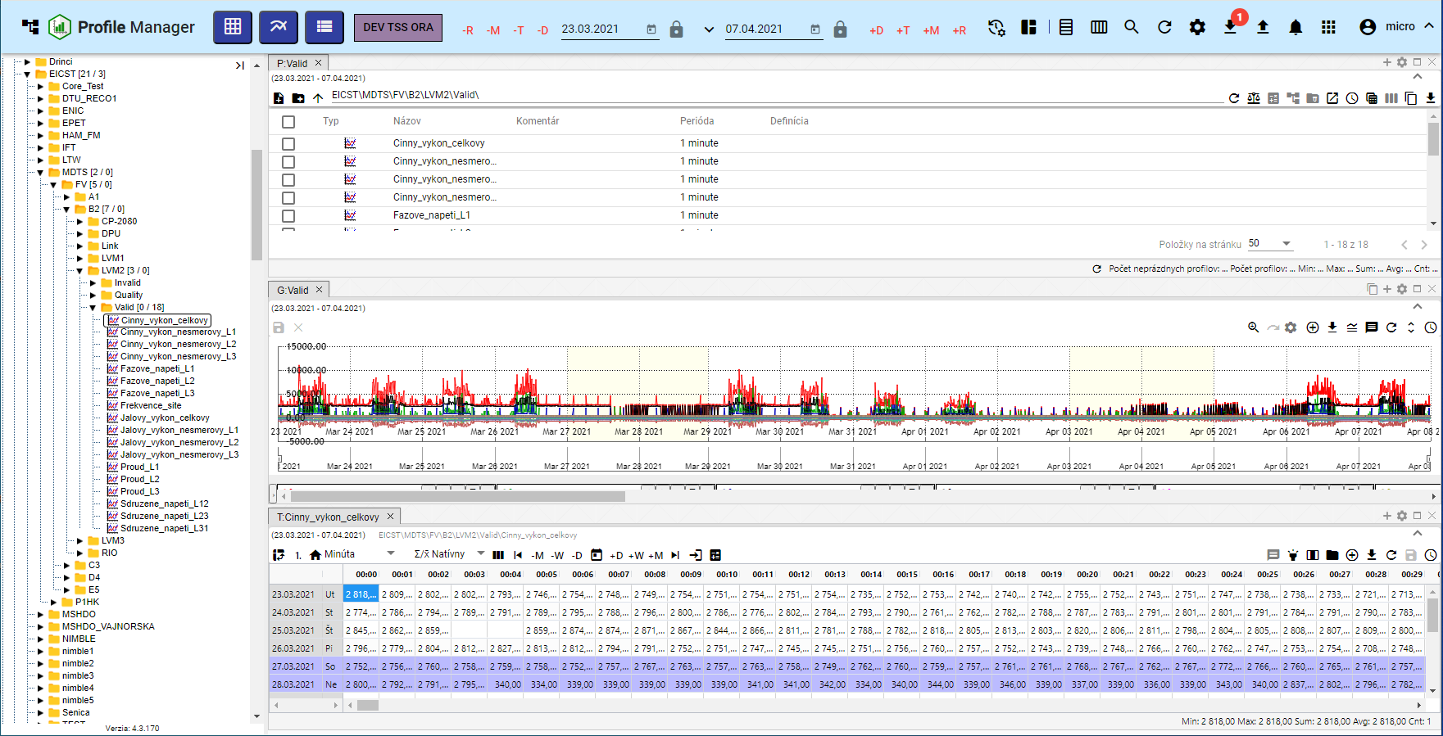

Figure 105: Aligning windows into a single column

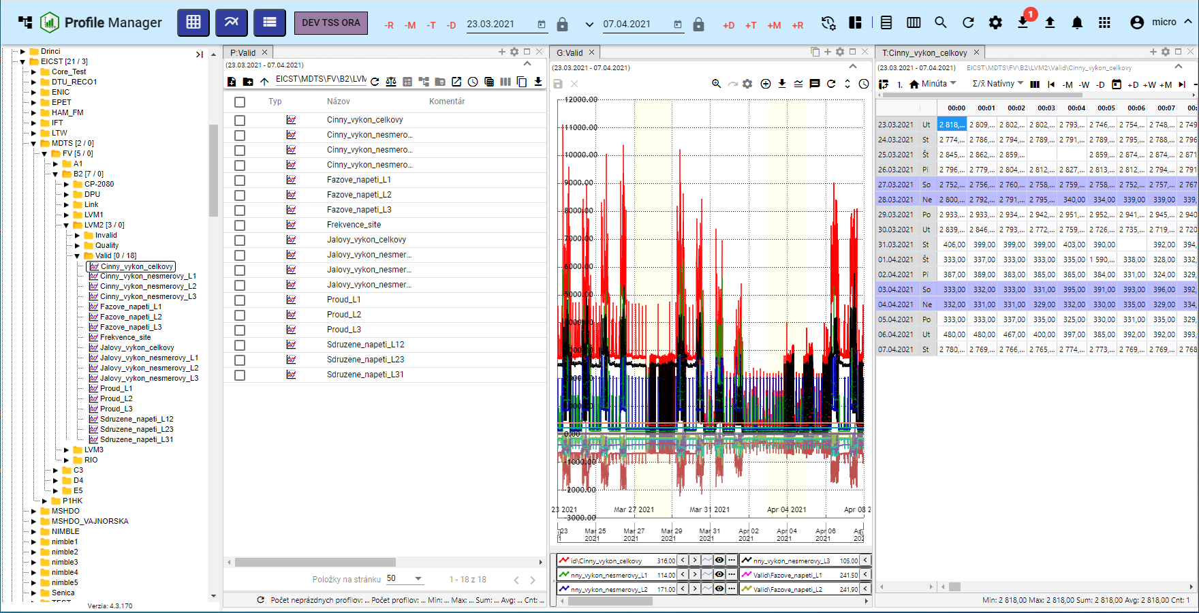

Figure 106: Aligning into three columns

### How to align the arrangement into rows

Proceed:

1. Click the "Report Management" button, located in the top bar of the application.
2. A menu will appear, in which use your mouse cursor to select the "Alignment" item and then use your mouse cursor to select the "Into Rows" item.
3. A menu will appear, in which select the number of rows.

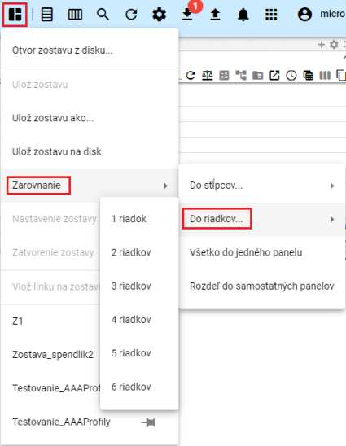

Figure 107: "Into Rows" item

1. The windows in the application will align into the selected number of rows.

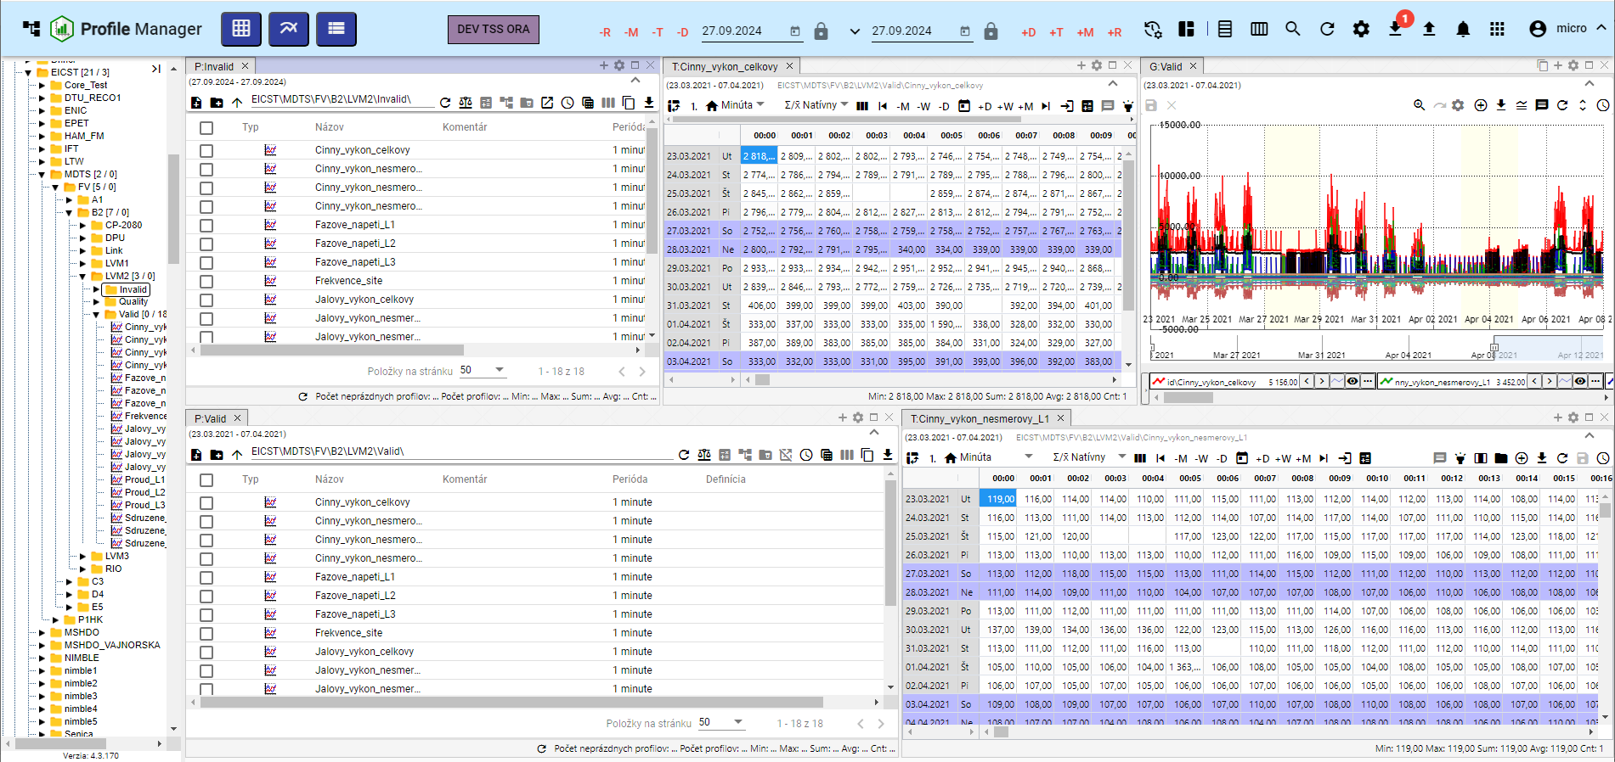

Figure 108: Align into two rows

### How to align everything into one panel

Proceed:

1. Click the "Report Management" button.
2. A menu will appear. Use your mouse cursor to select "Alignment" and then select "All to One Panel".
3. All windows will appear in one panel.

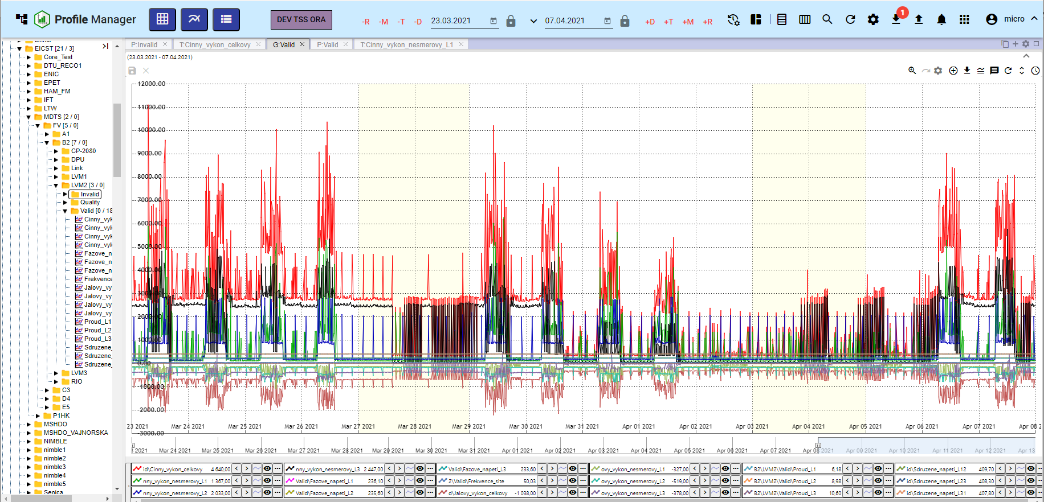

Figure 109: Alignment to One Panel

### How to split the layout into separate panels

Proceed:

1. Click the "Report Management" button.
2. A menu will appear, in which use the mouse cursor to select the "Alignment" item and choose "Split into separate panels".
3. Each open window will be displayed in a separate panel.

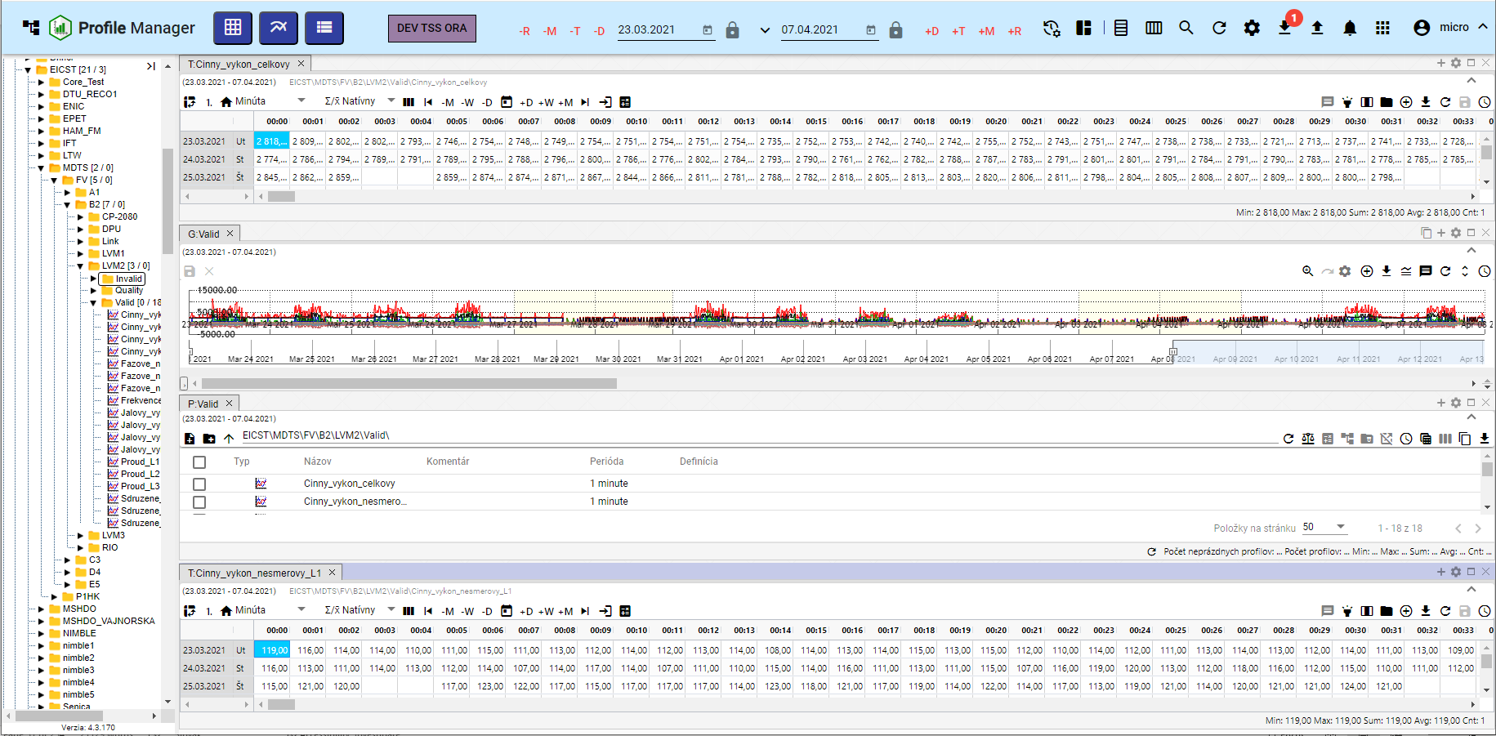

Figure 110: Split into separate panels

### How to set the global time range when displaying a report

To change the global time range for a saved report, proceed as follows:

1. Click the "Report Management" button.
2. Select "Report Settings".

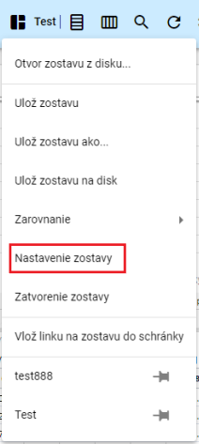

Figure 111: "Report Settings" item

1. The "Report Settings" window appears.

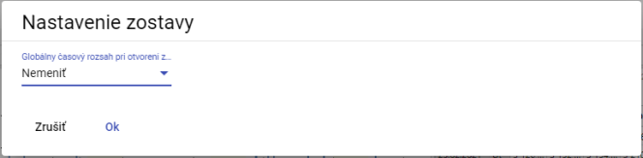

Figure 112: "Report Settings" window

1. Click in the "Global Time Range on Report Open" field.
2. A menu appears, in which select the date range.

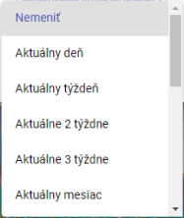

Figure 113: Menu for setting the global time range

1. Save by clicking the "OK" button.
2. A confirmation window appears, in which click the "Yes" button.

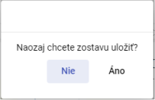

Figure 114: Confirmation window for saving

### How to close the report

To close the report, click the "Report Management" button and select "Close Report". The report will then close.

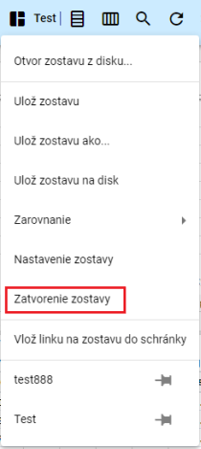

Figure 115: "Close Report" item

## How to horizontally align windows

To horizontally align windows, click the "Horizontal Alignment" button, which is located in the top bar of the application. The open windows in the "Profile Manager" application will be horizontally aligned, Figure 117.



Figure 116: "Horizontal Alignment" button

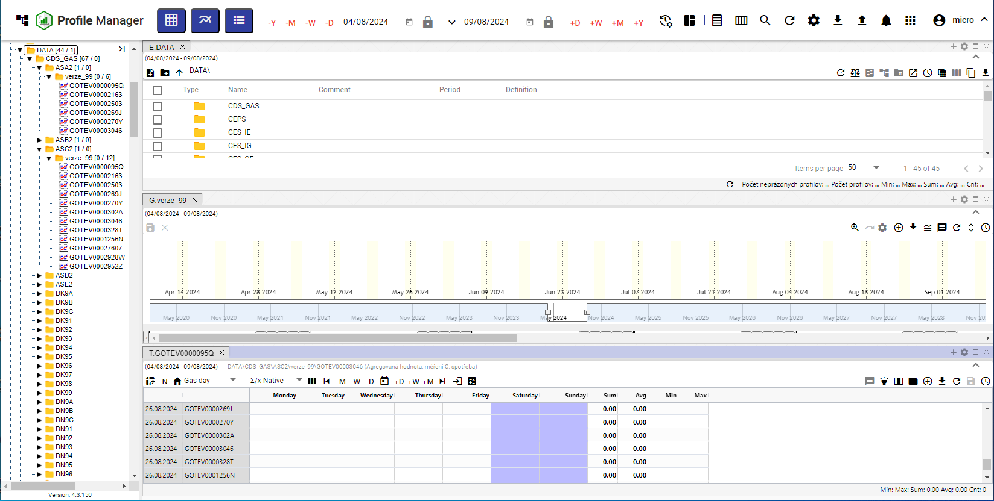

Figure 117: Horizontal Alignment of Windows

## How to vertically align windows

To vertically align windows, press the "Vertical Alignment" button, located in the application's top bar. The open windows in the "Profile Manager" application will be vertically aligned, Figure 119.



Figure 118: "Vertical Alignment" Button

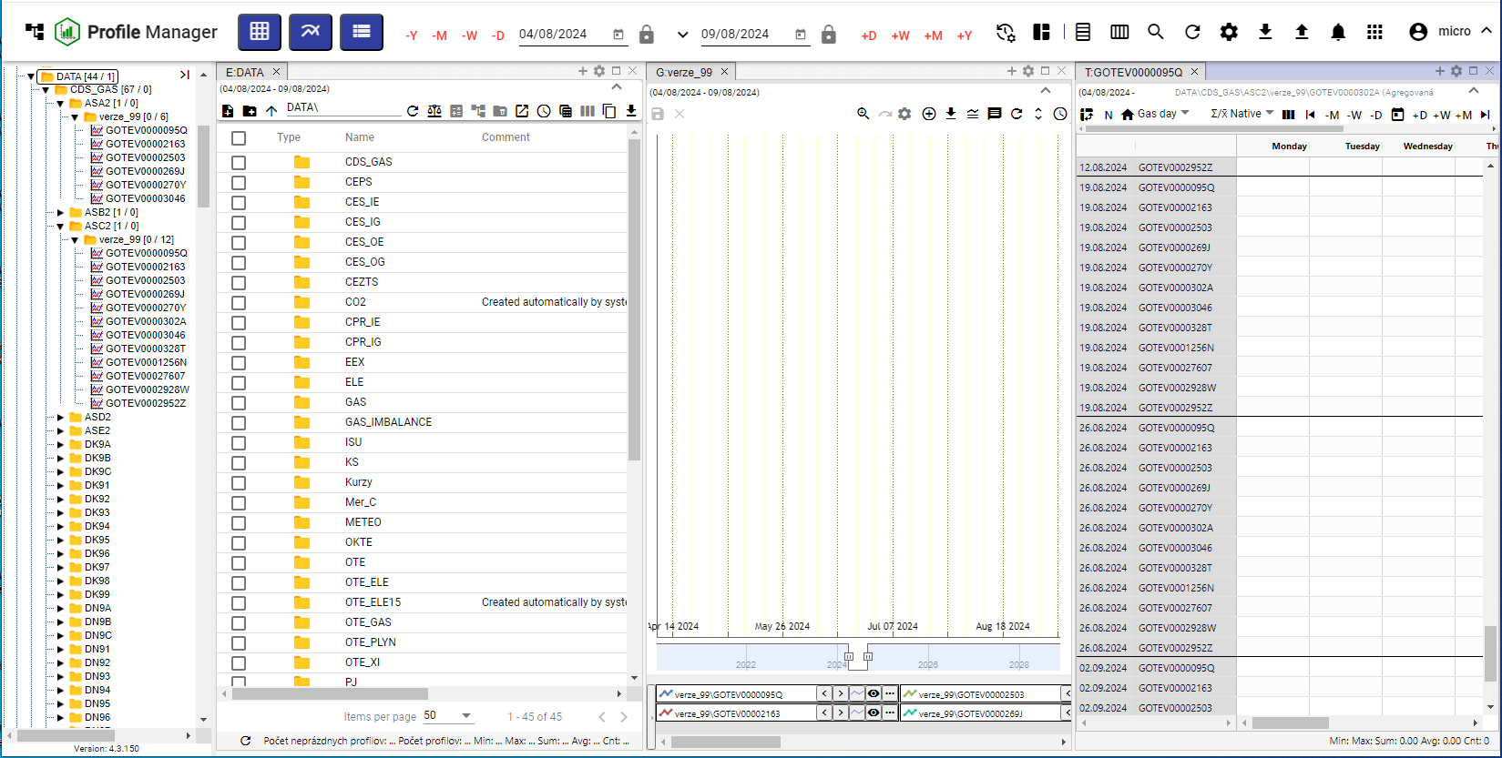

Figure 119: Vertical Alignment of Windows

## How to view and download exports

In the top bar of the "Profile Manager" application, there is an "Export" button used to display the list of exports in the "Exports" window. If the export is successful, it can be downloaded by clicking the green "Download" button. The procedure for creating an export is detailed in chapter 2.16.



Figure 120: “Export” Button

The number of downloaded exports is displayed as a number in a red circle next to the "Export" button, Figure 121. An un-downloaded export in the "Exports" window has a red "N" next to the "Download" button, Figure 122.

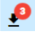

Figure 121: Three un-downloaded exports

Exports can be in the following states:

* IN PROGRESS – export in progress.
* COMPLETED – successfully completed export, it can be downloaded by clicking the "Download" button.
* ERROR – an error occurred during export.
* DELETED – the export was deleted. Information about the export deletion came from the Export Service application.

Export statuses come from the Export Service and are only used for display in the “Profile Manager” application. Close the “Exports” window by pressing the “Cancel” button.

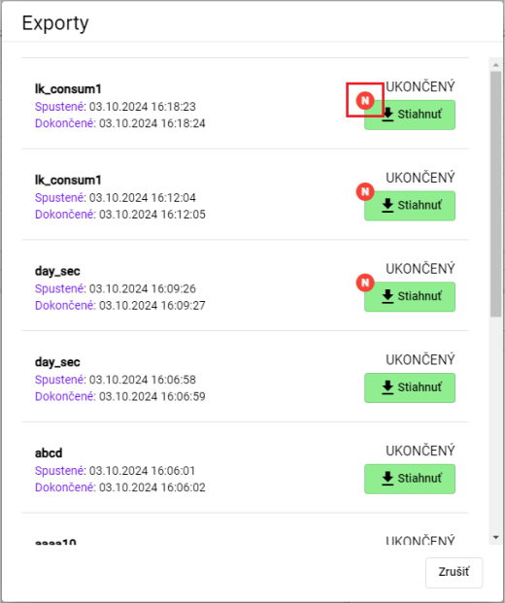

Figure 122: “Exports” Window

## How to display imports

In the top bar of the “Profile Manager” application, there is an “Import” button, which is used to display the list of imports in the “Imports” window. The procedure for creating an import can be found in chapter 2.17.



Figure 123: “Import” Button

After clicking the “Import” button, the “Imports” window is displayed, where the details of the imports can be viewed, as shown in Figure 125.

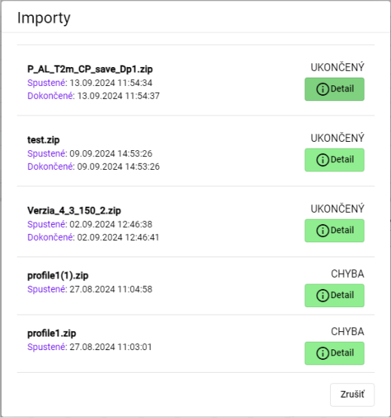

Figure 124: “Imports” Window

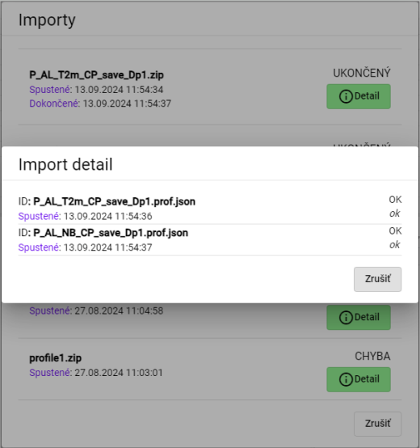

Figure 125: Display of Import Detail

## Keyboard Shortcuts

You can display the list of keyboard shortcuts in the “Profile Manager” application:

1. Click the button with the name of the logged-in user, located in the top bar of the application.
2. Select the “Help” item from the menu that appears.
3. Click the “Keyboard shortcuts” item.

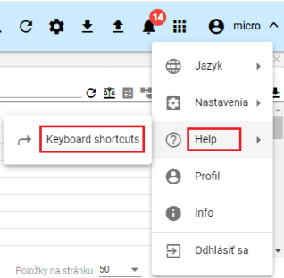

Figure 126: “Keyboard shortcuts” item

1. The “Keyboard shortcuts” window will appear.

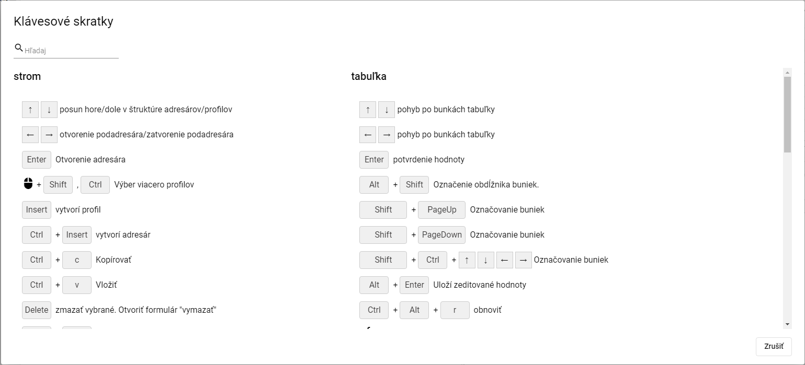

Figure 127: “Keyboard shortcuts” window

1. You can search for keyboard shortcuts by entering text into the “Search” field located in the upper left corner of the window. A list of keyboard shortcuts matching the entered text will appear automatically.
2. Close the window by pressing the “Cancel” button.

In the “Profile Manager” application, you can use the keyboard shortcuts listed in the following table.

|  |  |  |
| --- | --- | --- |
| Klávesová skratka | Časť aplikácie | Popis |
| šípky HORE/DOLE | strom | Posun hore/dole v štruktúre adresárov/profilov |
| šípky HORE/DOLE | prieskumník | Posun hore/dole v štruktúre adresárov/profilov |
| šípky HORE/DOLE | tabuľka | Pohyb po bunkách tabuľky |
| šípky HORE/DOLE | graf | Hore zoom OUT, dole zoom IN |
| šípky Doprava a doľava | strom | Otvorenie podadresára/zatvorenie podadresára |
| šípky Doprava a doľava | prieskumník | Posun celej tabuľky doľava a doprava, aby bolo možné vidieť schované stĺpce |
| šípky Doprava a doľava | tabuľka | Pohyb po bunkách tabuľky |
| šípky Doprava a doľava | graf | Posun grafu o jedno zobrazené časové okno doľava a doprava |
| ENTER | strom | Otvorenie adresára |
| ENTER | prieskumník | Otvorenie adresára/Otvorenie editačného okna profilu |
| ENTER | tabuľka | Potvrdenie hodnoty |
| ENTER | graf | Bez akcie |
| Výber myšou pomocou Shift, Ctrl | strom | Výber viacero adresárov/profilov |
| Výber myšou pomocou Shift | prieskumník | Výber viacero adresárov/profilov |
| Výber myšou pomocou Shift, Ctrl | graf | Výber viacero profilov |
| Alt + Shift | tabuľka | Označenie obdĺžnika buniek |
| Insert | prieskumník | Založí profil |
| Ctrl + Insert | prieskumník | Založí adresár |
| Insert | strom | Založí profil |
| Ctrl + Insert | strom | Založí adresár |
| Ctrl + ALT + K | graf | Zmena koeficientu označeného profilu / označených profilov |
| Ctrl + ALT + W | graf | Skryje označený profil / označené profily |
| Ctrl + ALT + Q | graf | Odkryje označený profil / označené profily |
| Ctrl + ALT + T | PMW | Nové okno Tabuľka |
| Ctrl + ALT + G | PMW | Nové okno Graf |
| Ctrl + ALT + E | PMW | Nové okno Prieskumník |
| Ctrl + C | strom/ prieskumník | Kopírovať |
| Ctrl + ALT + C | prieskumník | Export prieskumníka do clipboardu |
| Ctrl + V | strom/ prieskumník | Paste |
| Ctrl + S | PMW | Uloženie zostavy. Ak nie je žiadna otvorená ponúkne formulár na uloženie do stromu. |
| Ctrl + O | PMW | Otvorenie zostavy z disku |
| Ctrl + ALT + F4 | PMW | Zavretie grafu/tabuľky |
| Ctrl + šípka NAHORU/DOLŮ | graf | Posun/radenie zobrazovaných profilov pod grafom |
| Alt + ENTER | graf | Uloží rozkreslenú čiaru |
| Alt + ENTER | tabuľka | Uloží zeditované hodnoty |
| Delete | graf | odoberie z grafu vybrané profily |
| Delete | strom/prieskumník | Zmazať vybrané. Otvoriť formulár "Delete" |
| CTRL+ R | strom/prieskumník | Refresh |
| CTRL+ ALT + R | graf/tabuľka | Refresh |
| Koliesko myši | graf | Zmena rozsahu časovej osi |
| Koliesko myši + CTRL | graf | Zmena rozsahu ľavej osi |
| Koliesko myši + CTRL + ALT | graf | Zmena rozsahu pravej osi |
| SHIFT + šípka NAHORU/DOLŮ | prieskumník | Výber adresárov/profilov |
| SHIFT + HOME | prieskumník | Výber viacero adresárov/profilov |
| SHIFT + END | prieskumník | Výber viacero adresárov/profilov |
| CTRL + X | prieskumník /strom | Presun adresárov/profilov |

## How to search for a profile in the application

To search for a profile, proceed as follows:

1. Press the button located in the application's top bar.
2. A field labelled "search for profile" will appear, into which you can enter the profile name.

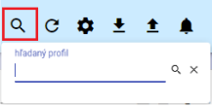

Figure 128: Profile search field

1. Enter the text you want to search profiles by.
2. Press the Enter key or the search button.

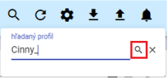

Figure 129: Search button

1. In the active window, the “B:Root” tab will appear displaying profiles matching the entered text.

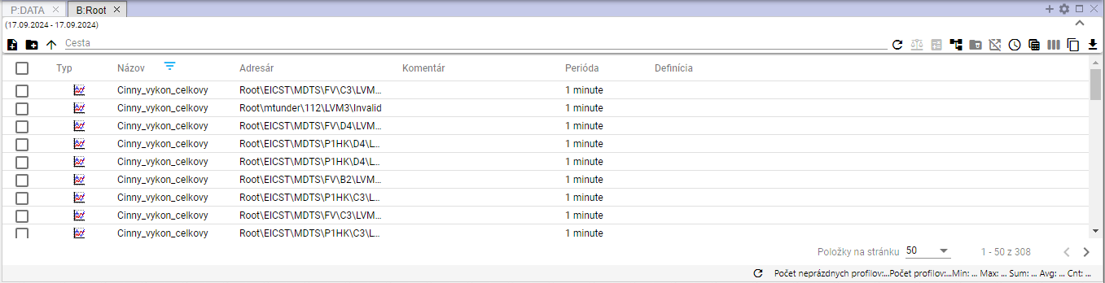

Figure 130: Search results

## Informing the user about logout

If the user has the “Profile Manager” application open in multiple browser tabs and logs out in one of the tabs, a window informing the user about the logout will appear, Figure 131. To log in, press the “Log In” button. The login screen will appear, where you can enter your username and password to log in, Figure 2. After logging in, the “Profile Manager” application will be in the state it was in before the logout.

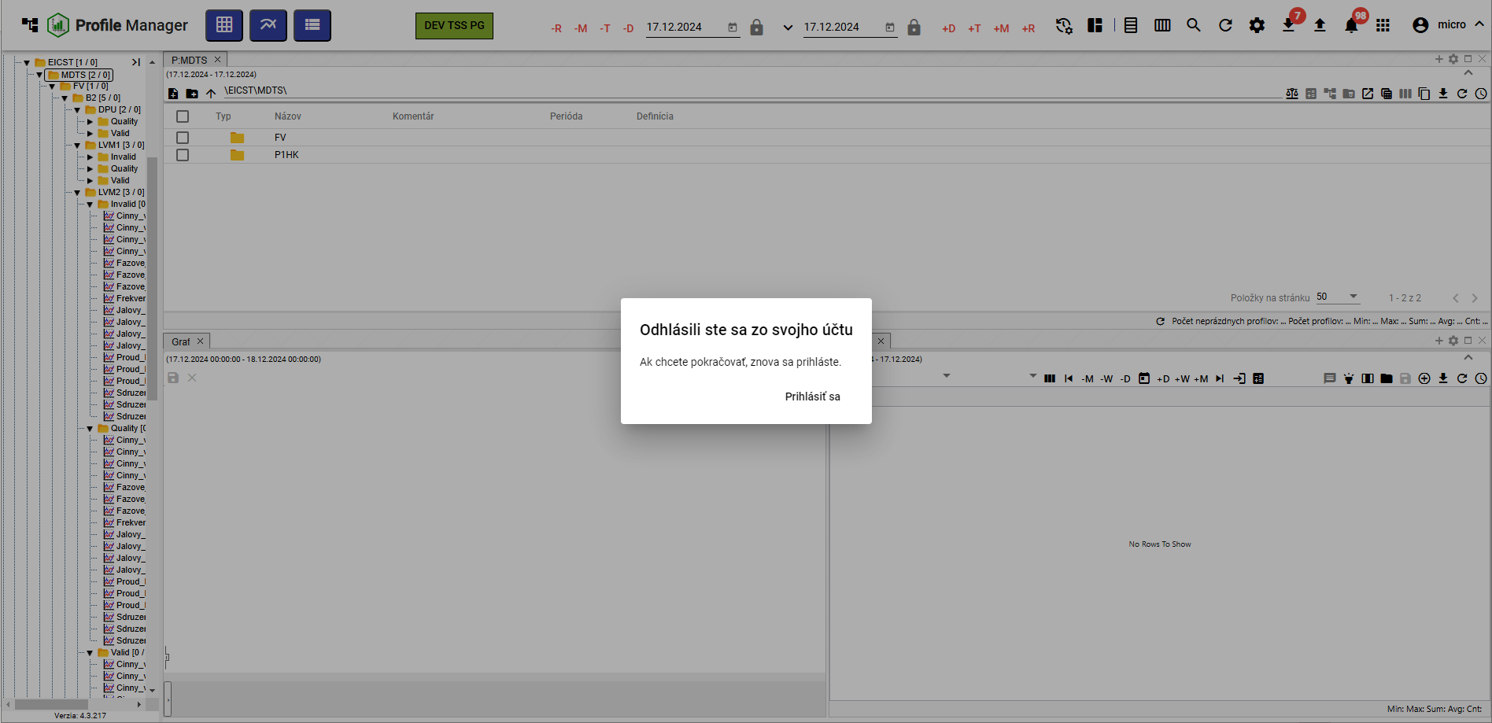

Figure 131: "You have been logged out of your account" window

## How to display the time remaining until the user is logged out

If you are not actively working with the “Profile Manager” application, the time remaining until the user is logged out of the “Profile Manager” application counts down. If you are working with the application, the time is reset.

You can check how much time remains until logout:

1. Click the button with the logged-in user's name.
2. A menu will appear, containing information about the remaining time until the login session expires, Figure 132.

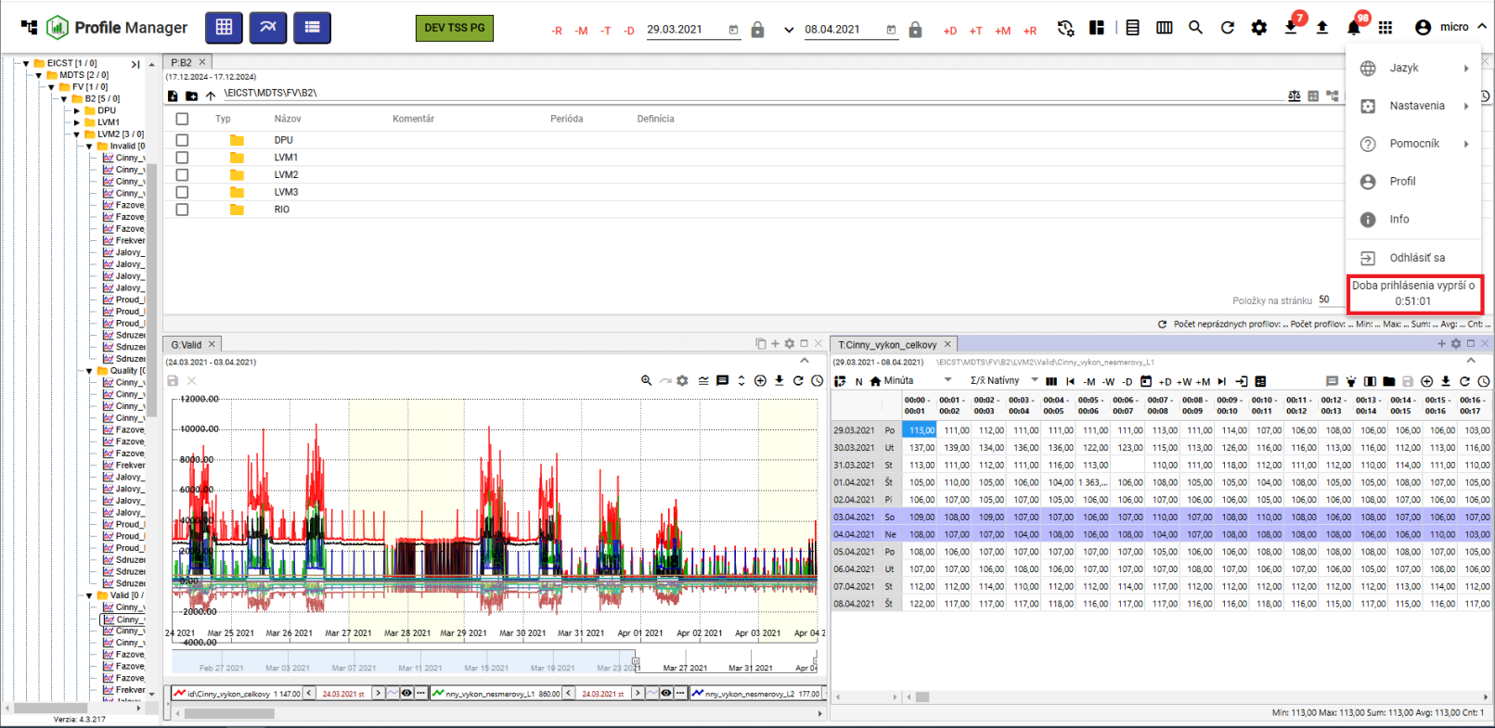

Figure 132: Information about the remaining time until the user logs out.

If the user has not actively worked with the “Profile Manager” application and the login session expires, the user is logged out of the application. A window titled “Login Session Expired” will appear. To log in again, click the “Log In” button.

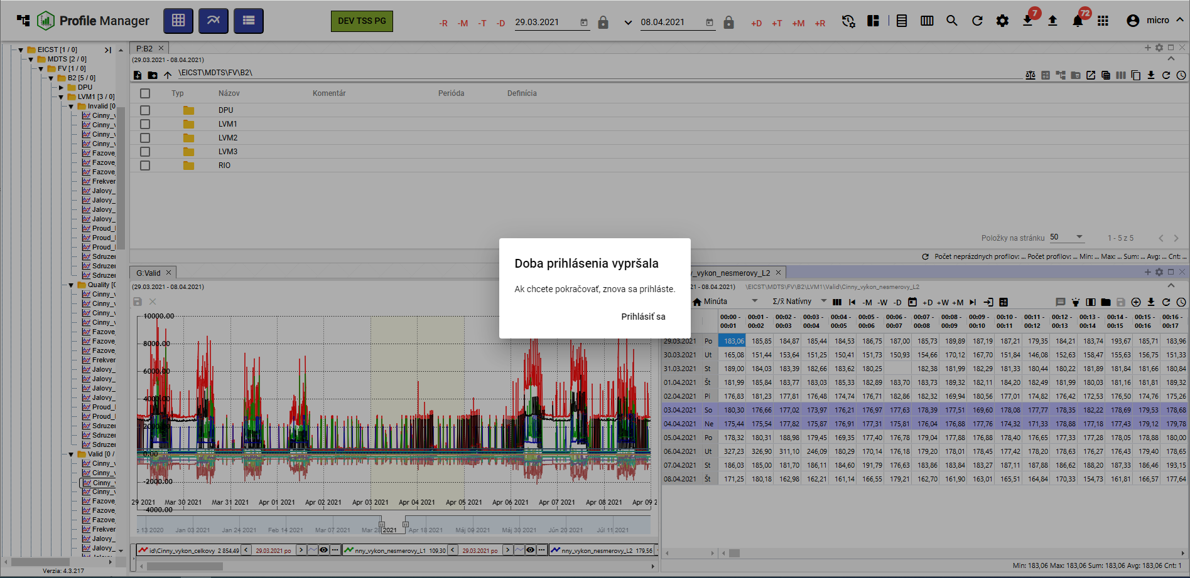

Figure 133: Login Session Expired Notification

# Working with Directories and Profiles

You can create, rename, edit, and delete directories and profiles found in the tree structure. You can also filter directories.

A directory allows for the logical grouping of data into a single group. Each directory can contain further directories or profiles.

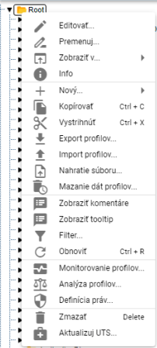

Figure 134: Window with functions for directories and profiles

## How to add a new directory

To add a new directory, proceed as follows:

1. Right-click on the directory in the tree structure where you want to add the new directory.
2. In the menu, select "New" and then "Folder".

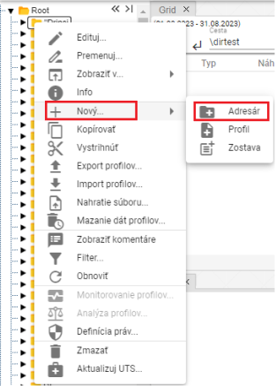

Figure 135: "Folder" item

1. A window for creating a directory will appear.

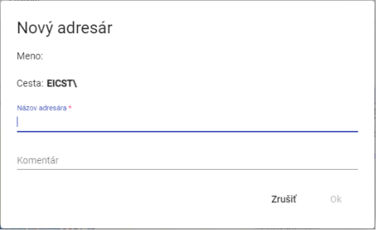

Figure 136: Window for creating a directory

1. Enter the details. The "Directory Name" field is required. The directory name must not start with a number. It may contain letters, numbers, and underscores. The name must be at least 3 characters and a maximum of 50 characters long. If you do not enter a name or enter an invalid name, information regarding the directory name will be displayed, Figure 137. The rules for entering the directory name may vary depending on the configuration of the environment.

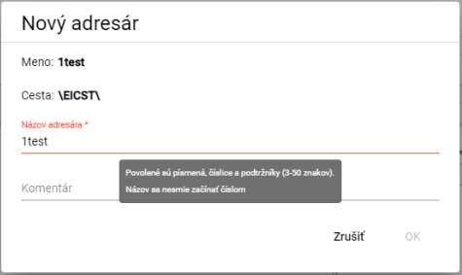

Figure 137: Information regarding the directory name

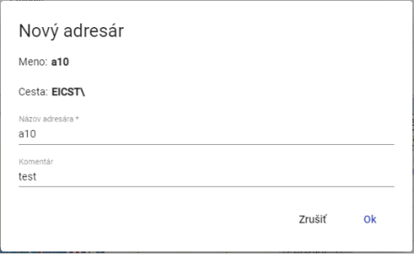

Figure 138: Entering the name and comment

1. You create the directory by pressing the "OK" button.

## How to rename a directory

How to rename a directory:

1. Click the left mouse button on the directory name and press the "F2" key, or right-click on the directory you want to rename and select "Rename".

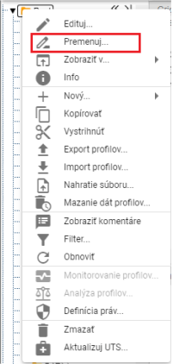

Figure 139: "Rename" item

1. A window will appear where you can enter the new directory name. The directory name cannot start with a number. It may contain letters, numbers, and underscores. The name must be at least 3 characters and a maximum of 50 characters long. If you do not enter a name or enter an invalid name, an information message regarding the directory name will be displayed. The rules for entering the directory name may vary depending on the configuration of the environment.

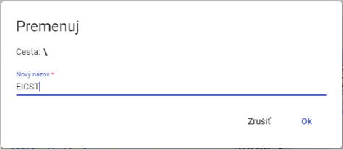

Figure 140: Rename directory window

1. You save the changes by pressing the "OK" button.

## How to rename a directory

To edit a directory, proceed as follows:

1. Right-click on the directory you want to edit.
2. In the menu, select "Edit".
3. A window will appear where you can edit the "Comment" field.

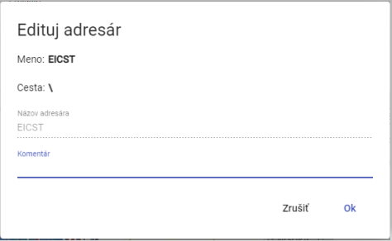

Figure 141: Window for editing the directory

1. You save the changes by pressing the "OK" button.

## How to delete a directory

You delete the directory:

1. Right-click on the directory you want to delete.
2. A menu will appear, in which select "Delete".
3. In the confirmation window, click the "Yes" button.

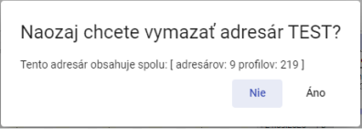

Figure 142: Confirmation Delete Window

## How to copy a directory

To copy a directory, proceed as follows:

1. Right-click on the directory you want to copy.
2. In the menu, select "Copy".
3. Right-click on the directory where you want to paste the copied directory and select "Paste".
4. A "Move/Copy" window will appear.

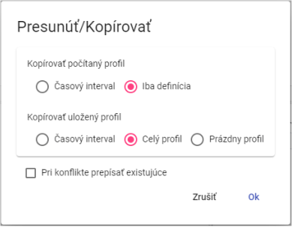

Figure 143: Window for copying the directory

1. Press the "OK" button.

## How to cut/move a directory

To move a directory from one location to another in the tree structure, use the "Cut" option. To cut a directory, proceed as follows:

1. Right-click on the directory you want to cut.
2. In the menu, select "Cut".
3. Right-click on the directory where you want to paste the directory.
4. Select "Paste".
5. A confirmation window will appear, in which press the "OK" button.

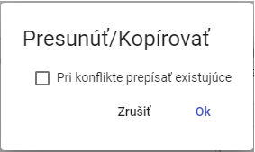

Figure 144: "Move/Copy" Window

## How to upload a file

To upload a file, proceed as follows:

1. Right-click on the location in the tree structure where you want to upload the file.
2. A window will appear, in which select “File Upload...”

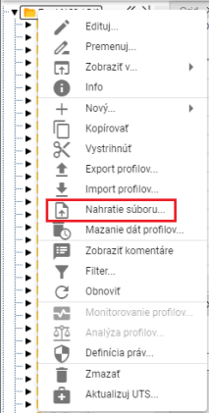

Figure 145: “File Upload...” item

1. A “Upload” window will appear, in which you click and select the file you want to upload. You can also upload the file by dragging it into the “Upload” window.

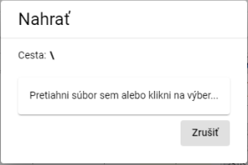

Figure 146: “Upload” window

1. The window will close and a notification will appear at the bottom of the screen: “Upload request sent.”

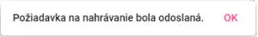

Figure 147: “Upload request sent.”

Recognized document file types:

* pgz2 - reports
* pvs2 - reports
* xlsx - template for reports

## How to delete profile data

The "Profile Data Deletion" function will delete data in all profiles within the selected folder(s) according to the specified time interval. You can also select multiple folders or multiple profiles at the same time. Data can also be deleted in subdirectories.

To delete profile data, proceed as follows:

1. To delete data in only one selected folder (including its subdirectories) or in one profile, right-click on the selected folder or profile. A window will appear, in which select the “Profile Data Deletion...” option.

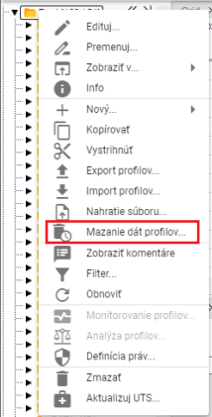

Figure 148: “Profile Data Deletion...” item

1. To delete data in multiple folders or profiles simultaneously, proceed as follows:
   1. Select the folders or profiles in which you want to delete data.
   2. If the folders you want to select are consecutive, click the left mouse button on the first folder, hold down the SHIFT key, and then click on the last folder you want to select. All folders in between will be highlighted.

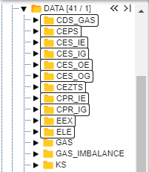

Figure 149: Selecting Multiple Folders

* 1. If the folders you want to select are not consecutive, click the left mouse button on the first folder, hold down the CTRL key, and then click with the left mouse button to mark the other folders you want to select.

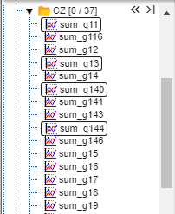

Figure 150: Selecting Multiple Profiles

* 1. Right-click on the selected folders or profiles and select "Delete Profile Data...".

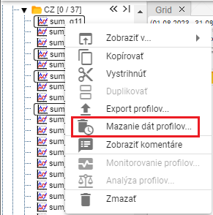

Figure 151: "Delete Profile Data..." Item

1. The "Delete Data Range" window will appear, where you select a daily or minute time interval. The minute time interval is selected by default.

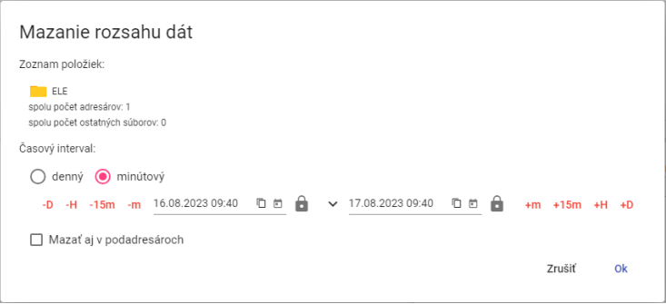

Figure 152: "Delete Data Range" Window for a Single Selected Folder

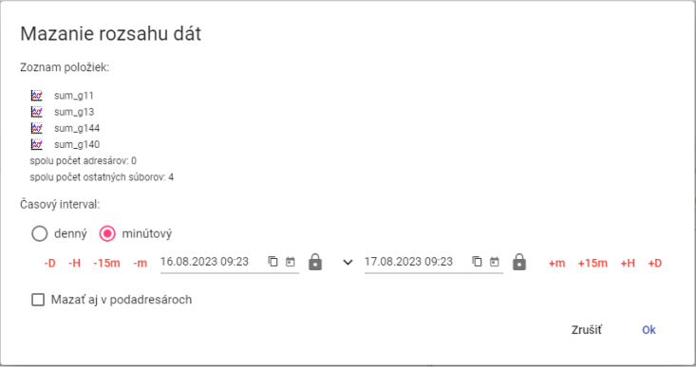

Figure 153: "Delete Data Range" Window for Multiple Selected Profiles

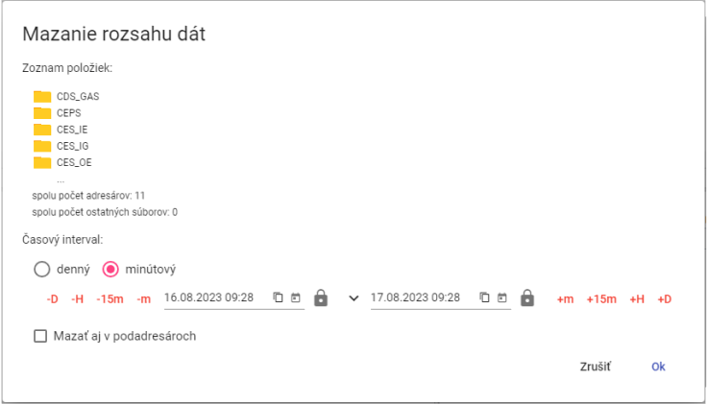

Figure 154: "Delete Data Range" Window for Multiple Selected Folders

1. Then, enter the time interval within which the data should be deleted.
2. If you check the "Delete also in subdirectories" checkbox, the subdirectories will also be traversed and the data in the profiles will be deleted according to the selected time interval.
3. Confirm by clicking the "OK" button.

## How to filter directories and profiles

To filter directories and profiles, proceed as follows:

1. Right-click on the directory.
2. From the menu, select "Filter".
3. A window for filtering will appear. To filter directories, type the name or part of the directory name in the "Filter directories" field. To filter profiles, type the name or part of the profile name in the "Filter profiles" field. The asterisk convention is not used here, it searches for any substring. Filtering is also “case sensitive”.

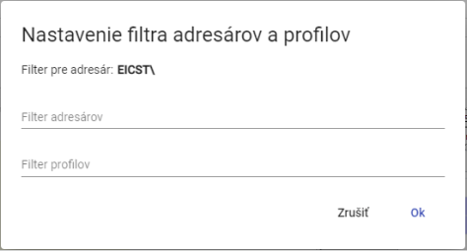

Figure 155: "Directory and Profile Filter Settings" window

1. Confirm the filter by pressing the “OK” button.

## How to clear the directory and profile filter

To clear the filter, proceed as follows:

1. Right-click on the directory where the filter is set.
2. Select "Filter".
3. Cancel the applied filter.
4. Save the changes by clicking the "OK" button.
5. After canceling the filter, all directories and profiles will be displayed in the tree structure.

## How to display comments

When creating directories and profiles, you can enter a comment. To enable the display of comments in the tree structure:

1. Right-click on any directory or profile in the tree structure.
2. A window will appear, in which use the mouse cursor to select the "View" item and choose "View Comments".
3. When displaying comments is enabled, directory and profile names are shown in parentheses, with comments displayed before the names (Figure 156). If no comment was entered, directory or profile names are shown only in parentheses (Figure 157).



Figure 156: Directory with comments display enabled



Figure 157: Directory not containing a comment

1. To disable comments, right-click on any directory or profile in the tree. In the window that appears, use the mouse cursor to navigate to the "View" item and select "Hide Comments".

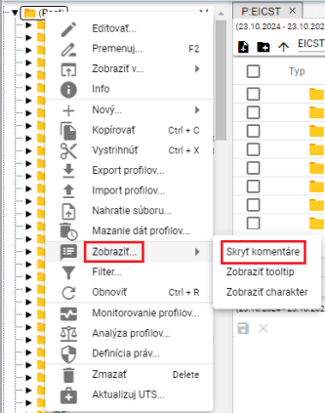

Figure 158: "Hide Comments" Item

1. Comments will then be hidden, and directory or profile names will be displayed without parentheses.



Figure 159: Directory with Hidden Comments

## How to display a tooltip

To display a tooltip for profiles in the tree structure, proceed as follows:

1. Right-click on any directory or profile in the tree structure.
2. A window will appear, in which use the mouse cursor to select the "View..." item and click on the "View Tooltip" item.

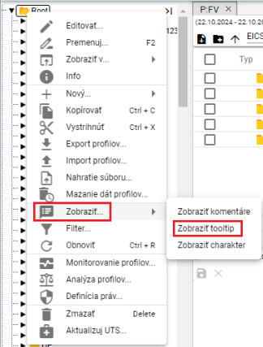

Figure 160: "View Tooltip" item

1. The tooltip will appear when you hover the mouse cursor over the profile name.

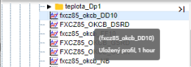

Figure 161: Displayed tooltip

1. To disable the tooltip display, right-click on any directory or profile in the tree. In the window that appears, use the cursor to select the "View" item and choose "Hide Tooltip".

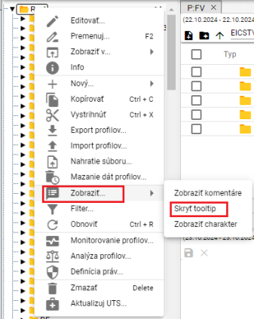

Figure 162: "Hide Tooltip" item

## How to display character

The character of the profile can be "Quantitative" or "Progressive", which are represented by markers.

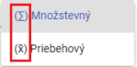

Figure 163: Markers representing quantitative and progressive character.

To display the character for profiles in the tree structure, proceed as follows:

1. Right-click on any directory or profile in the tree structure.
2. A window will appear, in which use the mouse cursor to select the "View..." item and click on the "View Character" item, Figure 160.
3. If a character was entered, the character mark will be displayed before the profile name.

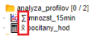

Figure 164: Character displayed with profiles

1. To disable character display, right-click on any directory or profile in the tree. In the window that appears, use the cursor to select the "View" item and choose "Hide Character".

## How to refresh the list

To refresh the list of profiles and directories, right-click on a directory in the tree and press the "Refresh" button.

## How to set user and group permissions

You set permissions for users and user groups:

1. Right-click on the directory for which you want to set permissions.
2. Select "Permissions Definition".

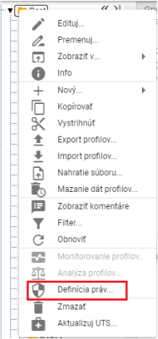

Figure 165: "Permissions Definition" item

1. The "Permissions Settings" window will appear.

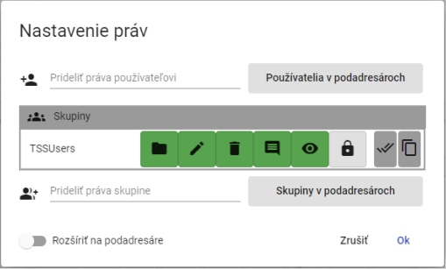

Figure 166: Permissions Settings window

1. To add permissions for a user, click in the "Assign Permissions to User" field and start typing the user's name. A list matching the entered text will appear automatically.

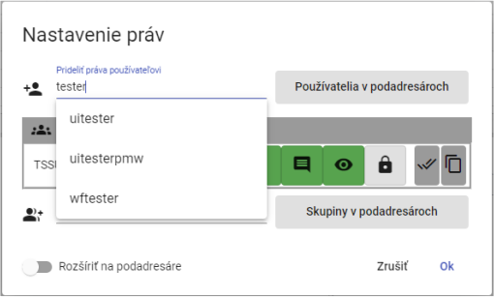

Figure 167: Start typing the user's name in the "Assign Permissions to User" field.

1. Select a user, which will display the "Users" table containing the selected user.

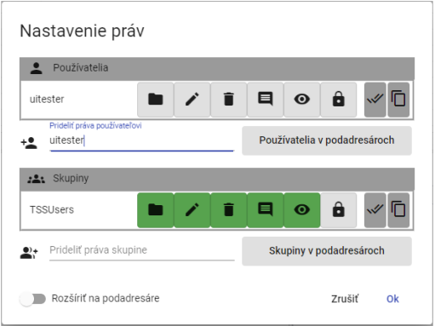

Figure 168: Selected User

1. Click the buttons to add permissions to the user.

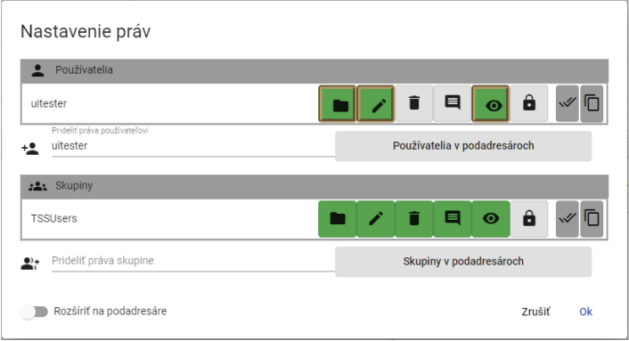

Figure 169: Assigning Permissions to User

1. To assign permissions to a group, select the group in the "Assign Permissions to Group" field.

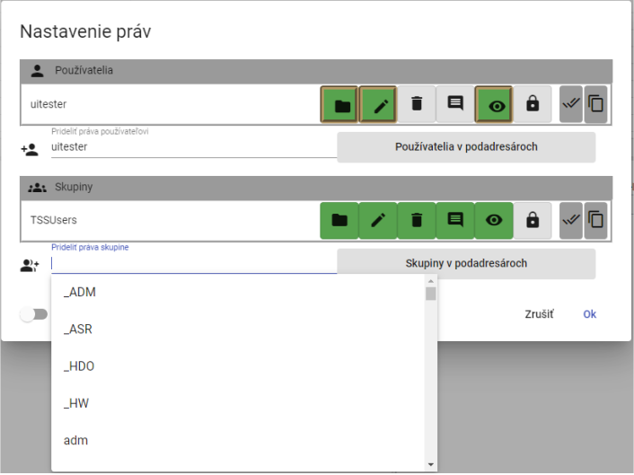

Figure 170: Selecting a Group

1. The selected group will be displayed in the "Groups" table.

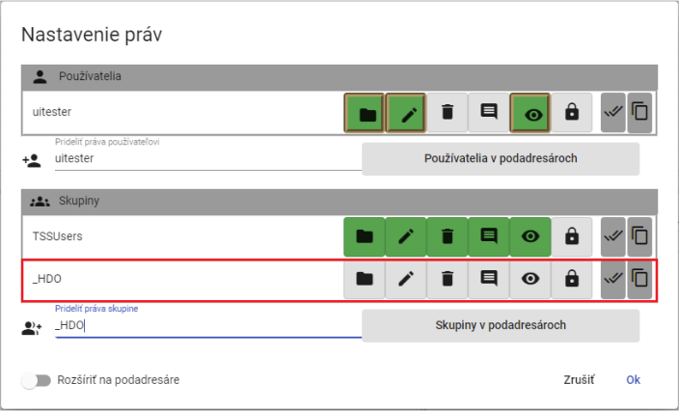

Figure 171: Selected Group

1. Click the buttons to set permissions for the selected group.

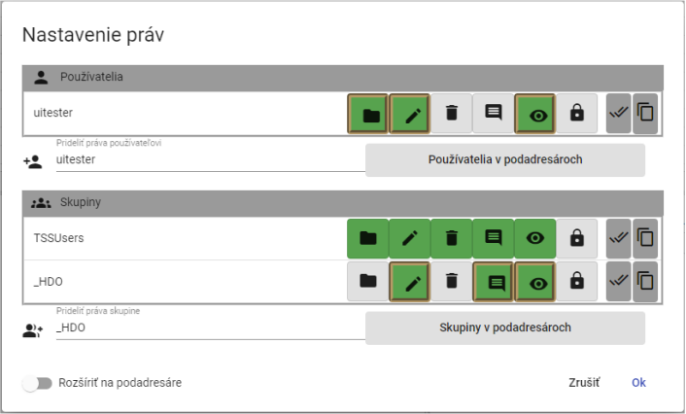

Figure 172: Assigning Permissions to Group

1. To set rules for subdirectories as well, check the "Apply to Subdirectories" button.

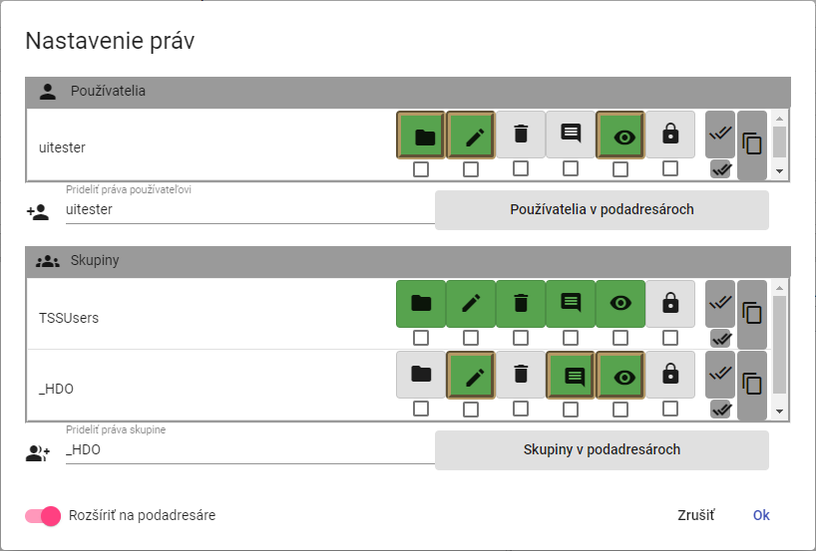

Figure 173: "Apply to Subdirectories" Permission

1. Checkboxes will appear below the buttons representing permissions for users and groups. Check the boxes below the buttons for which you want the permission to apply to subdirectories.

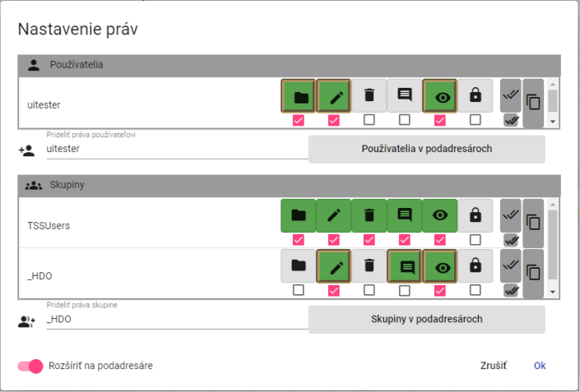

Figure 174: Setting User and Group Permissions for Subdirectories

1. Save the changes by clicking the "OK" button.

## How to create an export

To export profiles, proceed as follows:

1. In the tree structure, right-click on a directory, or in the explorer window, right-click on the row with the directory from which you want to export profiles.
2. Select "Export Profiles..."

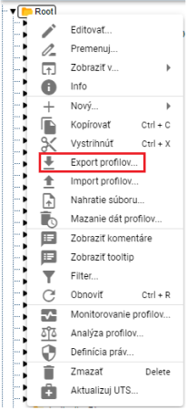

Figure 175: "Export Profiles..." item

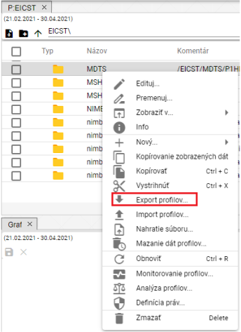

Figure 176: "Export" item in the Explorer window

1. The "Export" window appears, containing two tabs: "All" and "Profiles (CSV)". The "All" tab is displayed by default. The "All" tab allows you to export calculated profiles as an expression. The "Profiles (CSV)" tab exports only the data.

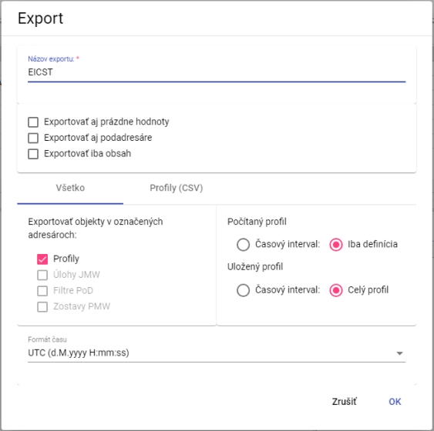

Figure 177: "Export" window, "All" tab

1. The "Export Name" field is populated by default with the name of the directory from which you want to export the profiles. You can change the name for the export.
2. In the top part of the window, select what should be exported (including subdirectories, also empty values, only content).
3. In the "All" tab, in the "Export Objects in Selected Directories" section, select which objects to export.
4. For "Calculated Profile", select whether to export "Time Interval" or "Definition Only".
5. For "Saved Profile", select whether to export "Time Interval" or "Full Profile".
6. In the "Time Format" field, select the desired time format.
7. To export profiles in CSV format, click on the "Profiles (CSV)" tab.
8. In the "Time Interval (mm/dd/yyyy)" section, select the dates in the "From Date" and "To Date" fields.
9. Click in the "Column Separator" field and select a separator.
10. Click in the "Decimal Separator" field and select a separator.
11. In the "Time Format" field, select a time format.

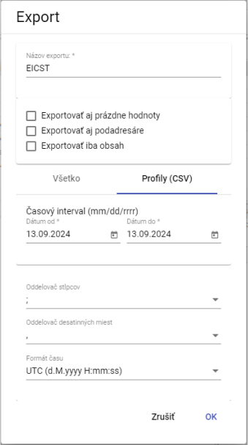

Figure 178: "Export" window, "Profiles (CSV)" tab

1. Start the export by clicking the "OK" button.
2. Information about the export status is displayed in the "Exports" window, which is covered in chapter 1.20. The completed export can then be downloaded from the "Exports" window.

## How to create an import

To create an import, proceed as follows:

1. Right-click on the directory in the tree structure where you want to import the file.
2. Select "Import Profiles..."

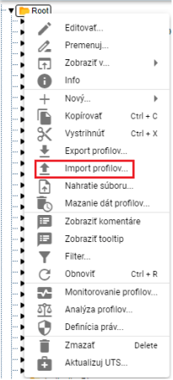

Figure 179: "Import Profiles..." item

1. The "Import" window will appear.

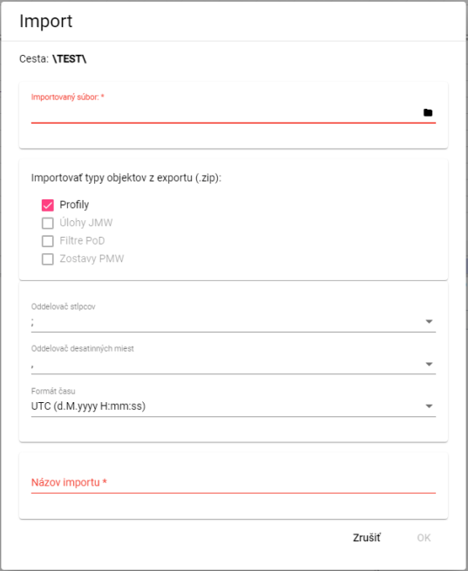

Figure 180: "Import" window

1. In the "Imported File" section, click the black file icon and select the file you want to import.
2. In the "Import object types from export (.zip)" section, select what to import. "Profiles" is selected by default.
3. Click in the "Column Separator" field and select the separator.

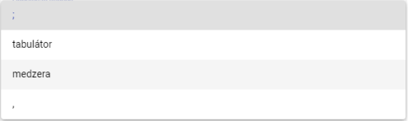

Figure 181: Menu for the "Column Separator" item

1. Click in the "Decimal Separator" field and select the separator.
2. In the "Import Name" field, enter a name for the imported file.
3. You import the file by pressing the "OK" button.
4. The imported file will be displayed in the selected directory.



Figure 182: Imported file

Information about the import status will be displayed in the "Imports" window, which is covered in chapter 1.21.

## How to add a new profile

To add a profile, proceed as follows:

1. Right-click on the directory where you want to add the profile.
2. In the menu, select "New" and then "Profile".

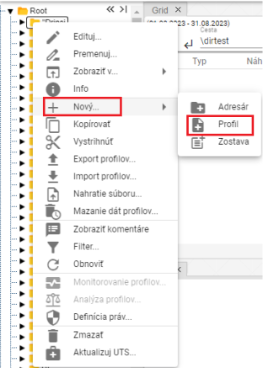

Figure 183: Creating a profile

1. A window for creating a profile will appear.

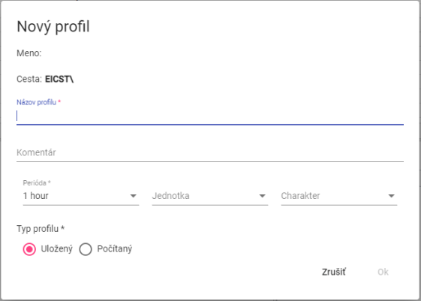

Figure 184: Window for creating a profile

1. Enter the details.
2. The “Profile Name”, “Period”, and “Profile Type” fields are required.
3. The profile name must not begin with a number. It may contain letters, digits, and underscores. The name must be at least 3 characters and a maximum of 50 characters long. If you do not enter a name or enter an invalid name, a message regarding the profile name will be displayed. The rules for entering the profile name may vary depending on the configuration of the given environment.

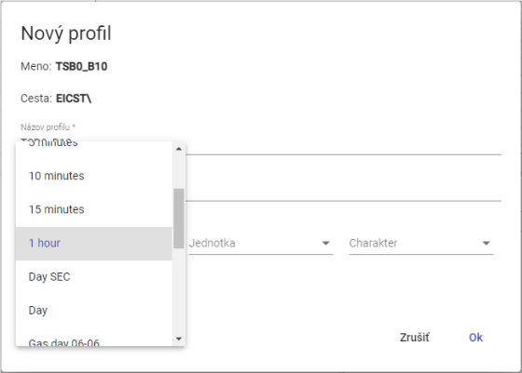

Figure 185: Selecting a Period

1. If you select a calculated profile type, enter the definition. For example, profilA+2*(profilC-2). The options for arithmetic are described in the document “Xenergie TSS Kompl_prehl_fnc_G2 R12.xlsx”. Chapter 2.18.1 deals with creating a definition for a calculated profile.

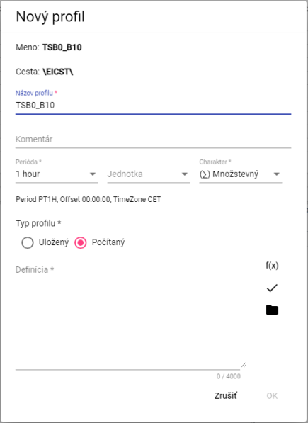

Figure 186: Calculated Profile Type

1. You create a profile by pressing the "OK" button.

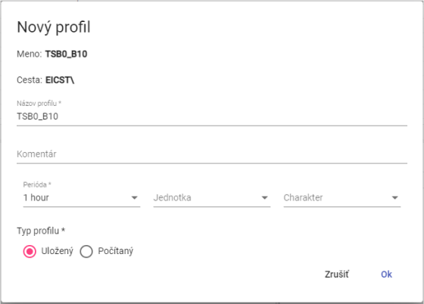

Figure 187: Saved Profile Type

Profile characteristics:

• Quantity – represents the amount, for example, energy consumed over a certain period of time.

• Transient – represents the state of a certain quantity at a specific time. For example, temperature profile.

• Undefined – If a profile does not explicitly define one of the two characteristics mentioned above, the system treats it as Transient. This behaviour was chosen to maintain backwards compatibility with older versions of the Xenergie system and allows for a seamless transition to newer versions of the system.

The profile character serves to identify the method for resampling values in the profile to finer or coarser sampling. For example, ¼-hour energy values in MWh should be summed when converting to hours, while ¼-hour power values in MW should be averaged.

The profile character is used solely and only in connection with the need for resampling (recalculating the profile to a different period). When using the profile in its native period, this setting is irrelevant.

### How to define a calculated profile type

To define a calculated profile type, proceed as follows:

1. In the "New Profile" window, click the "Function Wizard" button to display the function input window.



Figure 188: "Function Wizard" button

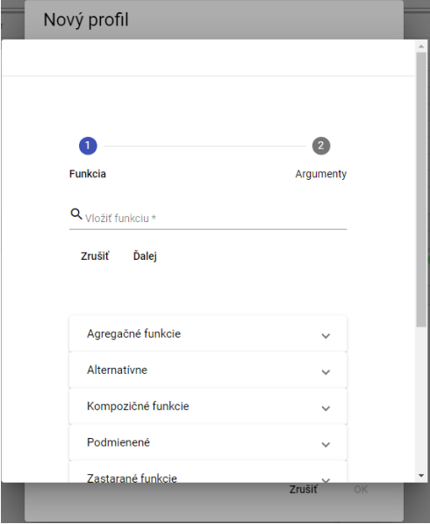

Figure 189: Function Input Wizard

1. Click in the "Insert Function" field.

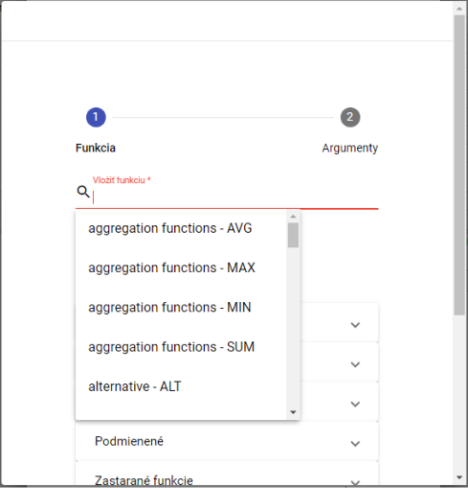

Figure 190: Function Selection

1. A list of functions will appear, from which you select a function.
2. After selecting a function, a description will appear.

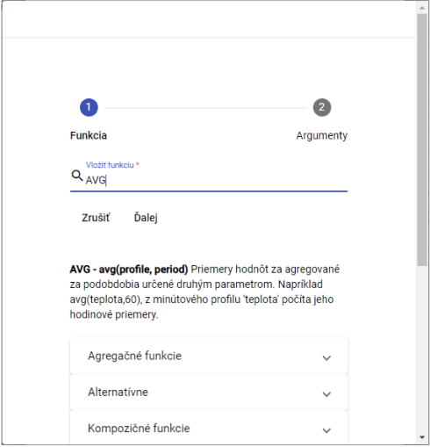

Figure 191: After selecting a function, a description of the function will appear.

1. Clicking on a function group will display a list of functions with descriptions.

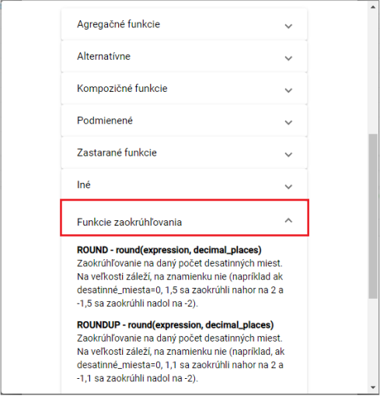

Figure 192: Function Descriptions

1. Enter the path to the profile or click the button to display the "Profile Selection" window, where you select a profile.
2. Enter the period.

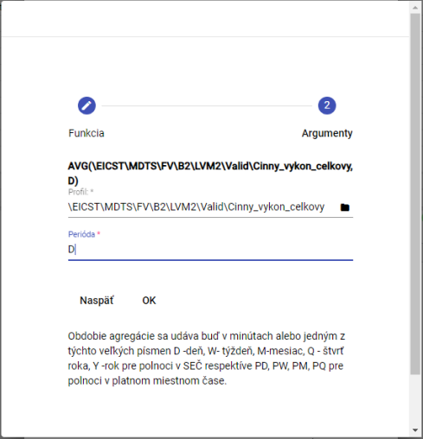

Figure 193: Enter the period.

1. Click the "OK" button.
2. In the "New Profile" window, after entering the definition, click the "Check Definition" button.

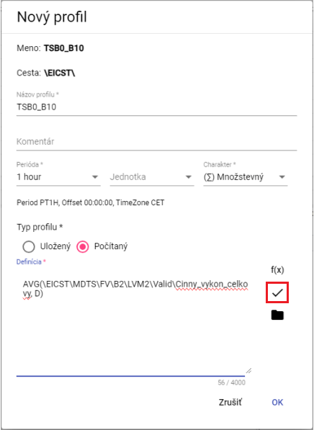

Figure 194: "Check Definition" button

1. A "Status" window will appear, which you close by clicking the "OK" button.

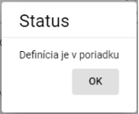

Figure 195: "Status" window

1. The button is used to add a profile.
2. You save the profile by clicking the "OK" button.

## How to add a new report

You create a new report:

1. Right-click on the folder where you want to add a new report.
2. Select “New...” and then “Report”.

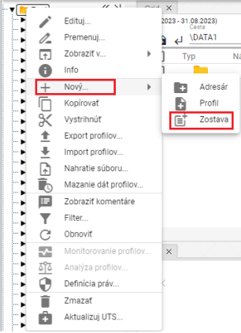

Figure 196: “Report” item

1. The “Report Name” window will appear.

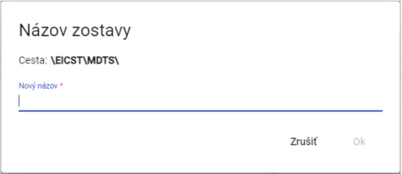

Figure 197: “Report Name” window

1. Enter a name for the new report. The report name must not begin with a number. It may contain letters, numbers, and underscores. The name must be at least 3 characters and no more than 50 characters long. If you do not enter a name or enter an invalid name, a message with the rules for the name will be displayed. The rules for entering the name may vary depending on the configuration of the environment.

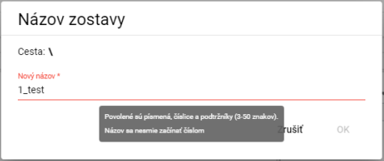

Figure 198: A message with the rules for the name will be displayed if the name is invalid.

1. Confirm by clicking the "OK" button.
2. A new report will be added to the selected folder.

## How to rename a profile

Rename profile:

1. Right-click on the profile you want to rename.
2. In the menu, select "Rename".
3. A window will appear where you enter the new name. The profile name must not start with a number. It may contain letters, digits, and underscores. The name must be at least 3 characters and a maximum of 50 characters long. If you do not enter a name or enter an invalid name, an information message regarding the profile name will be displayed. The rules for entering the profile name may vary depending on the configuration of the environment.

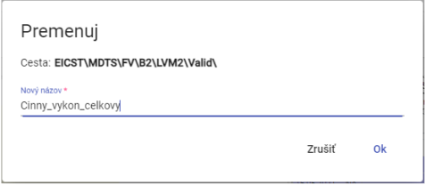

Figure 199: Renaming a profile

1. You save the changes by pressing the "OK" button.

## How to edit a profile

To edit a profile, proceed as follows:

1. Right-click on the profile you want to edit.
2. In the menu, select "Edit".
3. A window will appear where you can edit the details.

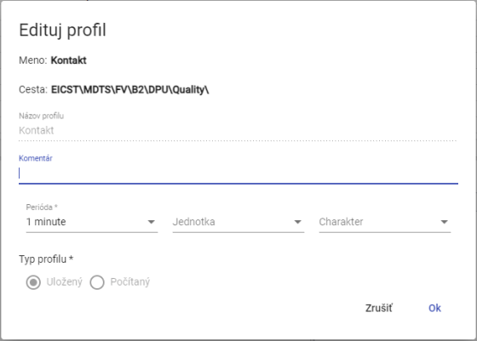

Figure 200: Profile Edit Window

1. Save the changes by clicking the "OK" button.

## How to delete a profile

How to delete a profile:

1. Right-click on the profile you want to delete.
2. In the menu, select "Delete".
3. A window will appear where you confirm the deletion of the profile by clicking the "Yes" button.

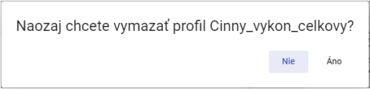

Figure 201: Confirmation of deletion window

## How to display profile dependencies

You will display profile dependencies:

1. Right-click on the profile in the tree structure.
2. Select "Dependencies".
3. A window will appear with three tabs: “Used Profiles”, “Full Definition”, and “Dependent Profiles”. The first tab contains a list of used profiles.

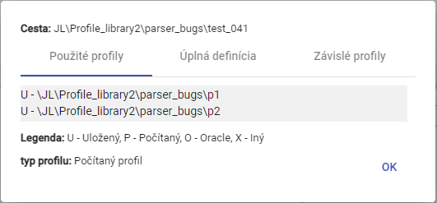

Figure 202: “Used Profiles” tab

1. The second tab, “Full Definition”, contains the profile definition entered when creating the profile.

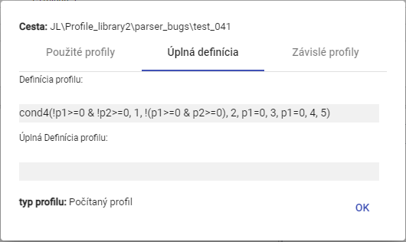

Figure 203: “Full Definition” tab

1. The third tab, “Dependent Profiles”, contains a list of dependent profiles.

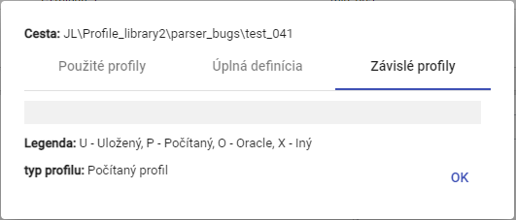

Figure 204: “Dependent Profiles” tab

## How to create a new profile

In the Explorer window, you create a new profile by clicking the “Create New Profile” button, located in the upper-left corner of the Explorer window. The “New Profile” window will appear. The procedure for creating a profile is detailed in chapter 2.18.

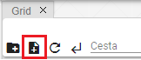

Figure 205: “Create New Profile” button

## How to set up Profile Policy

The policy defines special profile behavior. Policies are added to the system based on specific customer requirements.

Profile Time Policy:

Profile Time Policy is a profile property that allows handling very specific data transformation cases within profiles.

One use of the policy is the ability to change the period of a stored profile from 1h to 15 minutes without the need for lengthy and slow data transformation. After applying the "1h to 15min" policy, the originally hourly stored profile becomes a 15-minute profile across the entire range. All applications using the profile will see it only as a 15-minute profile from the moment of transformation. Therefore, the policy is fully transparent to other applications outside of TSS.

The "1h to 15min" policy, however, must have a firmly defined change date, from which the profile should be used as a fully functional 15-minute profile. Before this date, the profile will appear as 15-minute, but all 4 values within the hour will always be the same. Their value will depend on the specified profile characteristic.

Example:

The original hourly profile contained a value of 100 MWh. If the profile characteristic is set to "Quantity", then the 15-minute profile will return a value of 25 MWh every 15 minutes.

If the same profile had the characteristic set to "Flow", then the 15-minute profile after setting the policy would return a value of 100 MWh in each 15-minute interval of that hour.

To set the policy, proceed as follows:

1. Right-click on the profile in the tree structure that you want to set the policy for.
2. Select "Policy".
3. The "Policy Settings" window will appear.

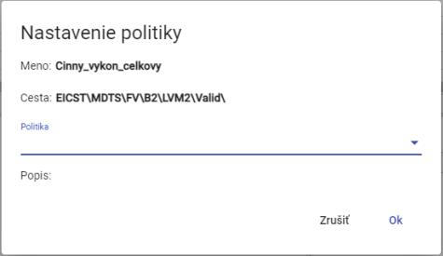

Figure 206: "Policy Settings" window

1. Currently, two policies are available.

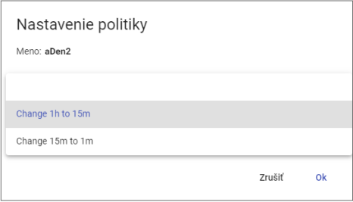

Figure 207: Policy Selection

1. You save changes by pressing the "OK" button.

## How to display profile information

To display profile information, proceed as follows:

1. Right-click on the profile you want to display information for.
2. Select "Info".
3. A window with the information will appear.

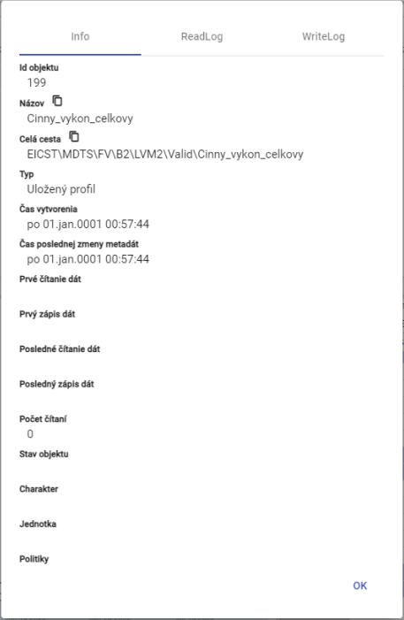

Figure 208: Profile Information

## How to copy a profile

To copy a profile, proceed as follows:

1. Right-click on the profile you want to copy.
2. Select "Copy".
3. Right-click on the directory where you want to paste the copied profile and select "Paste".
4. A "Move/Copy" window will appear.

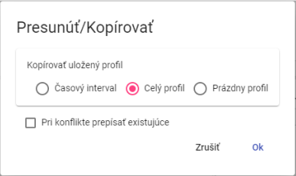

Figure 209: "Move/Copy" window

1. Select whether to copy only the time interval, the entire profile, or an empty profile. "Entire profile" is selected by default.
2. Press the "OK" button.

You can also copy a saved profile from one directory to another by grabbing the profile with the left mouse button and moving it over the directory you want to copy the profile to.

To copy a directory, proceed as follows:

1. Grab the directory and move it over to the directory you want to copy the profile to.
2. Subsequently, release the directory, which will display the "Move/Copy" window.

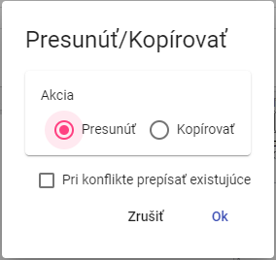

Figure 210: Move Profile Window

1. Check the "Copy" action.

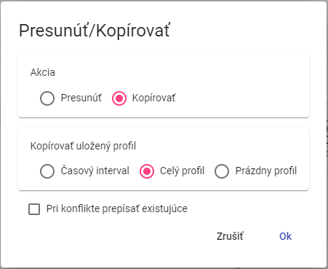

Figure 211: Copy Profile Window

1. In the "Copy Stored Profile" section, select whether to copy the entire profile, the profile time interval, or an empty profile.
2. If you select a time interval, enter the time interval to be copied.

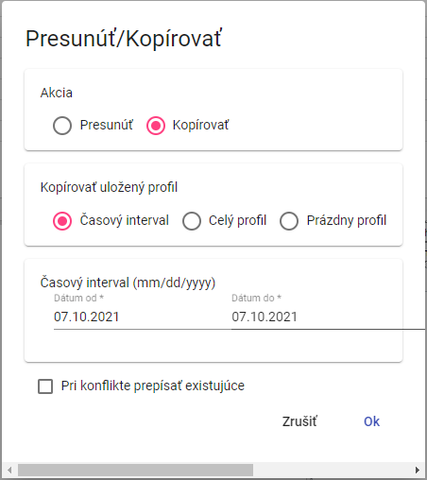

Figure 212: Window for Copying a Stored Profile Time Interval

1. Checking the "Overwrite existing if conflict" checkbox means that if a profile with the same name as the profile you want to copy already exists in the directory, the profile will be overwritten. If you do not check the checkbox and a conflict occurs, the original profile will be retained.
2. You copy the profile to the directory by pressing the "OK" button.

## How to cut/move a profile

To cut/move a profile, proceed:

1. Right-click on the profile you want to cut.
2. In the menu, select "Cut".
3. Right-click on the folder where you want to insert the profile.
4. Select "Insert".
5. A confirmation window will appear, in which press the "OK" button.

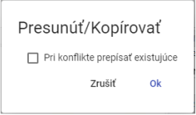

Figure 213: "Move/Copy" Window

You can also move a saved profile from one directory to another by clicking and dragging the profile to the directory you want to move it to.

To move a directory, proceed as follows:

1. Grab the profile and move it to the directory you want to move the profile to.
2. Then, release the profile over the directory, which will display the "Move/Copy" window.



Figure 214: Profile Move Window

1. Checking the "Overwrite existing in case of conflict" checkbox means that if a profile with the same name as the profile you want to move is already in the directory, the profile will be overwritten. If you do not check the checkbox and a conflict occurs, the original profile will be retained.
2. You save the profile to the directory by clicking the "OK" button.

## How to display a time series preview in the tree

To display a time series preview in the tree, double-click the profile in the tree. The "Time Series Preview" window will be displayed. The "Time Series Preview" window is described in chapter 4.7.

## How to resize the window for creating and editing a calculated profile.

You can resize the window for creating and editing a calculated profile. Proceed as follows:

Grab the button with the left mouse button – and drag. Resize the window to the desired size and release the left mouse button.

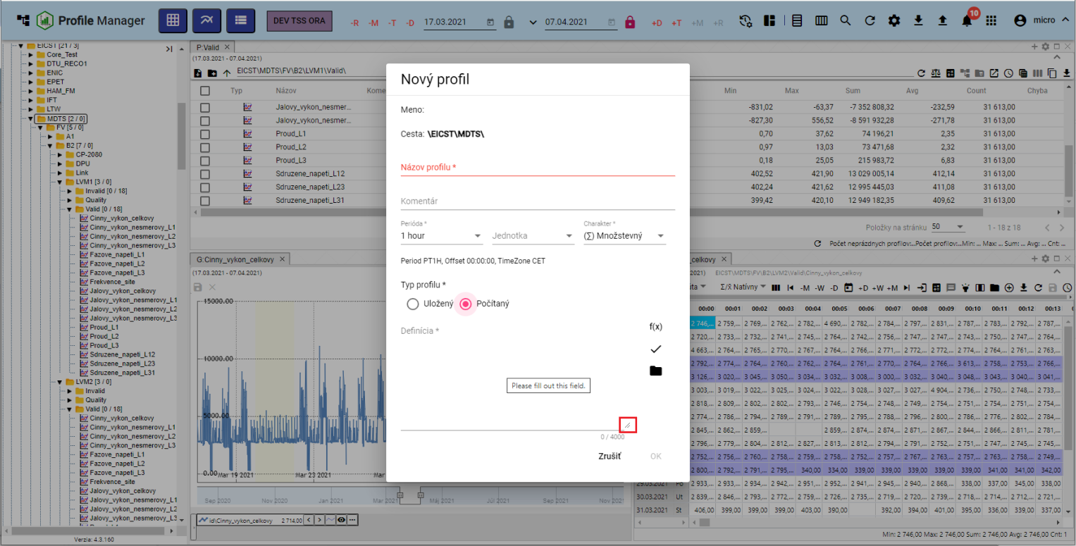

Figure 215: Button for resizing the "New Profile" window.

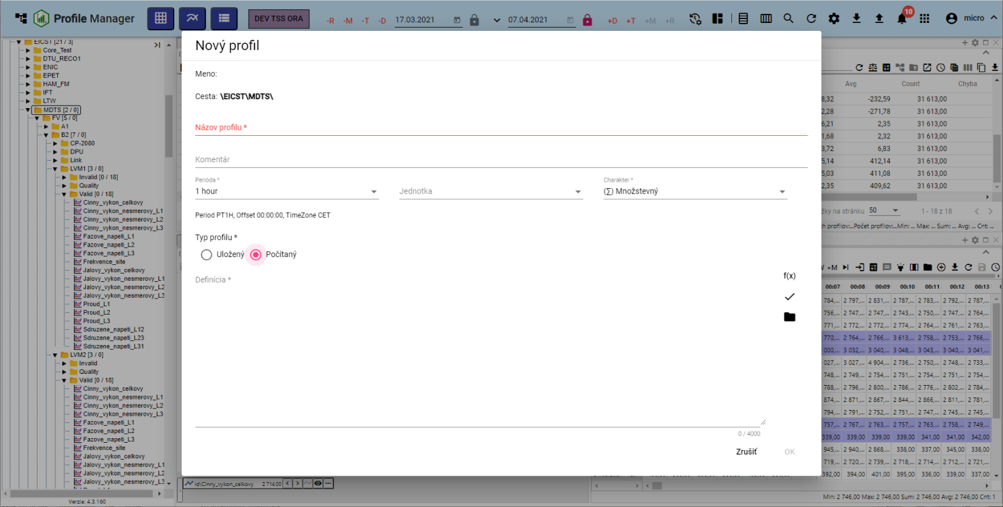

Figure 216: Enlarged "New Profile" window.

## How to move windows

To move windows in the "Profile Manager" application, click and drag the top of the window with the left mouse button and move the window to the desired location.

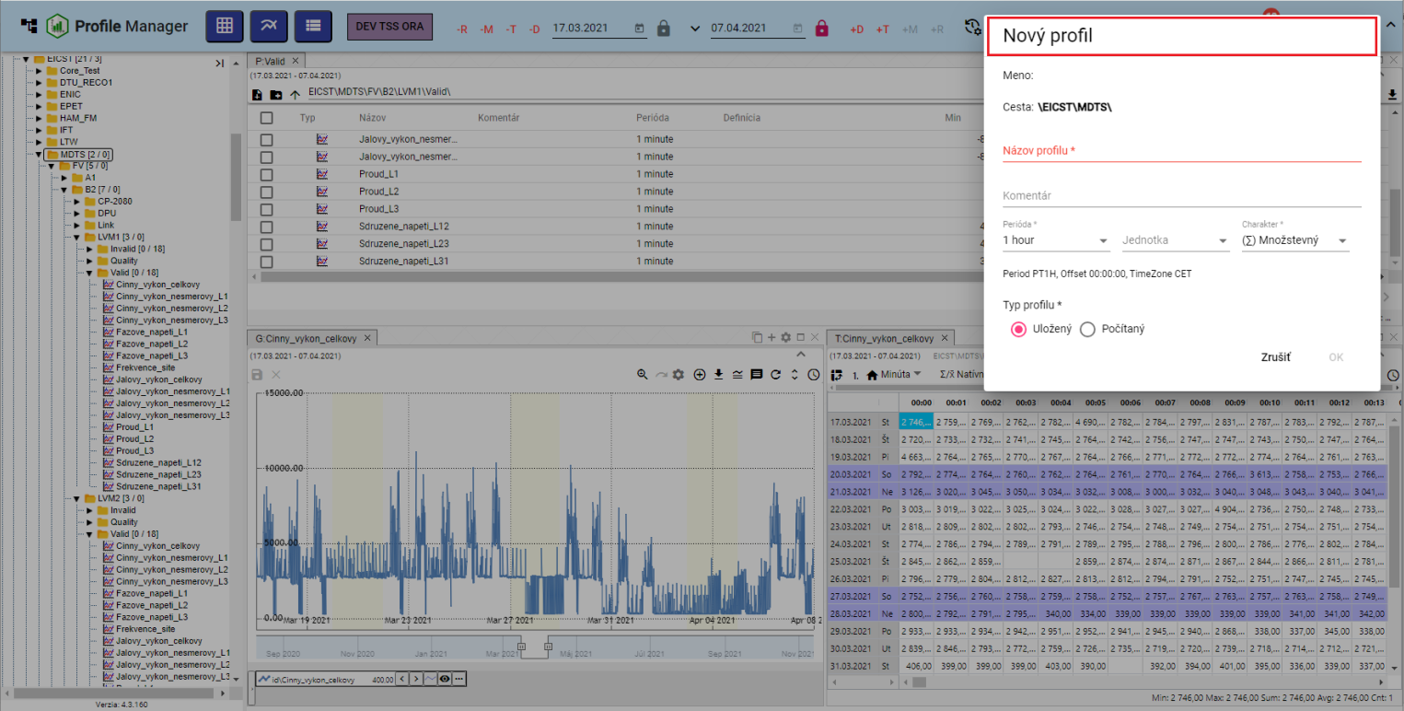

Figure 217: Moving the "New Profile" window

## How to rename a document

You rename the document (e.g., a report) as follows:

1. Right-click on the document you want to rename.
2. In the menu, select "Rename".
3. A "Rename" window will appear.

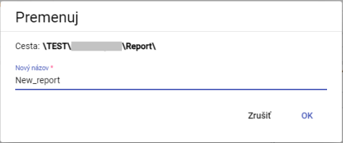

Figure 218: "Rename" window

1. Modify the name.
2. Save by pressing the "OK" button.

# Common controls for the explorer, table, and chart.

Window manipulation buttons are located at the top of the explorer, table, and chart windows. Working with the buttons is described in the following subsections.

## How to restore data in windows

To reload data in windows, press the button displaying Image 219.



Image 219: Button for reloading data in the explorer, table, and chart windows.

## How to change the date range

You change the date range in the explorer, table, or chart window:

1. Click the "Change Date Range" button, located in the upper right corner of the window.



Figure 220: "Change Date Range" button

1. A window for setting the date range appears.

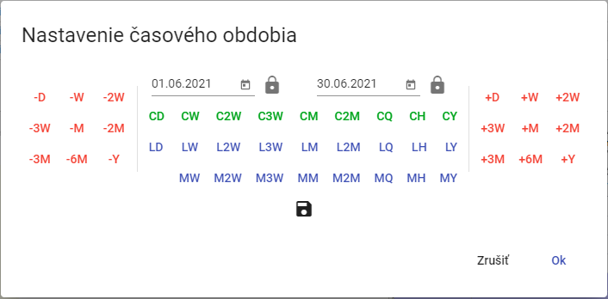

Figure 221: Window for changing the date range

1. You can set the date by pressing the buttons, selecting a date, or directly overwriting the date.
2. You can save the new date range by pressing the diskette button. A maximum of 3 date ranges can be saved.



Figure 222: Button for saving the date range

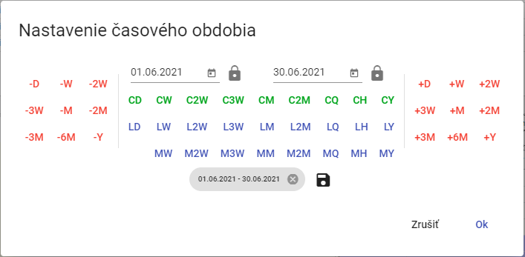

Figure 223: Saved date range

1. You start the date range by pressing the "OK" button.

## How to maximize the window to fill the application area

To maximize the graph, explorer, and table windows, press the "Maximize" button (Figure 224) or double-click on the top bar of the panel, as shown in Figure 226. The window will then fill the entire application area. After pressing the "Maximize" button, a "Restore Size" button will appear in its place, used to return the window to its original size. You can also resize the maximized window by double-clicking on the top bar of the panel.



Figure 224: "Maximize" button



Figure 225: "Restore Size" button

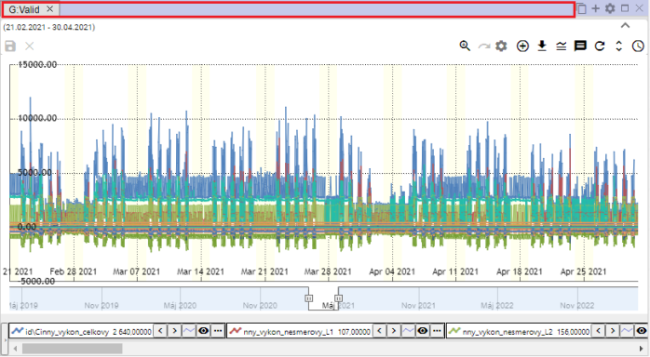

Figure 226: Top bar of the panel

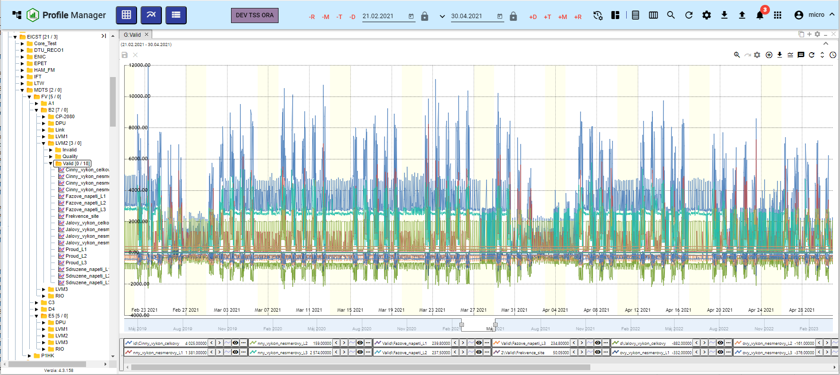

Figure 227: Zooming the graph window

## How to close the window

You can close the graph, explorer, and table windows by clicking the x button, which is located next to the window title and in the upper right corner of the window.



Figure 228: The "Close" button for closing the window

## Setting the panel title and color

Panels are named Explorer, Table, and Graph by default. To change the panel name and color, proceed as follows:

1. Press the "Panel settings" button, which is located in the top right corner of the window.



Figure 229: “Panel settings” button

1. The “Panel settings” window will appear.

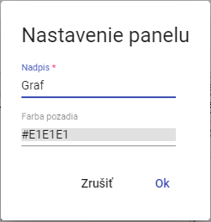

Figure 230: “Panel settings” window

1. In the “Title” field, enter a name.
2. You set the panel color by clicking in the “Background color” field and selecting a color.

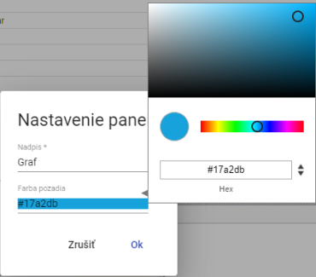

Figure 231: Color selection

1. Save the changes by clicking the "OK" button.

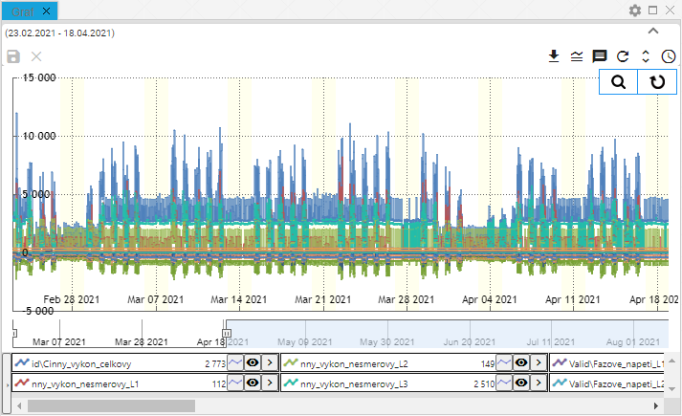

Figure 232: Changed panel color

## How to export the displayed data from the Explorer window.

You can export the displayed data from the Explorer window, table, or chart by clicking the export button, Figure 233.



Figure 233: Export button

## How to hide the top button bar in the Explorer window, table, and chart.

The top part in the Explorer window, table, and chart can be hidden using the button shown in Figure 234. To display the top part in the windows again, click the button again, Figure 235.

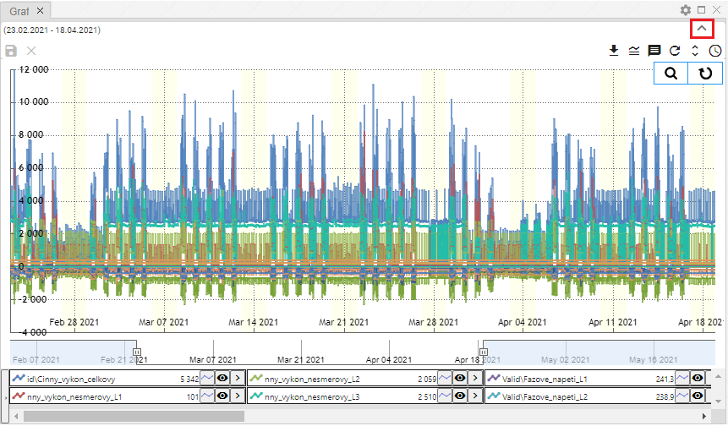

Figure 234: Button to hide the top part in the Explorer window, table, and chart.

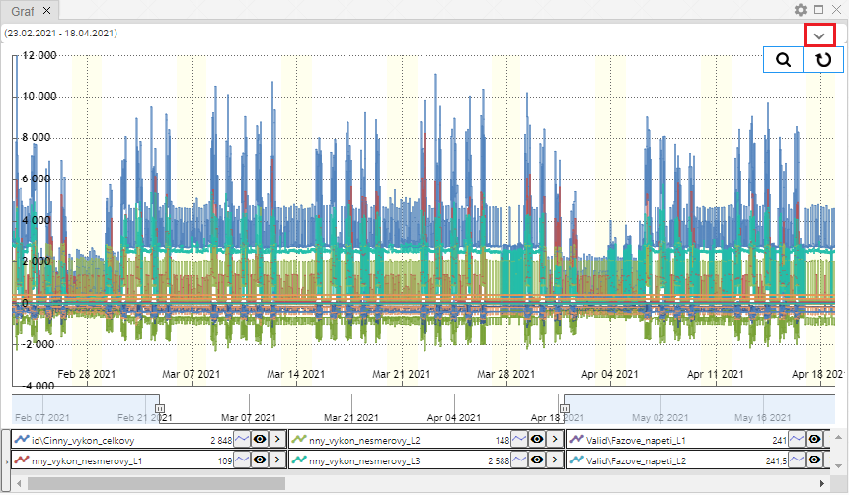

Figure 235: Button to display the top part in the Explorer window, table, and chart.

## How to add a profile to a chart and table

You can add a profile to a chart and table as follows:

1. Press the "Add Profile" button, located at the top of the chart or table window.



Figure 236: "Add Profile" Button

1. The "Add Profile" window will appear.

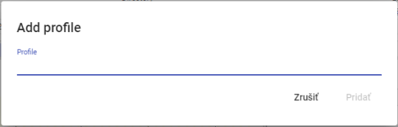

Figure 237: "Add profile" Window

1. Enter the path where the profile is saved.

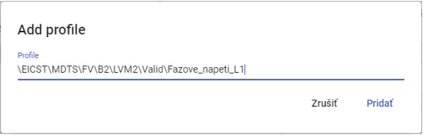

Figure 238: Entering the path to the profile

1. Click the "Add" button.
2. The selected profile will be added in the graph/table window.

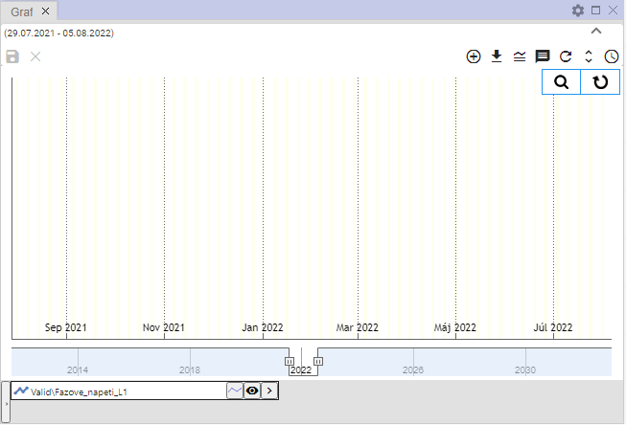

Figure 239: Added profile in the graph window

# Working with the Explorer window

After launching the "Profile Manager" application, the Explorer window is populated with directories and profiles from the tree structure. While working with the application, you can add any number of Explorer windows.

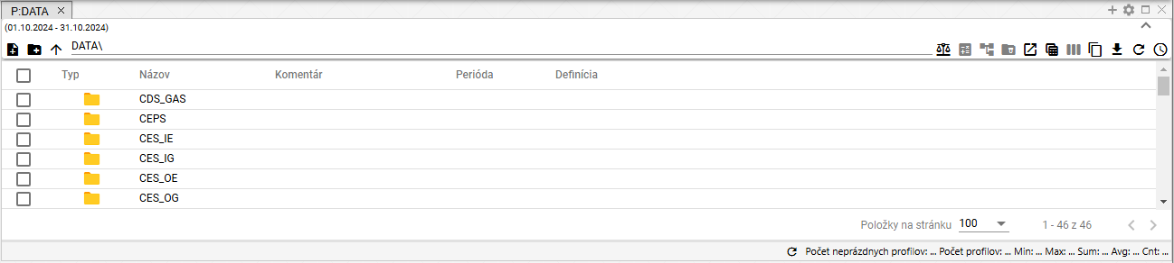

Figure 240: "Explorer" window

## How to display profiles from the selected directory in the Explorer window.

In the Explorer window, directories and profiles from the tree structure are displayed by default. To display profiles from the selected directory, double-click the left mouse button on the button in the "Type" column.

You can display the list of directories in reverse order by clicking on the arrow.

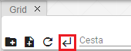

Figure 241: Back button

## How to create a new directory

In the Explorer window, you can create a new directory by clicking the “create new directory” button. The “New Directory” window will appear. The procedure for creating a directory is in chapter 2.1.

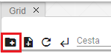

Figure 242: “create new directory” button

## How to synchronize Explorer with the tree view

The “Synchronize with Tree” button indicates that Explorer is synchronized with the tree view. A crossed-out “Synchronize with Tree” button indicates that if the directory in the tree view changes, the change will not be reflected in the Explorer window.



Figure 243: “Synchronize with Tree” button



Figure 244: Synchronization with Tree Disabled

## How to filter a profile

You can filter the profiles displayed in the Explorer window by individual columns. Proceed as follows:

1. Position the mouse cursor on the name of the column you want to apply the filter to.
2. Press the button to display the filter input window.



Figure 245: Filter button

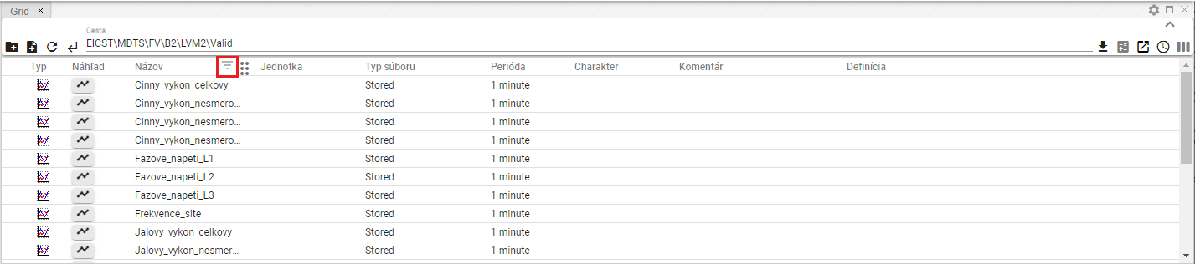

Figure 246: Filter button above the "Name" column

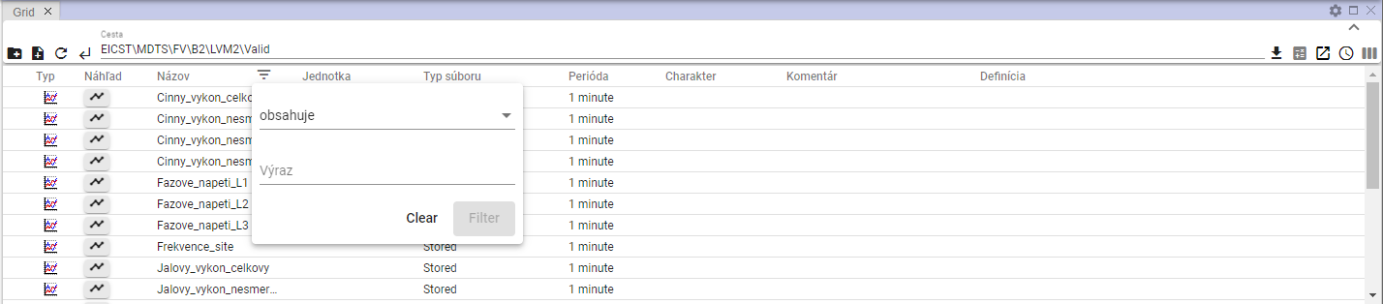

Figure 247: Filter window

1. Write a filter criterion.

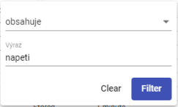

Figure 248: Entering a filter criterion

1. Press the "Filter" button or the Enter key.
2. Profiles matching the filter criteria will be displayed.

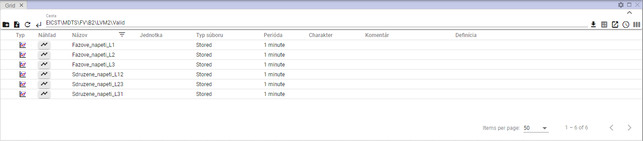

Figure 249: Filter applied

1. A button is displayed above the column where the filter is applied.
2. You can cancel the filter by clicking the button, which will display a window for filtering and then pressing the "Clear" button.

## How to sort data in columns

To sort data in a column, hover over the column name and click the arrow that appears next to the column name.



Figure 250: Button for sorting data in a column

## How to calculate Min, Max, Sum, Avg and Count values in the Explorer window

To calculate values in columns in the Explorer window, follow these steps:

1. In the Explorer window, display the directory profiles for which you want to calculate summary values.

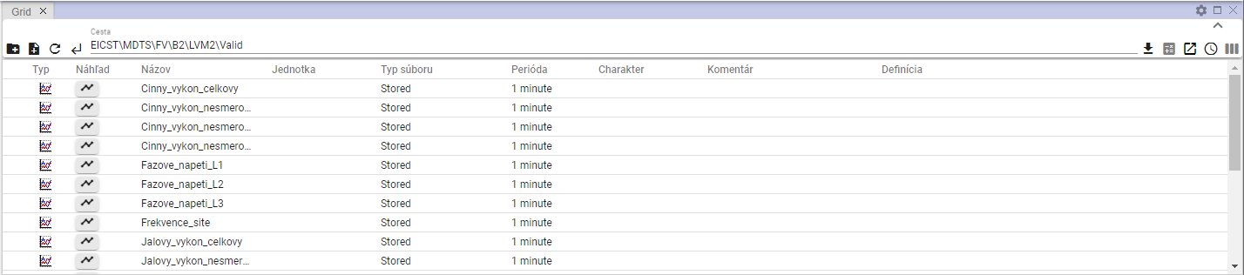

Figure 251: Displaying a directory in the Explorer window

1. Click the "Statistics" button.



Figure 252: The "Statistics" button

1. The values in the "Min", "Max", "Sum", "Avg", and "Count" columns are populated.

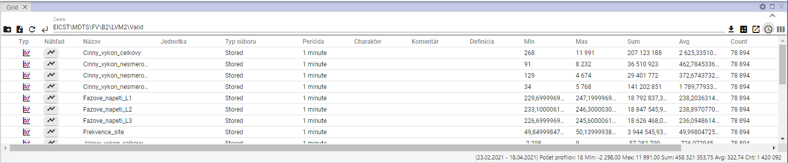

Figure 253: Statistics Calculation in the Explorer Window

## Time Series View

To view a time series preview, proceed as follows:

1. In the "Explorer" window, in the "Type" column, double-click the button next to the profile whose time series preview you want to view.

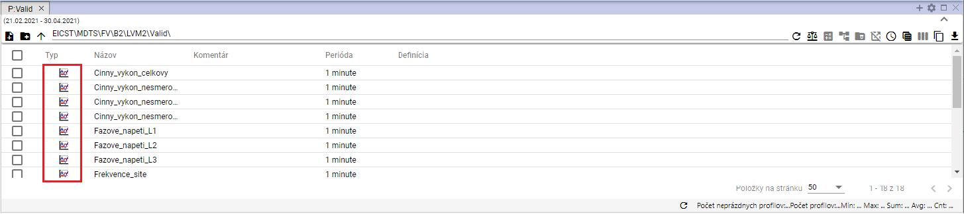

Figure 254: Button to display the "Time Series Preview" window

1. The "Time Series Preview" window will be displayed.

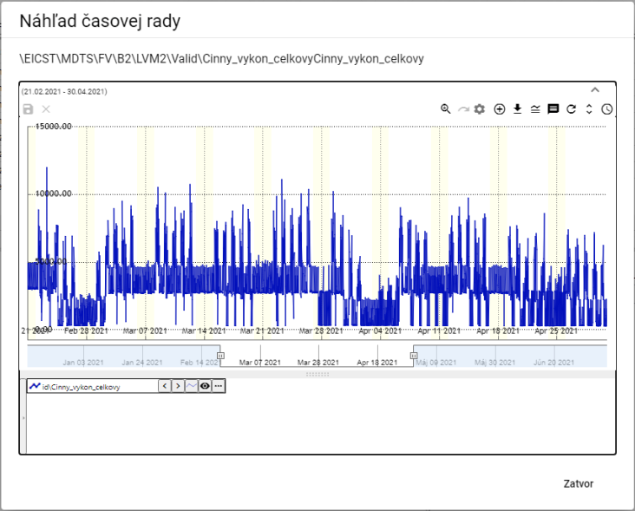

Figure 255: "Time Series Preview" window

1. Subsections in Chapter 5 cover working with the buttons located in the top right corner of the chart.



Figure 256: Buttons for working with the chart

1. At the bottom of the window is the profile name. Right-clicking on the profile name displays a list of functions for working with the profile. The functions are described in Chapter 5.7.

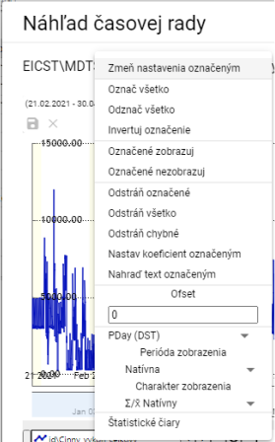

Figure 257: Functions for working with the profile

1. Clicking the arrow next to the profile name displays a window with functions, which are described in Chapter 5.8.

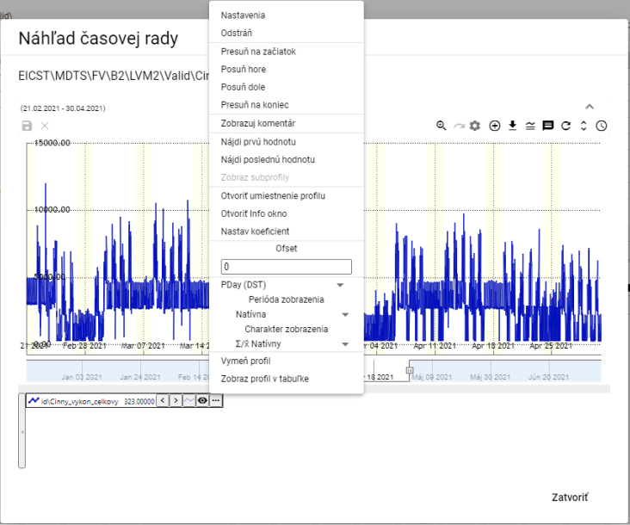

Figure 258: List of functions for working with the profile

## How to move a profile from the Explorer window to the Chart or Table window

You can move a row from the Explorer window to the Chart or Table window. You can move a directory from the Explorer window to the Graph window. You can grab and move a profile from the Explorer window to the Graph or Table window.

Proceed:

1. In the Explorer window, position the mouse cursor on the directory row or profile that you want to move to the Graph or Table window.

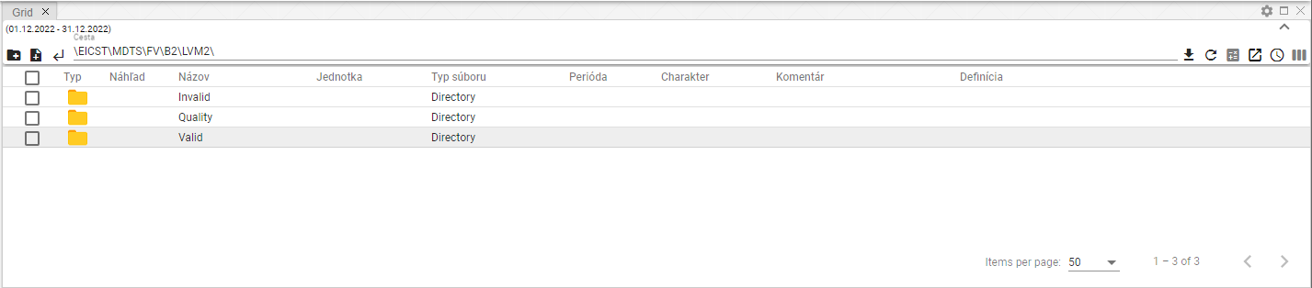

Figure 259: Selected profile

1. Click and hold the left mouse button on the row in the Explorer window, and drag the row over the window where you want to display it and release.

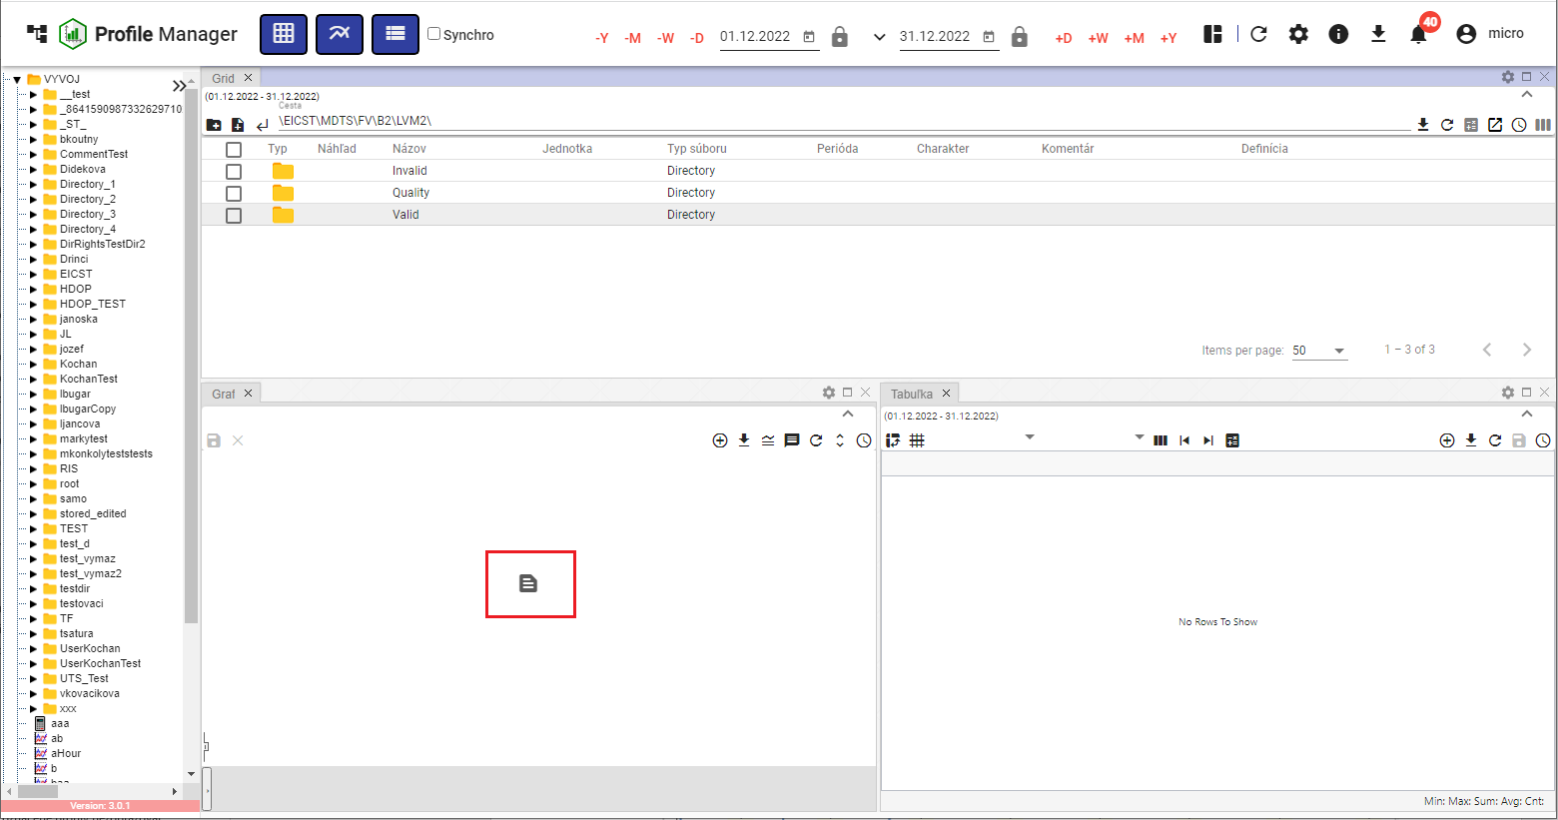

Figure 260: Moving the profile to the Graph window

1. The profile will appear in the selected window.

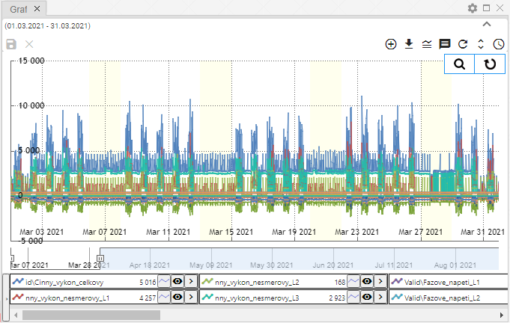

Figure 261: Profile moved from the Explorer window to the Graph window

## How to edit, add or remove columns in the Explorer window

You can change the list of displayed columns in the Explorer window. You can add or remove columns.

To change the displayed columns:

1. Click the "Choose columns" button, located in the upper right corner of the Explorer window.

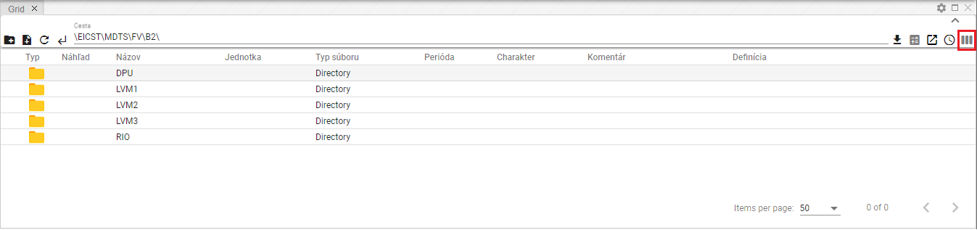

Figure 262: "Choose columns" button

1. A block with a list of columns will appear.

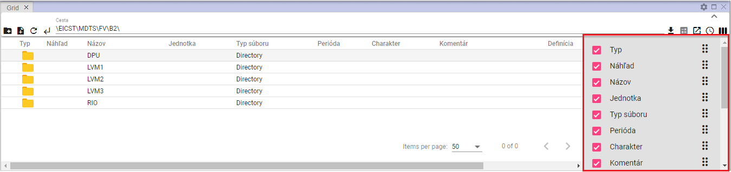

Figure 263: List of columns

1. Add or remove columns to be displayed. Any changes to the selected columns list will be automatically reflected in the explorer window.
2. You can change the column order in the explorer window. To change the column order, grab the column move button and drag the column to the desired position in the list.

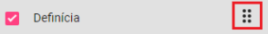

Figure 264: Column move button

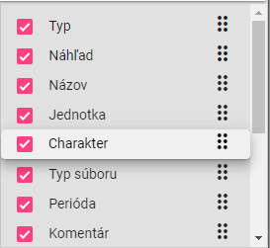

Figure 265: Moving the “Character” column

## How to edit the Name and Comment fields

You can edit the “Name” and “Comment” fields for profiles and directories in the Explorer window.

To edit, proceed as follows:

1. Double-click the field to open it for editing.

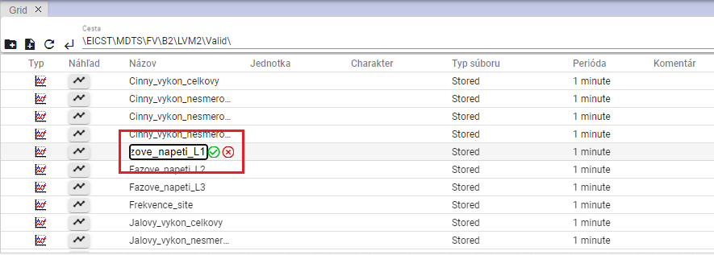

Figure 266: Editing the profile name

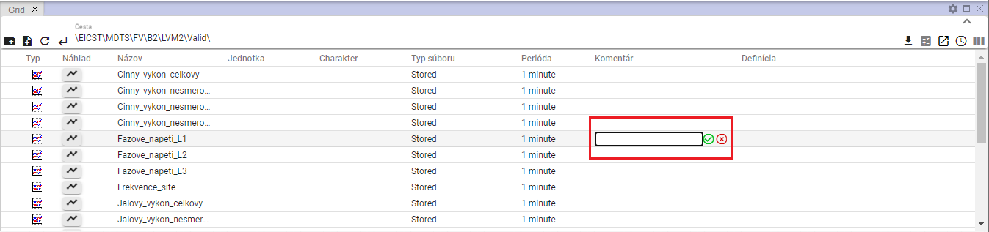

Figure 267: Entering a comment for the profile

1. Edit the text.
2. Save the changes by pressing the button.

## Features for working with address books in the Explorer window

To display the features for working with address books, right-click on the address book in the Explorer window. Working with these features is detailed in Chapter 2.

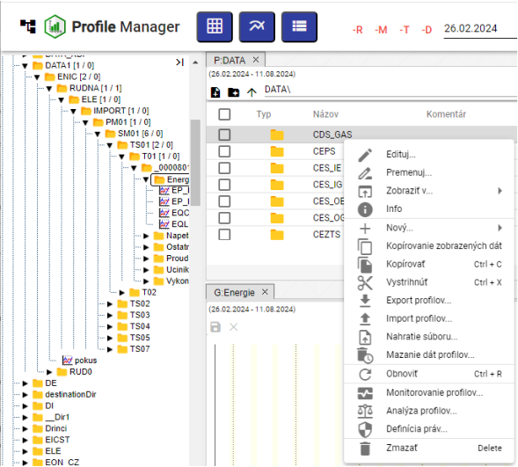

Figure 268: List of features for working with address books

## Features for working with filters in the Explorer window

To display the features for working with profiles, right-click on the profile in the Explorer window. Working with these features is detailed in Chapter 2.

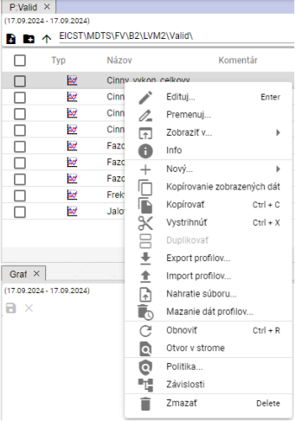

Figure 269: List of features for working with profiles

## Branch View Button

The "Branch View" button allows performing bulk operations on all profiles in the database, regardless of which directory the profile is located in. The "Edit" and "Delete" options can be used for bulk operations.

The "Branch View" button displays items from the selected directory without sorting them into nested directories, Figure 271. To return to the standard directory view in the Explorer window, click the "Branch View" button again.

Procedure for bulk editing profiles:

1. Click the "Branch View" button to display a list of profiles without directories.

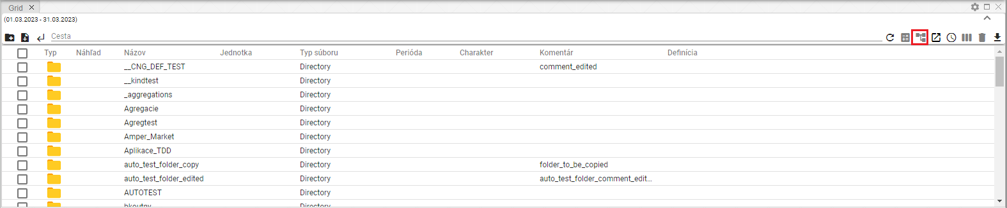

Figure 270: "Branch View" button

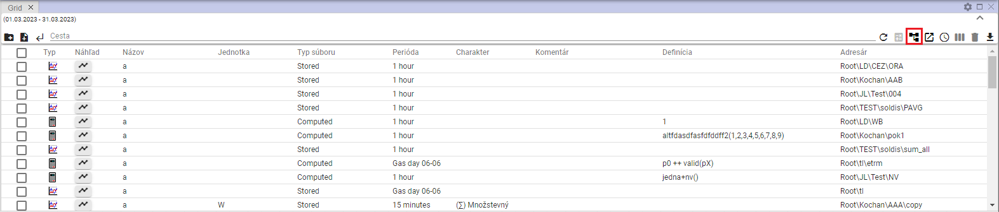

Figure 271: Display of profiles without directories

1. Enter a filter to obtain a list of profiles you want to perform bulk operations on.

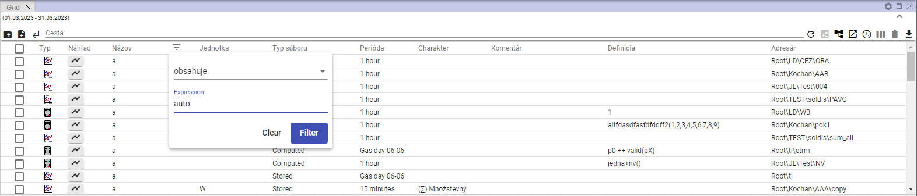

Figure 272: Entering a filter

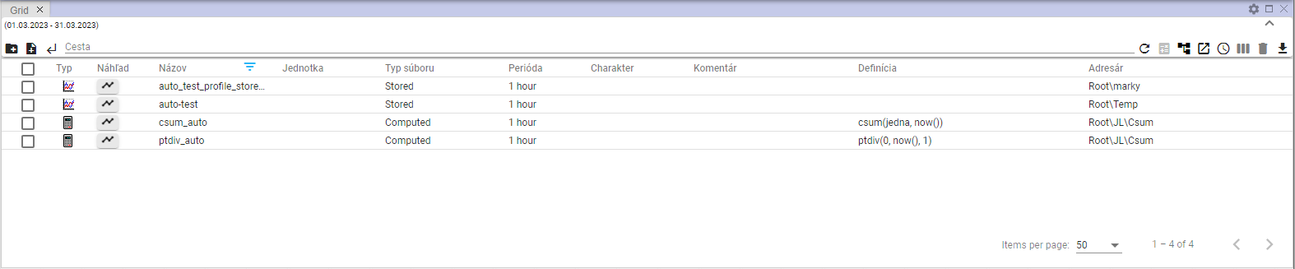

Figure 273: Filtered items

1. Check the box in the first column to select the profiles on which the bulk operation will be performed. To select all profiles, check the first box and the remaining boxes will be marked automatically.

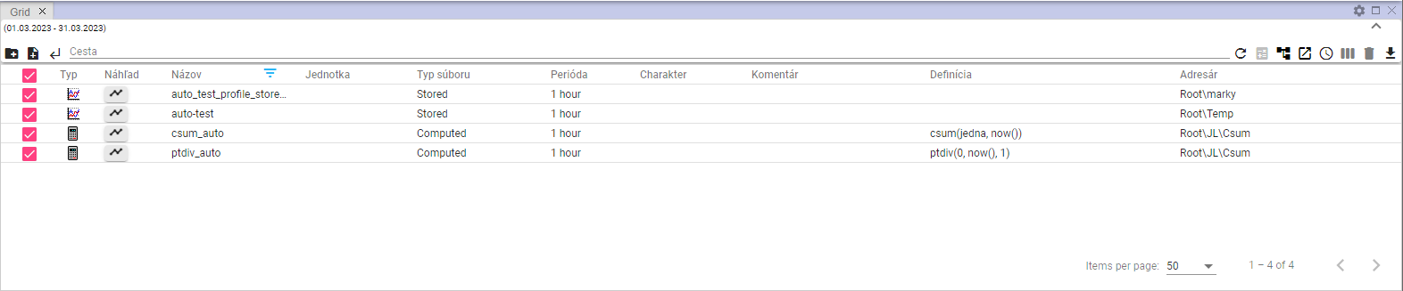

Figure 274: Selected profiles

1. Right-click anywhere on the selected profiles and select "Edit".

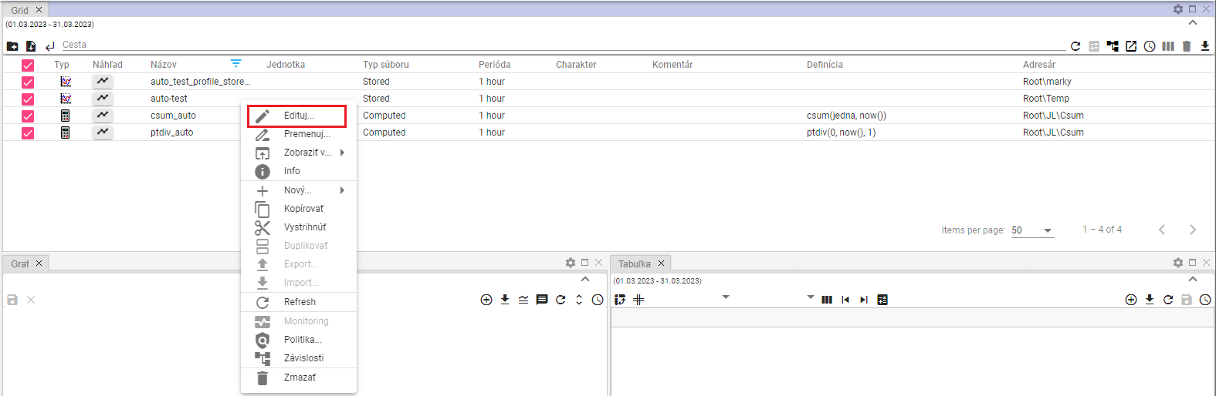

Figure 275: "Edit" item

1. The "Bulk Edit" window will appear.

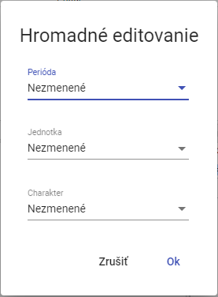

Figure 276: "Bulk Edit" window

1. You can edit the "Period", "Unit", and "Character" fields.
2. Edit the data and save the changes by clicking the "OK" button.

## How to display deleted items in the Explorer window

The "Recycle Bin" button in the Explorer window is used to display deleted items. The button is inactive – gray – by default. After clicking it, it turns black. To stop displaying deleted items, click the "Recycle Bin" button again. Afterward, directories and profiles from the tree structure will be displayed in the Explorer window.



Figure 277: "Recycle Bin" button – inactive



Figure 278: "Recycle Bin" button – active

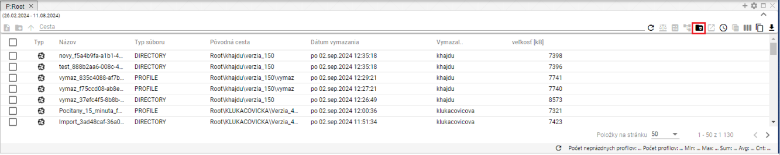

Figure 279: Displaying the contents of the "Recycle Bin" button

## How to copy the displayed data

The "Copy Displayed Data" button, Figure 280, is used to copy data from the "Explorer" window. Figure 282 displays the copied data.

Proceed:

1. Display the data you want to copy in the Explorer window.
2. To copy all displayed data, press the "Copy Displayed Data" button.

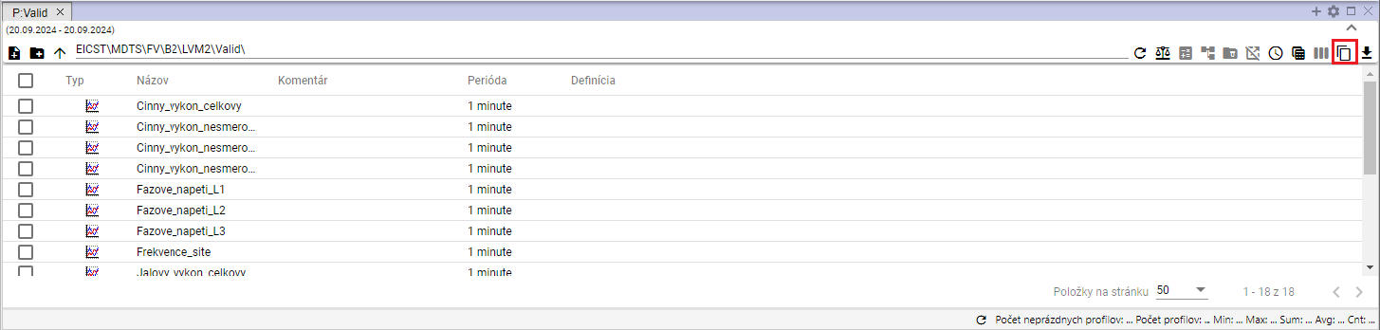

Figure 280: "Copy Displayed Data" button

1. To copy a specific file or files, select the desired files in the Explorer window. Right-click on the selected files and select "Copy Displayed Data".

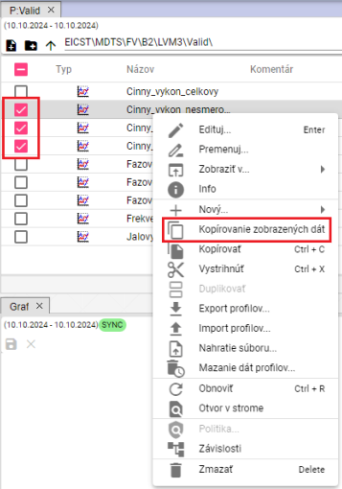

Figure 281: "Copy Displayed Data" item

1. You can paste the copied data into Microsoft Excel.

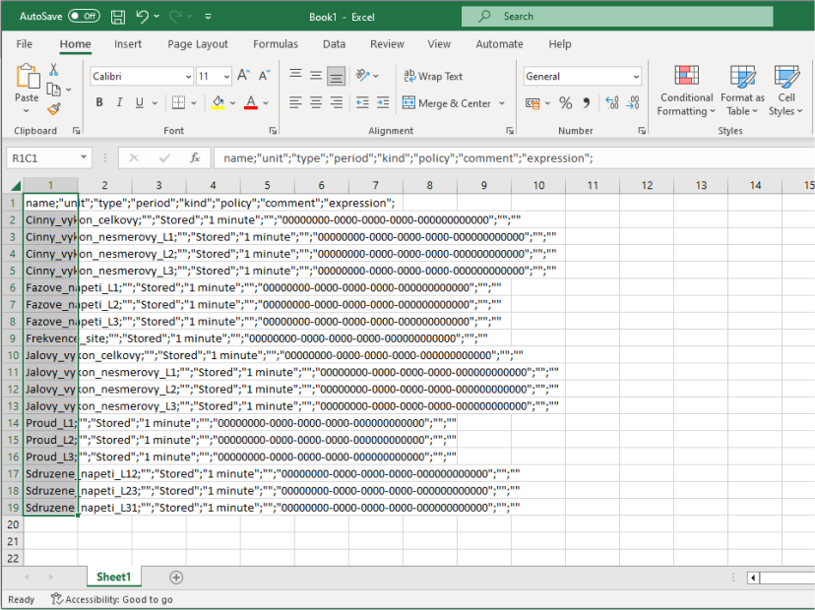

Figure 282: Data copied to MS Excel

## Use as default Explorer settings

You can set the current column settings as default. The saved column settings will be displayed each time you open a new explorer or when you open the “Profile Manager” application.

To set the current column settings as default, proceed as follows:

1. Click the "Use as default Explorer settings" button, located in the upper right corner of the Explorer window.



Figure 283: "Use as default Explorer settings" button

1. A confirmation window will appear, in which click the "Yes" button.

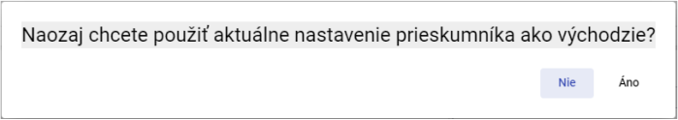

Figure 284: Confirmation window for saving default Explorer settings

## How to filter in columns using the * wildcard

In the Explorer window, you can filter in columns using wildcards, using *.

Examples:

* Text* - finds everything that starts with the specified text.
* *Text - finds everything that ends with the specified text.
* *Text* - finds everything that contains the specified text.

Example: Cinny* - finds everything that starts with "Cinny"

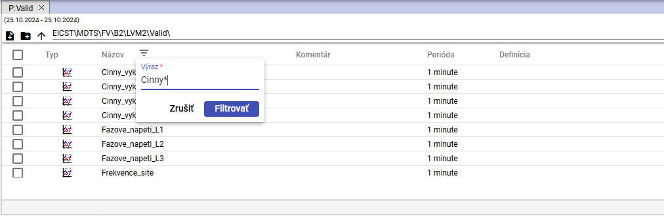

Image 285: Filter assignment for searching profile names starting with "Cinny"

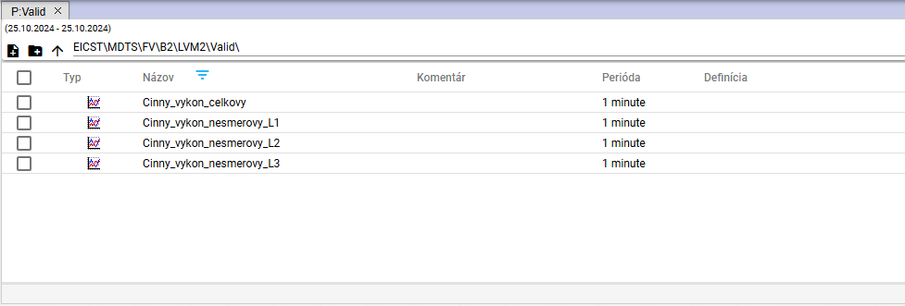

Image 286: Searching for profiles starting with "Cinny"

Example: *L2 - finds everything that ends with the text "L2"

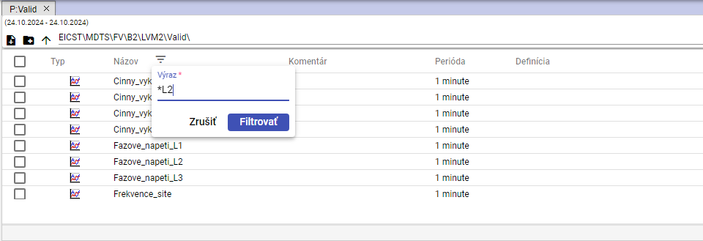

Image 287: Filter assignment for searching profile names ending with "L2"

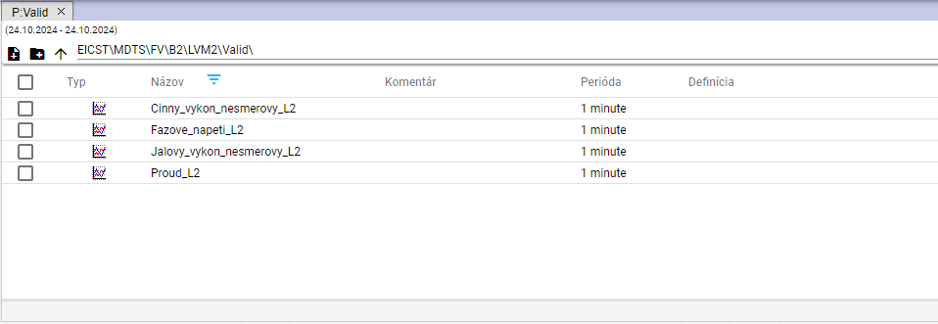

Image 288: Searching for profiles ending with "L2"

Example: *napeti* - finds everything that contains the text "napeti"

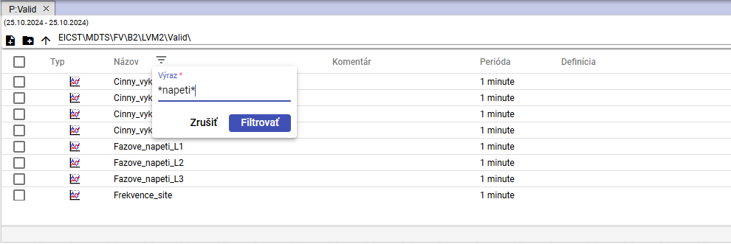

Image 289: Filter assignment for searching profile names containing the text "napeti"

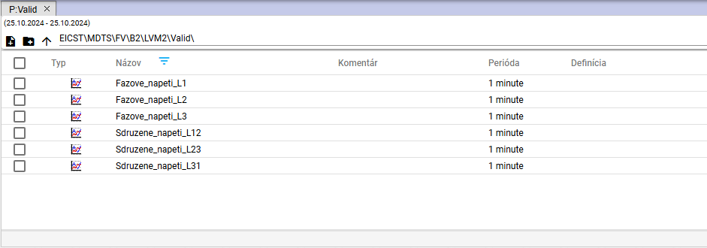

Image 290: Searching for profile names containing the text "napeti"

# Working with the graph

After launching the "Profile Manager" application, the working window with an empty graph area opens. While working with the application, you can add any number of windows for the graph. You can display an optional number of profiles in one graph.

## How to display a profile in the graph

To display a profile in the graph window, proceed as follows:

1. By default, the graph window is empty.

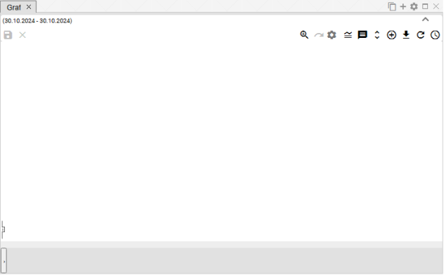

Figure 291: By default, the graph window is empty.

1. To display a profile in the graph window, grab a profile or profile directory with the left mouse button in the profile tree and drag it into the graph window. Release the profile or profile directory in the graph window.

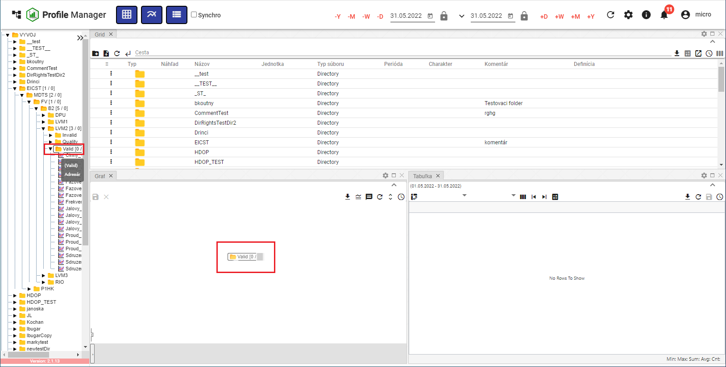

Figure 292: Moving a directory onto the graph window

1. A graph will be plotted in the graph window from the data.

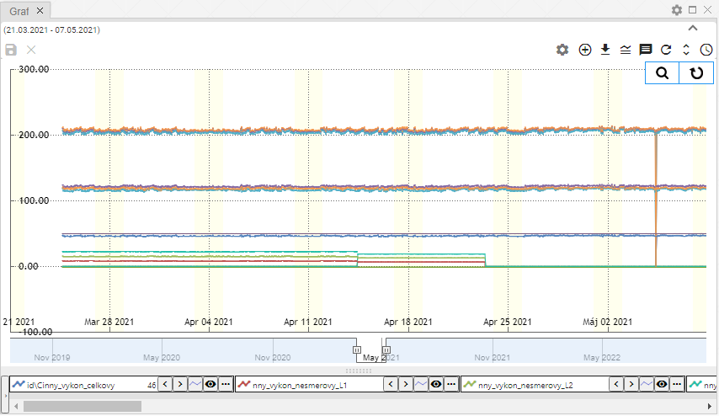

Figure 293: Graphical Display of Profiles

## How to display an information window with values for a specific location in the graph.

To display the values for a specific location in the graph, position the mouse cursor at the selected location.

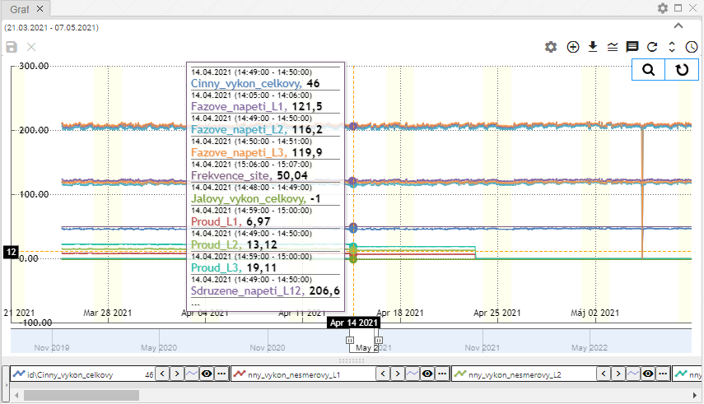

Figure 294: Displaying Profile Values at a Specific Location in the Graph

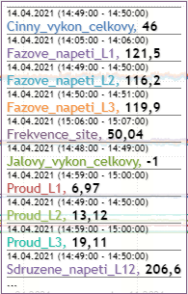

Figure 295: Profile Values at a Selected Location in the Graph

If the data is incomplete within a given range (decimation), a yellow exclamation mark will be displayed (Figure 296).

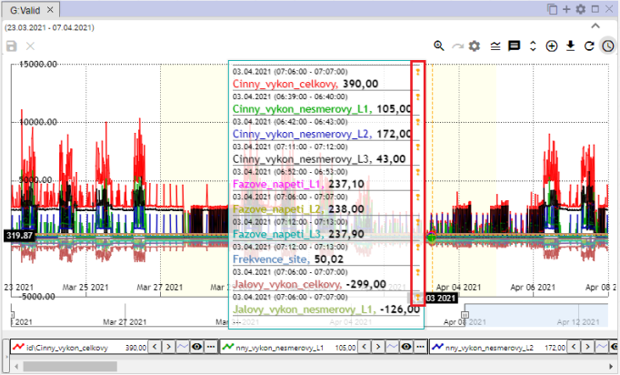

Figure 296: Yellow Exclamation Mark

## How to change the date range in the graph

You can change the date range for which the graph is displayed using the “Change Date Range” button located in the upper right corner of the graph window. The procedure is detailed in chapter 3.2.



Figure 297: “Change Date Range” Button

## How to save the graph in JPG format

You can save the graph as an image in JPG format. Proceed as follows:

1. Click the "Export Graph to JPG" button, located in the upper right corner of the graph window.



Figure 298: "Export Graph to JPG" button

1. The graph image will be created and saved among the downloaded files on your computer.

## How to copy the entire graph into a new window

You can copy the entire graph into a new window:

1. Press the "Copy the entire graph to a new window" button.
2. The graph will be copied and displayed in a new tab in the graph window.

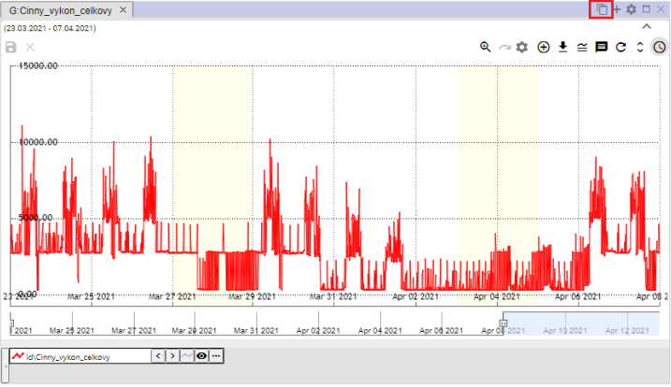

Figure 299: "Copy the entire graph to a new window" button

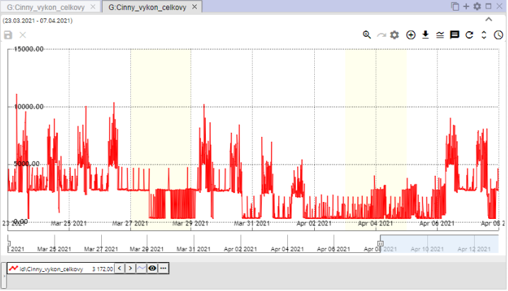

Figure 300: Copied graph in a new tab

## How to set graph parameters

You can set graph parameters, such as the font size for the graph title:

1. Click the "Graph Settings" button, located in the upper right corner of the "Graph" window.



Figure 301: "Graph Settings" button

1. A "Graph Legend" window will appear, where you can set the parameters.

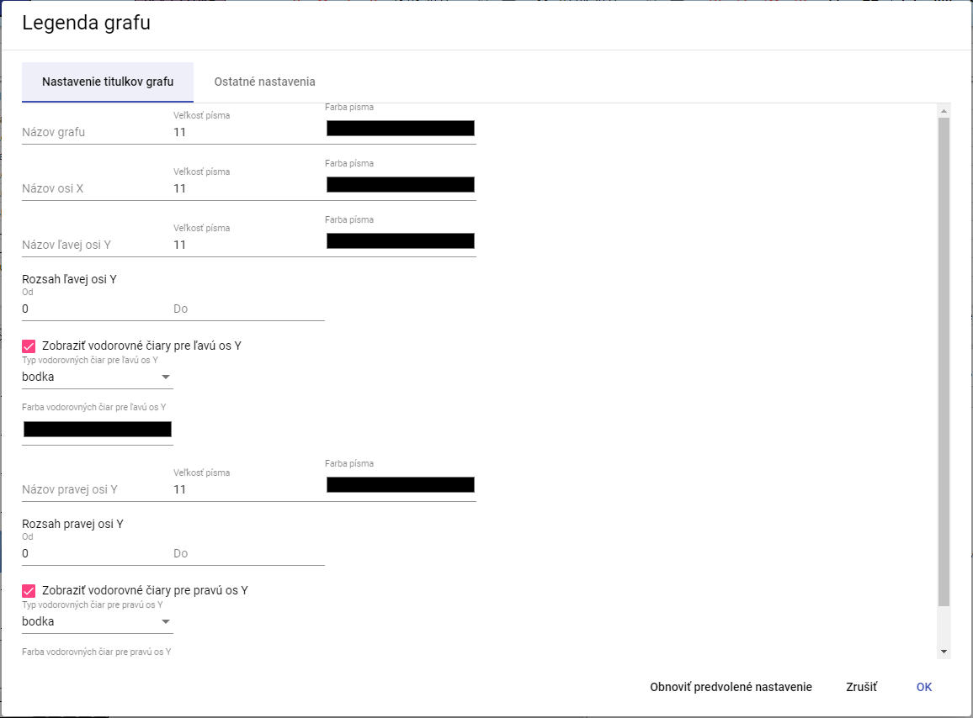

Figure 302: "Graph Legend" window

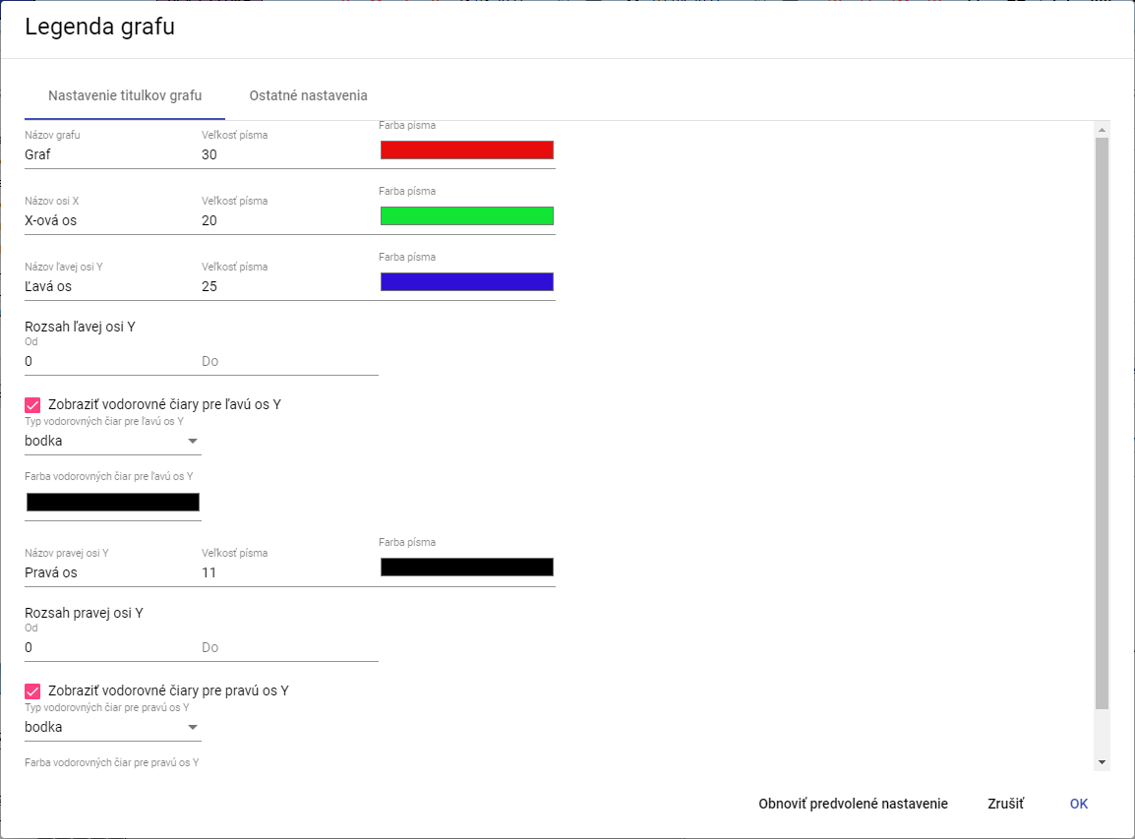

Figure 303: Changes in the "Graph Legend" window

1. Save the changes by pressing the "OK" button.

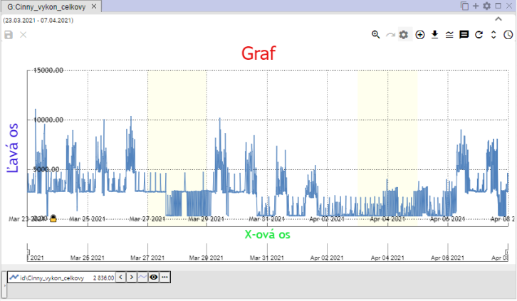

Figure 304: Changes in the Graph window

### How to set the number of decimal places for each Y-axis

Proceed:

1. In the “Graph Legend” window, enter the number of decimal places for the left and right Y-axis.

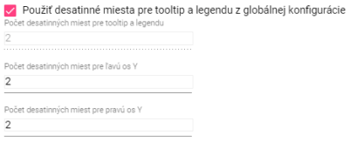

Figure 305: Settings for the Y-axis

1. To enter a value for the “Number of decimal places for tooltip and legend” field, uncheck the “Use decimal places for tooltip and legend from global configuration” box.

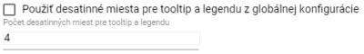

Figure 306: Entering a new value for the “Number of decimal places for tooltip and legend” field.

1. Save the changes by pressing the “OK” button.

### How to disable horizontal lines

To disable horizontal lines in the chart, proceed as follows:

1. Press the “Chart Settings” button, Figure 301.
2. In the “Chart Legend” window, uncheck the boxes “Show horizontal lines for the left Y axis” and “Show horizontal lines for the right Y axis”.

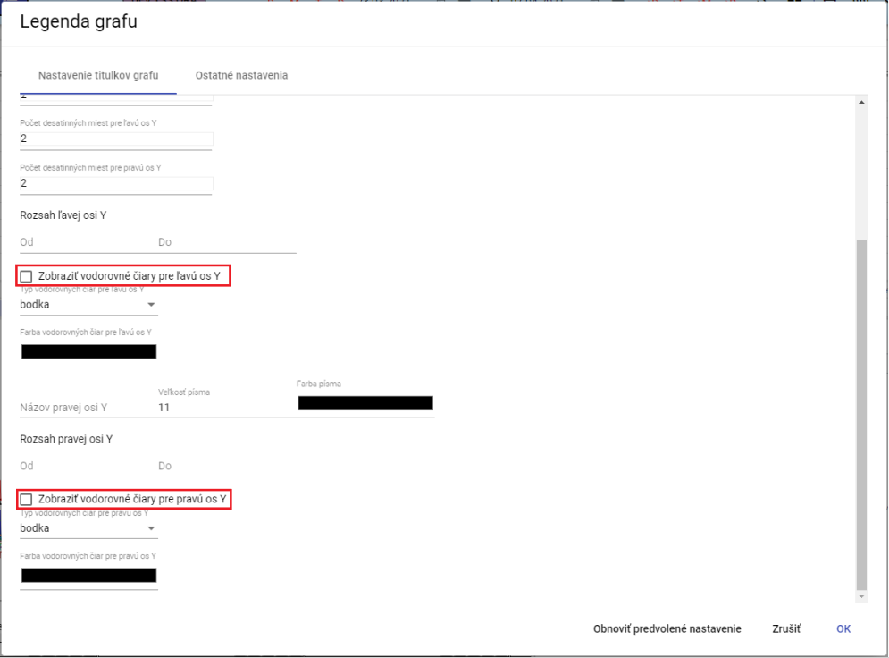

Figure 307: Disabling horizontal lines in the chart

1. Save the changes by pressing the “OK” button.

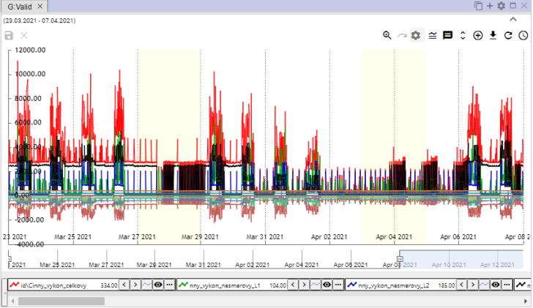

Figure 308: Horizontal lines disabled in the chart

## Functions for working with selected profiles

To display functions across multiple profiles, proceed as follows:

1. Press the Ctrl key and select the desired profiles by clicking the left mouse button on the names of the selected profiles. After selection, the profile name will be highlighted in blue.
2. Press the button located in the lower-left corner of the chart window.

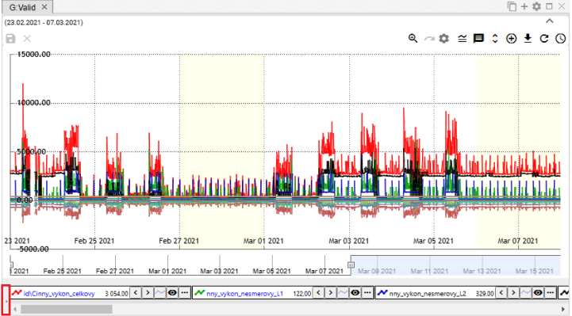

Figure 309: Button to display functions for selected profiles

1. A list of functions for the selected profiles will be displayed. The functions are detailed in the following chapters.

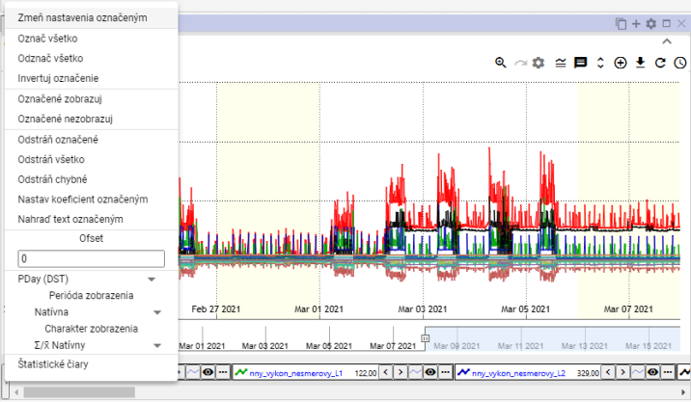

Figure 310: List of functions for selected profiles

### How to select profiles

To select a profile, press the Ctrl key and click on the profile name. You can select multiple profiles at the same time. The font color of the selected profile will change from black to blue.

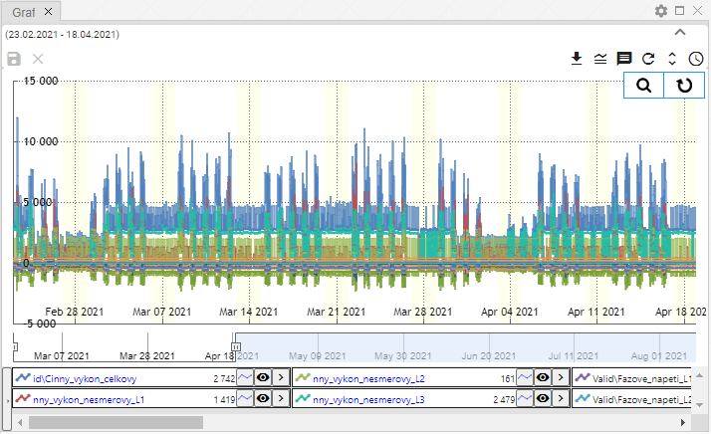

Figure 311: Selecting Multiple Profiles

### How to display profile properties

You display profile properties:

1. Click the button located before the profile name at the bottom of the Graph window.

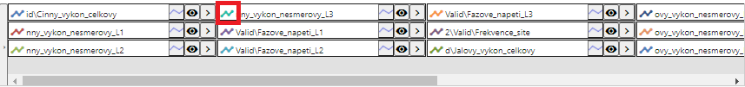

Figure 312: Button to display profile properties

1. The "Line Profile Property" window will appear.
2. Edit the data.
3. Save the changes by pressing the "OK" button.

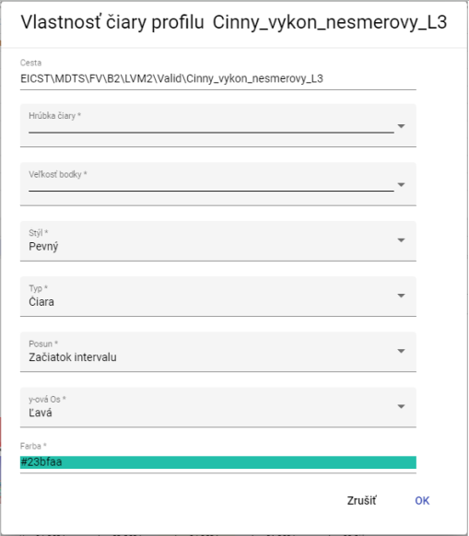

Figure 313: "Line Profile Property" window

### How to change the settings of the selected item.

You change the settings for multiple selected profiles:

1. Select the profiles for which you want to change the settings.
2. Right-click on the name of one of the profiles.
3. In the displayed window, select "Change settings for selected".

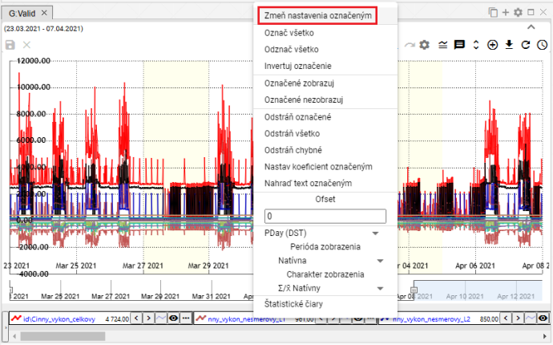

Figure 314: "Change settings for selected" item

1. A window will appear in which you change the settings for the selected profiles.

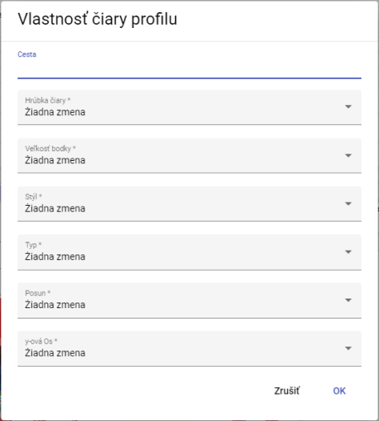

Figure 315: Window for settings of selected profiles

1. You save the changes by pressing the “OK” button.

### How to select all profiles

To select all profiles, right-click on the profile name and select “Select All”, Figure 316. All profiles will be highlighted, Figure 317.

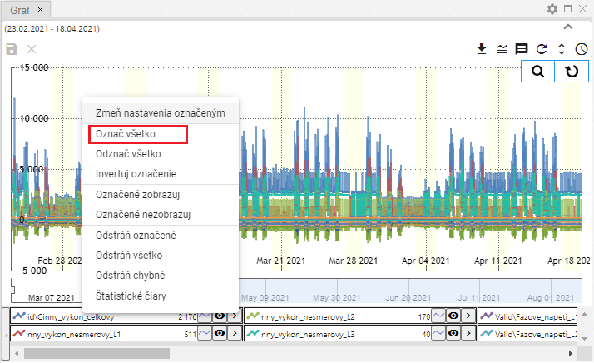

Figure 316: “Select All” item

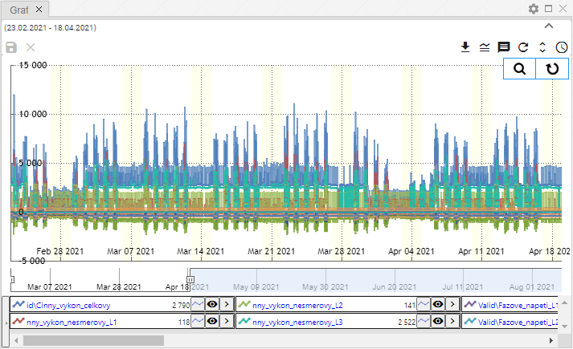

Figure 317: Highlighted profiles

### How to deselect all profiles

The “Deselect All” item is used to clear the selection of all selected profiles.

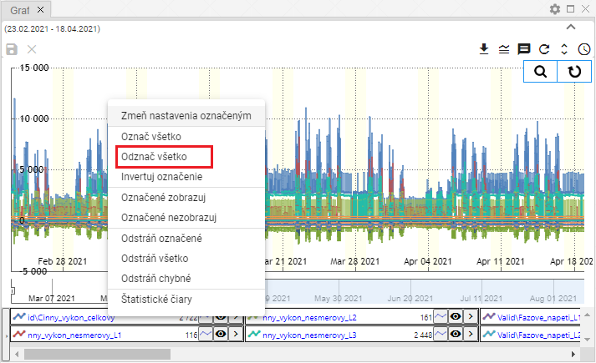

Figure 318: “Deselect All” item

### How to invert selected profiles

The “Invert Selection” item will toggle the selection of profiles. Selected profiles will be deselected and unselected profiles will be selected, Figure 320.

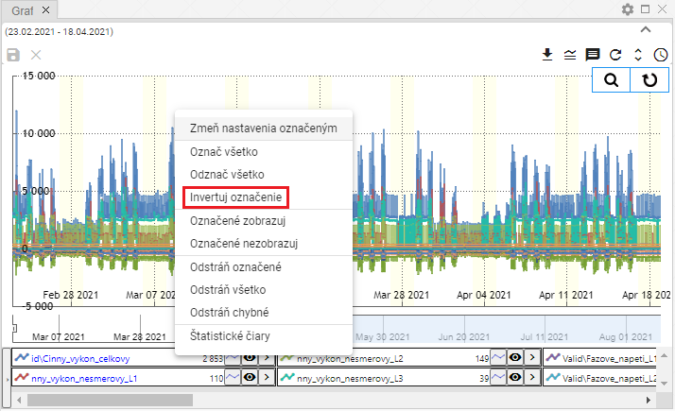

Figure 319: “Invert Selection” item

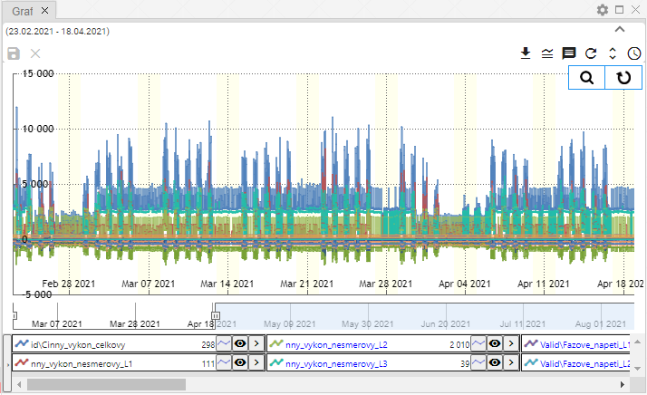

Figure 320: Inverted profile selection

### How to display only selected profiles

The "Show Marked" item is used to display marked profiles.

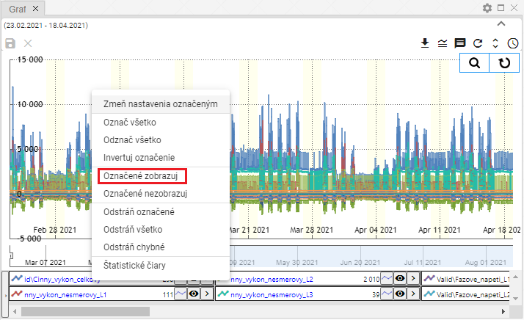

Figure 321: "Show Marked" item

### How to not display marked profiles

To not display marked profiles in the graph, proceed as follows:

1. Mark the profiles you do not want to display.
2. Right-click on the profile name.
3. Select "Do not display marked".

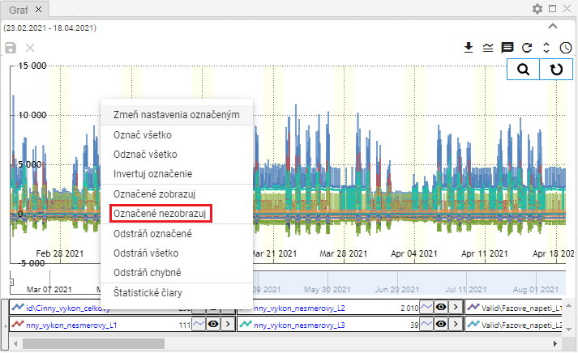

Image 322: "Do not display marked" item

1. Selected profiles will be hidden.

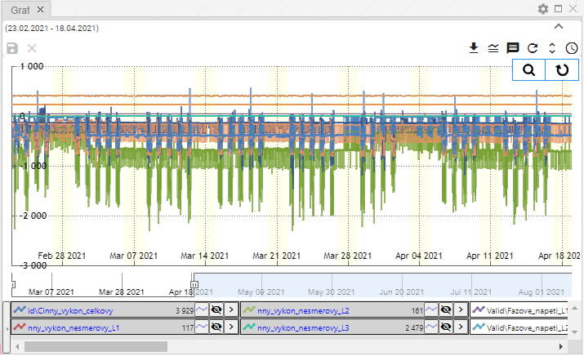

Image 323: Hidden profiles

### How to remove marked, all, or faulty profiles

You can use three functions to remove profiles:

* Remove marked - used to remove marked profiles,
* Remove all - all profiles will be removed,
* Remove faulty - only faulty profiles will be removed.

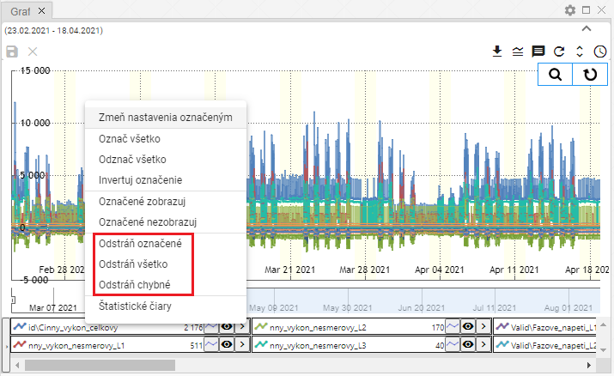

Image 324: "Remove marked", "Remove all", and "Remove faulty" items

To remove profiles, proceed:

1. To remove marked profiles, select the profiles you want to remove.
2. Right-click on the profile name.
3. Select "Remove Marked", "Remove All", or "Remove Faulty".
4. The profiles will be removed.

### How to set the coefficient for marked profiles

To set the coefficient, proceed:

1. Click on the profile name to select the profiles you want to set the coefficient for.
   1. To mark multiple profiles, click on the profile name, hold the Ctrl key, and click the left mouse button to mark the profile names you want to select.
   2. To select multiple profiles at once, click the left mouse button on the name of the first profile, hold the Shift key, and click the left mouse button on the last profile. All profiles in between will be selected.
2. Marked profile names will turn blue.
3. Right-click on the name of one of the marked profiles.
4. A window will appear where you select “Set coefficient for marked profiles”.

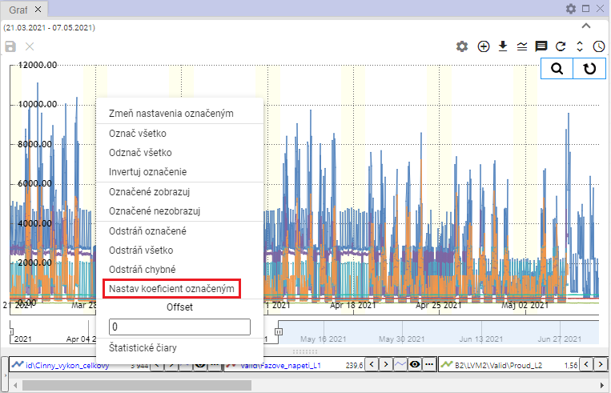

Figure 325: "Set coefficient for marked profiles" item

1. A window will appear with "Set coefficient".
2. Set the coefficient and save by clicking “OK”.

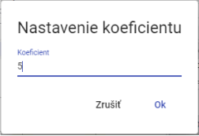

Figure 326: "Set Coefficient" window

1. The coefficient will be set for the selected profiles. An information about the set coefficient will be displayed next to the profile names.

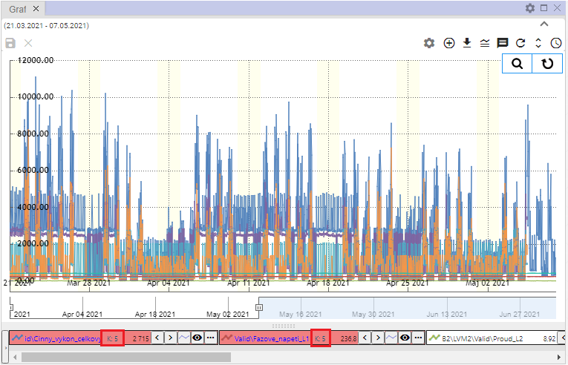

Figure 327: Set Coefficient

### How to set offset

To set the offset, proceed as follows:

1. Click on the profile names to select the profiles you want to set the offset for.
2. Right-click on the name of one of the selected profiles.
3. A window will appear where you can enter the offset and press Enter.

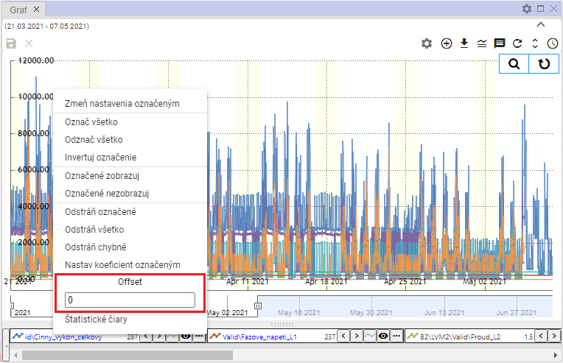

Figure 328: "Offset" field

1. When profiles are selected, information about the set offset will be displayed.

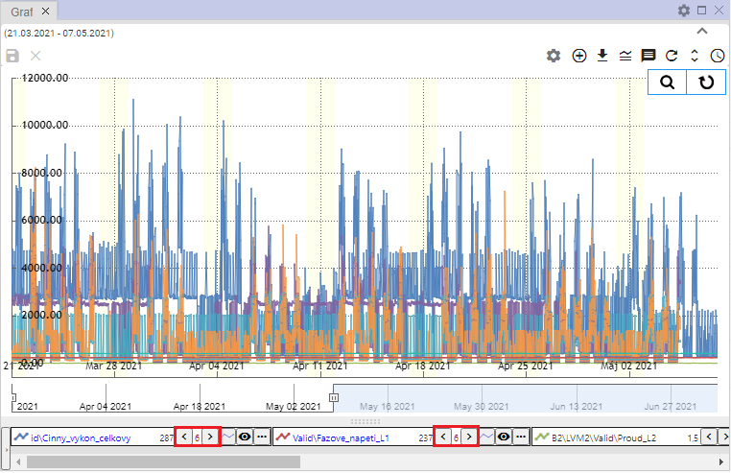

Figure 329: Set offset

### How to display statistical lines

To display statistical lines, proceed as follows:

1. To display statistical lines only for selected profiles, hold down the Ctrl key and click on the profile names to which the statistical lines should be displayed.
2. Right-click on the profile name.
3. Select "Statistical Lines".

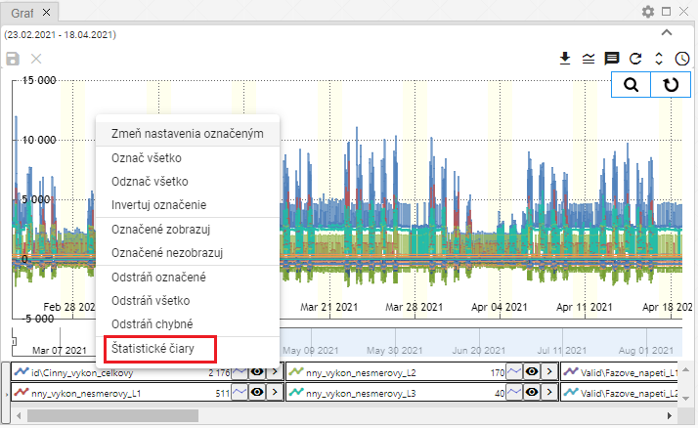

Figure 330: "Statistical Lines" item

1. The "Statistical Lines" window will appear.

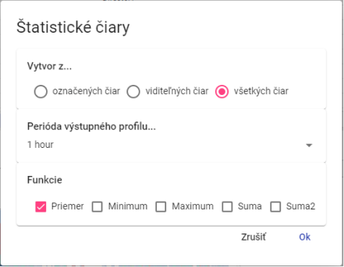

Figure 331: "Statistical Lines" window

1. Select whether the statistical lines should be created from the selected lines, visible lines, or all lines.
2. Select a function. You can select multiple functions at once.
3. Press the "OK" button.

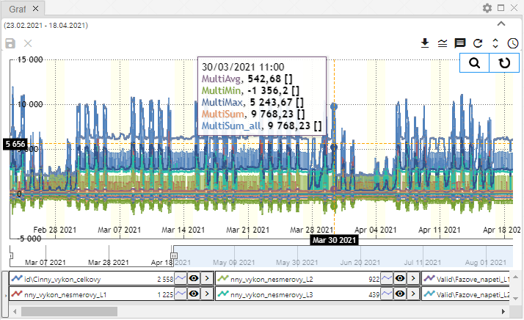

Figure 332: Statistical Lines

### How to replace selected text

This function is used for bulk renaming of profiles. Proceed as follows:

1. Select the profiles whose text in the profile path you want to change.
2. Right-click on the profile name.
3. A menu will appear, in which select the “Replace Text with Marked” item.

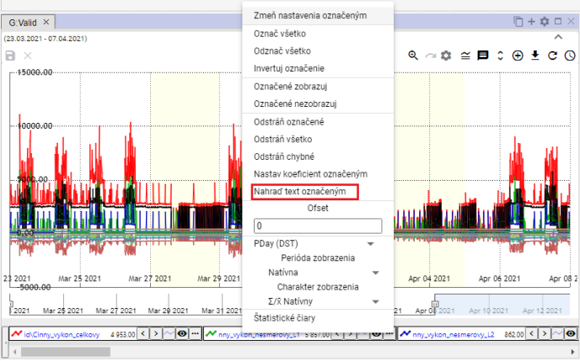

Figure 333: "Replace Text with Marked" item

1. A window “Replace Text in Profile Path” will appear.
2. In the “Find” field, enter the text you want to replace.
3. In the “Replace” field, enter the text to replace the text in the “Find” field.

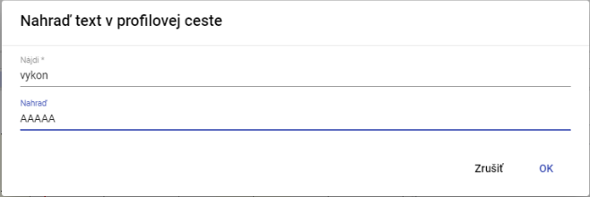

Figure 334: “Replace Text in Profile Path” window

1. Confirm by clicking the “OK” button.
2. The entered text will be replaced with new text.

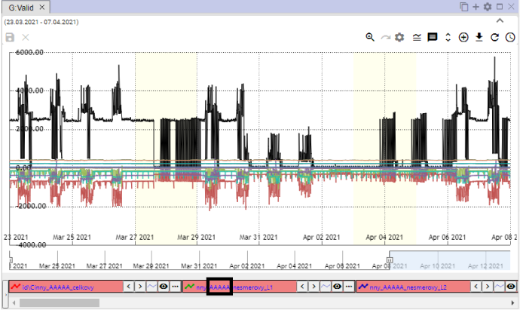

Figure 335: Replaced Text

## Features for working with a single profile

Each profile has a button next to its name, which is used to display functions. These functions are used to work with the selected profile.

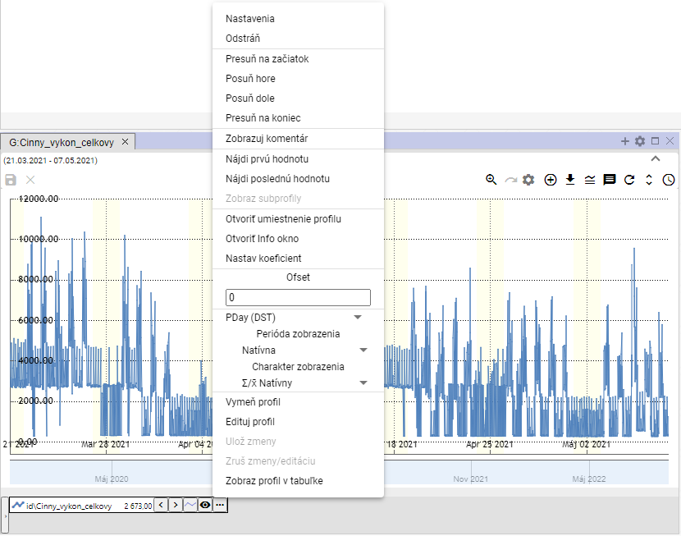

Figure 336: Functions for working with a profile

### How to edit settings

You can change the display of profile data in the graph in the settings window. For example, you can change the color used to display the profile, the line style..

To change the settings, proceed as follows:

1. Click the button next to the name of the profile whose settings you want to change.
2. A window will appear where you select the “Settings” item.

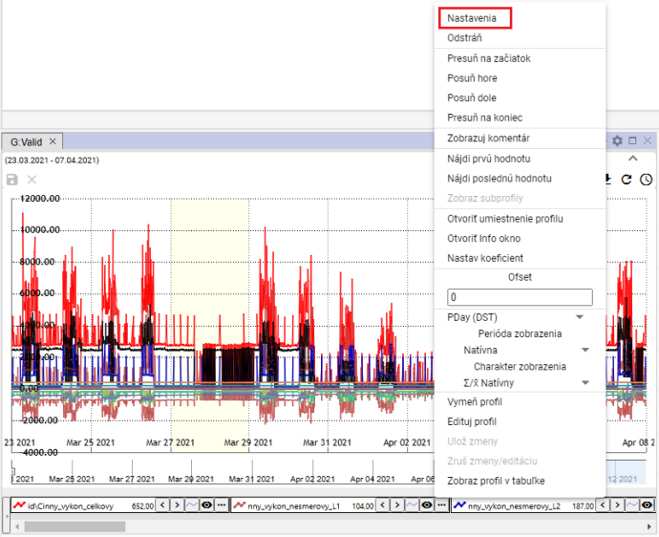

Figure 337: “Settings” item

1. In the window that appears, change the profile settings.
2. Save the changes by pressing the “OK” button.

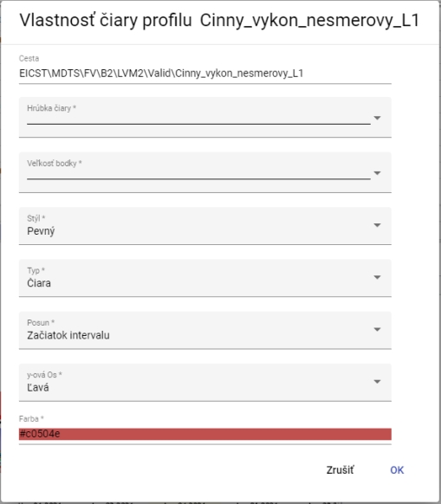

Figure 338: Profile Settings

### How to delete a profile

Delete profile:

1. Click the button next to the name of the profile you want to delete.
2. The profile will be removed from the list of profiles at the bottom of the Graph window and from the profile display.

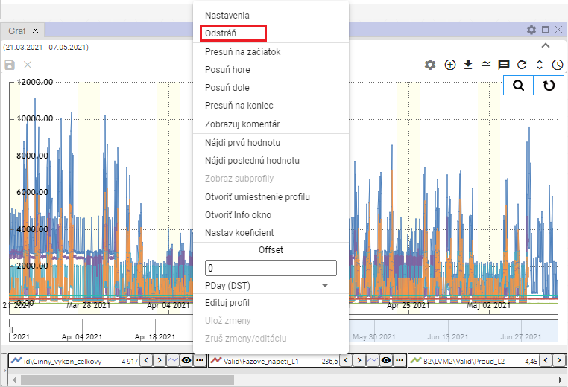

Figure 339: "Delete" item

### How to move a profile to the top

To move a profile to the top of the profile list, proceed as follows:

1. Click the button next to the name of the profile you want to move to the top.
2. Select "Move to Top".
3. The selected profile will be moved to the top of the list.

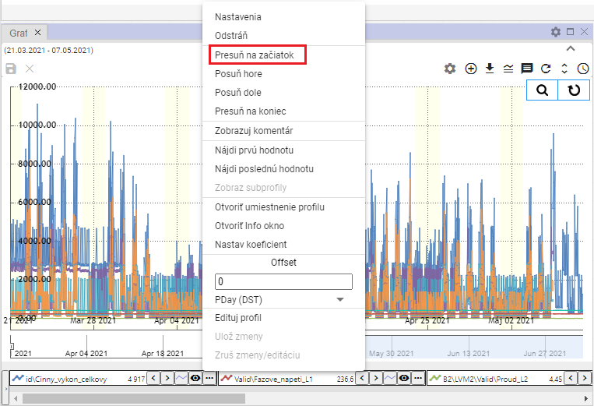

Figure 340: "Move to Top" item

### How to move a profile up

The "Move Up" item is used to move the profile name one position higher in the profile list at the bottom of the "Graph" window, for example from the third position to the second position.

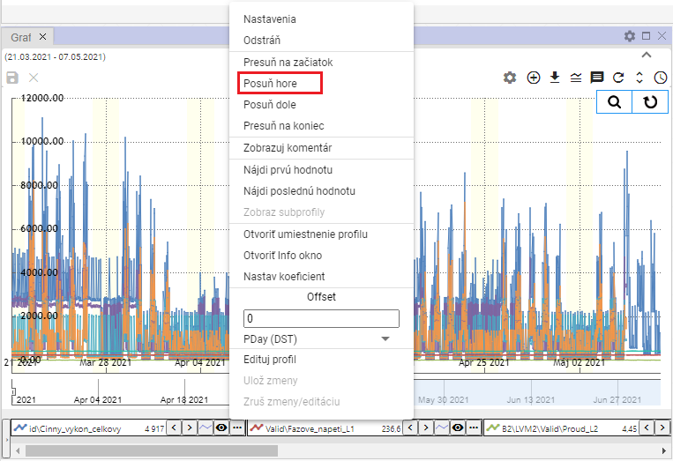

Figure 341: "Move Up" item

### How to move a profile down

The "Move Down" item is used to move the profile name one position lower in the profile list at the bottom of the "Graph" window, for example from the second position to the third position.

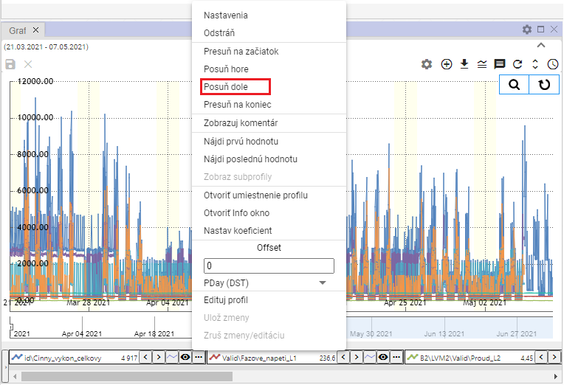

Figure 342: "Move Down" item

### How to move a profile to the end

The "Move to End" item is used to move the profile to the end of the profile list at the bottom of the "Graph" window.

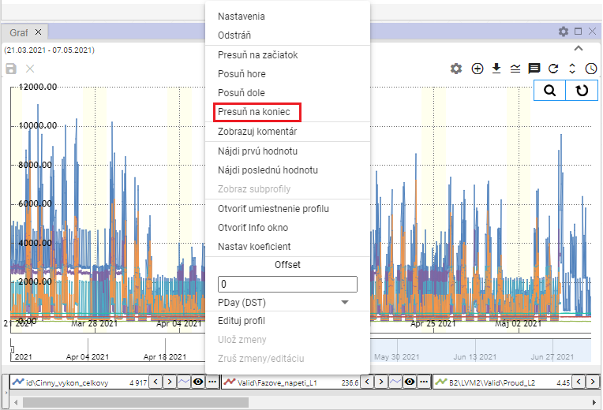

Figure 343: "Move to End" item

### How to display a comment

The "Show Comment" item determines the display of the profile name. After selecting "Show Comment", the comment is displayed instead of the profile name, Figure 345. To display the profile name, click the "Show Comment" item again.

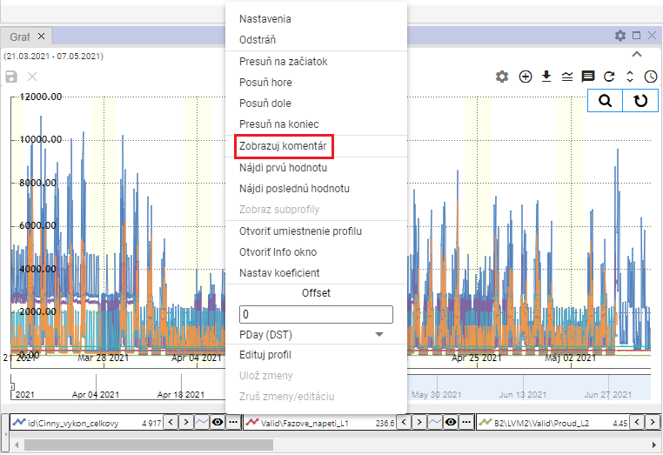

Figure 344: "Show Comment" item

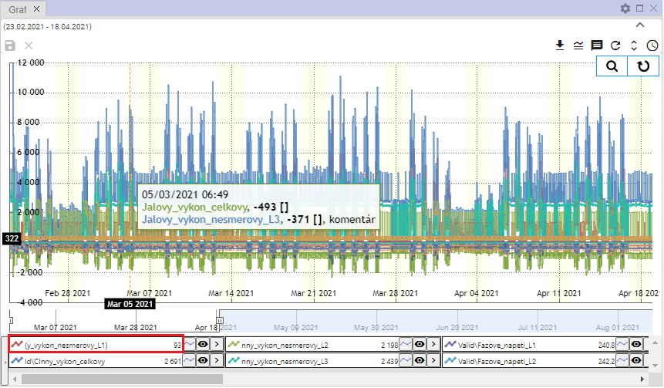

Figure 345: Profile comment displayed

### How to find the first value

The "Find First Value" item is used to find the first profile value in the graph.

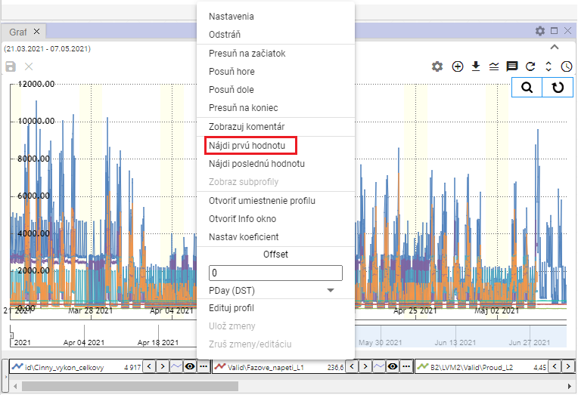

Figure 346: "Find First Value" item

### How to find the last value

The "Find Last Value" item is used to find the last profile value in the graph.

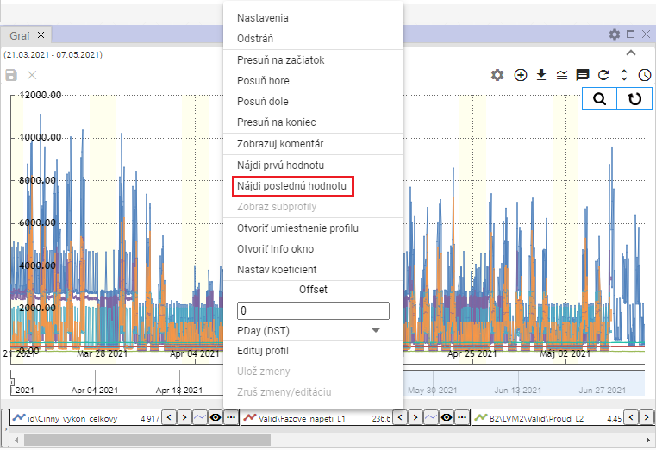

Figure 347: "Find Last Value" item

### How to display subprofiles

Calculated profiles may use other profiles in their definition, so-called subprofiles. To display them, proceed as follows:

1. Click the button next to the profile name whose settings you want to change.
2. A window will appear where you select the "Display subprofiles" item.
3. All profiles used in the definition of the calculated profile will be displayed.

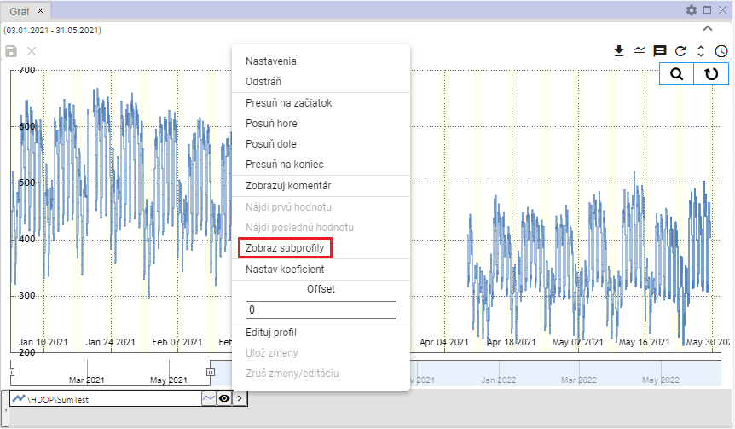

Figure 348: "Display subprofiles" item

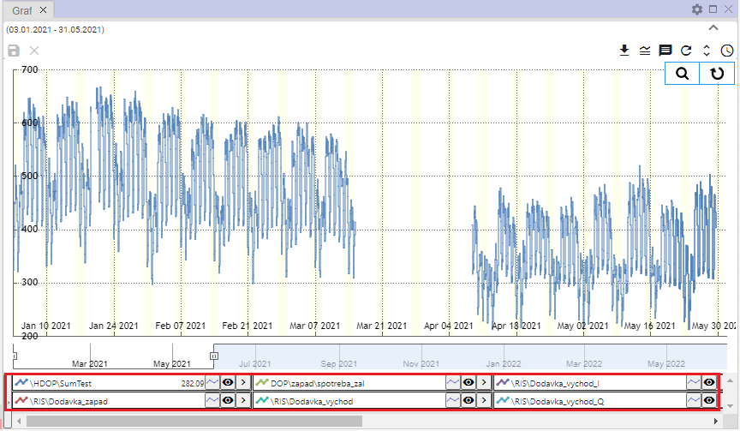

Figure 349: Displayed subprofiles

### How to open the profile location

You can display the profile location in the tree structure:

1. Click the button next to the name of the profile you want to open in the tree.
2. A window will appear where you select “Open Profile Location”.

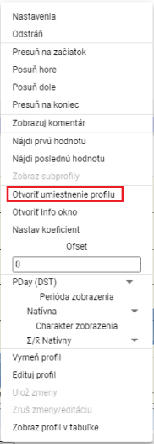

Figure 350: “Open Profile Location” item

1. A folder containing the profile will open in the tree structure.

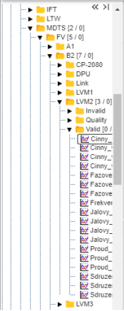

Figure 351: Profile Location in the Tree Structure

### How to open the info window

You can open an info window for each profile, for example displaying the profile name, profile path, and profile type.

You open the info window:

1. Click the button with the three-dot icon, located next to each profile.



Figure 352: Button to display functions

1. Select "Open Info Window".

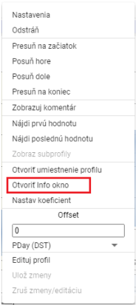

Figure 353: "Open Info Window" item

1. The directory containing the profile will open in the tree structure, Figure 351.
2. Subsequently, the profile information window will be displayed, which contains three tabs: "Info", "ReadLog", and "WriteLog", Figure 354.
3. In the "Info" tab, you can copy the profile name and profile path by pressing the button.

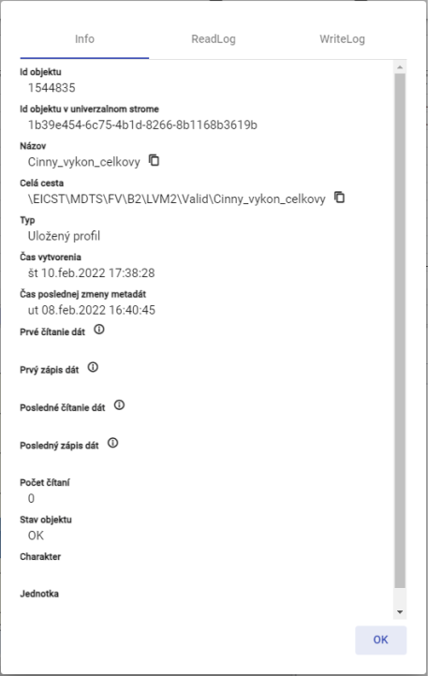

Figure 354: "Info" tab

### How to set the coefficient

To set the coefficient, proceed as follows:

1. Click the button next to the profile name you want to set the coefficient for.
2. Select "Set Coefficient".

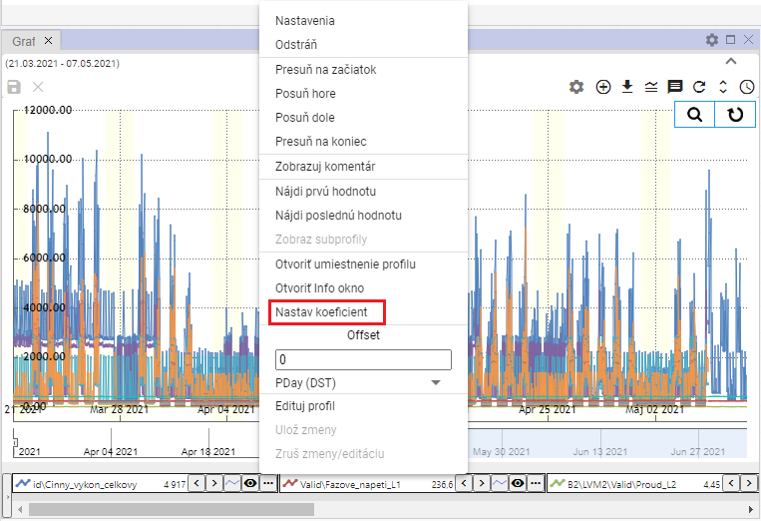

Figure 355: "Set Coefficient" item

1. A window will appear where you enter the coefficient.

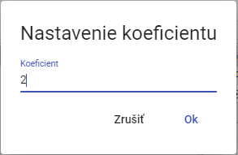

Figure 356: Setting Coefficient

1. Save by pressing the "OK" button.
2. Information about the set coefficient will be displayed next to the profile name.



Figure 357: Set Coefficient

### How to enter the offset

To enter the offset, proceed as follows:

1. You can enter the offset by clicking the arrows next to the profile name or click the button and enter the value in the “Offset” section and press the “Enter” key.



Figure 358: Buttons for offset adjustment

1. The same value that you entered for the offset using the arrows next to the profile name will also be displayed after clicking the button in the “Offset” section.

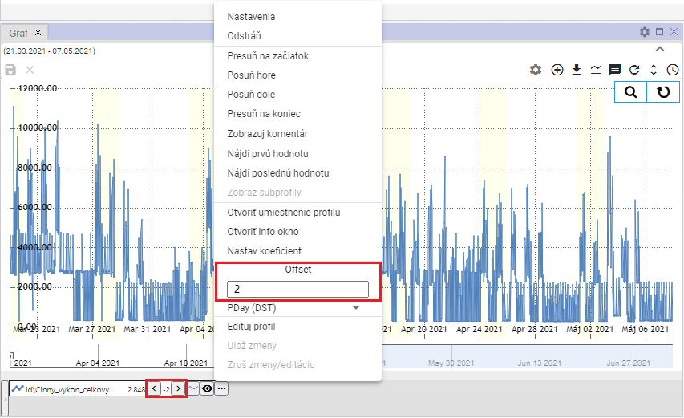

Figure 359: Offset set

1. Below the Offset field is a field for selecting the period for the offset, Figure 360. After clicking the field, a list of time periods for the offset will be displayed, Figure 361.

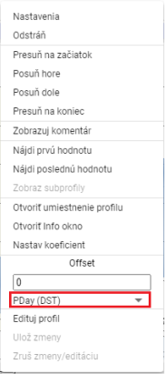

Figure 360: Field for selecting the period for the offset

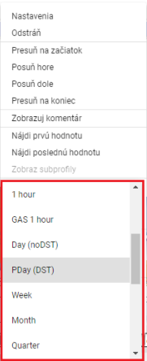

Figure 361: Selecting the time period for the offset

### How to change the profile

To change the profile to a different profile, proceed as follows:

1. Click the button next to the name of the profile you want to replace.
2. Select "Replace Profile".

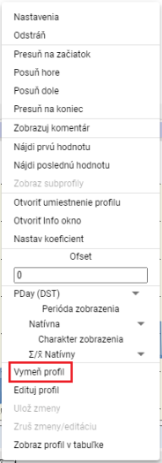

Figure 362: "Replace Profile" item

1. A "Replace Profile" window will appear.

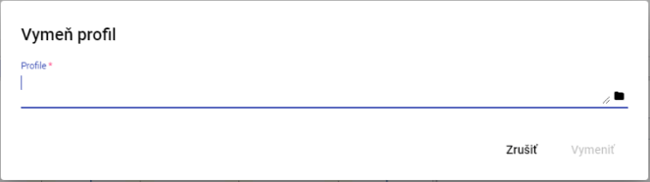

Figure 363: "Replace Profile" window

1. Enter the path to the profile or click the button.
2. To confirm, click the "Replace" button.

### How to edit a profile

To edit a profile, proceed as follows:

1. Click the button next to the name of the profile you want to edit.
2. Select "Edit Profile".

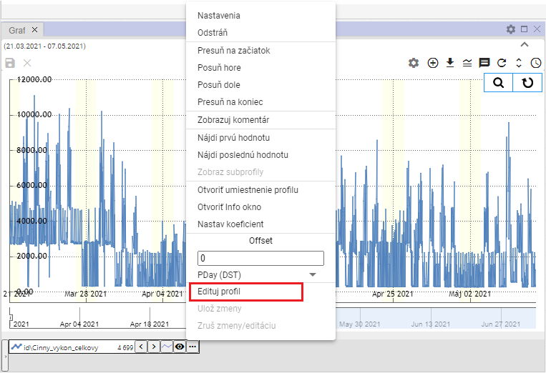

Figure 364: "Edit Profile" item

1. A copy of the profile will be created. The fields with the names of the original and copied profiles will be highlighted in green.

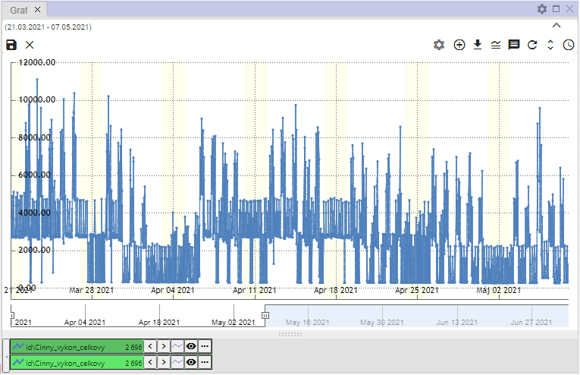

Figure 365: A copy of the profile will be created.

1. Edit the profile.
2. You save changes by clicking the button and selecting "Save Changes" or by pressing the button with the floppy disk icon located in the upper left corner of the chart.

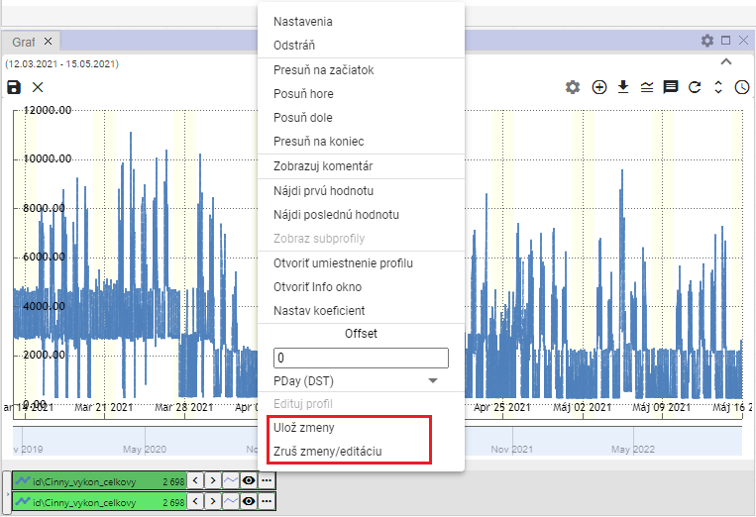

Figure 366: The "Save Changes" and "Discard Changes/Edit" items.

1. To discard changes, select the "Discard Changes/Edit" item or press the "x" button in the upper left corner of the chart.

### How to set the color for a profile

To set the color for a profile, proceed as follows:

1. Press the button next to the profile you want to set the color for.
2. Select "Settings" to display the "Profile Line Property" window.



Figure 367: "Settings" item

1. In the "Profile Line Property" window, click in the "Color" field.
2. A color selection window will appear. A color palette is located at the bottom for quick color selection.

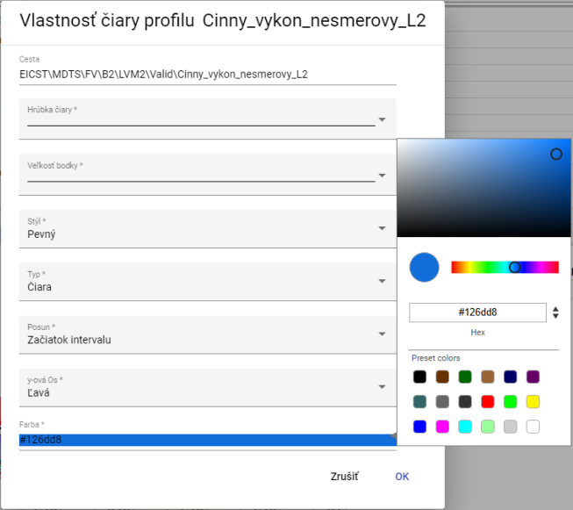

Figure 368: Color Selection

1. Click on the selected color.
2. Save changes by clicking the "OK" button.

### How to set the point size

To set the point size, follow these steps:

1. Click the button next to the profile name you want to set the point size for.
2. Select "Settings" to display the "Profile Line Property" window.



Figure 369: "Settings" item

1. Click in the "Point Size" field.

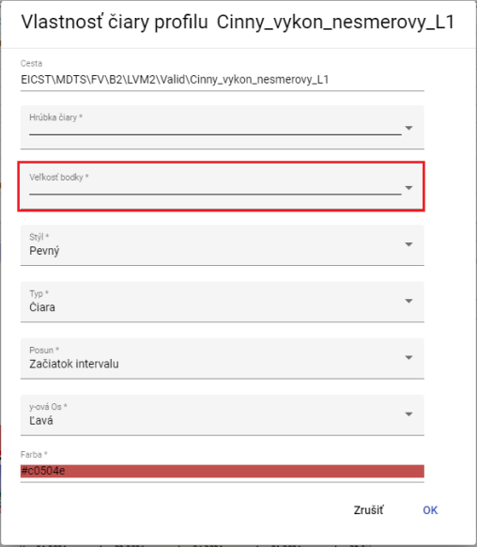

Figure 370: "Point Size" field

1. A window will appear where you can click to select the display size for the point.

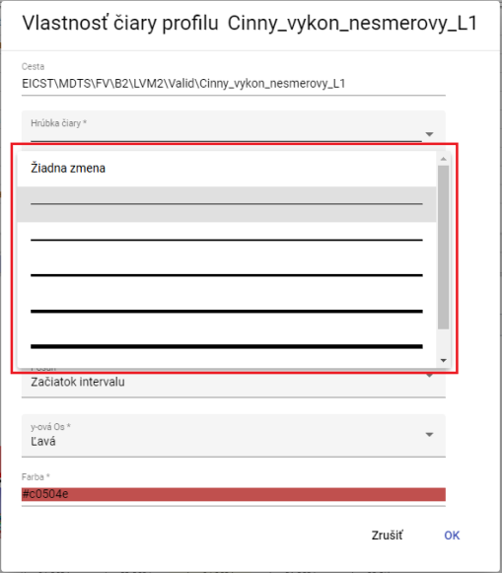

Figure 371: Selecting the Point Size

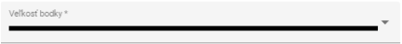

Figure 372: Selected Size

1. You save the changes by pressing the "OK" button.

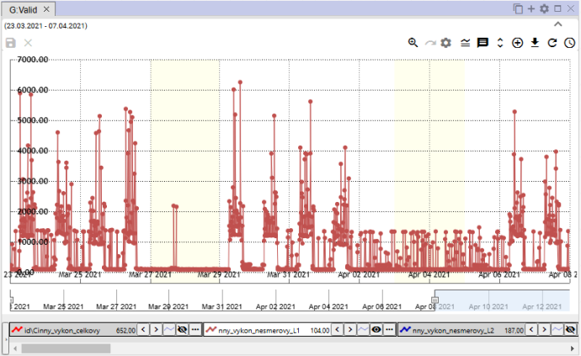

Figure 373: Set Point Size

### How to display the profile in the table

To display the profile in the Graph window in the table, follow these steps:

1. Click the button next to the name of the profile you want to display in the table.
2. Select the "Display profile in table" item.

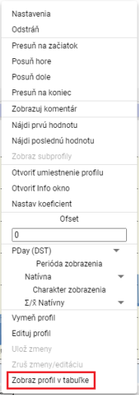

Figure 374: "Display profile in table" item

1. A new Table tab will be added to the Chart window.

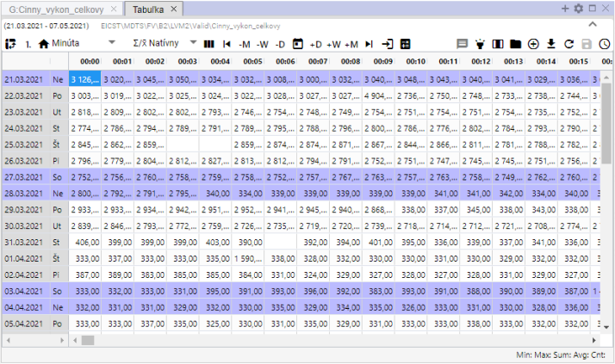

Figure 375: Display profile in table

## Quick chart type change

A quick chart type change button is located below the name of each profile in the Chart window. The button with a chart icon allows switching between StepLine, StepArea and StackedColumn chart types. The chart type can also be switched via the "Type" field in the "Profile Properties" window; the procedure is detailed in Chapter 5.8.1.



Figure 376: Quick chart type change button

By default, the chart type in the Chart window is set to “StepLine” (Figure 377). Pressing the button sets the chart type to “StepArea” (Figure 378) and the appearance of the quick chart type change button changes to . Pressing the button again sets the chart type to “StackedColumn” (Figure 379) and the button appearance changes to .

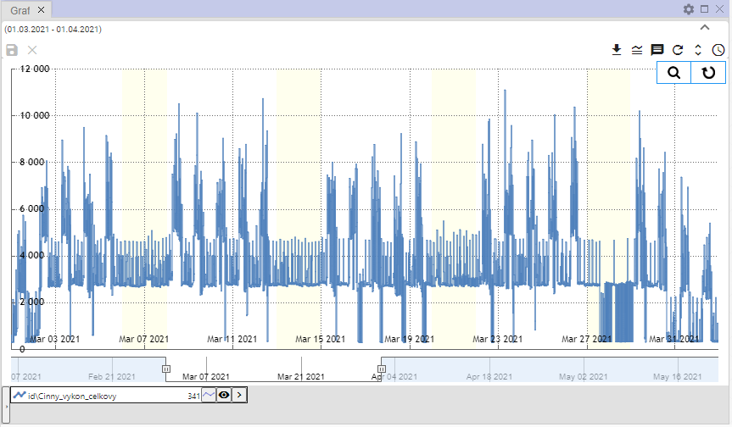

Figure 377: “StepLine” chart type

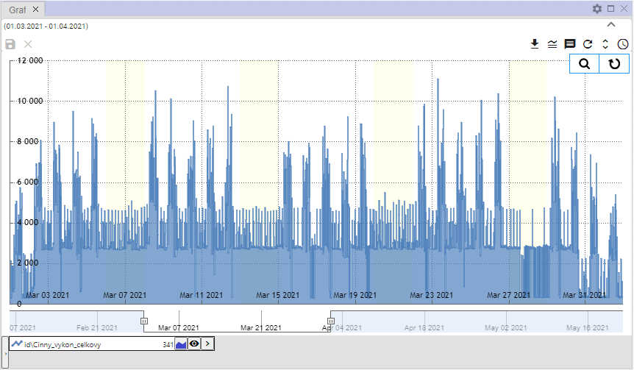

Figure 378: “StepArea” chart type

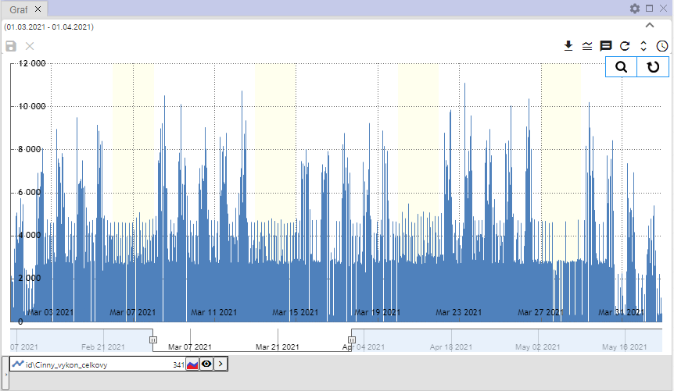

Figure 379: “StackedColumn” chart type

## How to zoom in on a selected part of the chart

How to zoom in on a selected part of the chart:

1. Press the "Switch to Zoom" button, located in the top right corner of the chart.

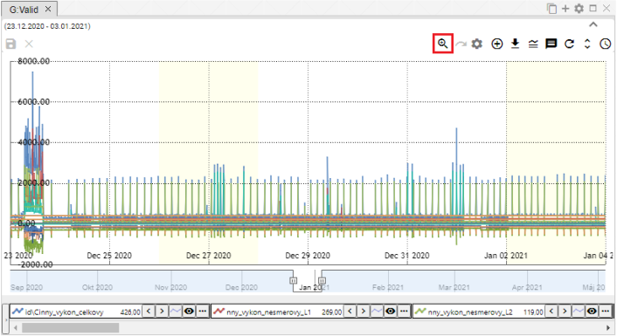

Figure 380: "Switch to Zoom" button

1. Press the left mouse button and select an area in the chart.

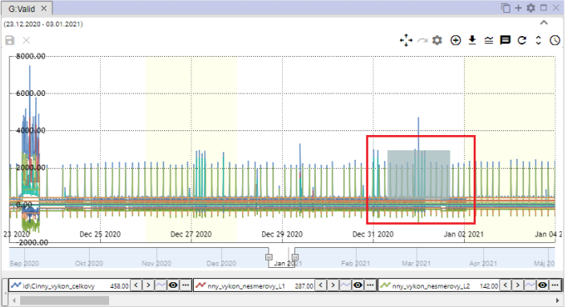

Figure 381: Selected area in the chart

1. Release the left mouse button.
2. The selected area will be zoomed in.

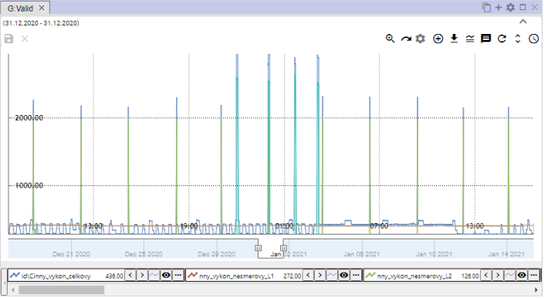

Figure 382: Zoomed area in the chart

1. To restore the y-axis, press the “Reset zoom” button, chapter 5.12.

## How to pan the chart

Clicking the “Toggle Zoom” button, Figure 380, changes the button from a magnifying glass to the “Toggle Pan” button, Figure 383. This allows you to move within the chart. To pan within the chart, grab a location in the chart with the left mouse button and move the chart.

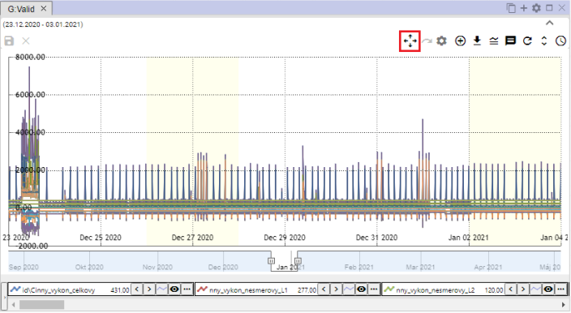

Figure 383: “Toggle Pan” button

## How to cancel zoom

After zooming in on a selected area in the chart using the zoom function, you restore the chart by pressing the “Reset zoom” button.

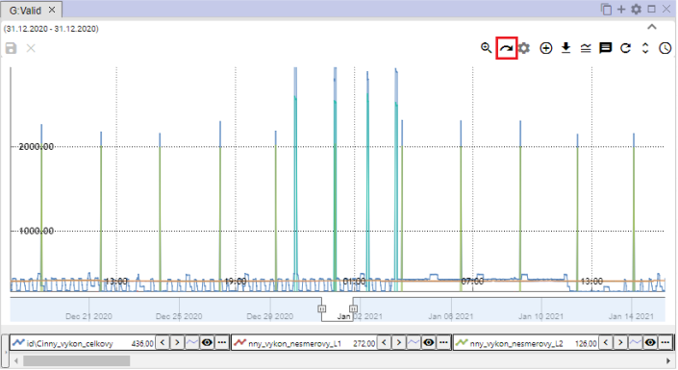

Figure 384: “Reset zoom” button

## How to show/hide the legend

At the bottom of the chart window, there is a list of displayed profiles, known as the legend. To hide the list of profiles, press the “Show/hide legend” button, located in the upper-right corner of the Chart window. To display the legend, press the “Show/hide legend” button again.



Figure 385: “Show/hide legend” button

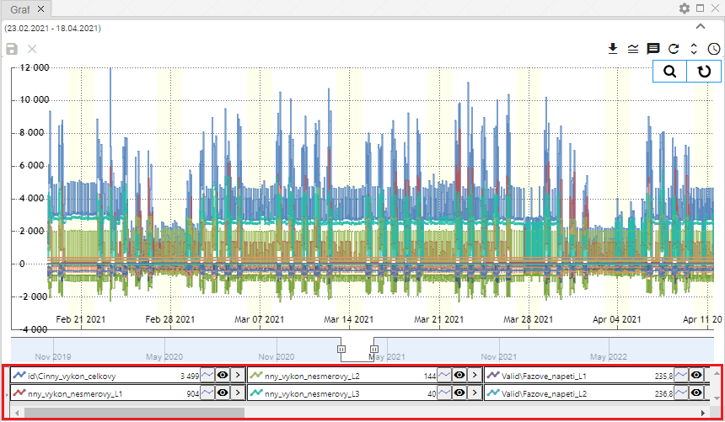

Figure 386: Legend displayed

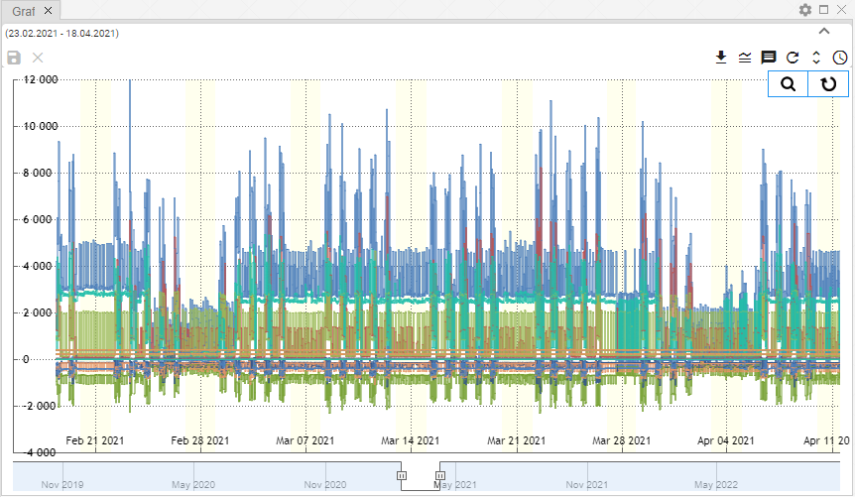

Figure 387: Hidden legend

## How to show/hide tooltip

To display the values (tooltip) for a specific location in the chart, hover over the selected location in the chart. You can hide the tooltip by pressing the "Show/Hide Tooltip" button, which is located in the upper right corner of the Chart window. Press the "Show/Hide Tooltip" button again to display the tooltip.



Figure 388: "Show/Hide Tooltip" Button

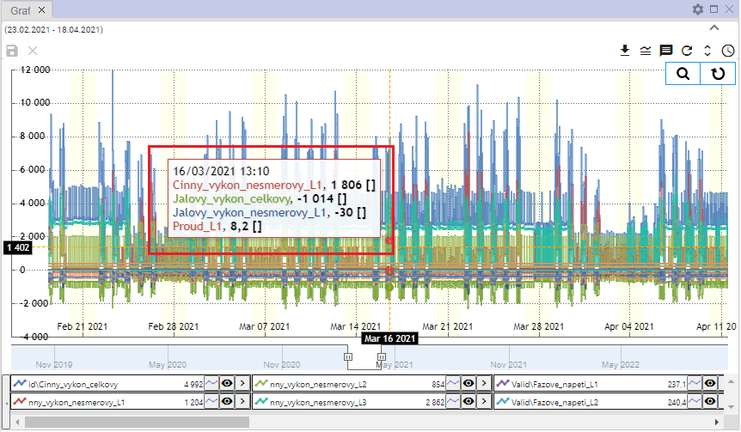

Figure 389: Tooltip Displayed

## How to adjust the y-axis to show values

The "Adjust y-axis to show values" button is used to zoom out the y-axis if all values (all lines) are not clearly visible when zooming in. The y-axis will be zoomed out to ensure all values are visible. The x-axis remains unchanged.

Proceed:

1. Press the "Zoom" button located in the upper right corner of the Graph window.



Figure 390: "Zoom" button

1. Mark the location in the graph that you want to zoom in on.

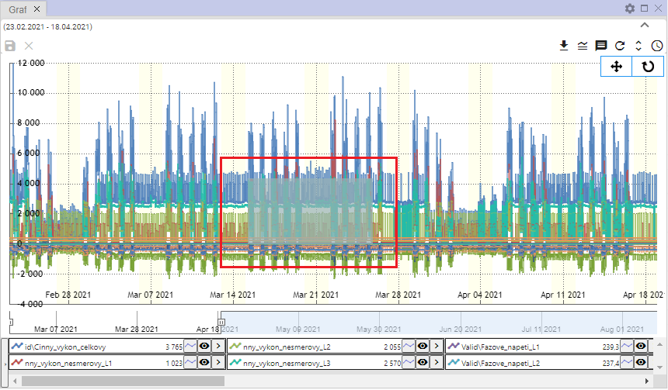

Figure 391: Mark the location in the graph

1. The location in the graph will be zoomed in on.

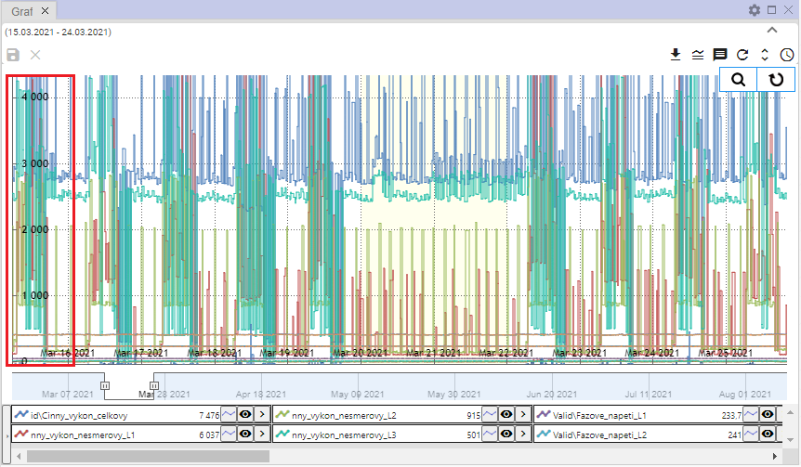

Figure 392: Zoomed area from the graph

1. Press the "Set y-axis to show values" button.



Figure 393: "Set y-axis to show values" button

1. The y-axis will zoom out.

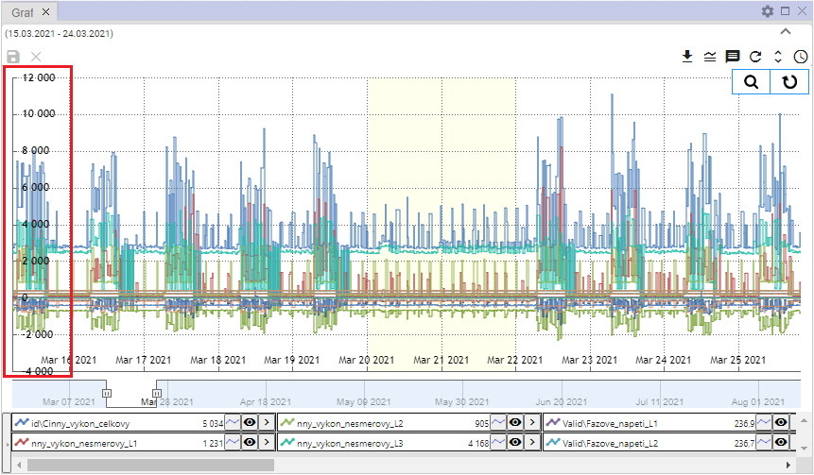

Figure 394: Changed y-axis

## How to change profile

To change profile, proceed as follows:

1. Click the button next to the profile you want to change.
2. Select the "Change Profile" item.

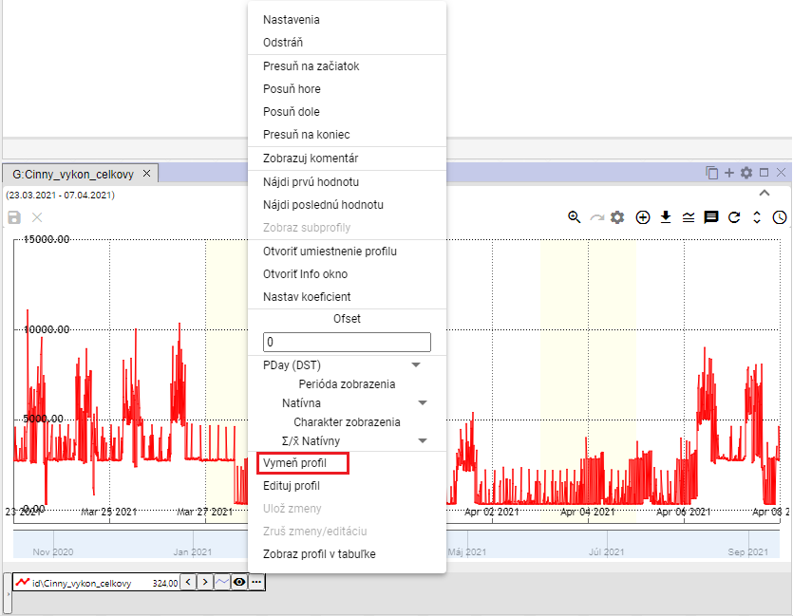

Figure 395: "Change Profile" item

1. A "Change Profile" window will appear.

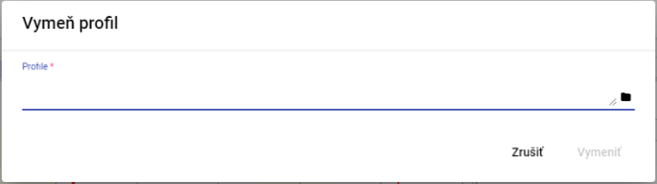

Figure 396: "Change Profile" window

1. Enter the profile path or click the button to browse for a profile.

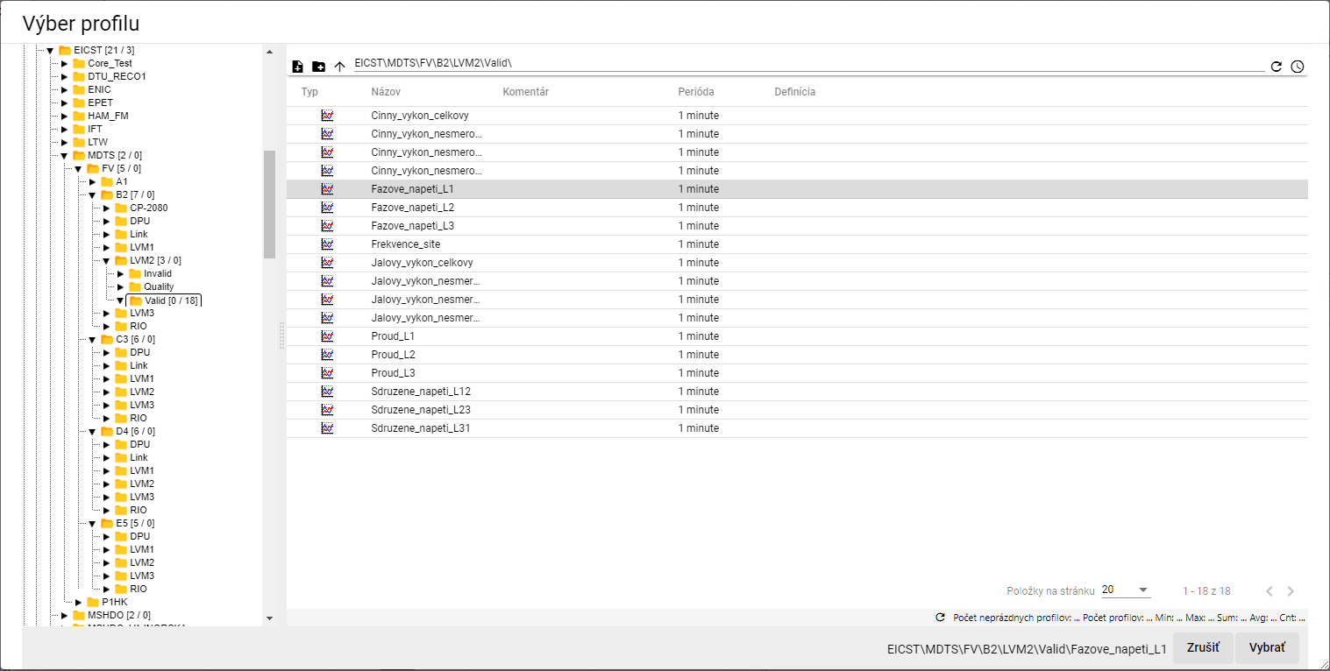

Figure 397: "Profile Selection" window

1. In the "Change Profile" window, click the "Change" button.

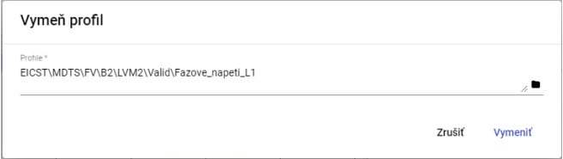

Figure 398: Selected Profile

1. The profile in the Graph window will be replaced with the selected profile.

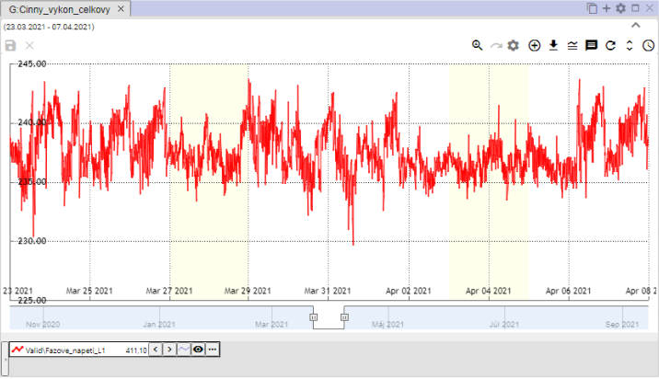

Figure 399: Replaced Profile

# Working with the Table

The “Profile Manager” application, in addition to working with the graph and explorer, also offers the ability to work with data in a table. Each table contains data from a single profile and is created in a separate window.

If the user closes the table window with unsaved data, a window will appear - Figure 400.

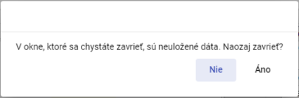

Figure 400: Notification about unsaved data

## How to display a profile in a table

You can display a profile in a table by transferring the profile from the explorer into the table (chapter 4.8) or by transferring the profile from the profile tree into the table.

To display a profile from the profile tree in a table, proceed as follows:

1. By default, the table window is empty.

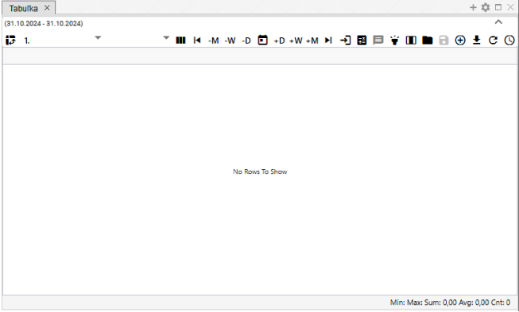

Figure 401: By default, the table window is empty.

1. In the profile tree, click on the profile you want to display in the table.
2. Drag the profile over the table window and release it.

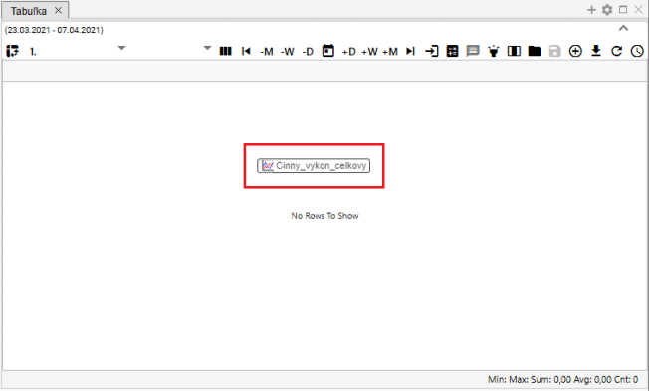

Figure 402: Adding a profile to the table

1. The profile values will be displayed in the table window.

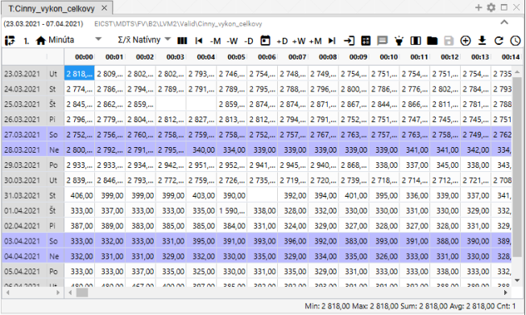

Figure 403: Displaying the profile in the table

## How to set up the column view

By default, the table is set to row view. To set column view, press the "Switch to Column View" button. To return to row view, press the "Switch to Column View" button again.

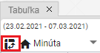

Figure 404: “Switch to Column View” button

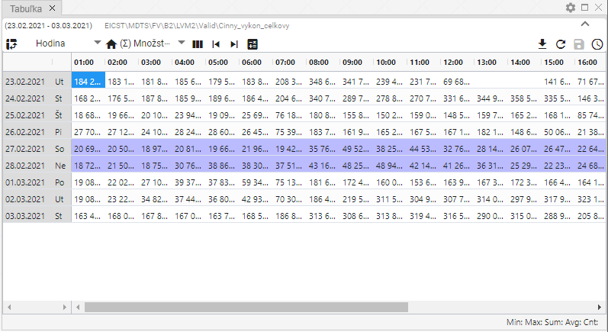

Figure 405: Row View

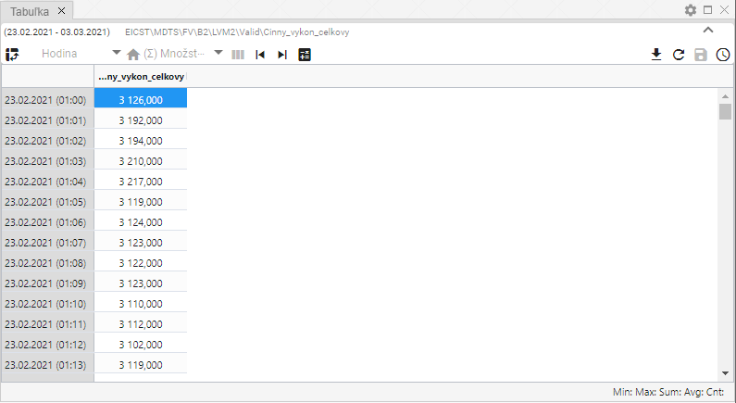

Figure 406: Column View

## How to switch to Single View

By default, the "Table" window is set to Single View, Figure 409. Pressing the button shown in Figure 407 will switch the table to Multi View, Figure 410. Switching to Multi View will change the appearance of the button in Figure 407 to a button – Figure 408, which is used to switch the table back to Single View.



Figure 407: "Switch to Multi View" Button



Figure 408: "Switch to Single View" Button

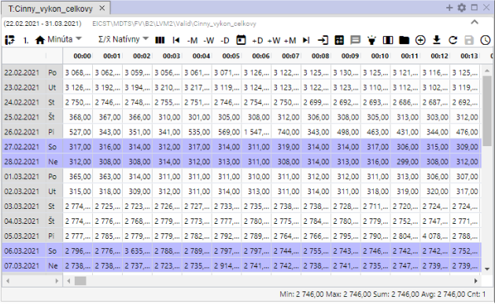

Figure 409: Single View

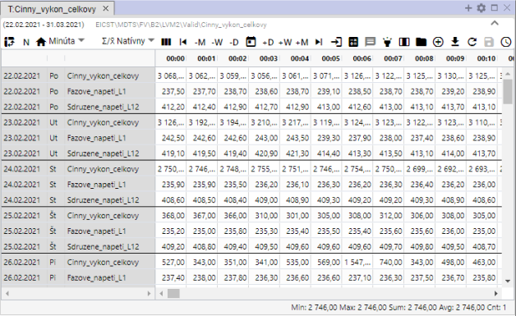

Figure 410: Multi-Profile View

## How to change the time format display

Data is displayed in the table by default in the same period as the profile from which the data is displayed, always one day per row. This means that an hourly profile will display 24 columns, a 15-minute profile will display 96 columns, a 1-minute profile will display 1440 columns, and a 1-second profile will display 900 columns.

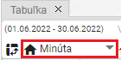

Figure 411: Button for changing the time format

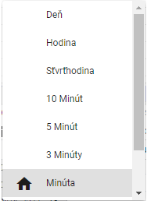

Figure 412: List of time formats in the table

Data can also be viewed in periods:

* Day – daily data overview
* Hour – hourly data overview
* Quarter Hour – 15-minute data overview
* 10 Minutes – 10-minute data overview
* 5 Minutes – 5-minute data overview
* 3 Minutes – 3-minute data overview
* 1 Minute – 1-minute data overview
* 1 Second – 1-second data overview
* Unknown – displayed if the table does not recognize the profile period. In this case, the profile values will be stretched into one column and the time column will be populated based on the data.

## How to set the number of columns

In the Table window, you can set the number of columns to display. Proceed as follows:

1. Click the "Number of columns" button, located at the top of the Table window.

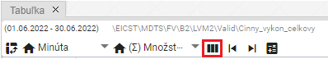

Figure 413: "Number of columns" button

1. The "Column Number Settings" window will appear.

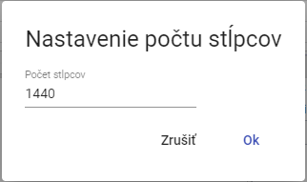

Figure 414: "Column Number Settings" window

1. Enter the number of columns to display.

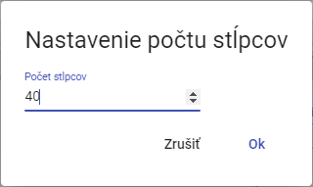

Figure 415: Changed Number of Columns

1. The number of columns will be adjusted. The set number of columns will be displayed above the "Number of Columns" button.

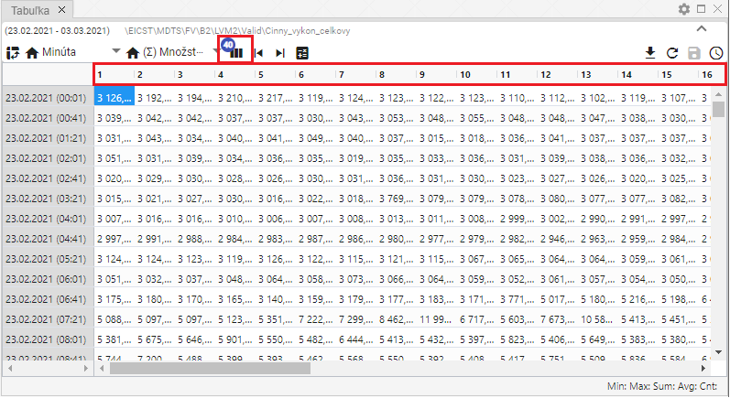

Figure 416: Set Number of Columns

1. To restore the number of columns, press the "Number of Columns" button and press the "Cancel" button in the "Set Number of Columns" window.
2. Subsequently, the original number of columns will be restored.

## How to select the resampling method

The resampling method determines how the profile will be resampled when displayed in periods other than its "natural" period.

With the "Quantity" resampling method, the underlying profile will be treated as a quantity (e.g., energy), and when displayed in smaller periods, the profile value will be divided by the appropriate ratio. In the case of the "Pieber" resampling method, the underlying profile will be treated as a waveform (e.g., temperature), and when resampling to lower periods, the profile value will remain at the same level.

“Native” mode means that the profile’s inherent characteristic is selected for the given profile. This means that a waveform characteristic is used for a waveform profile, and a quantity characteristic is used for a quantity profile. This choice is especially important when displaying multiple profiles with different characteristics. In that case, each is displayed according to its own definition.

This setting only affects the profile display in the table. The change does not affect the behavior of the underlying profile in the system or the behavior of profiles dependent on it.

You select the resampling method by pressing the “Resampling Method” button and choosing from the window that appears, Figure 418.

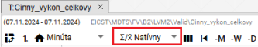

Figure 417: “Resampling Method” button

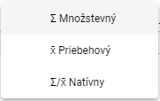

Figure 418: Selecting the Resampling Method

## How to display the first value

The "Go to First Value" button is used to display the first measured value of the profile.

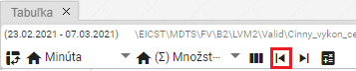

Figure 419: The "Go to First Value" Button

## How to display the last value

The "Go to Last Value" button is used to display the last measured value of the profile.

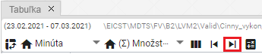

Figure 420: The "Go to Last Value" Button

## How to display the current day

To display the current day, press the "Go to Current Day" button. The cell in the table representing the current date and time will be highlighted.

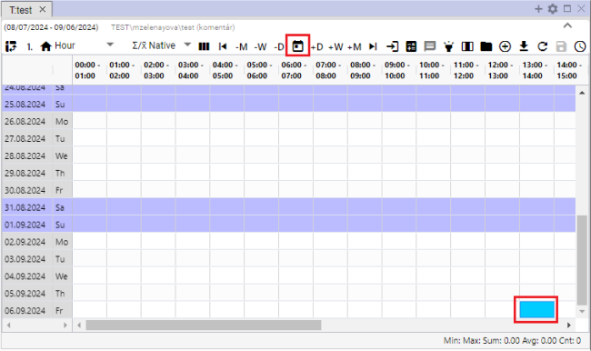

Figure 421: "Go to Current Date" Item

## How to display a specific date

You display a specific date in the table:

1. Press the "Go to Specific Date" button.

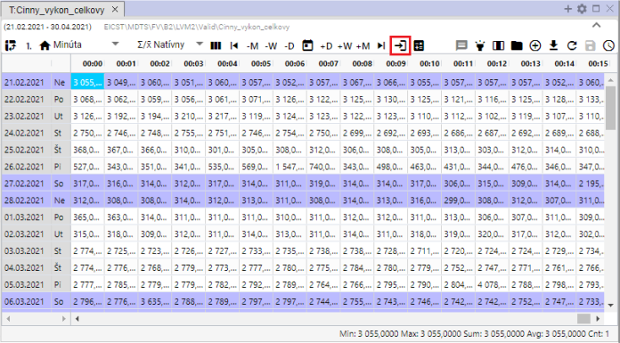

Figure 422: "Go to Specific Date" button

1. Select a date.

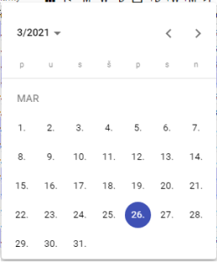

Figure 423: Date Entry

1. The selected date is displayed, and the first cell in the selected date is highlighted in blue.

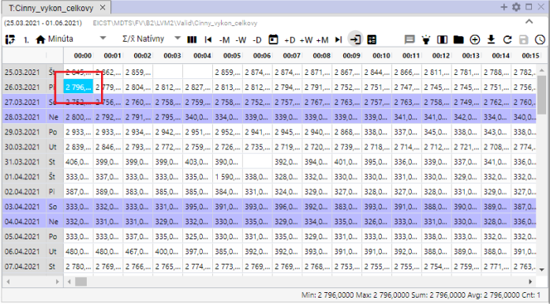

Figure 424: Display of the Selected Date

## How to move the date by day, week, or month.

You can move the date range for which data is displayed in the table using the buttons:

* "-M" - subtracts one month from the selected date,
* "-W" - subtracts one week from the selected date,
* "-D" - subtracts one day from the selected date,
* "+M" - adds one month to the selected date,
* "+W" - adds one week to the selected date,
* "+D" - adds one day to the selected date.

Proceed:

1. Click on the cell that represents the date from which you want to add or subtract the selected date range. The cell is highlighted in blue.
2. Press the selected button to shift the date.
3. The data display in the table will shift by the selected date range.

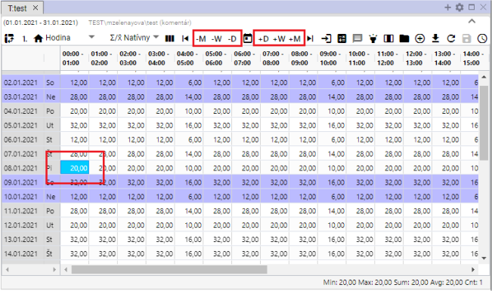

Figure 425: Buttons to shift the date by day, week, month

## How to add a Sum, Average, Min, Max column

You can add columns:

* Sum – enables/disables the calculation of the daily sum of values in the table. A "Sum" column will be added to the table.
* Average – enables/disables the calculation of the daily average of values in the table. An "Average" column will be added to the table.
* Min – enables/disables the display of the minimum value from the values for a given day. A "Min" column will be added to the table.
* Max – enables/disables the display of the maximum value from the values for a given day. A "Max" column will be added to the table.

By default, the table does not contain Sum, Average, Min, and Max columns. To add them, proceed as follows:

1. Click the "Row Statistics" button at the top of the table window.
2. A window will appear where you select which columns to display.
3. You can pin columns to the right side of the table by checking the "Pinned to the Right" box. If you do not select "Pinned to the Right", the Sum, Average, Min, and Max columns will be added to the end of the table. If you select it, the selected columns will be pinned to the right side of the table.

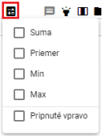

Figure 426: "Row Statistics" button

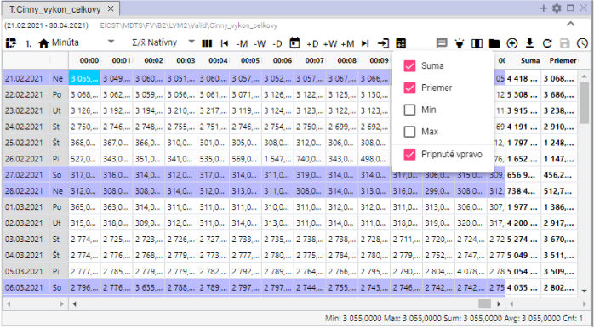

Figure 427: Pinned "Sum" and "Average" Columns

## How to enable/disable tooltip

By default, the tooltip display in the table is disabled. You can enable the tooltip by clicking the "Enable/Disable Tooltip" button, located in the top right corner of the Table window. To display values (tooltip) for a specific location in the table, hover your mouse cursor over the selected location. To hide the tooltip, click the "Enable/Disable Tooltip" button again.

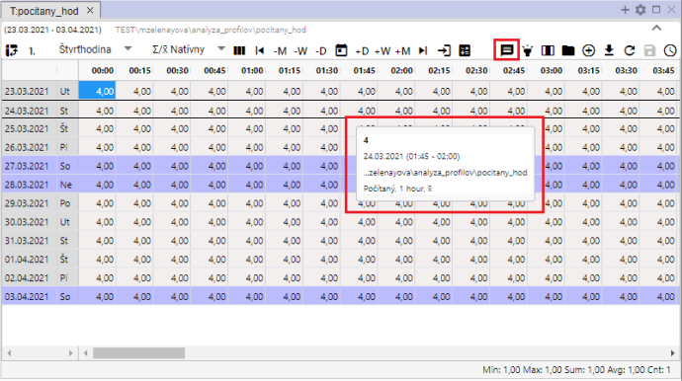

Figure 428: Tooltip displayed in the table

## How to enable/disable row highlighting

Row highlighting means that the row will be highlighted when you hover your mouse cursor over it. If the "Enable/Disable Row Highlighting" button is black, highlighting is enabled. The button is disabled if it is grey.

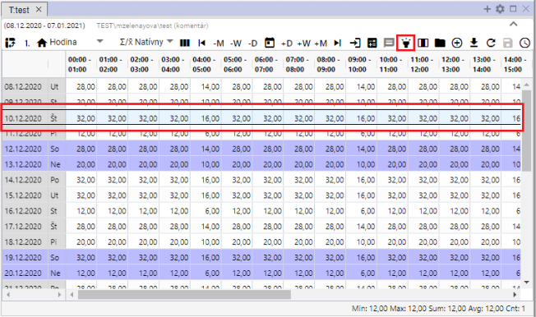

Figure 429: "Enable/Disable Row Highlighting" button and a highlighted row

## How to edit a profile value in the table

You can edit the values of the saved profile in the Table window. The calculated profile cannot be edited.

Proceed:

1. Click to select a cell in the Table window.

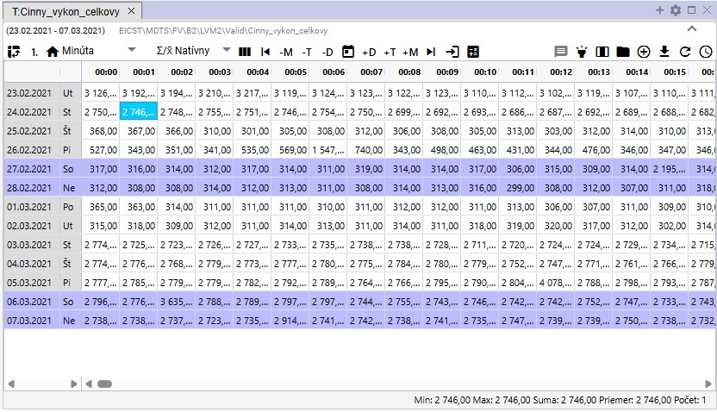

Figure 430: Cell Selection

1. Double-click a cell and enter a value.

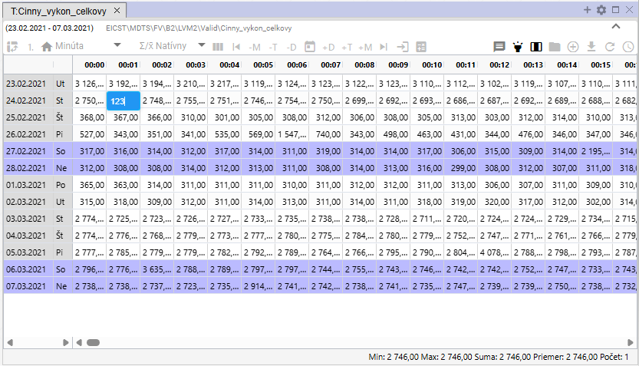

Figure 431: Entering a Value

1. After editing the value, click in another cell in the table. The button with the floppy disk icon will become active.

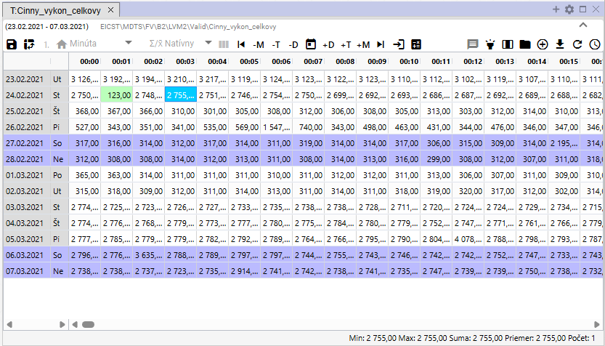

Figure 432: Edited Value in the Table

1. You save changes by clicking the "Save Modified Values" button, which is located at the top of the Table window.



Figure 433: "Save Modified Values" Button

## How to Change a Profile Definition

You can modify the definition of the calculated profile in the Table window. Proceed as follows:

1. Right-click on the profile in the Table window.
2. A window will appear where you select the “Edit Definition” item.

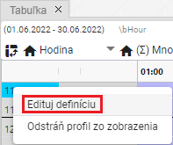

Figure 434: “Edit Definition” item

1. A window will appear where you select the “Change Profile Definition” item.

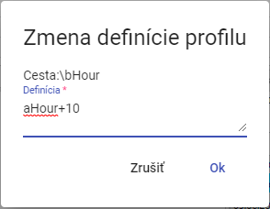

Figure 435: “Change Profile Definitions” window

1. Edit the definition and confirm by pressing the “OK” button.

## How to remove a profile from the table

To remove a profile, proceed as follows:

1. Right-click on the row of the profile you want to remove.
2. A window will appear where you select the item "Remove profile from view".

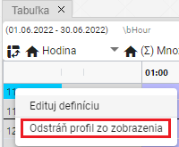

Figure 436: Remove profile from view

1. The profile will be removed from the "Table" window.

## How to enable automatic column width adjustment

By default, cells in the "Table" window have a fixed width. Using the "Automatic Column Width Adjustment" button, Figure 437, you can adjust the width to display the entire cell content, Figure 438.

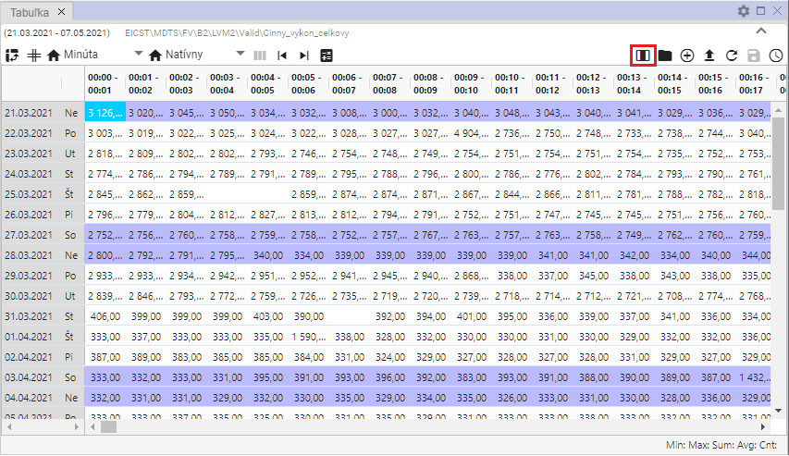

Figure 437: "Automatic Column Width Adjustment" button

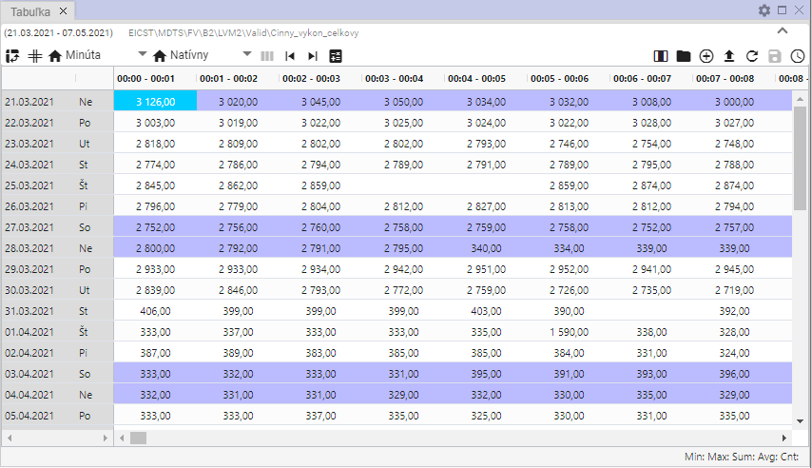

Figure 438: Automatic Column Width Adjustment Enabled

## How to open the profile location

The "Open Profile Location" button, Figure 439, is used to open the profile from the Table window in tree structure, Figure 440.

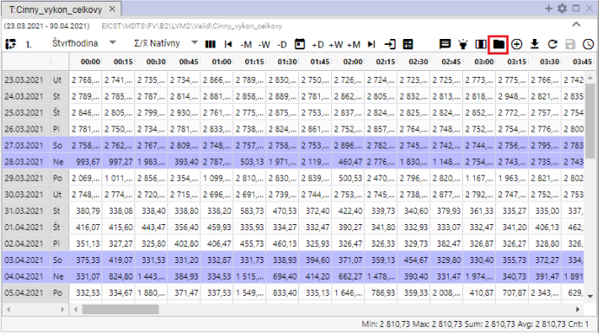

Figure 439: "Open Profile Location" Button

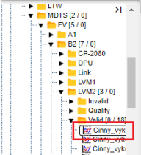

Figure 440: Opening the profile in tree structure

## How to Add a Profile

To add a profile to the "Table" window, proceed as follows:

1. Click the "Add Profile" button, located in the upper right corner of the "Table" window.

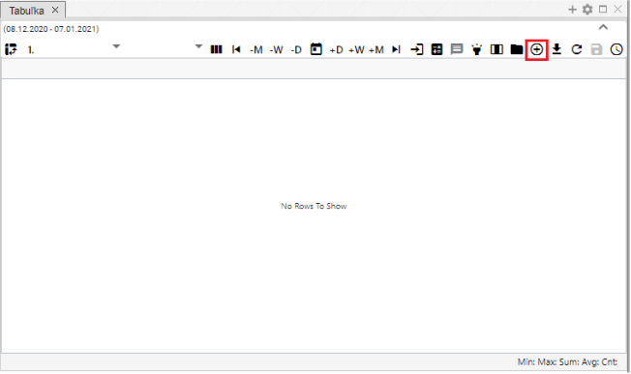

Figure 441: "Add Profile" Button

1. The "Add Profile" window will appear, where you enter the path to the profile in the tree structure or click the button to display the "Profile Selection" window.

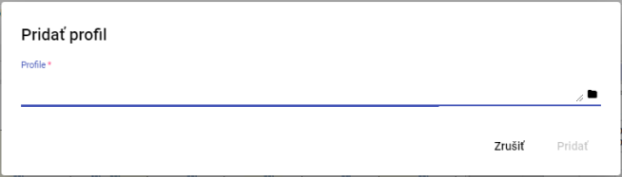

Figure 442: "Add Profile" Window

1. In the "Profile Selection" window, find the profile and click the "Select" button.

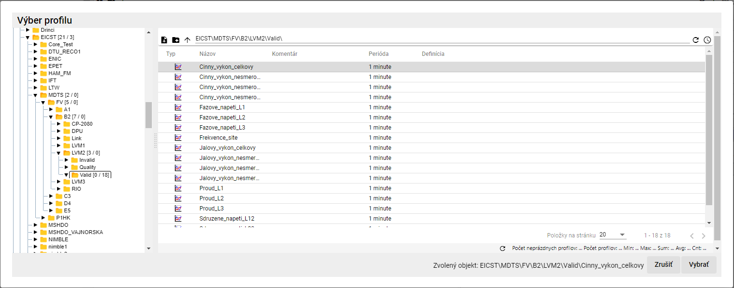

Figure 443: "Profile Selection" Window

1. In the "Add Profile" window, the profile path is displayed.

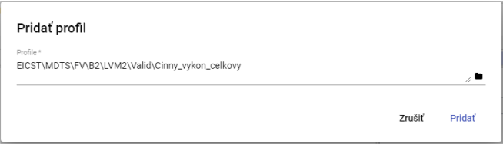

Figure 444: Profile Path Entered

1. Confirm by clicking the "Add" button.
2. In the "Table" window, the added profile is displayed.

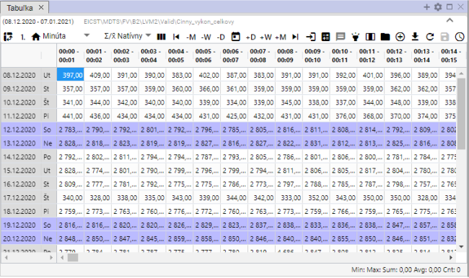

Figure 445: Added profile in the "Table" window.

1. If a profile is displayed in the table and you add another profile, multiprofile view is automatically enabled.

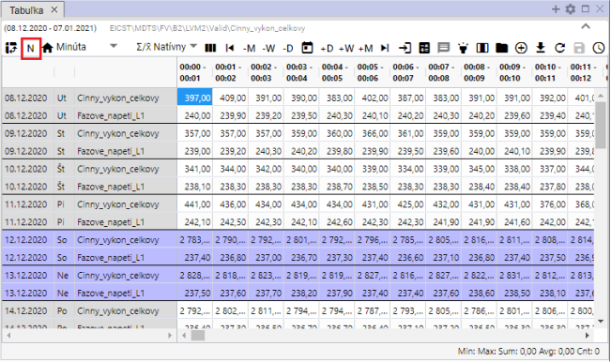

Figure 446: Multiprofile view

## How to export displayed data to CSV

You can download the data displayed in the "Table" window by clicking the "Export displayed data to CSV" button. A file will then be downloaded, Figure 448.

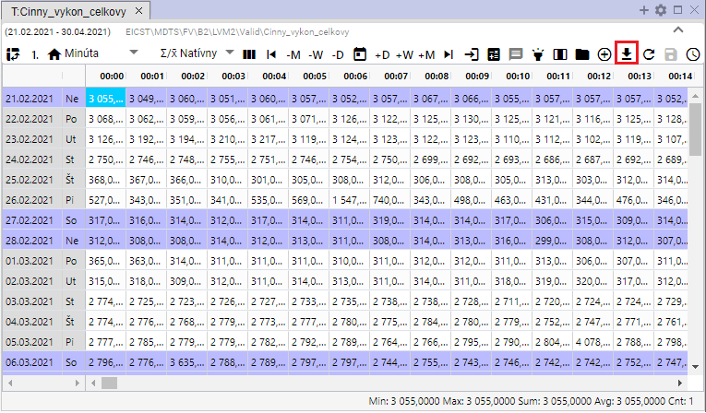

Figure 447: "Export displayed data to CSV" button



Figure 448: Downloaded export

## How to change the definition

You can edit the definition for the calculated profile:

1. Right-click on any cell in the table.
2. A menu will appear where you select “Change definition”.

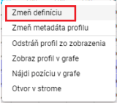

Figure 449: “Change definition” item

1. A “Change Profile Expression” window will appear, where you can edit the definition of the calculated profile.

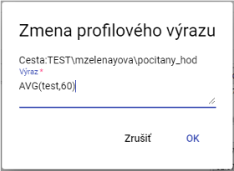

Figure 450: “Change Profile Expression” window

1. Save the changes by clicking the “OK” button.

## How to Change Profile Metadata

Proceed:

1. Right-click on a cell in the table.
2. A menu will appear, in which click on "Change Profile Metadata".

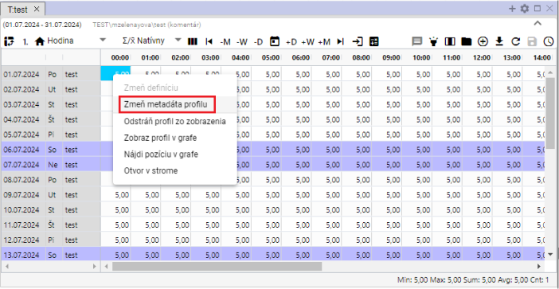

Figure 451: "Change Profile Metadata" item

1. A "Edit Profile" window will appear.

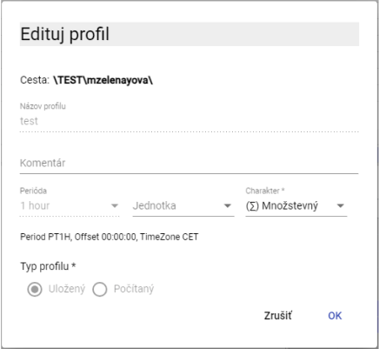

Figure 452: "Edit Profile" window for a saved profile

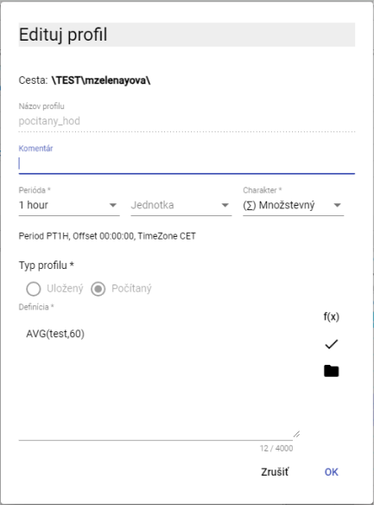

Figure 453: "Edit Profile" window for a calculated profile

1. For a saved profile, you can edit the fields: Comment, Unit, and Character. For a calculated profile, you can also edit the “Definition” field.
2. You save the changes by pressing the "OK" button.

## How to remove a profile from view

To remove a profile from the table:

1. Right-click on any cell in the table.
2. A menu will appear, in which select "Remove profile from view".

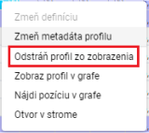

Figure 454: "Remove profile from view" item

1. The profile will be removed from the table.

## How to display a profile in the graph

To display a profile from the table in the graph, follow these steps:

1. Click on the header of the window where you want to display the graph. This will activate the window. If the active window is the table, the graph will be displayed in the table window.

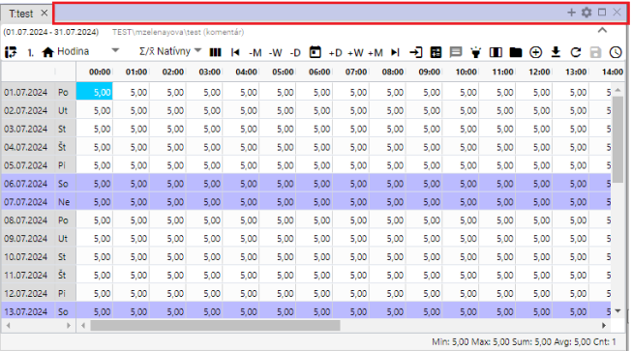

Figure 455: Active Window

1. Right-click on any cell in the table.
2. A menu will appear, in which select the item "Display profile in graph".

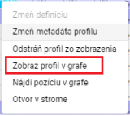

Figure 456: "Display profile in graph" item

1. A new tab with the graph display will be added to the active window.

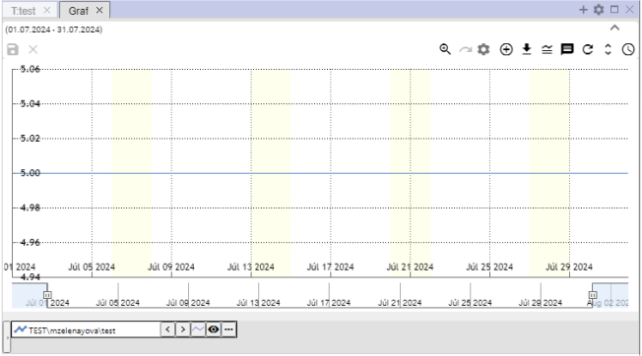

Figure 457: Display profile from table in graph

## How to find a position in the graph

Proceed:

1. Display the profile in the table and in the graph.
2. Right-click on the cell in the table/location you want to display in the graph.
3. A menu will appear; select “Find Position in Graph”.

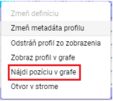

Figure 458: “Find Position in Graph” item

1. The location representing the cell from the table will be displayed in the graph. The graph will scroll so that the selected location is in the center of the graph. A line will be displayed in the center of the graph for one second.

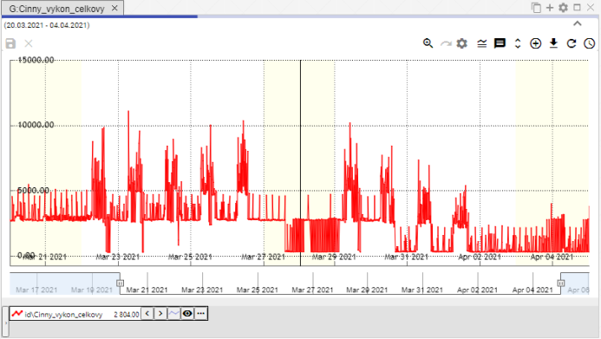

Figure 459: A line representing the selected cell from the table will be displayed in the center of the graph.

## How to open a profile in the tree

To open a profile in the tree:

1. Right-click on any cell in the table window.
2. A menu will open, in which select the item "Open in Tree".

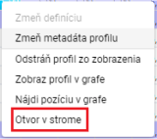

Figure 460: "Open in Tree" item

1. A directory will open in the tree, containing the profile displayed in the table.

## Select the block using the left mouse button.

To select a block in the table, click the left mouse button on the desired cell in the table, hold down the left mouse button, and select the block.

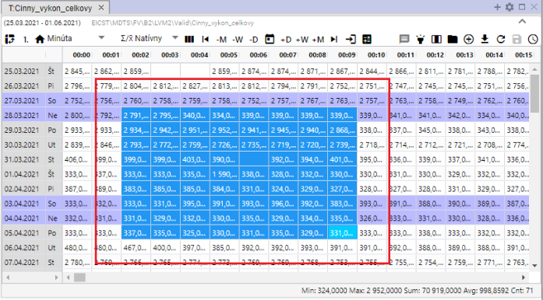

Figure 461: Cell Selection in the Table

## How to set up scrolling in the table using the mouse wheel.

You can scroll through the table using the mouse cursor. Scrolling is done day by day. You can also scroll beyond the set range in the table. An active cell must be set in the table.

Proceed:

1. Press the "Settings" button located in the top toolbar of the application.



Figure 462: "Settings" button

1. The "Settings" window will appear.
2. In the "Table" section, check the "Mouse wheel scrolls the cursor" box.

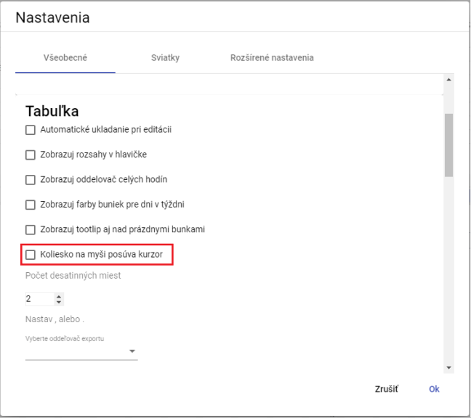

Figure 463: "Mouse wheel scrolls the cursor" item

1. Save by clicking the "OK" button.
2. Next, in the table, scroll the cursor using the mouse wheel. The cursor is the active cell in the table. This cell is highlighted in blue.

If the "Mouse wheel scrolls the cursor" item is not checked, scrolling with the mouse wheel will scroll the rows in the table.

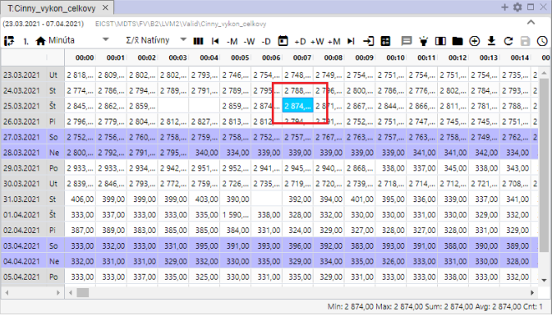

Figure 464: Active cell in the table

## How to change the order of profiles in the table

To change the order of profiles in the table, you need to switch the view to columns. Each profile represents one column. The order of columns can be changed. After changing the order of columns, you can re-enable row-based view.

Proceed:

1. Display the desired profiles in the table.
2. Press the "Switch to column view" button.

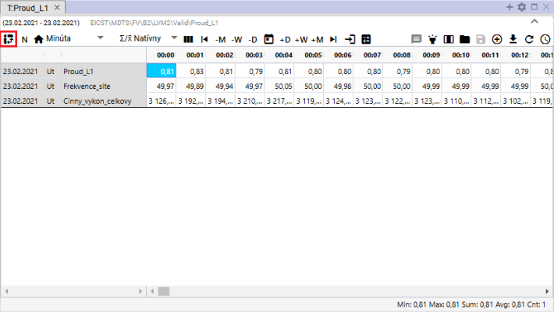

Figure 465: "Switch to column view" button

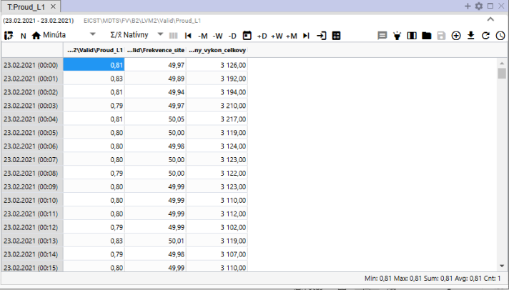

Figure 466: Column view in the table

1. Click and drag the column header to the desired location, then release the column.

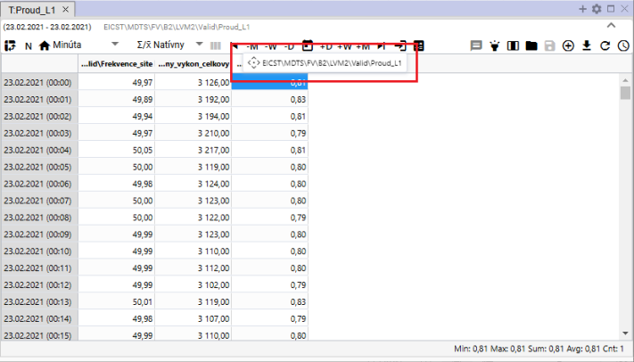

Figure 467: Moving the column

1. After moving the column, you can switch back to row view for profiles.

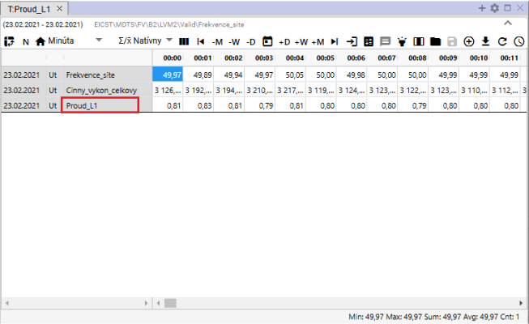

Figure 468: Profiles reordered

# Arithmetic of calculated profiles

## Resampling rules

When performing arithmetic operations on profiles with different periods, resampling occurs during their calculation. This resampling has its own rules, which mainly depend on the established nature of the input profiles. The resampling rules are described in more detail in the following text.

### Resampling rules for the input profile to the output profile, taking into account its nature.

Example: Output_profile := input_profile1 + input_profile2 * input_profile3 ...

1. If the input profile is inside an aggregation function (avg, sum, min, max, count) or cp(), then its resampling is determined explicitly by its parameter and the following rules are not taken into account.
2. If not, the input profile is resampled to the sampling of the output profile before applying the arithmetic, according to the following rules:
3. A characterless profile is taken as a transient one. This is the default character, and as such it was treated as such even before the introduction of characters.
4. If the periods of the input and output profiles are the same, then no resampling takes place and characters are not taken into account at all. Values are copied 1:1.
   1. If the profiles have different characters and we want to perform a conversion between them, we must do it manually using a formula in profile arithmetic. The most common conversion is from ¼-power to ¼-energy using input_profile/4.
5. If the periods of the input and output are different, then resampling will take place:
   1. Down-sampling: if resampling from finer to coarser sampling, then:
6. When down-sampling, aggregation using SUM is used.
7. When down-sampling, aggregation using AVG is used.
8. Up-sampling: if resampling from coarser to finer sampling, then:
9. When up-sampling, the input value divided by the ratio of output and input periods is multiplied into the output.
10. during runtime, the input value is multiplied (unchanged)
11. When up-sampling, only the character of the input profile is considered. The character of the output is not considered at all.

## Calculated profile

Create a profile according to the following procedure:

1. In the tree structure, right-click on the name of the directory where you want to create a new calculated profile. A window with items will appear, in which use the mouse cursor to select the "New" item and click to select "Profile", Figure 469. The "New Profile" window will open, Figure 470.

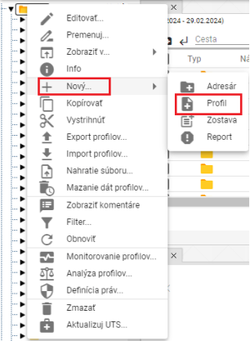

Figure 469: "Profile" item

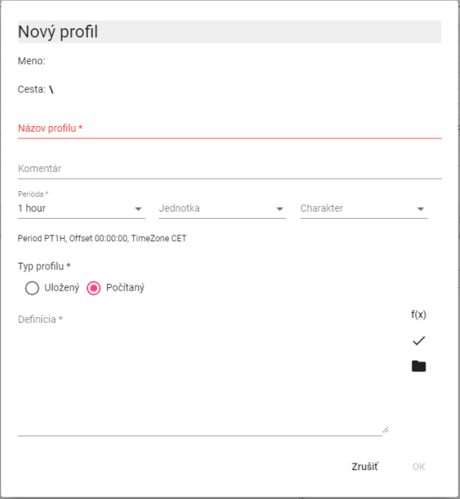

Figure 470: New Profile Window

1. In the "Profile Name" field, enter a name for the profile. The profile name must start with a letter, and may then also contain digits and the underscore character "_". The profile name may contain a maximum of 22 characters. The profile is identified by its name, or by specifying the path to the profile and its name (path\profile).
2. You can enter a comment.
3. Select the period, unit, and character.
4. In the "Profile Type" section, select "Calculated".
5. When defining a calculated profile, we can use the following buttons:
6. if we want to work with standard functions for a calculated profile
7. If we want to use another saved or calculated profile in the definition. For a calculated profile, we can also use another calculated profile in the definition.
8. You create the profile by pressing the "OK" button.

The profile is identified by its name, or by specifying the path to the profile and its name (path\profile).

* For a calculated profile, you can also use plugin functions in the definition (described later).

Warning

Oracle profiles cannot be created in Xenergie G2. Depending on the specifics of the particular Xenergie G2 implementation, their backward compatibility may be maintained.

### Expression writing method

We write the definition of the calculated field into the "Definition" window.

The profile name must start with a letter, and may then also contain digits and the underscore character “_”. The profile name may contain a maximum of 22 characters. The profile is identified by its name, or by specifying the path to the profile and its name (path\profile).

Case does not matter when creating definitions.

Examples:

**cez**

link to profile via in the main directory

**through**

link to profile through in the directory one level up

**through**

link to profile through 2 directory levels up, in the subdirectory “repair”

**100**

The profile will contain a value of 100 for the entire time range.

The number format is [-]nnn.mmm[E[-]eee].

The expression may contain spaces, tabs, and newline characters. These will be ignored.

### Expression evaluation

The expression will be evaluated for the requested time period for each time (hour, minute) separately.

If a profile has no value at a given time, an invalid value is used.

If any of the values entering the +, -, *, /, >, <, >=, <=, =, <>, |, &, ! operation is invalid, the result is an invalid value.

Division by 0 produces an invalid value.

The program always calculates all values, even if they are not necessarily needed, therefore for example alt(100.0, unknown_profile) is not a valid expression.

### Arithmetic operations:

* Addition + ++
* Subtraction - --
* Multiplication * **
* Division / //
* Parentheses ()

Operations are calculated from left to right. The highest priority is given to ( ), then “*”, “**”, and “/”, “//”.

Operations "++", "--", "**", "//" replace an invalid value with the value 0.

### Functions

Clicking the button opens a window where you can select one of the standard functions. The functions are stored in categories:

* Aggregation functions
* Alternatively
* Composition functions
* Conditional
* Obsolete functions
* Other
* Rounding functions
* Character functions

After selecting a category, a list of functions with function help will open.

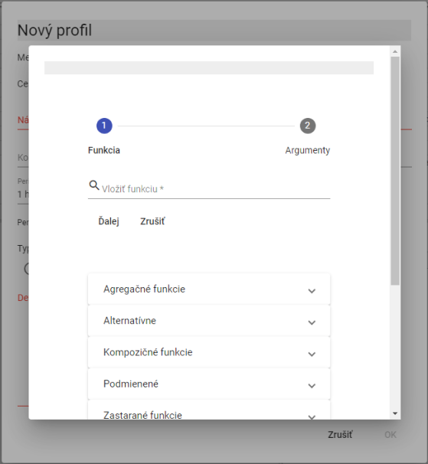

Figure 471: List of functions

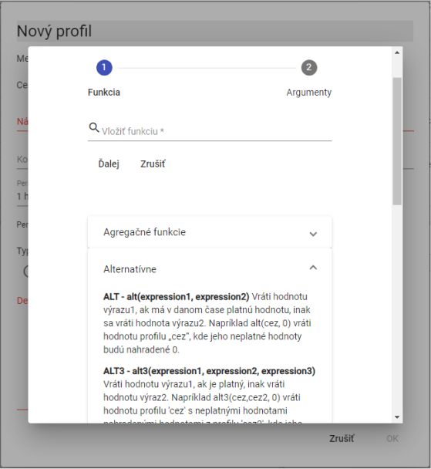

Figure 472: List of functions with function help

#### Aggregate functions

Aggregate functions have two parameters.

1. **profile – profile name,**
2. **period – the period with which the given function is to be calculated. The period is specified by the following constants (for calculation in valid time, the constants starting with the letter "P" are used):**

Constants for specifying the period must always be written in uppercase letters.

**D, PD – daily period (in CET and in valid time – in summer in CEST)**

**W, PW – weekly period /the week starts on Monday and ends on Sunday/**

**E, PE – weekly period /the week starts on Saturday and ends on Friday/**

**M, PM – monthly period**

**Q, PQ – quarterly period**

**Y, PY – annual period**

For calculated profiles, the period can be entered in minutes. It does not have to be entered using an abbreviation.

**sum(profile, period)**

Summation with the given period in CET.

(Periods: D, W, E, M, Q, Y, and in calculated profiles the period can be entered in minutes.)

For example, if we calculate the function sum(measurement, M) where the measurement profile has an hourly period, the resulting profile will contain the sum of the measurement profile values for the given month in all values.

**avg(profile, period)**

Averaging with the given period in CET

For example, if we calculate the function avg(temperature, 60), where the temperature profile has a minute period, the resulting profile will contain hourly temperature averages.

**min(profile, period)**

Minimum values within the period in CET.

The minimum value is calculated for each period.

**Maximum values within the period in CET.**

Maximum values within the period. The function operates in CET.

The maximum value is calculated for each period.

**checksum(profile, period)**

Cumulative summation of profile values within the time units defined by the period parameter. The output profile at a given time point provides a value that is the sum of all previous values of the input profile, from the beginning of the time interval (defined by the period parameter) up to the specific time point (inclusive).

For example, if the input profile has an hourly period, then the output profile with the definition "csum(input_profile, PD)" will have, in each day, in its last hour (in valid time), a value equal to the sum for the entire day.

**Average summation of profile values within the time units defined by the period parameter.**

Averaging with a given period in valid time.

**pcsum(profile, period)**

Summation with a given period. The function operates in valid time.

At each time t, it determines the given period's sum of values from the beginning of the period to time t.

**Maximum with a given period.**

Maximum of values in a period in valid time.

**pmin(profile, period)**

Minimum of values in a period in valid time.

**Sum of values in a period in valid time.**

Summation with a given period in valid time.

(Periods: D, W, E, M, Q, Y, with the period being definable in minutes within calculated profiles.)

Functions starting with P control the way time is divided into intervals to be aggregated.

P stands for Valid Time, which switches to UTC+1 to UTC+2 in summer.

The functions PSUM, PAVG, PMIN, PMAX are deprecated. (others, such as PHOUR, PDAY, PTDIV, ... are not).

We recommend using functions without P in their names instead, and using P as a prefix for the time parameter.

Therefore, for example, instead of the expression PAVG(profile, X), we recommend using AVG(profile, PX).

By “deprecated”, we mean that we no longer recommend using these functions when establishing new calculations.

These “deprecated” functions remain as they are in the system. However, we will no longer modify their behavior.

Functions without the P prefix, which we recommend as replacements, are more versatile and will be gradually expanded to include new periods.

Old functions can still be used. However, for creating new formulas, we recommend using the new, more versatile versions.

#### Alternative

**alt(expression1, expression2)**

**alt3(expression1, expression2, expression3)**

**...**

**alt9(expression1, expression2,..., expression9)**

If expression1 does not have a valid value, the calculation continues with expression2, and if that does not have a valid value either, then the next expression is used...

**alt(expression1, expression2)**

If expression1 does not have a valid value, expression2 is used.

alt(Data\DGC2000\cez, 0)

If the profile "...\cez" does not contain a valid value, the function will use the value 0 during processing.

**alt3(expression1, expression2, expression3)**

If expression1 does not contain a valid value, expression2 will be used, and if that does not contain a valid value either, then expression3 will be used.

We can sometimes suitably replace alternative functions with:

Example:

alt(supplier1,0)+alt(supplier2,0)

can be replaced

supplier1++supplier2

It adds two profiles, replacing any invalid value with 0.

Example:

alt(through,alt(through2,0))

or

alt3(through,through2,0)

An invalid value in the "through" profile will be replaced by the value from the "through2" profile, or if the "through2" profile does not contain a valid value either, the value 0 will be used. The second variant is, of course, more efficient.

#### Stopping error propagation / suppressing the error

**nv()**

A function that returns an empty (invalid) value. (NO_VALUE). All operations with an invalid value produce an invalid value.

Examples:

*nv()*

*nv() + 100*

The result will be a profile containing invalid values. (Not containing any values.)

valid(profile)

If there is an error when retrieving profile values (e.g., it does not exist), the result will be invalid values. If the VALID function is not used and the specified profile does not exist, the program will display an error message (the calculated profile definition is incorrect) and the expression will not be executed.

Example:

*test*

or

*alt(test,0)*

If the "test" profile is invalid (or does not exist), the program will report an error when the following expressions are entered.

If the "test" profile becomes invalid after this expression is entered, an error message will be displayed in the info window of the resulting profile.

Example:

valid(test)

The resulting profile will be okay, but it will not contain a valid value.

alt(valid(test),0)

The resulting profile will be okay and will contain values of 0.

#### Simple condition

**cond(logical_expression,expression1,expression_false)**

If the logical_expression is true, then expression1 is executed. If it is false or has an invalid value, expression_false is executed.

The logical expression may contain

* expressions and numerical values
* comparison operators: ">", "<", ">=", "<=", "=", "<>"

logical expressions can be combined using logical operations:

* logical product (and also): &
* logical sum (or): |
* negation: !

The order of evaluation of logical operations is: ! & |, and we can modify it using ().

Example:

cond(cez<0, 0, cez)

All values in the profile 'cez' less than 0 will be replaced with the value 0.

Example:

If 'cez' is equal to 'cez', then 1, otherwise 0.

If the 'cez' profile contains a valid value, the result will be 1, otherwise the result will be 0.

Example:

if ((cez < 0) or (cez > 1000)), then nv, otherwise cez

if ((cez >= 0) and (cez <= 1000)), then cez, otherwise nv

The resulting profile in both cases will not contain values less than 0 and greater than 1000. Parentheses are not necessary in these cases.

#### Multiple condition

**cond2(logical_expression1, expression1, logical_expression2, expression2, false_expression)**

**This function allows for multiple conditions.**

**cond9(logical_expression1, expression1,…logical_expression9, expression9,…false_expression)**

If logical_expression1 is true, expression1 is executed, if logical_expression2 is true, expression2 is executed... if no logical_expression is true, false_expression is executed.

Example:

cond(real<zjed*1.02,1,cond(real<zjed*1.05,1.1,1.2))

cond2(real<zjed*1.02,1,real<zjed*1.05,1.1,1.2)

In both cases, if the profile value real is less than 102% of the profile value zjed, it returns a value of 1, if it is greater than 102% and less than 105%, it returns a value of 1.1, otherwise it returns 1.2.

#### Composite functions

*day(selection_days)*

The output is a profile containing ones and zeros. The function writes 1 for those days of the week that are listed in the argument. The function operates in CET. The day of the week is identified by a number in sequence: Sun(1), Mon(2), Tue(3), Wed(4), Thu(5), Fri(6) and Sat(7).

Writing :day(136) creates a 0-1 profile that will have ones in Mon(1), Wed(3) and Sat(6).

***hour(selection_hours)***

The output is a profile containing ones and zeros. The function returns 1 for those hours of the day that are listed in the argument. The function operates in CET.

Writing for a calculated profile: hour(1, 5-10, 18, 24) writes the value 1 for hours 1, 5, 6, 7, 8, 9, 10, 18 and 24.

***month(selection_days)***

The output is a profile containing ones and zeros. The function writes 1 for those days of the month that are listed in the argument. The function operates in CET.

Writing: month(1, 3, 10–13, 30) returns the value 1 for days 1, 3, 10, 11, 12, 13, 30.

***day(selection_days)***

The output is a profile containing ones and zeros. The function returns 1 for those days of the week that are listed in the argument. The function operates in valid time. The day of the week is identified by a number in sequence: Sun(1), Mon(2), Tue(3), Wed(4), Thu(5), Fri(6), and Sat(7).

Writing: pday(136) returns a 0-1 profile that will have ones in Mon(1), Wed(3), and Sat(6)

The function operates in valid time.

***phour(hour_selection)***

The output is a profile containing ones and zeros. The function writes 1 for those hours in the day that are specified in the argument. The function operates in valid time.

Writing: phour(1, 5-10, 18, 24) returns the value 1 for hours 1, 5, 6, 7, 8, 9, 10, 18 and 24.

The function operates in valid time.

***pmonth(day_selection)***

The output is a profile containing ones and zeros. The function returns 1 for those days in the month that are specified in the argument. The function operates in valid time.

Entry: pmonth(1, 3, 10 – 13, 30) returns a value of 1 for days 1, 3, 10, 11, 12, 13, 30.

The function operates in valid time.

*ptdiv(expression0, time1, expression1,...., timeX, expressionX)*

Profile stacking by time. Until time time1, it uses the values of profile expression0, from time1 (inclusive) to time2, it uses the values of profile expression2, ..., from timeX (inclusive) it uses the values of profile expressionX.

Time is entered in the format DD.MM.YY[YY] [HH:MM]. The year can be entered in full format (1990-2030) or abbreviated format (00-30, 90-100).

The ptdiv function operates in valid time.

***tdiv(expression0, time1, expression1, ..., timeX, expressionX)***

Profile stacking by time. Until time time1, the values of profile expression0 are used, from time1 (inclusive) to time2, the values of profile expression2 are used, ..., from timeX (inclusive), the values of profile expressionX are used.

Time is entered in the format DD.MM.YY[YY] [HH:MM]. The year can be entered in full format (1990-2030) or abbreviated format (90-100, 00-30).

The tdiv function operates in CET (Central European Time).

***vdiv(input_expression, expression0, value1, expression1, ... valueX, expressionX)***

Profile stacking based on value. If the input_expression is less than value1, it is replaced by expression0. If it is greater than or equal to value1 and less than value2, it is replaced by expression1, ... . If it is greater than or equal to valueX, it is replaced by expressionX.

For a calculated profile, the function assigns the value NO_VALUE to the value NO_VALUE.

#### Rounding functions

The parameter number_of_decimal_places determines the position to which rounding occurs. If this number is positive – we round to units, tens, etc., negative – we round to tenths, hundredths...

If the number_of_decimal_places is 2, then the rounding functions will round to the nearest tens.

***round(expression, number_of_decimal_places)***

Mathematical rounding (round up from 5 or greater in absolute value). If the number_of_decimal_places parameter = 0, the number 1.5 rounds to 2. The number -1.5 rounds to -2.

***round up(expression, number_of_decimal_places)***

Rounding always up in absolute value. If the number_of_decimal_places parameter = 0, the number 1.1 rounds to 2. The number -1.1 rounds to -2.

*trunc((expression, number_of_decimal_places)*

Truncating the specified number of places. If the parameter number_of_decimal_places = 0, the number 1.1 truncates to 1 and the number -1.1 to -1.

#### Sign functions

***abs(expression)***

Absolute value from each value in the profile.

***minus(expression)***

Values greater than 0 will be replaced with 0.

***plus(expression)***

Values less than 0 will be replaced with 0.

Example:

if(odch<0, -1*odch, odch)

it is the same as abs(odch)

Example:

cond(odch<0, 0, odch)

it is the same as plus(odch)

Example:

cond(odch<0, odch, 0)

it is the same as minus(odch)

# Additional features

Additional features are not included as standard with “Profile Manager” but are ordered separately.

## Profile Monitoring

This function is used for profile monitoring. The monitoring job is used to watch profiles. It checks, for example, that the value in a profile does not fall below zero or exceed 100. The following chapters deal with creating, modifying, deleting and exporting the monitoring job.

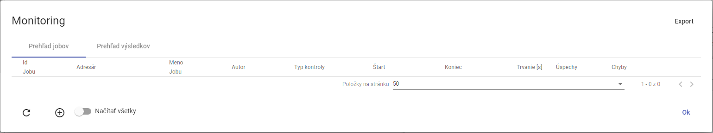

Figure 473: “Monitoring” Window

### How to create a new monitoring job

To create a new monitoring job, proceed as follows:

1. Right-click on the directory in the tree structure.
2. A menu will appear, in which select the "Profile Monitoring" item.

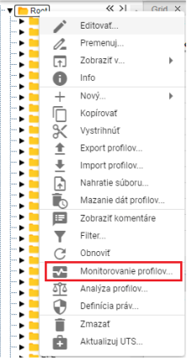

Figure 474: "Profile Monitoring" item

1. A "Monitoring" window will appear.
2. Press the button or right-click on an existing job and select the "Create New Job" item.

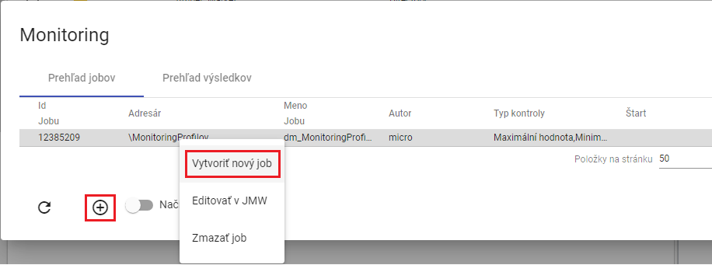

Figure 475: "Create New Job" item

1. A "New Monitoring Job" window will appear. Field Description:

* “Criteria” - criteria according to which the profile is monitored,
* “Value Change” - a criterion checking for a value change in the monitored profile. The profile is monitored at a defined time interval, and if all values within the interval are the same, an error message is displayed. (Profile: “Profile Name” No change in value in interval 27.3.2017 1:00:00 - 27.3.2017 4:00:00),
* “Monotonic” - a criterion checking for monotonicity of values in the monitored profile within a defined interval. If values violating ascending monotonicity are found within the selected time period, an error message is displayed. (Profile: “Profile Name” Monotonicity condition of the series is not fullfilled at time point 6.4.2017 11:00:00).
* “Ascending” - a criterion checks for ascending behavior. The profile must consistently increase.
* “Maximum Value” - a criterion checking for reaching the maximum value in the monitored profile. If a value exceeding the selected maximum value is found within the values of the selected profile in a defined time interval, an error message is displayed. (Profile: “Profile Name” 1.1.2013 0:00:00 > 14 is larger than allowed max: 8),
* “Minimum Value” - a criterion checking for reaching the minimum value in the monitored profile. It functions analogously to the maximum value criterion.
* “Missing Value” - a criterion checking the number of missing values in the monitored profile within a defined interval. If the number of missing values within the defined interval exceeds the “Missing Value” parameter, an error message is displayed. (Profile: “Profile Name” Interval 1.1.2013 0:00:00 - 2.1.2013 0:00:00 contains 3 empty values.),
* “Different Value” - a criterion checking the difference between the maximum and minimum value in the monitored profile within a defined interval. If the difference between the max and min values within the defined interval exceeds the “Different Value” parameter, an error message is displayed. (Profile: “Profile Name” Difference in values was 12),
* “Interval Start (D:H:M:S)” - is the interval for the start of data monitoring in the profile. It relates to the action start time or to a specified absolute time,
* “Interval End (D:H:M:S)” - is the interval for the end of data monitoring. It relates to the action start time or to a specified absolute time.
* “Time Zone” - is the zone in which the server running JMW is located. The zone is taken into account when using a sliding time window, where it determines the local time of action start.
* “Alignment” - the Alignment option allows aligning the data time window of the monitored profile to the following time periods:
  + day in valid time
  + hour in valid time

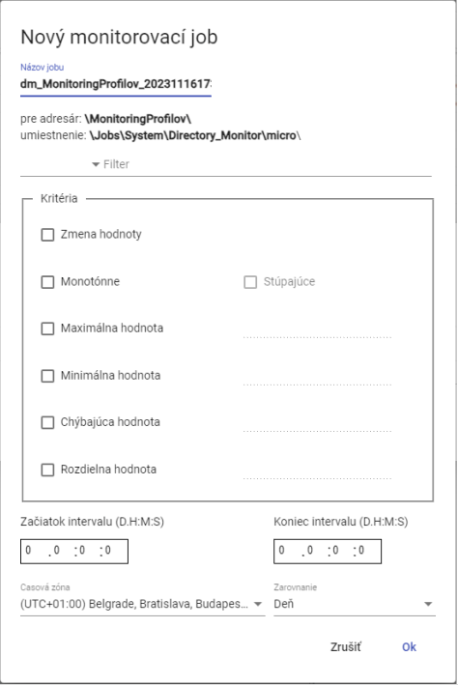

Figure 476: "New Monitoring Job" Window

1. By default, the job name is pre-filled. You can enter a name for the job in the "Job Name" field.
2. Click in the field to the left of the word "Filter" to display a window where you select a condition for the filter.

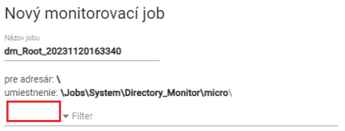

Figure 477: Filter Selection Field

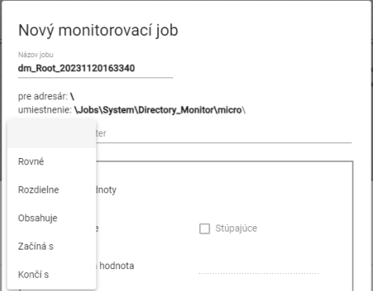

Figure 478: Window for Selecting a Condition for the Filter

1. Click in the "Filter" field and enter a value for the filter. For example: Starts with letter A – this will only display profiles whose name starts with the letter A.



Figure 479: Field for Entering a Value for the Filter

1. In the "Criteria" block, enter the criteria for monitoring.

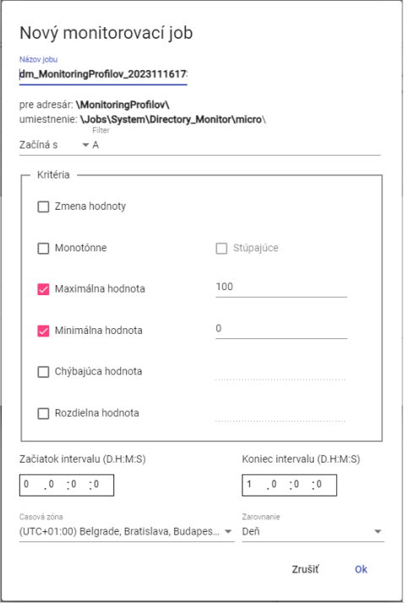

Figure 480: Job Submission

1. Enter the Start and End of the interval.
2. You can select the time zone and alignment.
3. To create a monitoring job, press the "Ok" button.
4. A new monitoring job will appear in the "Monitoring" window.

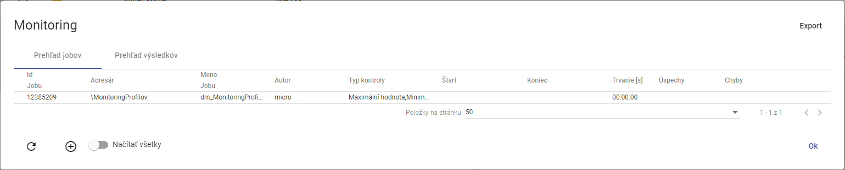

Figure 481: Created monitoring job

### How to edit a job in JMW

To edit a job, proceed as follows:

1. Right-click on the job and select "Edit in JMW".

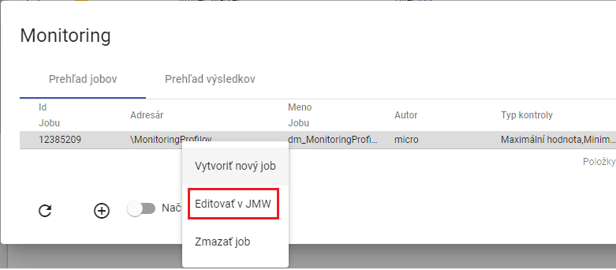

Figure 482: "Edit in JMW" item

1. A new tab will open in the browser, displaying the job in the “Job Manager” application.

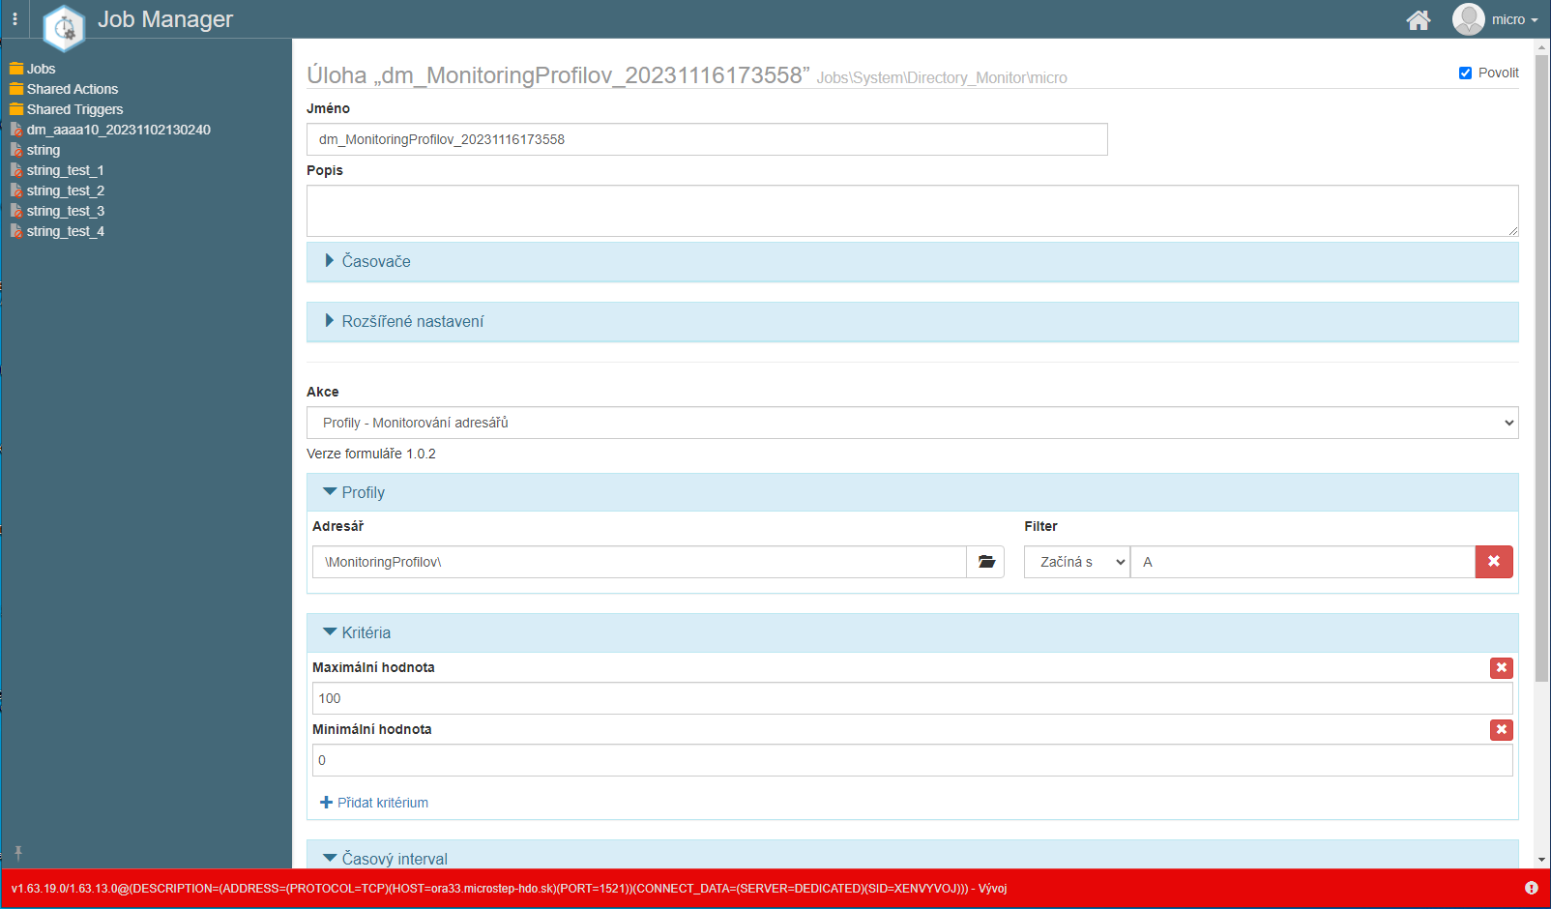

Figure 483: Editing the job in the “Job Manager” application

1. The procedure for editing a job can be found in the documentation for the “Job Manager” application.

### How to delete a job

To delete a job, proceed as follows:

1. Right-click on the job you want to delete in the "Monitoring" window.

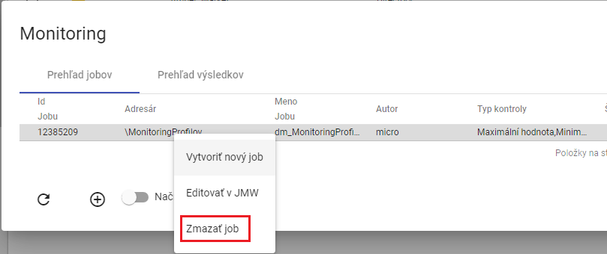

Figure 484: "Delete job" item

1. A confirmation window will appear; click the "Yes" button.

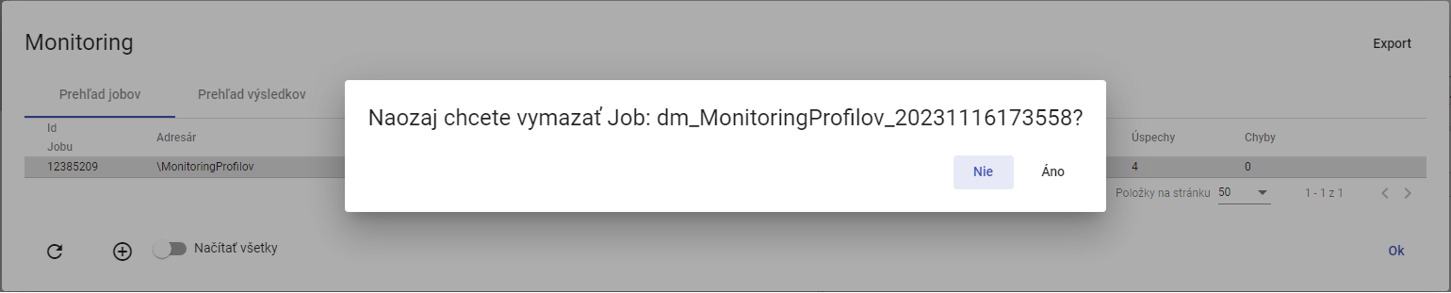

Figure 485: Job Deletion Confirmation Window

### How to export monitoring jobs and job results

To export jobs in the "Job Overview" tab, click the "Export" button located in the upper right corner of the "Monitoring" window. To export job results, display the "Result Overview" tab and click the "Export" button. A CSV file will be downloaded.

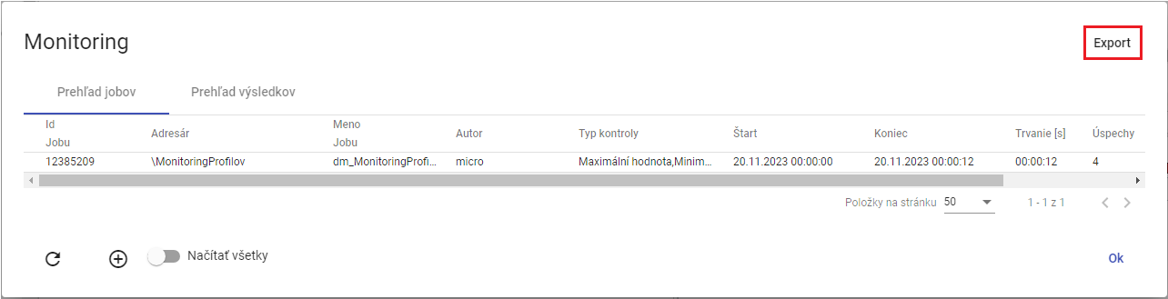

Figure 486: “Export” Button

### How to display all monitoring jobs

To display all monitoring jobs, click the "Load All" button. All monitoring jobs from the tree structure will be displayed in the "Monitoring" window.

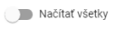

Figure 487: “Load All” Button

### How to refresh the list of jobs in the "Monitoring" window.

To refresh the list of jobs, click the button located in the lower-left corner of the "Monitoring" window.

### How to view the results overview of a monitoring job.

In the "Monitoring" window, display the "Results Overview" tab. Here you will find a list of monitoring job runs. If the criteria under which the profile is monitored have been violated, the text "ERR" will be displayed in the "result" column, and a description of the error can be found in the "detail" column. If the criteria have been met, the result is "OK".

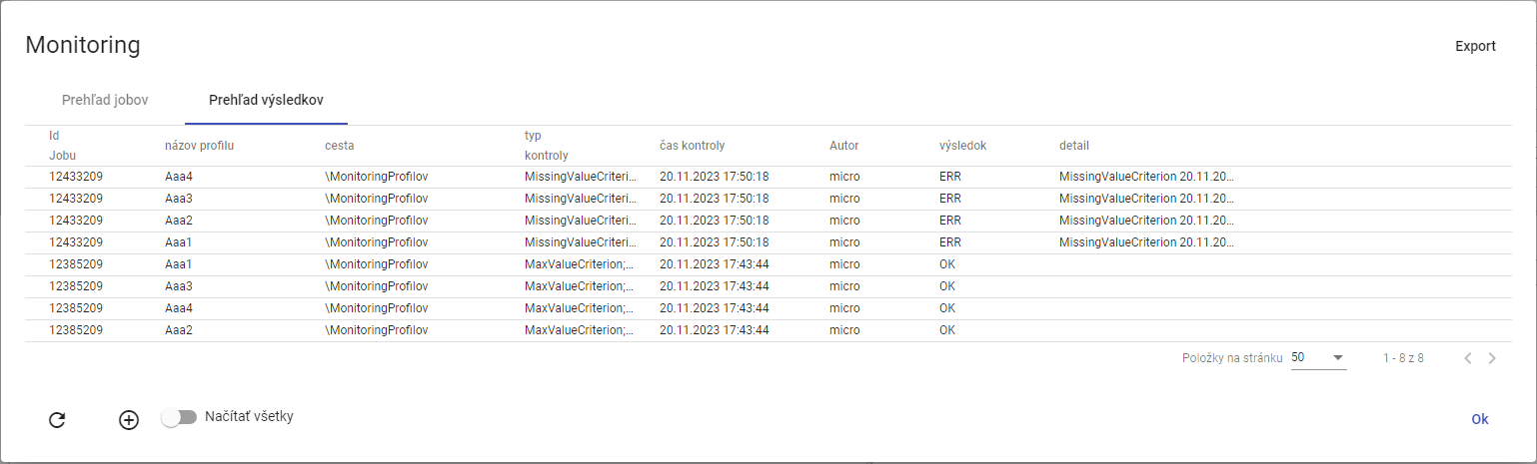

Figure 488: "Results Overview" tab

## Profile Analysis

Profile Analysis represents a static snapshot at a given time of computation. This means that if someone were to delete a profile, the Profile Analysis would remain preserved. Profile Analysis allows the user to filter and sort data. Creating a Profile Analysis is covered in chapter 8.2.1.

If you close a Profile Analysis, you can reopen it. Opening an existing Profile Analysis is detailed in chapter 8.2.2.

Profile Analysis is valid for 15 minutes after creation. You can extend the validity. The procedure is located in chapter 8.2.3.

Exporting the displayed data in a Profile Analysis is detailed in chapter 8.2.4.

### How to create a Profile Analysis

To create a Profile Analysis, proceed as follows:

1. In the tree structure, right-click on the directory containing the profiles for which you want to create a profile analysis.
2. A window will appear, in which click on the “Profile Analysis” item.

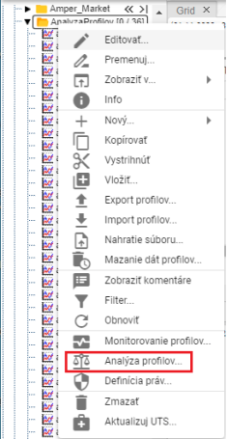

Figure 489: “Profile Analysis” item

1. Another option is to display the directory containing the profiles in the “Explorer” window and click on the “Statistics” button, which is located in the upper right corner of the “Explorer” window.



Figure 490: “Statistics” button

1. The “Profile Analysis” window will be displayed.
2. By default, the “Create new for period” option is selected.

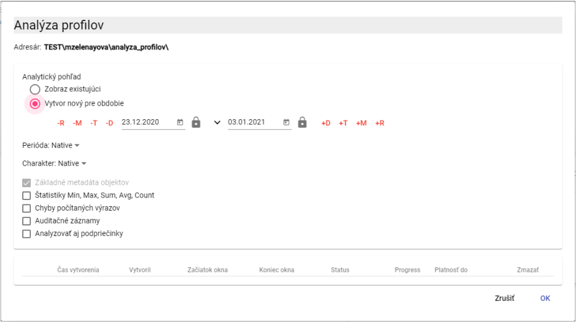

Figure 491: “Profile Analysis” window

1. Set the period for which the profile analysis should be performed. Click the button to display the default date range options.

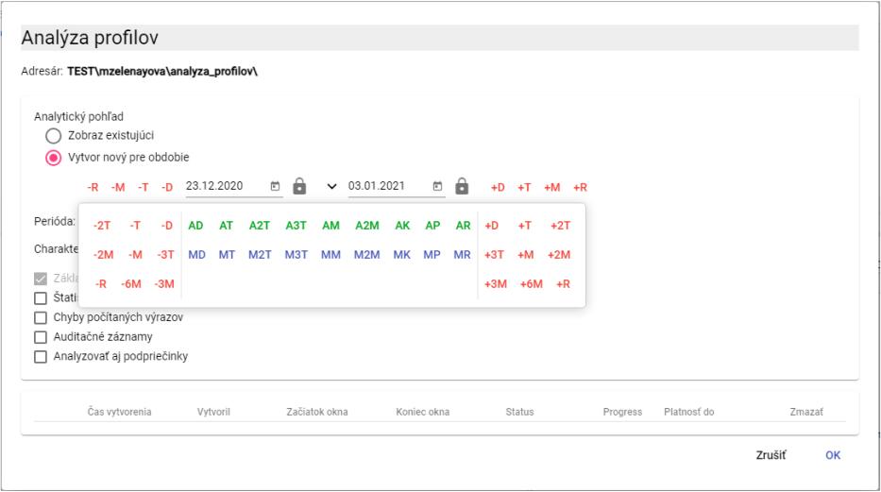

Figure 492: Date Selection

1. By default, the “Period” field contains “Native”. To enter a different period, click in the “Period” field and select a period.

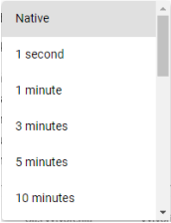

Figure 493: Period Selection

1. The profile character is used to identify how values in the profile should be resampled to finer or coarser sampling. By default, the “Character” field contains “Native”. To select a character, click in the “Character” field and select “Quantity” or “Continuous”."

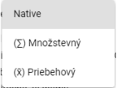

Figure 494: Character Selection

1. To calculate statistics in the analysis, check the "Min, Max, Sum, Avg, Count Statistics" box.

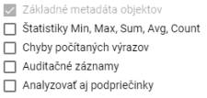

Figure 495: Optional Items in the Analysis

1. To display an error message if an error occurs, check the "Calculated Expression Errors" box.
2. Check the "Audit Records" box if you want to list the following data: First Read, Last Read, First Write, and Last Write.
3. To include subfolders in the analysis, check the "Analyze Subfolders" box.
4. To create a profile analysis, click the "OK" button.
5. A new tab labeled "A directory name" will be created in the "Explorer" window. Profile analysis represents a static snapshot in time during the calculation.

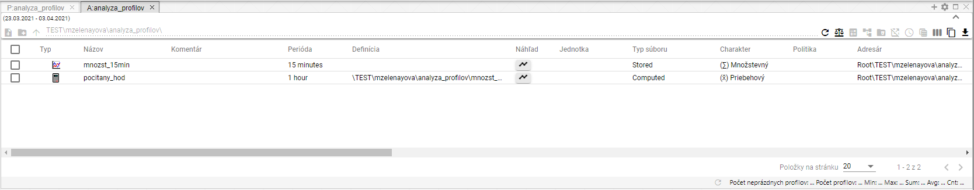

Figure 496: Created Profile Analysis

1. In the profile analysis window, you can filter the data. Position the mouse cursor on the column name where you want to enter a filter. A button for entering the filter will appear.



Figure 497: Button for entering a filter

1. To sort the data in a column, position the mouse cursor on the column name. An arrow will appear. Click the button with the arrow icon to sort the data in the column.



Figure 498: Button for sorting data in columns

### How to display an existing profile analysis

If you have closed a profile analysis and want to reopen it, it is possible during the analysis' validity period. A profile analysis is valid for 15 minutes after creation. This validity can be extended.

To reopen an existing profile analysis, proceed as follows:

1. In the "Profile Analysis" window, click on "Display Existing".
2. Click to select the analysis you want to display.

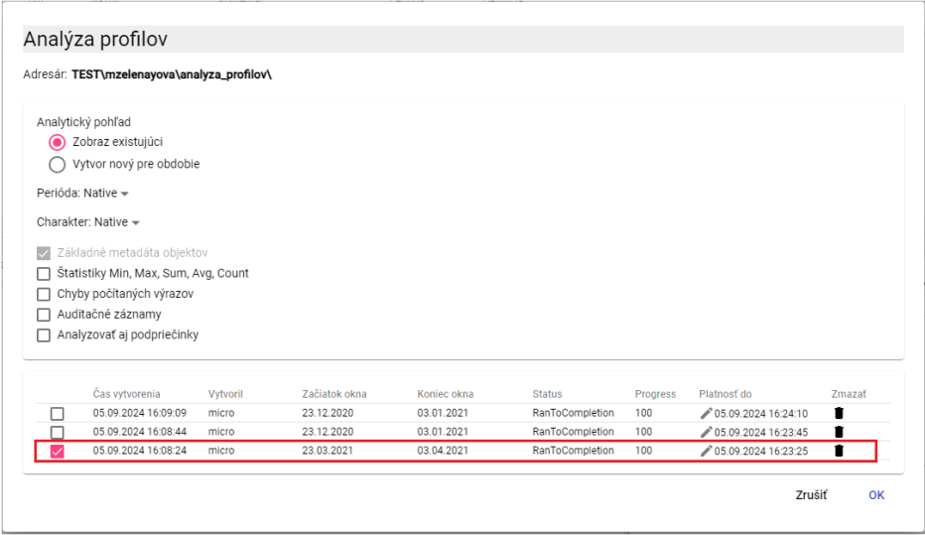

Figure 499: Displaying an Existing Profile Analysis

1. Click the "OK" button.
2. The profile analysis will be displayed in the "Explorer" window.

### How to change the validity of a created profile analysis

The validity of the profile analysis is standardly 15 minutes, but you can extend it.

To extend the validity of the profile analysis, proceed as follows:

1. In the "Profile Analysis" window, in the row of the analysis whose validity you want to extend, click the button with the pencil icon.

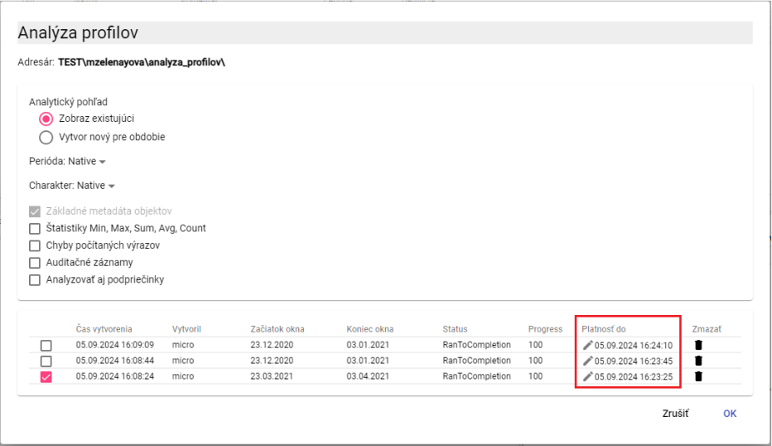

Figure 500: "Valid Until" field

1. The "Valid Until" field will become editable.

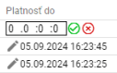

Figure 501: Extending the Validity of Profile Analysis

1. The first field represents days, the second field hours, the third represents minutes, and the fourth field seconds. If you want to extend the validity by 2 days, enter the value "2" in the first field. If you want to extend the validity by 6 hours, enter the value "6" in the second field.
2. Save by pressing the button.
3. The validity of the profile analysis will be extended.

### How to export the displayed data in the profile analysis

To export data in profile analysis, proceed as follows:

1. Press the button located in the upper right corner of the "Explorer" window.

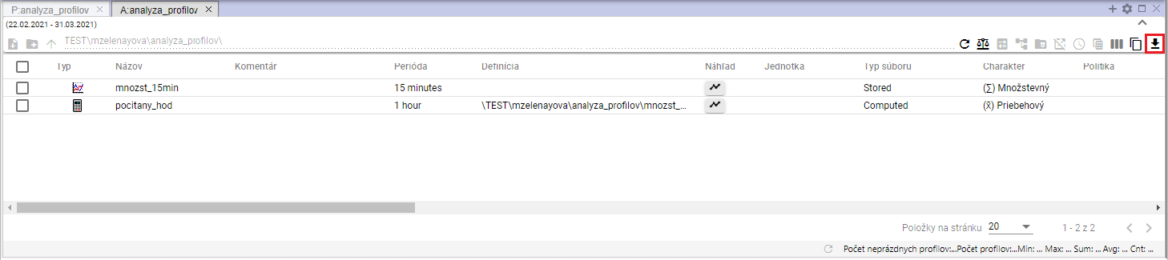

Figure 502: Button for exporting profile analysis

1. The "Export" window will appear.

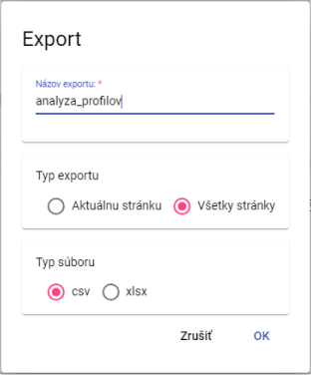

Figure 503: "Export" window

1. In the "Export Type" section, the "All Pages" item is set by default. All data is exported. If you select "Current Page", only the displayed data is exported.
2. In the "File Type" section, select the file type for export.
3. To confirm the export, press the "OK" button.

## Report Manager

### How to create a new report

To create a report, proceed as follows:

* 1. In the tree structure, right-click on the directory where you want to add a new report.
  2. A menu will appear, in which you should position the mouse cursor over the "New" item and then select the "Report" item.

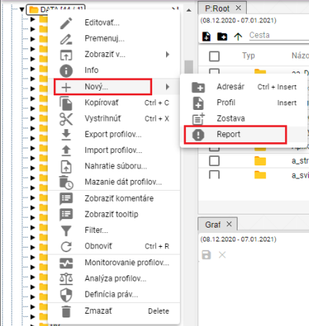

Figure 504: "Report" item

* 1. A "Report Manager" tab will appear, where you enter the data for the new report.

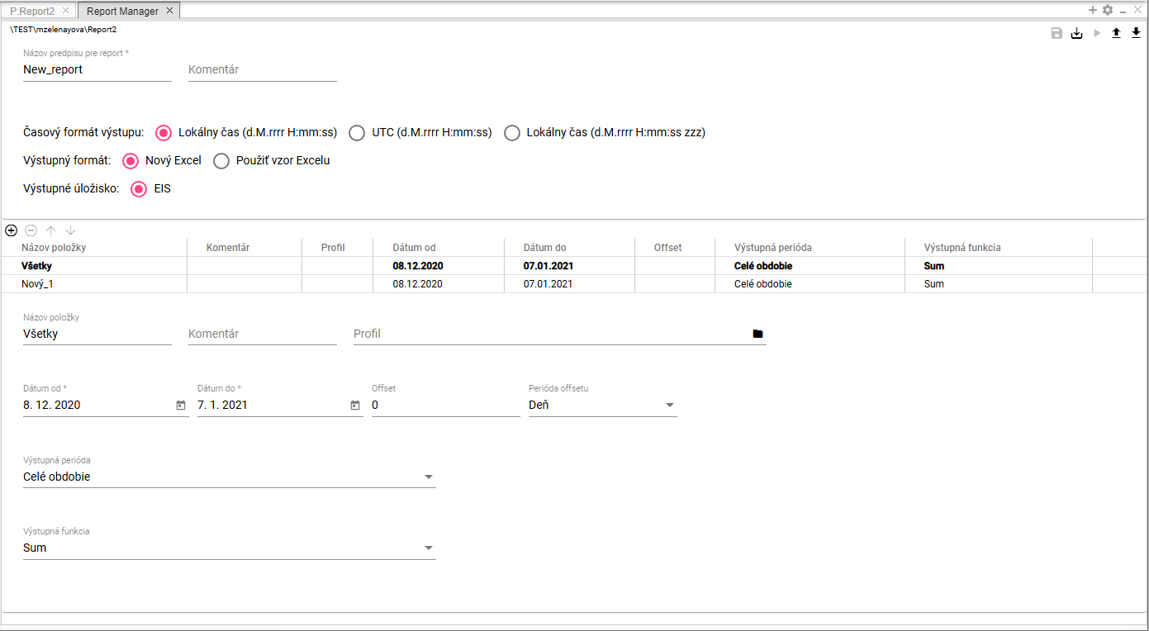

Figure 505: "Report Manager" tab

* 1. In the "Report Name" field, the text "New_report" is automatically entered. You can change the name.

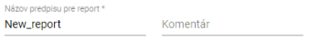

Figure 506: “Report Name” and “Comment” fields

* 1. In the "Comment" field, you can enter a comment.
  2. Select the output time format. “Local Time (d.M.yyyy H:mm:ss)” is selected by default.



Figure 507: “Output Time Format” field

* 1. In the "Output Format" field, select the output format for the report. "New Excel" is selected by default.



Figure 508: “Output Format” field

* 1. If you select “Use Excel Template”, the “Excel Name” and “Sheet Name in Excel” fields will appear.

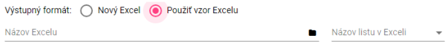

Figure 509: Fields for entering Excel details

* 1. In the “Excel Name” field, click the button to display the “Select xlsx” window, in which you can search for the Excel file in the tree structure.

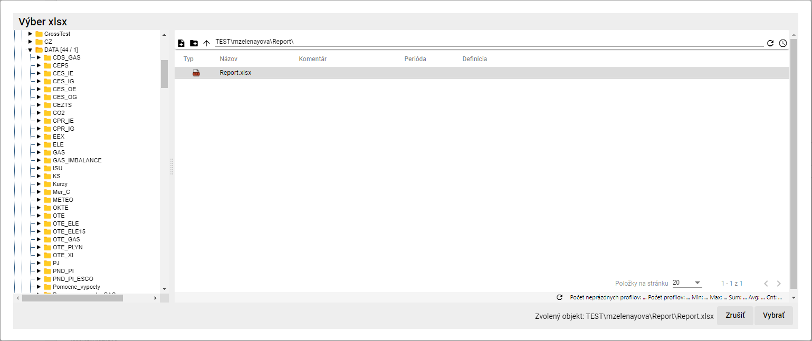

Figure 510: “Select xlsx” window

* 1. In the “Select xlsx” window, after searching for the Excel file, click the “Select” button. The path to the Excel file will be added to the “Excel Name” field, Figure 511.
  2. Click in the “Sheet Name in Excel” field and select the sheet name.



Figure 511: Filled in “Excel Name” and “Sheet Name in Excel” fields

* 1. Fill in the data for items.

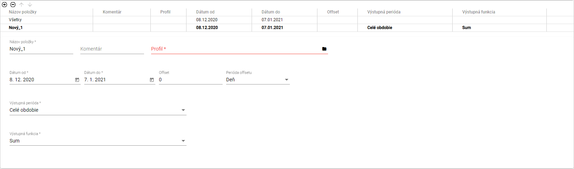

Figure 512: Entering data for items

* 1. To enter the same data for all items at once, click “All”. The data you enter will be filled in for all profiles.
  2. To enter data for each profile separately, click on the item in the table for which you want to enter the data.



Figure 513: Selected item in the table

* 1. Enter the data below the table. The data will be automatically filled in to the table.
  2. "The „Item Name“ field is automatically filled with „New_1“. You can change the name.
  3. You can enter a comment in the "Comment" field.
  4. In the "Profile" field, enter the path to the profile or click the button to display the "Profile Selection" window.
  5. In the "Profile Selection" window, find the profile and click the "Select" button.

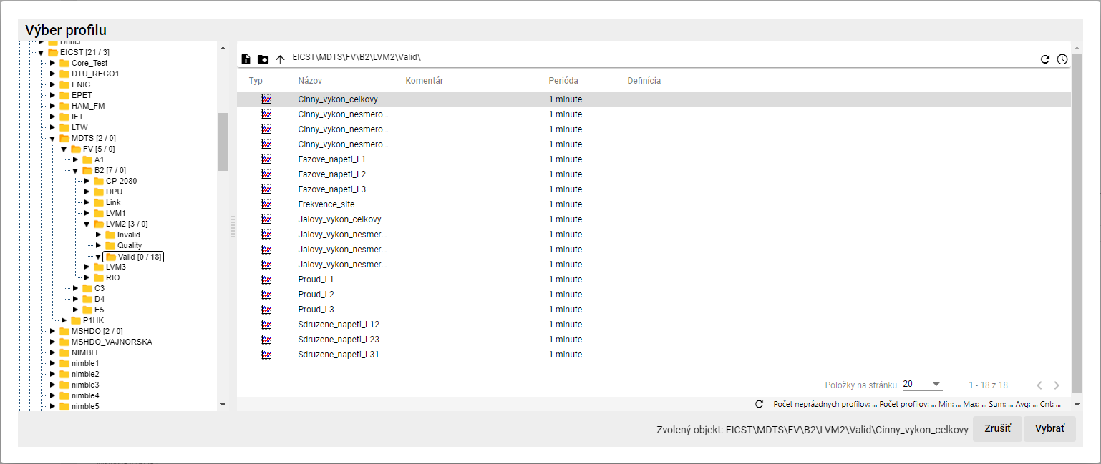

Figure 514: "Profile Selection" window

* 1. Select the "From Date" and "To Date" dates.
  2. In the "Offset" field, you can enter an offset.
  3. In the "Offset Period" field, select the period.
  4. Click in the "Output Period" field and select a period from the displayed menu.
  5. Click in the "Output Function" field and select a function.

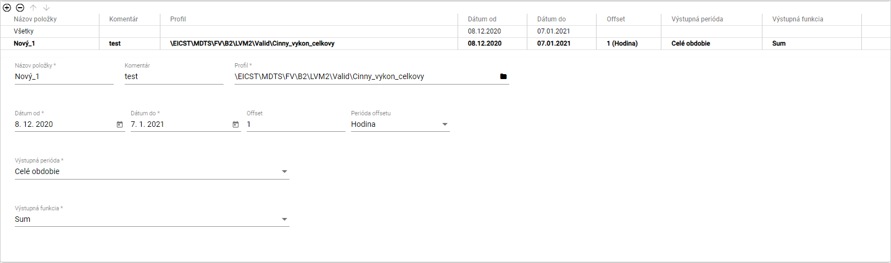

Figure 515: Completed data for the item

* 1. You can also add a profile by transferring it from the tree structure to the table in the “Report Manager” tab. In the tree structure, click and drag a profile with the left mouse button and move the profile over the table. Release the profile to add it as a new item to the table.

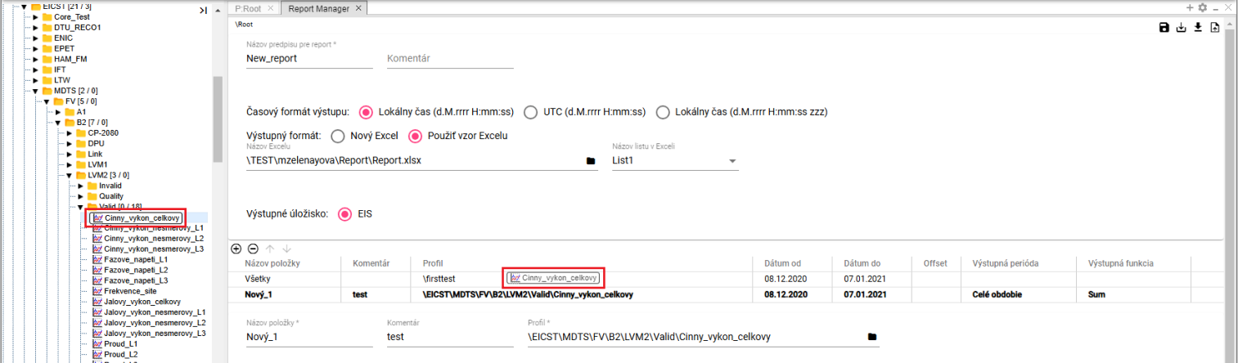

Figure 516: Transferring a profile from the tree structure to the table



Figure 517: Profile added from the tree structure

* 1. You can also add a profile to the “Report Manager” tab from the explorer. Click the profiles you want to transfer to the table in the “Report Manager” tab within the explorer window. Click and drag the profiles from the explorer window and move them over the table in the “Report Manager” tab. Release the profiles. The profiles will be added to the table in the “Report Manager” tab.

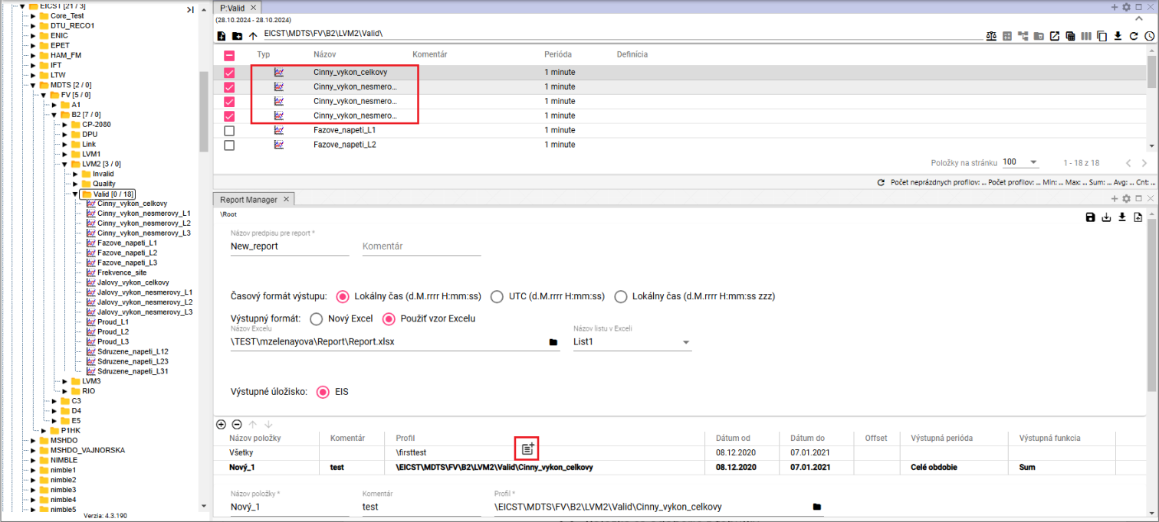

Figure 518: Transferring profiles from the table to the Report Manager using Drag and Drop

* 1. You can add another item by clicking the button.
  2. To remove an item, click the item in the table and press the button. The item will be removed from the table.
  3. You can change the order of profiles in the table using the buttons.
  4. You can save the report by clicking the “Save” button, located in the top right corner of the “Report Manager” screen. The report will be saved to the directory in the tree structure where you created it.



Figure 519: “Save” button

* 1. To save the report to a different directory, click the “Save As” button.
  2. The “New Report” window will appear.
  3. In the “Path” field, enter the path to the new directory or browse for a directory using the button.

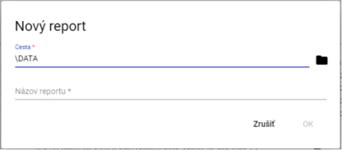

Figure 520: “New Report” window

* 1. In the “Report Name” field, enter a name for the report.
  2. You save the report by pressing the “OK” button.
  3. You generate the report by pressing the “Generate Report” button, which is located in the upper right corner of the “Report Manager” screen.



Figure 521: “Generate Report” button

* 1. A “Time Range Settings” window will appear, in which you select the time range.

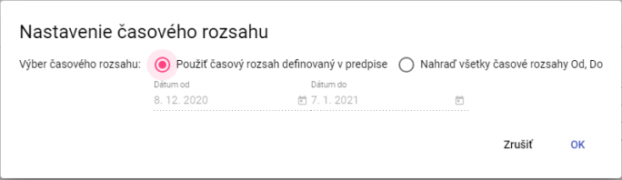

Figure 522: “Time Range Settings” window

* 1. To generate the report, press the “OK” button.
  2. To download the generated report, click the “Export” button in the top toolbar, which will display the “Export” window.
  3. In the “Export” window, click the “Download” button, which is located in the row of the generated report.

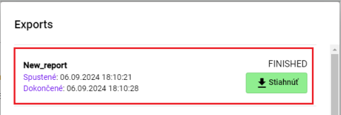

Figure 523: Generated report

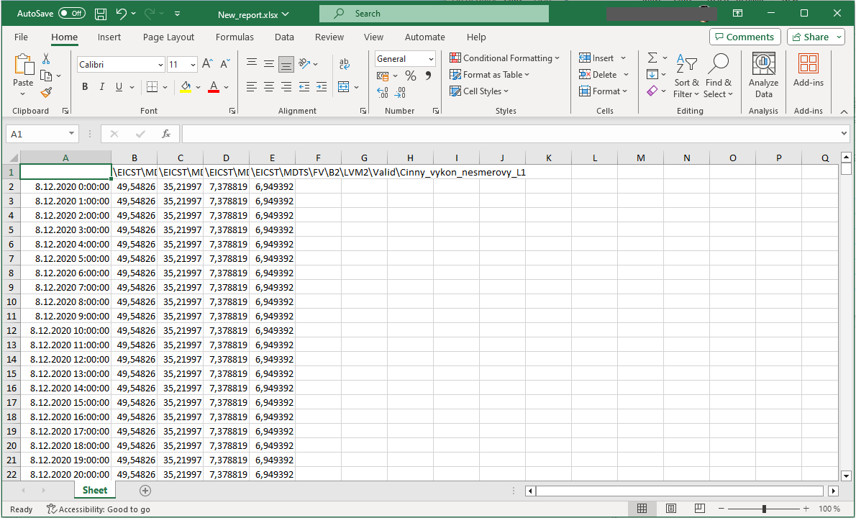

Figure 524: Downloaded report

* 1. You can save the report to disk in “CSV” or “PGZ2” format. To download the report, click the “Save report to disk…” button and select the format in which to download the report. The report will be saved among the downloaded files on your computer.

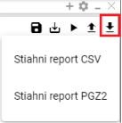

Figure 525: Save report to disk… button menu

### Rights for Report Manager

Rights can be set for “Report Manager”:

* Read - if the user does not have “Read” rights, they cannot open the form or pgz or pgz2.
* Create - if the user does not have “Create” rights, the “Save as…” button will not be enabled and the option to create a “Report” will not appear in the “New…” menu.
* Write - if the user does not have “Write” rights, the “Save” button will not be enabled, they will only have the “Save as…” button enabled, and will be able to save to disk.
* Execute - if the user does not have “Execute” rights, the “Generate Report” button will not be enabled.

## How to recover deleted items from the Recycle Bin

You can recover items from the Recycle Bin:

1. Display the contents of the Recycle Bin in tree structure or in Explorer window, 4.14.



Figure 526: Recycle Bin in tree structure

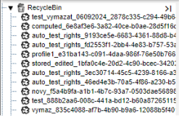

Figure 527: Displaying the contents of the Recycle Bin in tree structure

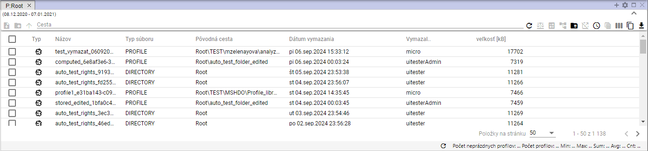

Figure 528: Contents of the Recycle Bin displayed in Explorer window

1. Right-click the item in the Recycle Bin that you want to restore.
2. A menu appears, in which select “Restore from Recycle Bin”.

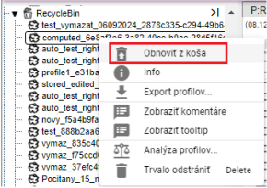

Figure 529: "Restore from Recycle Bin" item

1. A "Restore File" window appears.

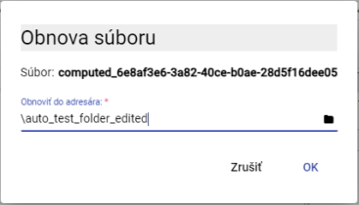

Figure 530: "Restore File" window

1. In the "Restore to directory" field, you will find the path to the directory from which the file was deleted. If you want to restore the file to a different directory, enter the path to the directory or search for the directory using the button.
2. To confirm the file restore, press the "OK" button.



© 2025 MicroStep – HDO spol. s r.o.

MicroStep and MicroStep-HDO are registered trademarks. This document is the intellectual property of MicroStep-HDO s.r.o. and may only be used for the purposes for which it was provided.

*MicroStep-HDO s.r.o., Vajnorská 158, 831 04  Bratislava*

*www.microstep-hdo.com, e-mail: info@microstep-hdo.sk*